HS-10 Barcode Scanner
User Manual

V1.1.1

Disclaimers

Please read all the contents of this manual carefully before using the products described in this manual to ensure safe and effective use of the products. It is recommended that this manual be kept in a safe place for the next time you use it for reference.
Warnings
Please do not disassemble the product or tear the seal label on the product by yourself, otherwise our company will not be responsible for warranty or replacement of the product.
The pictures in this manual are for reference only. If there is any discrepancy between individual pictures and actual products, please refer to the actual products. For product improvement and update, the company reserves the right to modify the document at any time without notice.

All information contained in this manual is protected by copyright and all rights are reserved. No unit or individual may make any kind of excerpt, copy or bundle with other products or sell this document in whole or in part in any way or for any reason without written permission.

Our company has the final right to interpret this manual.

Service Information
If you need more technical support, please call or email us and we will be happy to serve you.

Version Record
Instruction manual version number | Version Description | Release Date
V1.0 | Initial Version | 2021.12.27

Catalog
Preface 1
Introduction 1
Chapter outline 1
Brochure Legend 1
Chapter 1 About HS10 2
Introduction 2
Main Features 2
Open the package 2
Communication Port 3
Power on, power off, standby and restart 3
Maintenance and Care 3
Code Reading Tips 4
Chapter 2 System Setup 5
Introduction 5
Setting the logo 5
Use the setup code 5
Restore factory default settings 6
Read the version number 6
Product User Settings 6
Sound settings 7
Volume settings 7
Set the beep switch 7
Power On Beep Switch 8
Read success beep switch 8
Chapter 3 Reading Mode Settings 9
Level trigger mode 9
Continuous mode (default) 9
Pulse trigger mode 9
Repeat read switch 10
One read timeout 10
Chapter 4 Communication Setup 11
Introduction 11
Communication settings 11
System Upgrade 11
USB HID upgrade steps 11
RS-232 serial port upgrade procedure 13
USB Keyboard 16
USB Multi-Country Keyboard 16
USB keyboard sending speed 17
Setting the USB keyboard sending speed 18
Control characters 18
Serial communication settings 19
Serial port baud rate setting 19
Serial port parity bit setting 20
Chapter 5 Output Data Format Setting 21
Introduction 21
Custom Prefix Settings 21
Custom prefix on/off settings 21
Custom Prefixes 22
Custom Suffix Settings 22
Custom suffix on/off settings 22
Custom Suffixes 23
Code ID setting 24
Code ID output method 24
Custom Code ID 25
Terminator settings 25
Case output settings 26
Data output settings 27
Data output selection 27
前段 Pre/Post data length setting 28
Chapter 6 Decode Library Setup 29
Introduction 29
All barcodes 29
EAN8 Settings 29
EAN8 on/off setting 29
EAN8 checksum settings 30
EAN8 transcoding settings 30
Add-on code setting 30
EAN13 Settings 31
Turn on/off settings 31
Calibration settings 31
Leading code setting 31
ISSN Settings 32
ISBN settings 32
Data bit setting 32
Transcoding settings 32
UPC-A Settings 33
Checksum setting 33
Transcoding settings 33
UPC-E Settings 33
Turn on/off settings 33
校验 Checksum setting 34
Transcoding settings 34
Code 39 Settings 34
Turn on/off settings 34
Calibration settings 35
Start and stop character settings 35
Code39 Full ASCII code reading function 35
Code 39 Length Setting 36
Code 32 settings 37
Transcoding settings 37
Code 128 Settings 37
Turn on/off settings 37
Calibration settings 37
Code 128 Length Setting 38
Code 93 Settings 39
开启 Turn on/off settings 39
Calibration settings 39
Code 93 Length Setting 40
Codabar Settings 41
Turn on/off settings 41
Start and stop character settings 41
Codabar length setting 41
Crossover 25 code (ITF5) setting 42
开启 Turn on/off settings 42
Calibration settings 42
Crossover 25 yard length setting 43
Appendix 44
Appendix 1 Data code table 44
Appendix 2 Code System Support List 46
Appendix 3 Table of Control Characters 47
Appendix 4 ASCII code table 49

Preface

Introduction
This manual mainly provides users with detailed information on the use of HS10 and related precautions.

Chapter outline
Chapter 1 About HS10
Chapter 2 System Setup | Introduce the main setting method of the scanner and the system parameters setting
Chapter 3 Reading Mode Settings | List the supported reading modes and provide the corresponding parameter setting codes
Chapter 4 Communication Setup | Describes the setting of communication parameters
Chapter 5 Formatting of Output Data | Introduces how to use the barcode information in the set output data format
Chapter 6: Decode Library Setup | Lists all the code systems supported and provides the relevant parameter setting codes
Appendix | Provide common setting codes and factory default parameter table, etc.

Brochure Legend

ATT | Note the hint that the user needs to pay strong attention to the content here
Tips | Tips to help users better understand the content of the document
Example | Examples to help users become familiar with the operation

Chapter 1 About HS10

Introduction
Our product model HS10, to which this manual applies, uses laser scanning to identify barcodes. They apply a full set of our self-developed patented technology, with powerful recognition performance, fast and flexible scanning speed.
This section will introduce the use of the product step by step with pictures, please compare the actual product you have purchased when reading the document, so that it is more conducive to your understanding of this document. This section is suitable for general users, maintenance personnel and software developers.

Main features
* Completely self-developed, with a full set of patents, plug-and-play without installing drivers.
* With 32-bit main control chip equipped with patented software, it can smoothly decode reflective, wrinkled, blurred, and color barcodes, and can decode normally in strong light and dark environment.

Open the package
After you open the shipping carton containing the product, take the following steps:
- Check for damage during shipment. Report damage immediately to the carrier who delivered the carton.
- Make sure the items in the carton match your order.
- Save the shipping container for later storage or shipping.

Communication Port
The product must be connected to a host computer in order to operate. The host computer can be a PC, a POS machine or an intelligent terminal with any of the USB or RS-232 interfaces.
USB | USB port on the host | 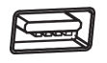
RS-232 | RS-232 interface on the host computer | 
The scanner will be equipped with the corresponding cable according to the customer's order interface, if you need to switch to other interfaces, please consult sales to purchase the corresponding cable.

Power on, power off, standby and restart
Power on: Connect the product to the host, and the product will automatically power on and be in working condition.
Shutdown: Remove the data cable connected to the product; remove the USB cable plugged into the host computer/the power adapter plugged into the RS-232 data.
Reboot: If the product appears to be dead or unresponsive, please turn it off and on again to achieve a reboot.

Maintenance and Care
*The literate window must be kept clean and the supplier is exempt from warranty liability for damage caused by improper maintenance.
* Avoid abrasion or scratching of the reading window by hard and rough objects.
* Removal of smudges on the identification window with a brush.
*Please use a soft cloth to clean the window. such as eyeglass cleaning cloths and lens-specific cleaning cloths.
* Prohibit the spraying of any liquid on the identification window.
* The use of any cleaning agent other than cleaning water is prohibited.

Code Reading Tips
If the barcode is small, you should make the barcode close to the product scanning window; if the barcode is large, you should make the barcode a little far from the product scanning window, so that it is easier to read the barcode correctly.
If the barcode is highly reflective (e.g., coated surface), you may need to tilt the barcode at an angle in order to successfully scan the barcode.
Example of sweeping code.


Chapter 2 System Setup

Introduction
This product is mainly used to set options and functions by reading a series of special barcodes. In this section, we will introduce in detail the options and functions available for users to set and provide the corresponding setting codes.
This method of setting up a scan is relatively straightforward and easy to understand, making it user-friendly.

Setting Barcode
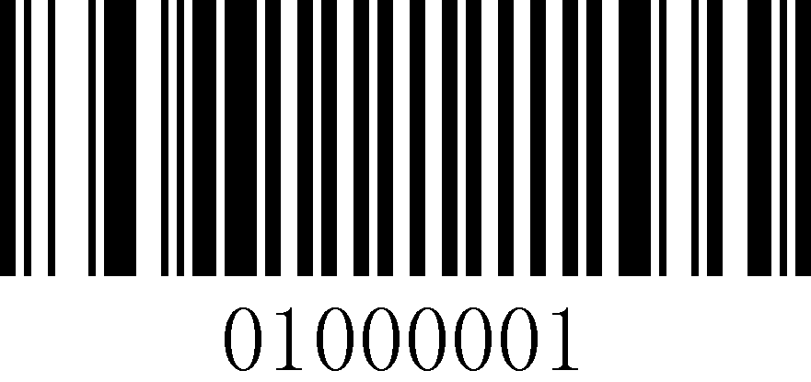
Startup settings (default)
1
2
This is the logo for the sweep configuration code function to turn on (default) barcode functionality. The logo consists of two parts.
- Set the barcode part of the code
- Set the name of the option or function, such as the function to turn on the configuration code function.

Use the setup code
Read the "Startup Settings" barcode to activate the setup code function, which allows you to set up the scanner by reading the setup code.
To exit the setup code function, simply read the "Exit Setup" barcode.
Startup settings (default)
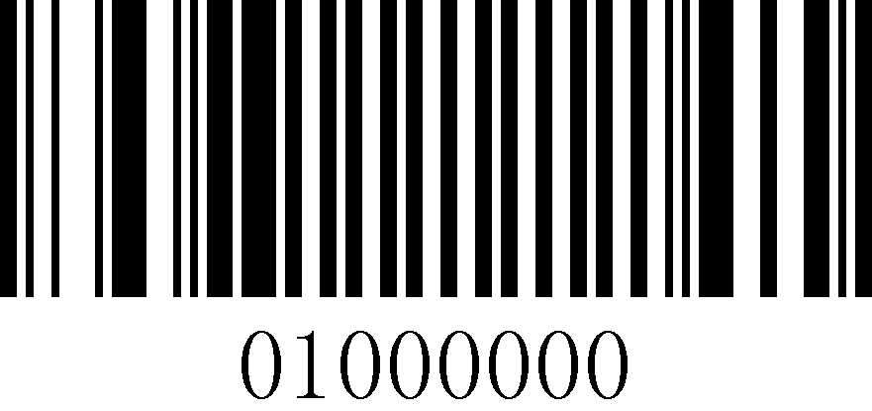
Exit Settings

Restore factory default settings

Restore factory settings

Read version number
Read the current device version number. If the version number data length exceeds the maximum length of the instruction, you need to send Get Instruction 1 and Get Instruction 2 respectively to get the complete version number, refer to Appendix: "Instruction Format Description" for details.

Read version number

Product User Settings
In addition to the factory default settings, you can save the frequently used settings as user default settings.
The user default settings also contain all property settings for the scanner and the user default settings will be saved and not lost unless the current settings are re-saved as user default settings.
Save User Defaults: will save the current user default settings and overwrite the previously set user default settings.
Restore User Defaults: will cause the scanner to switch to the user default settings.
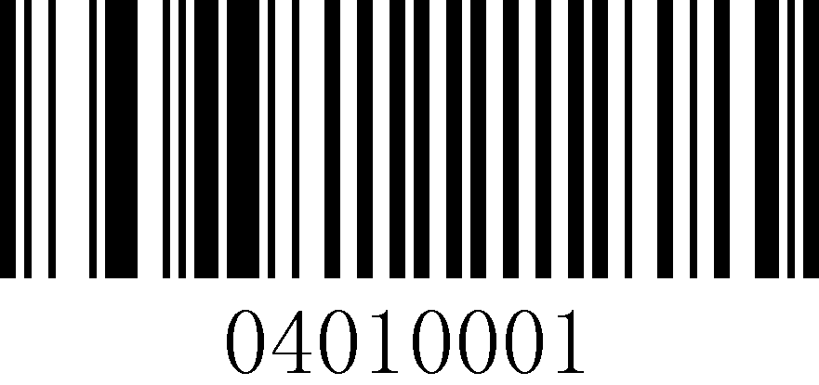
Save user default settings
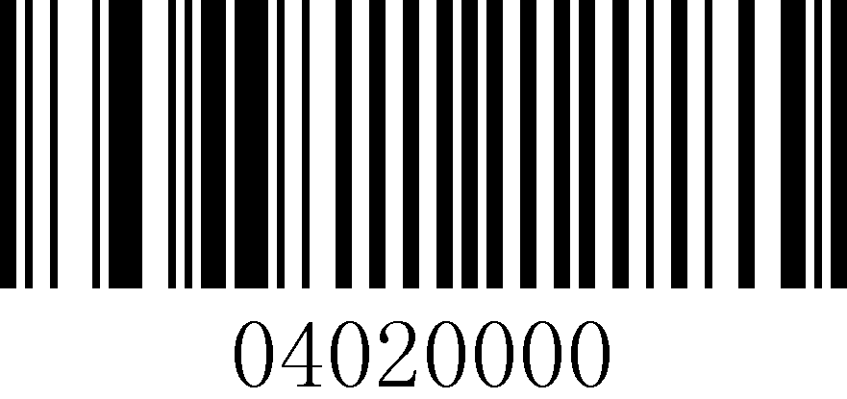
Restore user default settings

Beeper settings
Scanner sounds can be divided into: setup beep, power on beep and read success beep. This section will provide detailed instructions for setting the scanner sounds.

Volume Settings
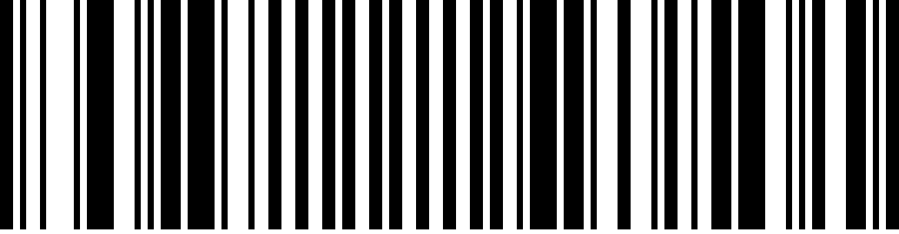
Volume set to High (50%) (default)

Volume set to midrange (25%)
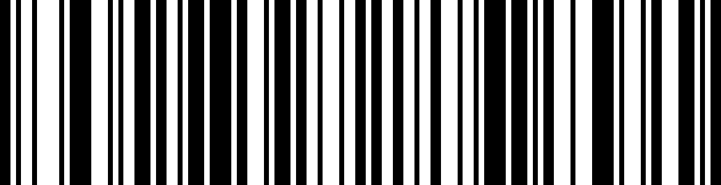
Volume set to bass (12.5%)

Set the beep switch
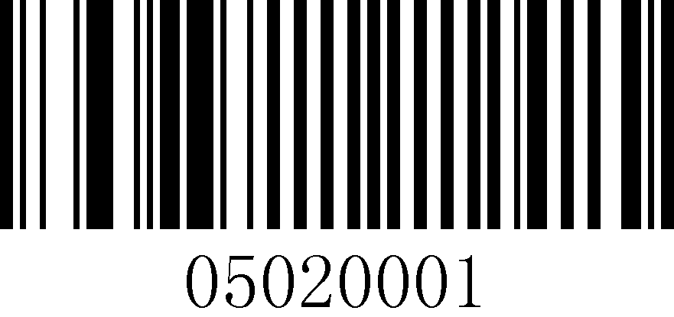
Open (default)
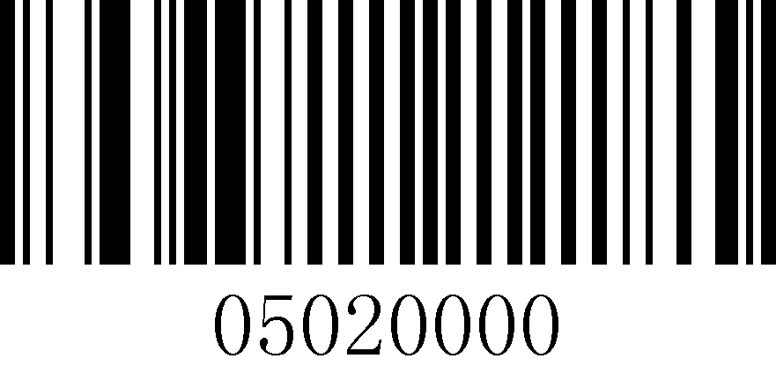
Close

Power on beep switch
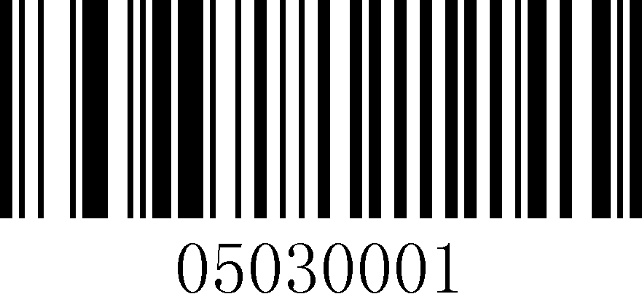
Open (default)
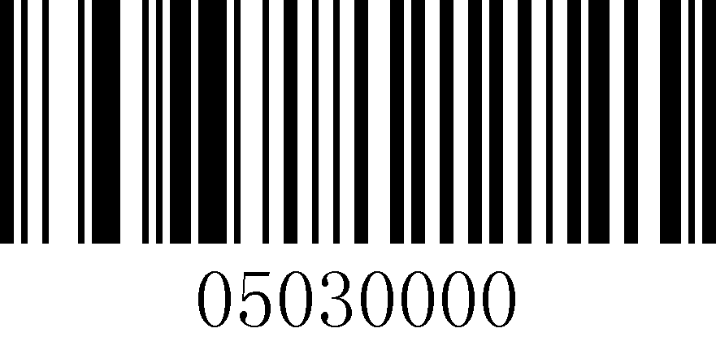
Close

Read success beep switch
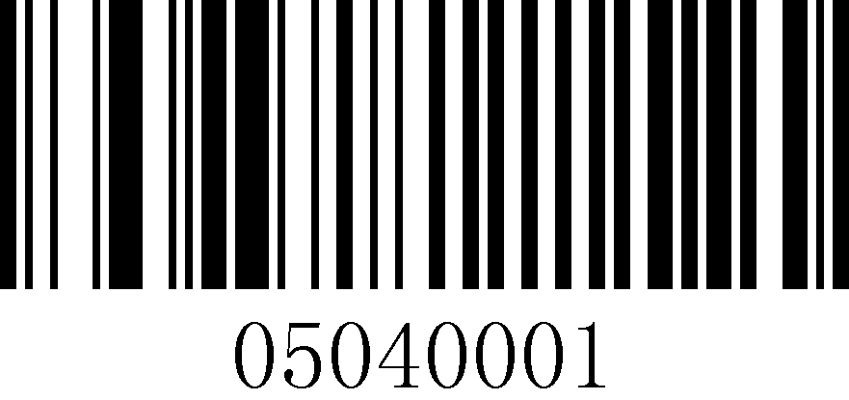
Open (default)
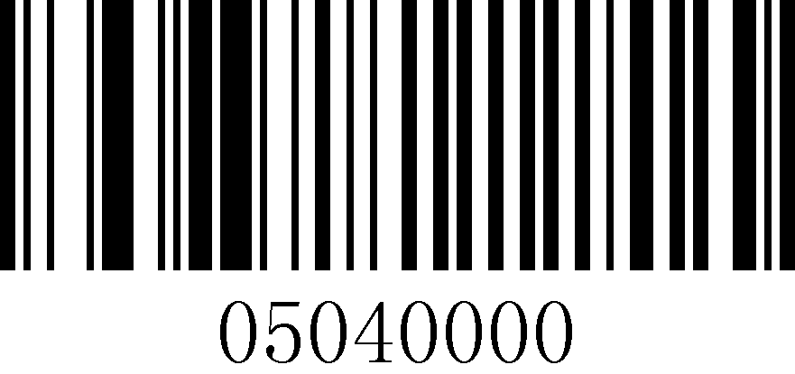
Close

Chapter 3 Reading mode settings

Level trigger mode
Enter the reading state when the trigger key pin is at low level. Press and hold the trigger key to start reading code. After reading the code successfully or releasing the trigger key, the code reading ends and the next decoding needs to re-enter the low level state.
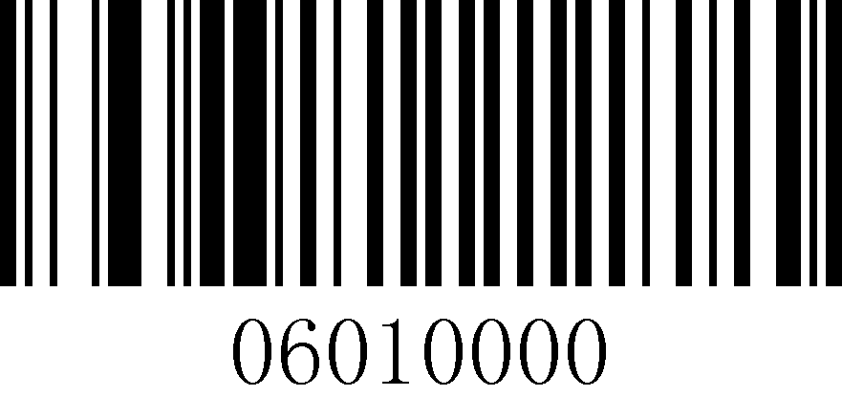
Level trigger mode

Continuous mode (default)
When the reading setting code is switched to this mode, it enters the continuous reading state. In this mode, the "repeat read switch" can be used to prevent the same barcode from being read more than once.
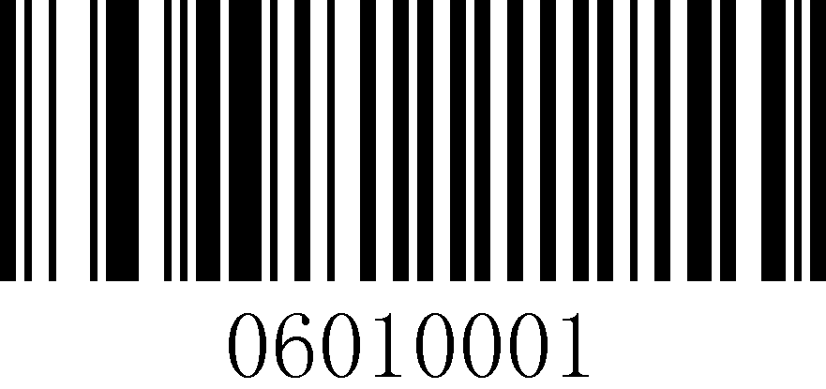
Continuous mode (default)

Pulse trigger mode
When the reading setting code is switched to this mode, it enters the pulse-triggered reading state.
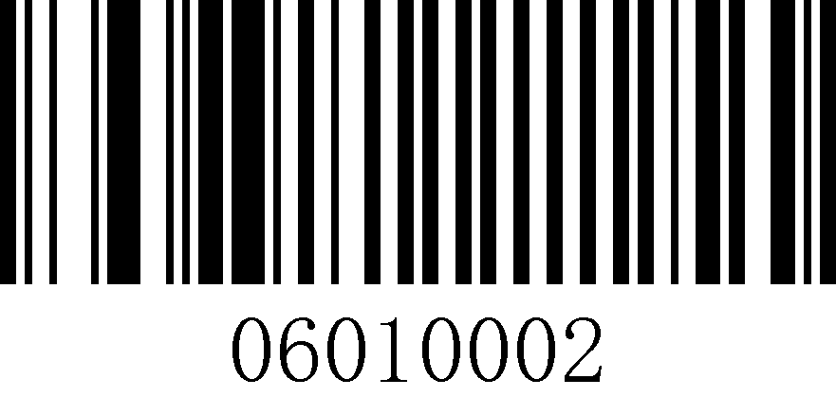
Pulse trigger mode

Repeat read switch
The repeat read setting is only available in continuous mode.
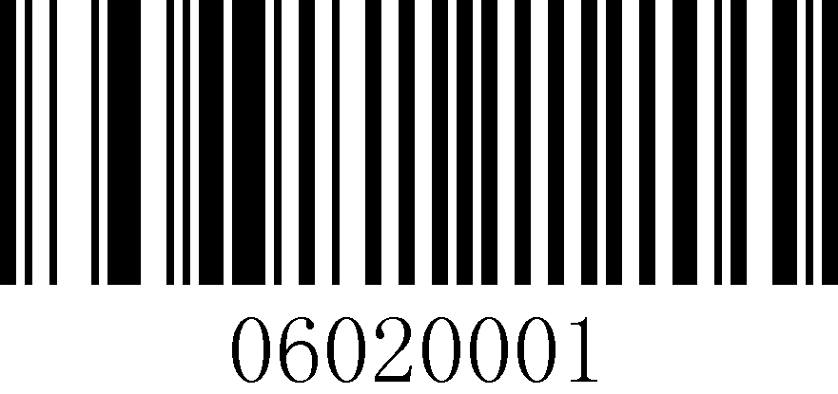
Allow repeat readings (default)
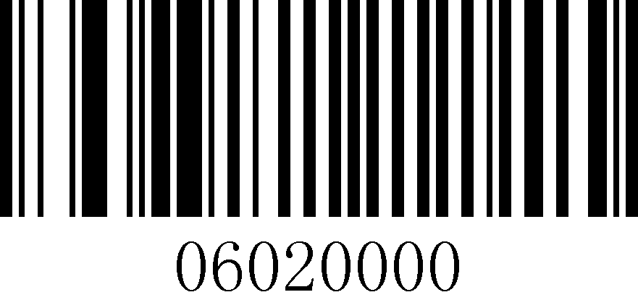
Repeat reading is not allowed

One read timeout
One time reading timeout time, the unit is 0.1 seconds. The default value is 30 (3 seconds), when set to 0, it means that the device is always in the reading state, and the time range can be set: 0~999.

Short time (3s)
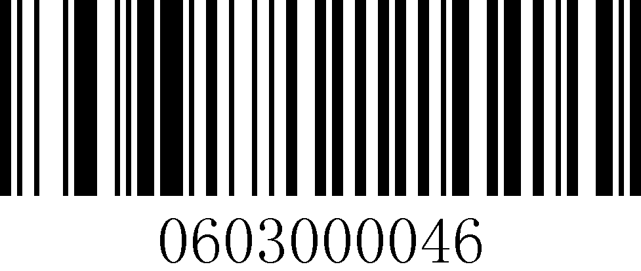
In time (7s)
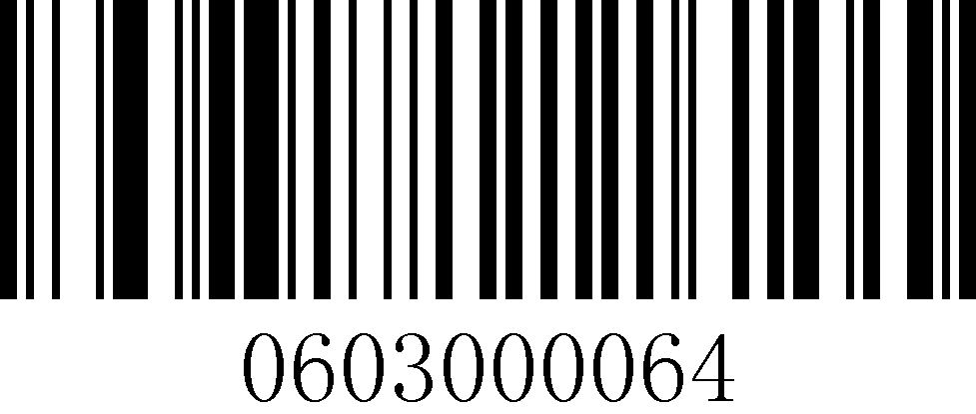
Long time(10s)
ATT | Valid only in "Level Trigger Mode" and "Pulse Trigger Mode".

Chapter 4 Communication Settings

Introduction
When connecting the scanner and the host, there are various connection methods to choose from, while the default method can be set according to the actual needs of the customer, and this section will introduce the settings of the relevant communication methods in detail.

Communication settings
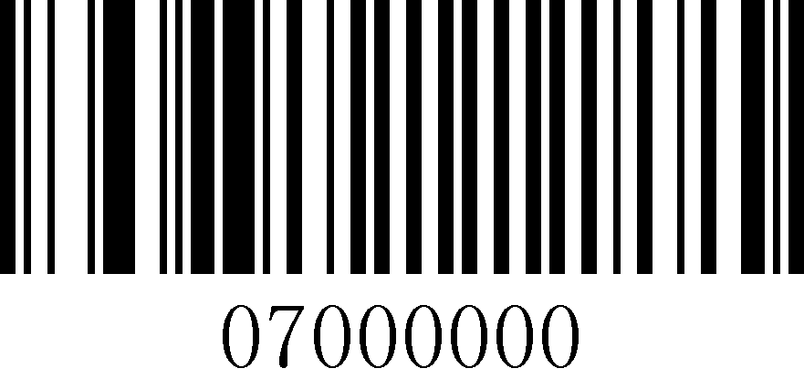
USB HID (default)
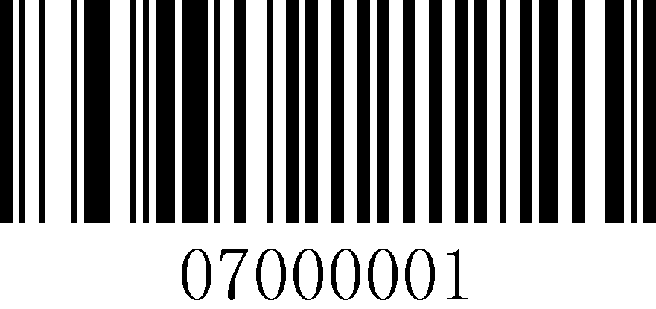
USB CDC serial port
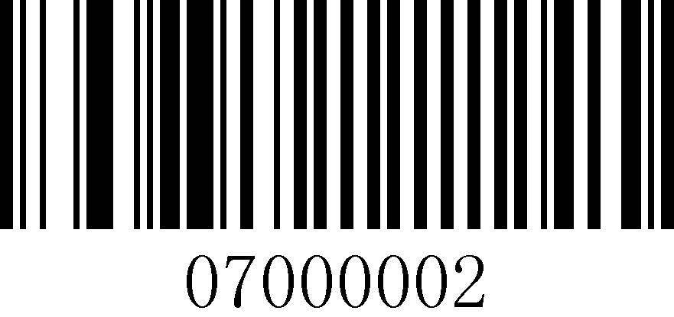
RS-232 serial port

System Upgrade
There are two ways to upgrade the system: USB HID upgrade and RS-232 serial upgrade, USB CDC serial upgrade is not supported for now.

USB HID upgrade steps
Take "LASER_SCANER_V1.1_20211124" version upgrade as an example.
Serial number | Operation | Operation Feedback / Legend
1 | Scan the "USB HID" barcode.  USB HID (default) | Automatic reboot of the device after successful code scanning

2 | Scan the "System Upgrade" barcode.    System Upgrade | The upgrade operation can be executed only after the successful setting beep sounds
3 | Open the software "HS_Update_V1.0.exe".  Click on the "USB Update" menu.  Click on the "Browswe" button | 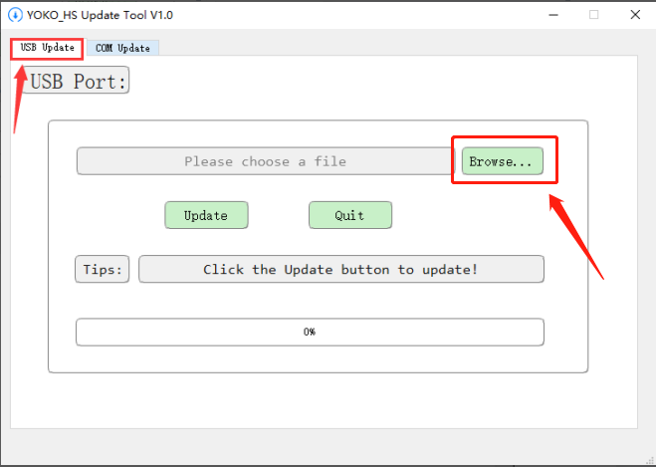
4 | Select the corresponding upgrade file.  Click the "Open" button | 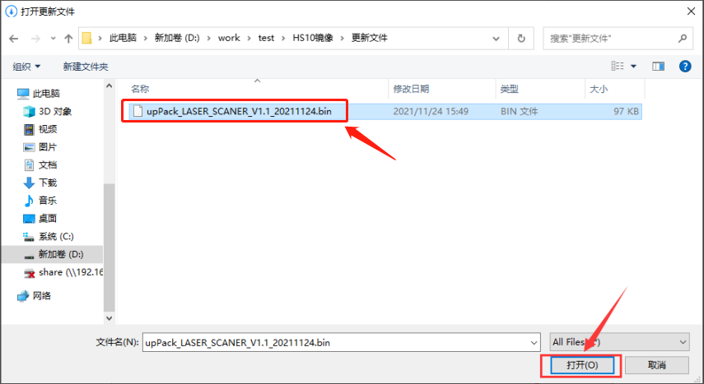
5 | Click on the "Upadte" button | 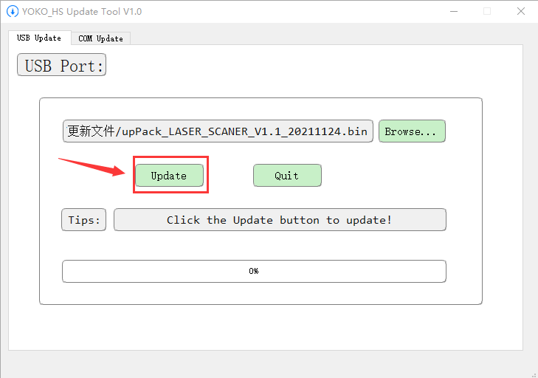
6 | The interface displays "Update Success!", and the device is automatically reset after a successful beep. | 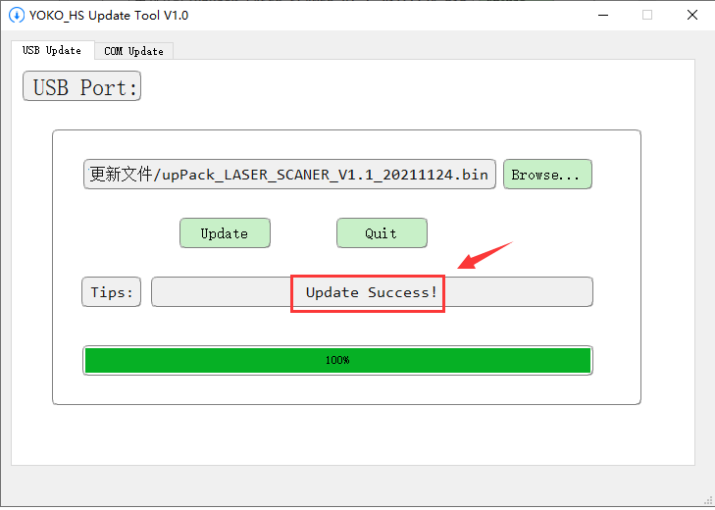
7 | In Window environment, open Notepad (TXT) and scan the "Read version number" barcode.  Read version number | The device correctly outputs "LASER_SCANER_V1.1_20211124".  Represents a successful system upgrade  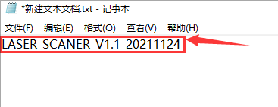

RS-232 serial port upgrade procedure
Take "LASER_SCANER_V1.1_20211124" version upgrade as an example.
Serial number | Operation | Operation Feedback / Legend
1 | Scan the "RS-232 serial" barcode.  RS-232 serial port | Automatic reboot of the device after successful code scanning
2 | Scan the "System Upgrade" barcode.  System Upgrade | The upgrade operation can be executed only after the successful setting beep sounds
3 | Open the software "HS_Update_V1.0.exe".  Click on the "COM Update" menu.  Click on the "Serch Port" button | 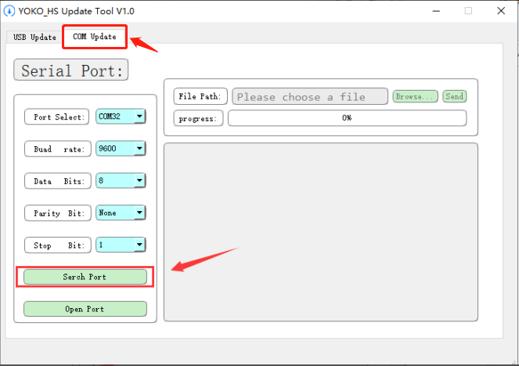
4 | "Port Select" sets the COM port.  Configure the parameters as shown on the right.  Click on the "Open Port" button | 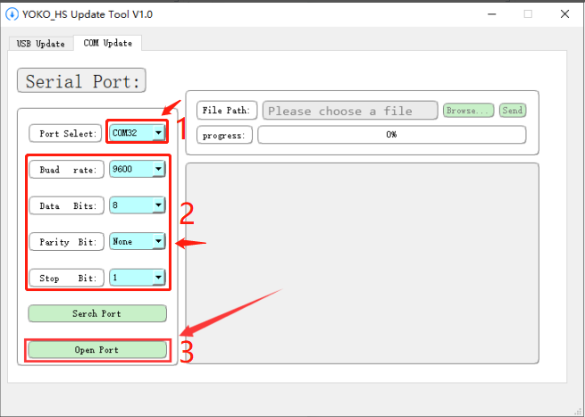
5 | The "C" character appears in the interface.  Click on the "Browse..." button | 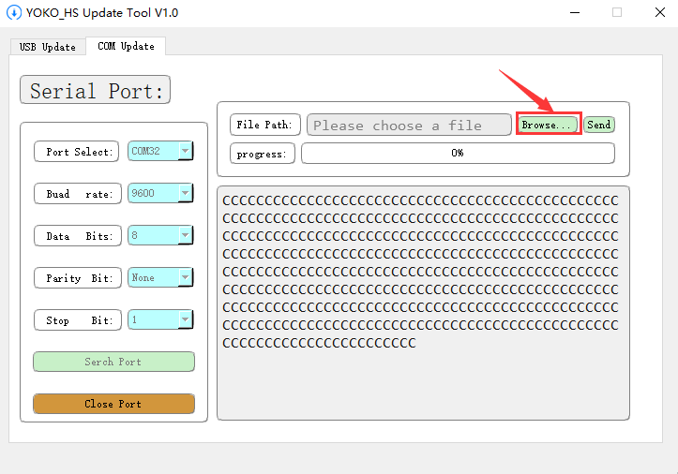
6 | Select the corresponding upgrade file.  Click the "Open" button
7 | Click the "Send" button | 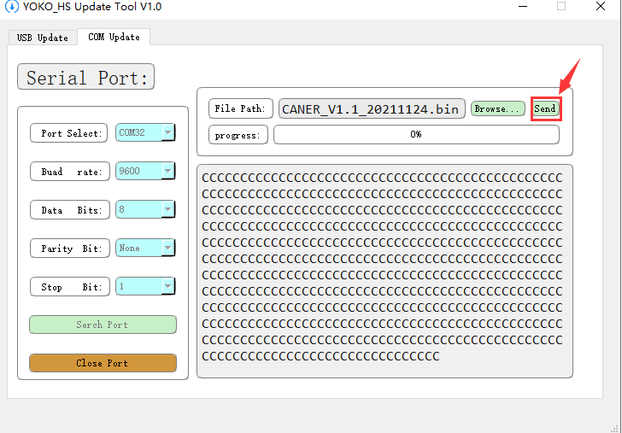
8 | The interface shows "File sent completed.", the device will be reset automatically after a successful beep. | 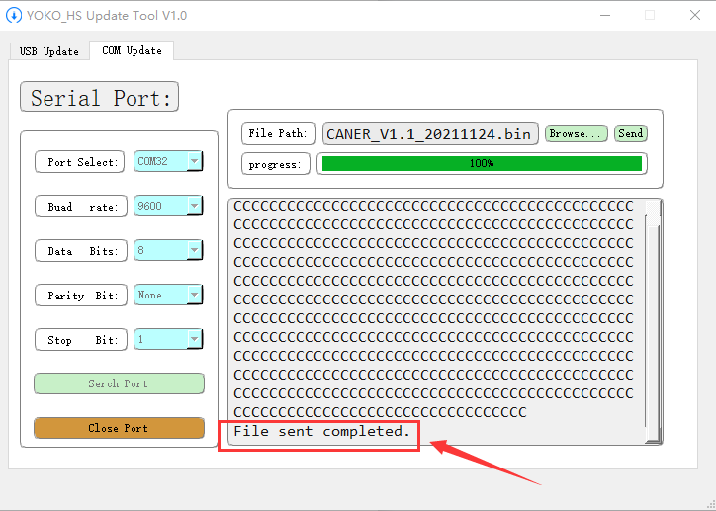
9 | Scan the "Read Version Number" barcode.  Read version number | The device correctly outputs "LASER_SCANER_V1.1_20211124".  Represents a successful system upgrade  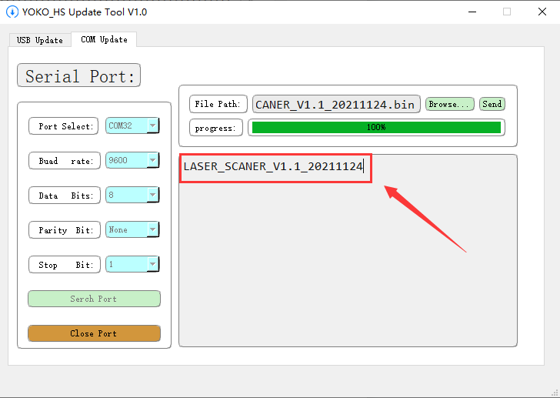

USB keyboard

USB multi-country keyboard
There are differences in keyboard key layout and symbols, etc. corresponding to different countries' languages, so the scanner can be virtualized into different countries' keyboard systems as needed, with the default English (US) keyboard.
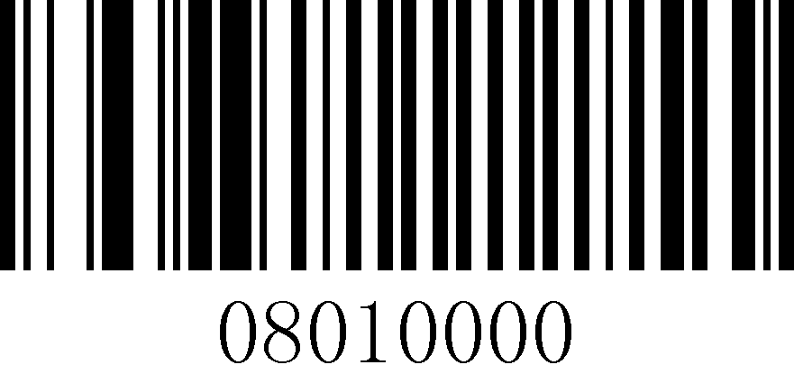
English (US) (default)
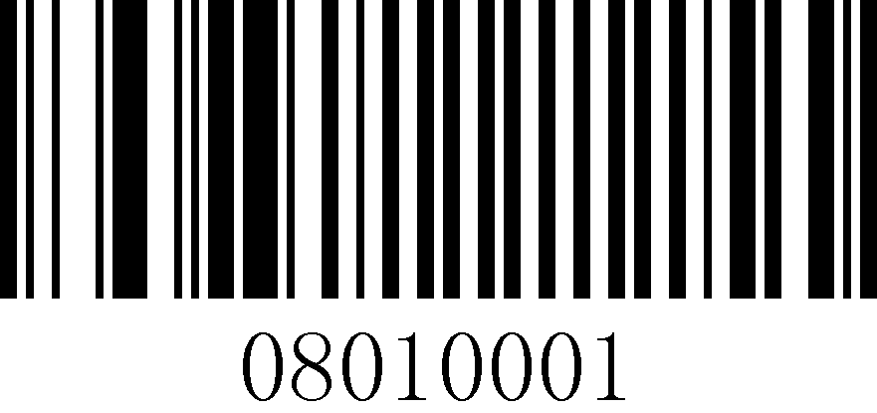
Italian (Italy)
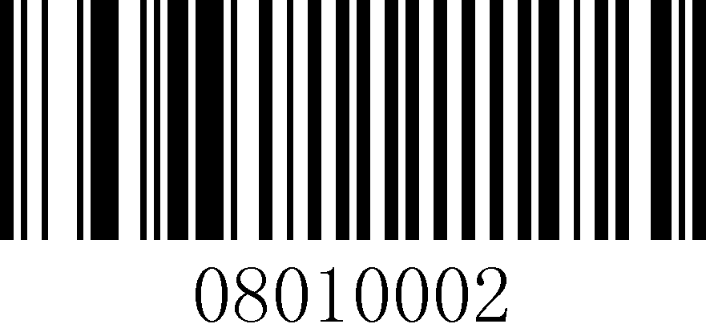
Spanish (Brazil)
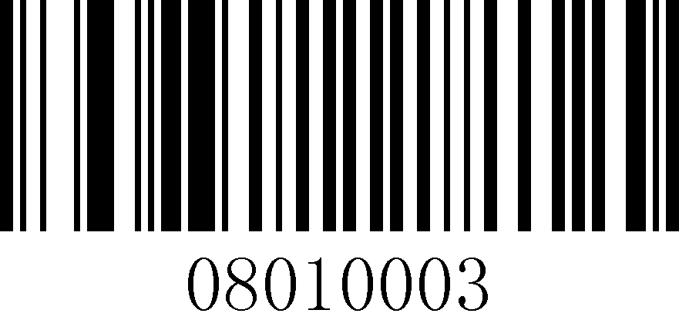
Portuguese (Portugal)
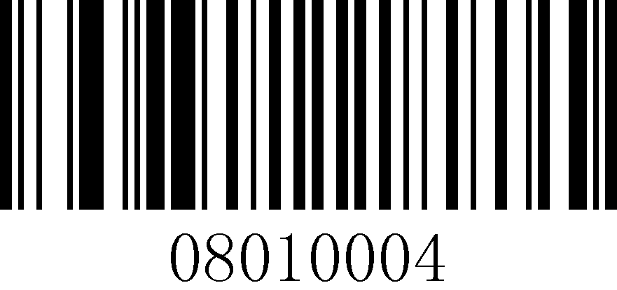
Portuguese (Brazil)
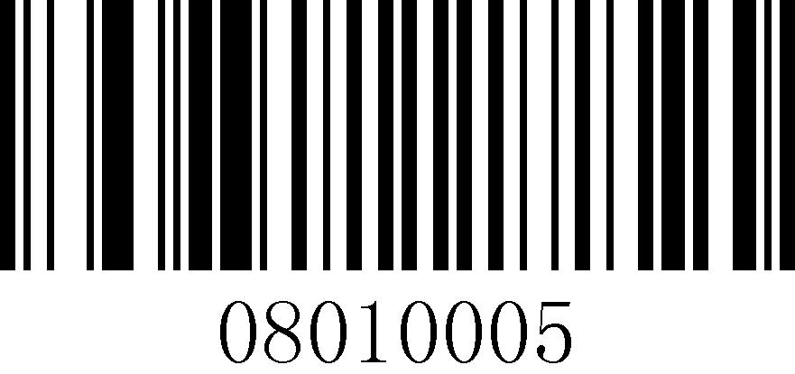
French (France)
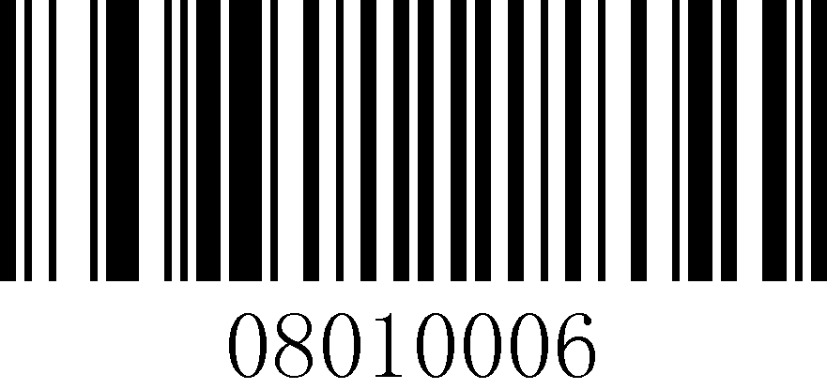
German (Austria)
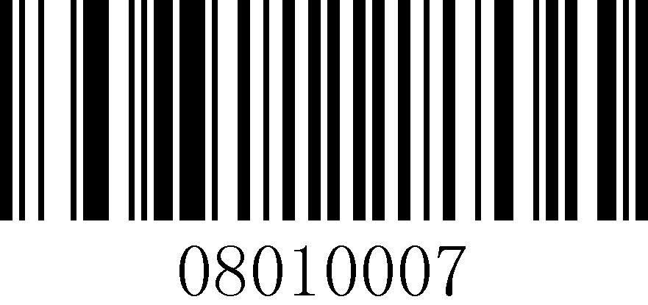
Turkish Q

Turkish F
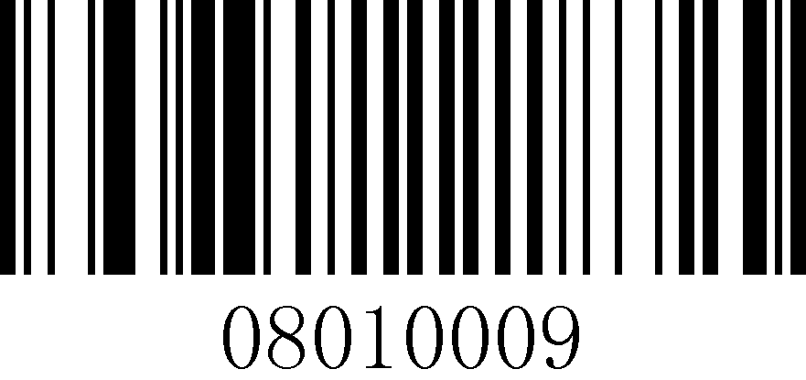
English (UK)
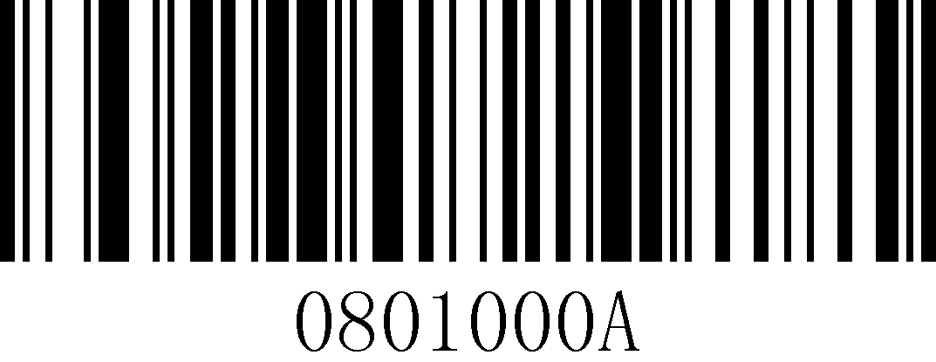
Japanese (Japan)
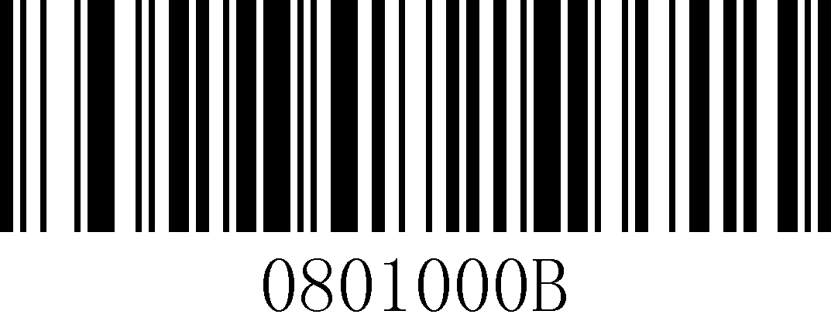
German (Switzerland)

French (Belgium)
ATT | Portuguese (Brazil) cannot output "?" and "/" .

USB keyboard sending speed
If there is missed data at the receiver side, the occurrence speed should be turned down, which is easy to occur at the receiver side with poor performance.
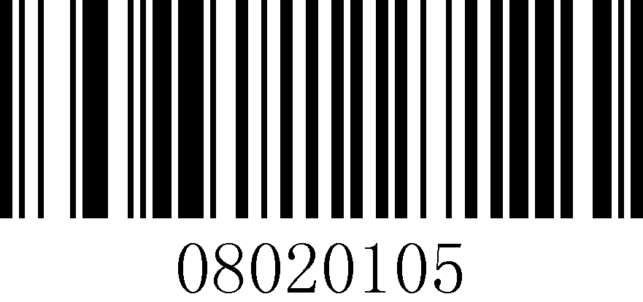
5ms (default)
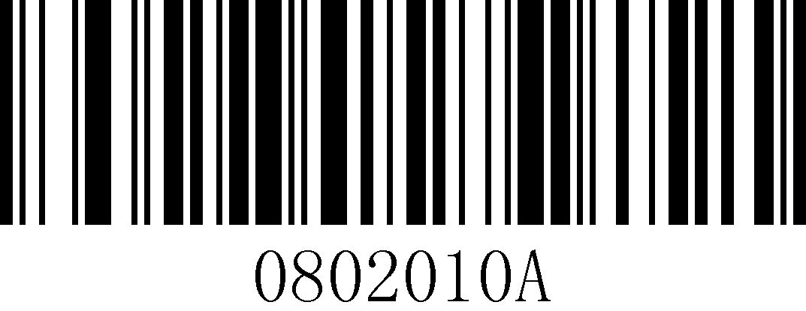
10ms

20ms

Set USB keyboard sending speed
USB keyboard send speed, unit is milliseconds (ms). The default value is 5ms, the settable time range: 0ms~200ms.
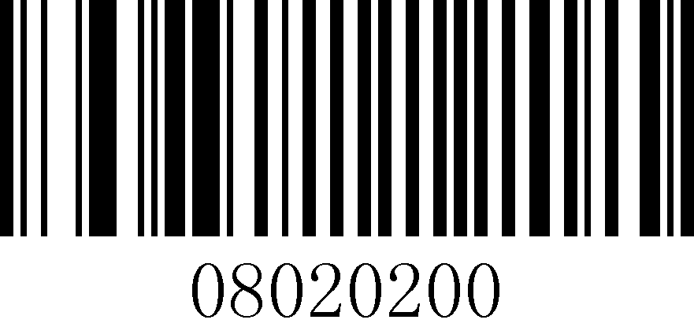
Set USB keyboard sending speed
Example | Setting the USB keyboard to send speed of 50ms can be set by reading the following barcodes in order.  1. Read "Startup Settings"  2. Read the "Set USB keyboard send speed" setting code  3. Read data code: "5" "0" (see data code table)  4. Read "Save" (see data code table)  5. Read "Exit Settings"

Control characters
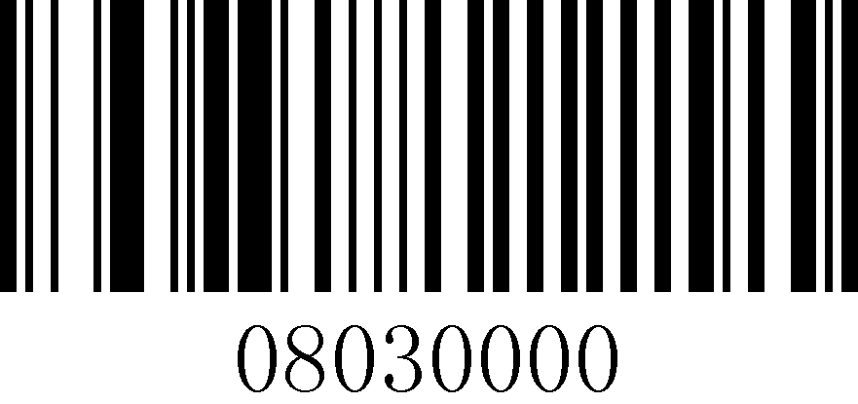
Off (default)
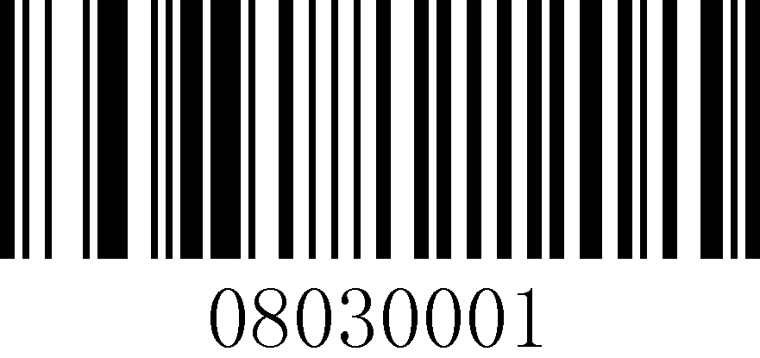
Control + ASCII mode
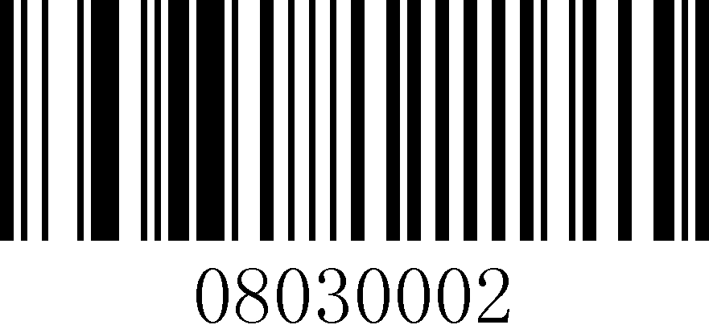
Alt + Keypad mode
Tips | Specific reference to the control character table, only the data content of the barcode is converted.

Serial communication settings
Tips | The serial data bit is 8 and the serial stop bit is 1.

Serial port baud rate setting
The baud rate is the number of bits per second that are transmitted for serial data communication. The baud rate used by the scanner and the data receiving host must be consistent to ensure accurate data transmission. The scanner supports the baud rates listed below, and the default is 9600bps.
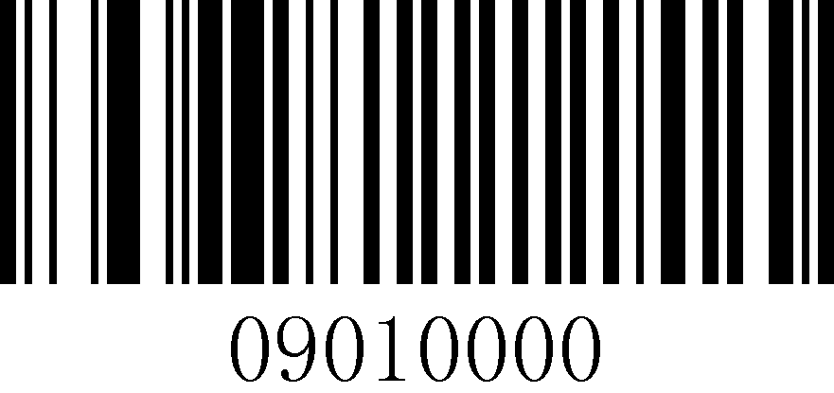
Baud rate 4800
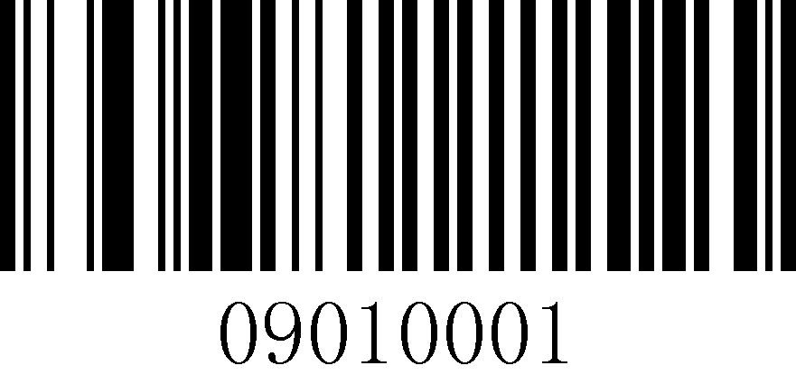
Baud rate 9600 (default)
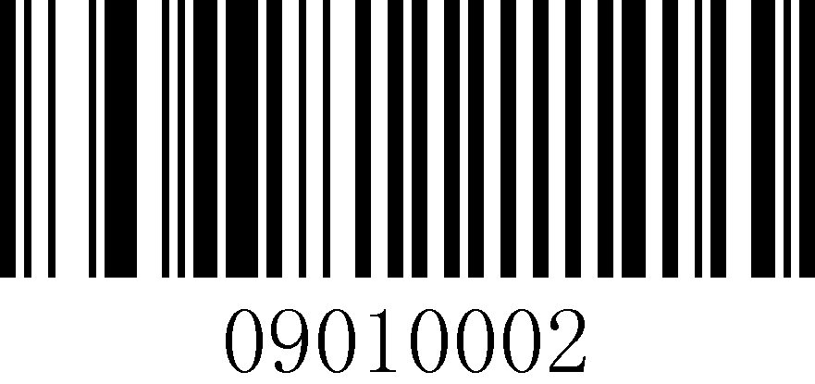
Baud rate 19200
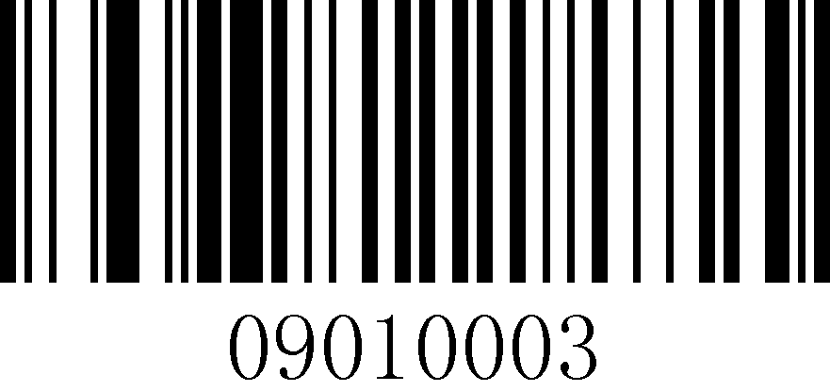
Baud rate 38400
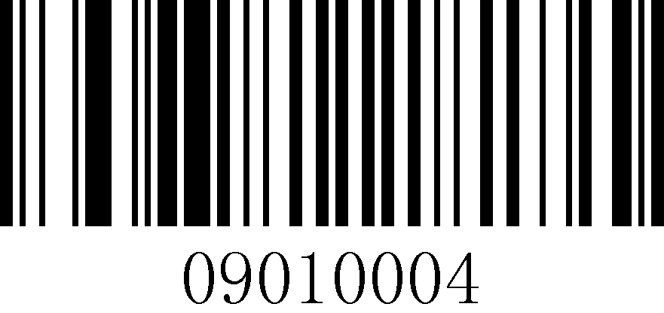
Baud rate 57600

Baud rate 115200

Serial port parity bit setting
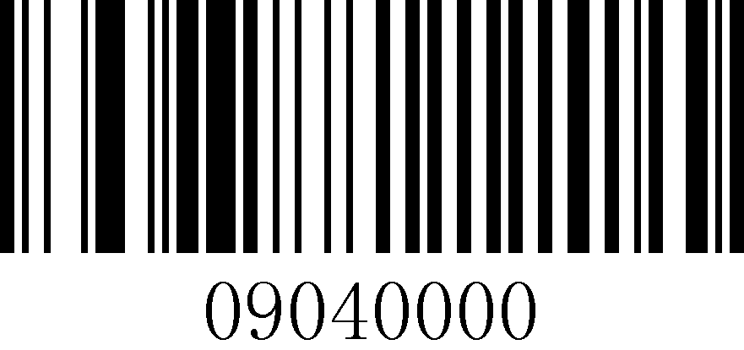
No checksum (default)
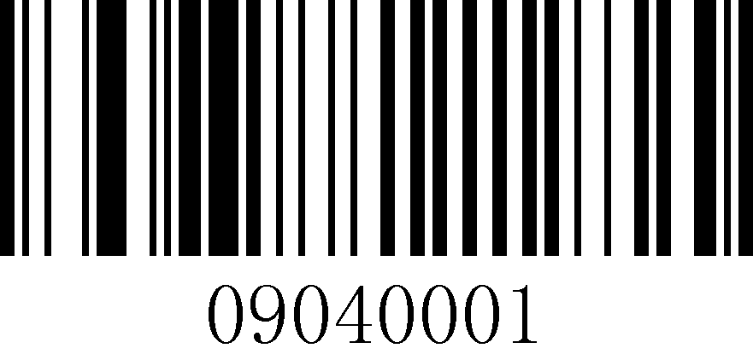
Odd calibration
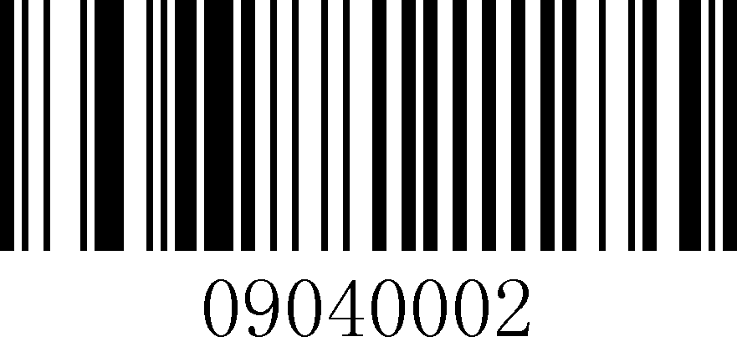
Even Check

Chapter 5 Data Format Setting

Introduction
Length of custom prefix and suffix: (0~10) characters, if set to "on", "Code ID prefix", "custom prefix", "end suffix", etc. will be added before and after the decoding information. "Custom suffix", "End suffix", etc.
ATT | The maximum number of data cache is 5, and the maximum length of individual data is 7900 characters; the data output is sequential output, and you need to wait for the first barcode output to finish before the second barcode output, and so on.

Custom Prefix Settings

Custom prefix on/off settings
Custom prefixes add a user-defined string before the decoded information. For example, if you allow to add a custom prefix and set the prefix to the string "AB", after reading the barcode with the data "123", the scanner adds the string "AB" before the string "123", and the host side receives "AB123". After the barcode reading data is "123", the scanner will add the string "AB" before the string "123", and the host side will receive "AB123".
If set to "Off", the decoded information will only have the barcode data information, no prefix, and the default value is to turn off the custom prefix output.
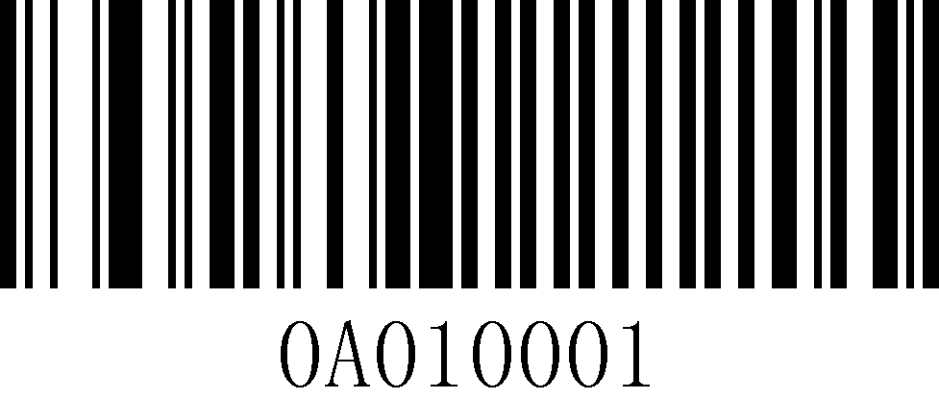
Enable

Disable (default)
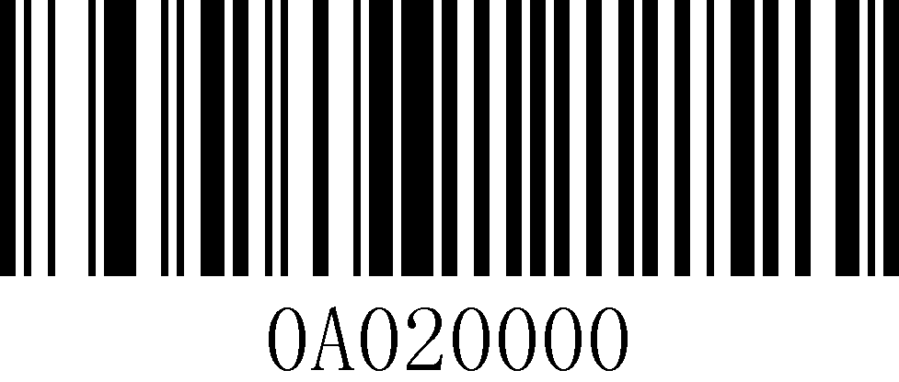
Clear all custom prefixes

Customized prefixes
The custom prefix adds a user-defined string before the decoded information, and the output format after customization is "Custom Content + Barcode Content".

Customized prefixes
Example | Set the custom prefix to 'a' (the hex value of a is 0x61)  1. Read "Startup Settings"  2. Read the "Custom Prefix" setting code  3. Check the ASCII code of the character "a": the ASCII code of "a" is "0x61" (see ASCII code table)  4. Read data code: "6" "1" (see data code table)  5. Read "Save" (see data code table)  6. Read "Exit Settings"

Custom Suffix Settings

Custom suffix on/off settings
The custom suffix adds a user-defined string after the decoded information. For example, it is allowed to add a custom suffix and set the suffix to the string "AB", after reading the barcode with the data of "123", the scanner adds the string "AB" after the string "123", and the host side receives "123AB". After the barcode reading data is "123", the scanner will add the string "AB" after the string "123", and the host side will receive "123AB".
If set to "Off", only the barcode data information will be in the decoded information, no suffix, and the default value is to turn off the custom suffix output.
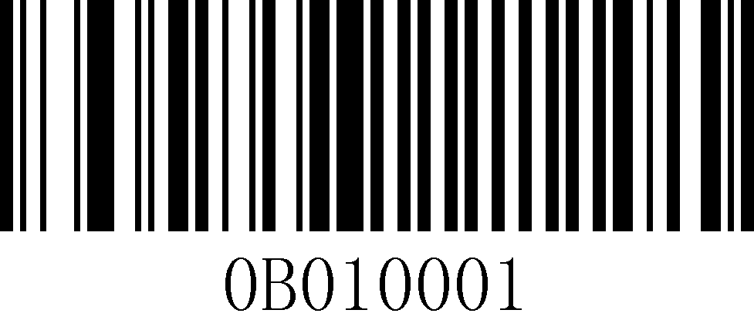
Enable
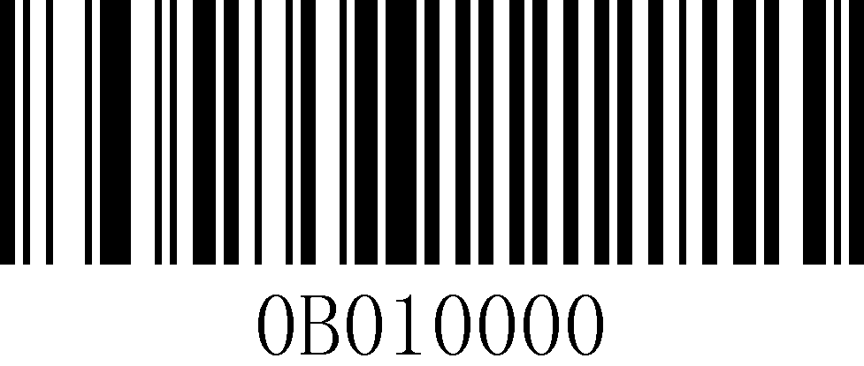
Disable (default)
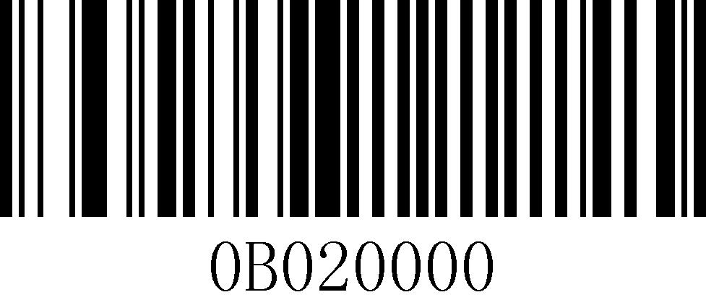
Clear custom suffixes

Custom Suffixes
Custom suffix adds a user-defined string after the decoded information, and the output format after customization is "barcode content + custom content".
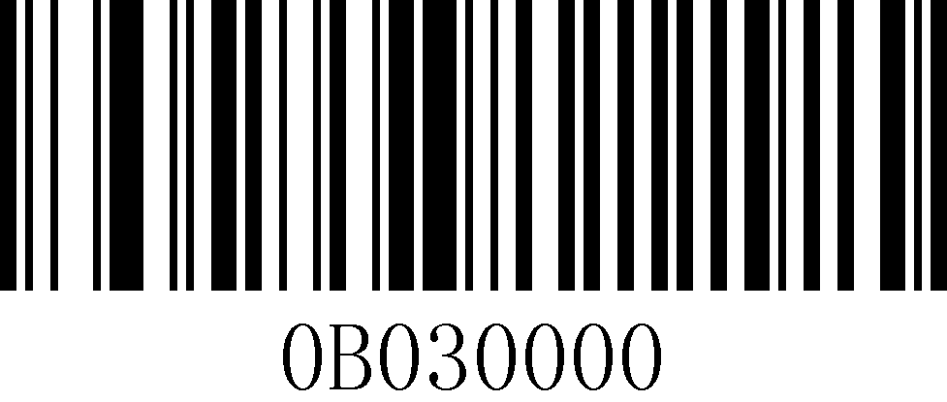
Custom Suffixes
Example | Set the custom suffix to 'a' (the hex value of a is 0x61)  1. Read "Startup Settings"  2. Read the "Custom Suffix" setting code  3. Check the ASCII code of the character "a": the ASCII code of "a" is "0x61" (see ASCII code table)  4. Read data code: "6" "1" (see data code table)  5. Read "Save" (see data code table)  6. Read "Exit Settings"

Code ID setting
The user can use Code ID to identify the barcode type and the Code ID corresponding to each barcode type is customizable. The Code ID for all barcodes is 1 character.

Code ID Output Method
Close Code ID (default): Code ID is not spliced to the read string.
Code ID prefix: The Code ID is spliced before the recognition string.
Code ID suffix: The Code ID is spliced after the recognition string.
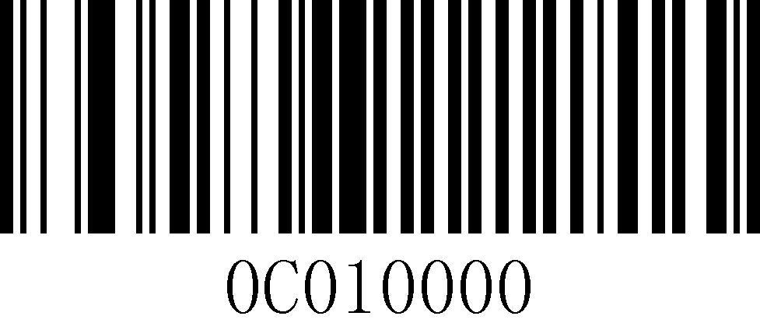
Disable Code ID (default)
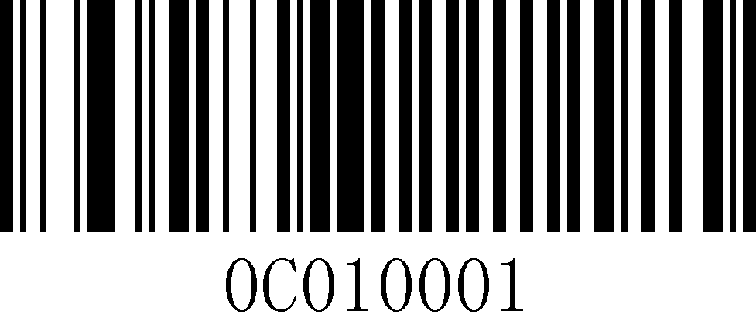
Code ID prefix
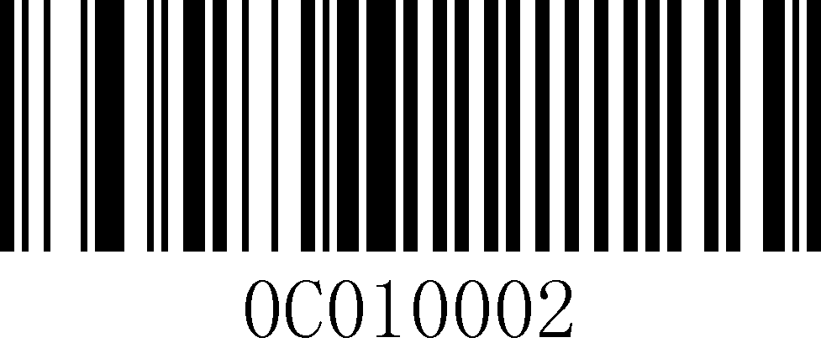
Code ID suffix

Clear all custom Code IDs
Example | Restore the Code ID of all barcodes, including Codabar, to the default value of.  1. Read "Startup Settings"  Read "Clear all custom Code IDs".  3. Read "Exit Settings"

Customize Code ID
Please refer to the following example for how to modify the Code ID.

Custom Code ID
Example | Modify the Code ID of Codabar (Code ID:0x61) to "Y" (hexadecimal value 0x59).  1. Read "Startup Settings"  2. Read "Custom Code ID"  3. Check the Code ID of the barcode: the Code ID of "Codabar" is "0x61" (see the list of code system support)  4. Check the ASCII code of the character "Y": the ASCII code of "Y" is "0x59" (see ASCII code table)  5. Read data code: "6" "1" "5" "9" (see data table)  6. Read "Save" (see data code table)  7. Read "Exit Settings"

Terminator settings
The terminator suffix is used to mark the end of a complete piece of data information. The terminator suffix stands alone and does not participate in any other form of data formatting. The terminator suffix must be the last piece of data sent, and no additional data will be added thereafter.
The ending character can be set to carriage return, line feed, carriage return line feed, tab or ETX, and the default ending character is set to carriage return.
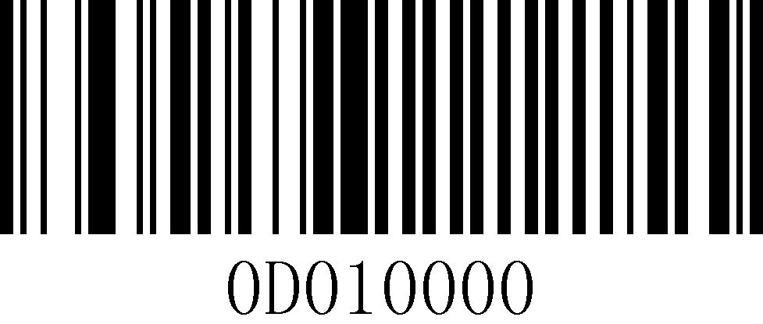
No terminator
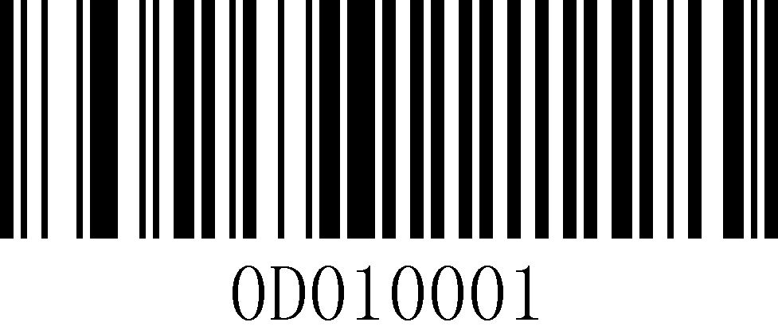
Enter (default)
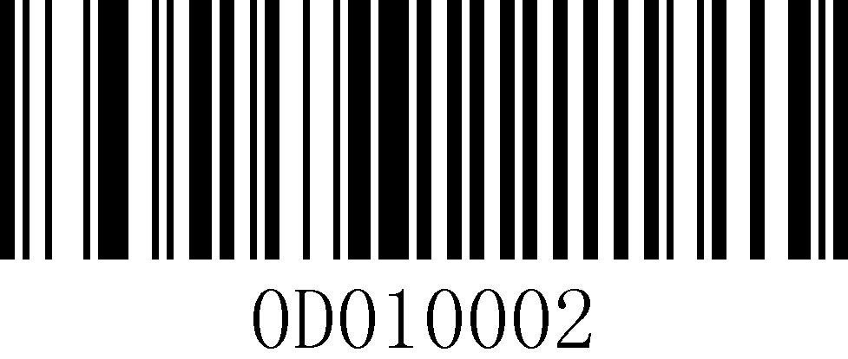
Line Feed (Down)
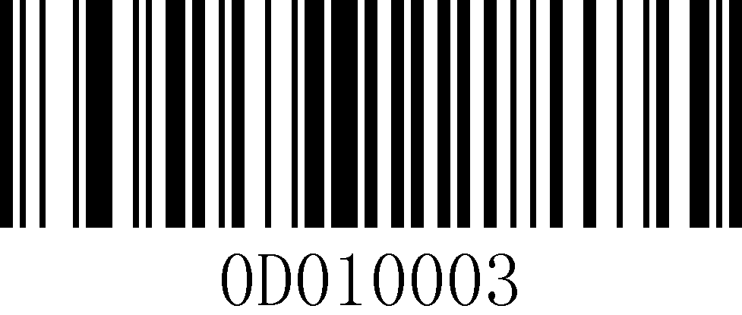
Carriage return + Line feed (Enter+Down)
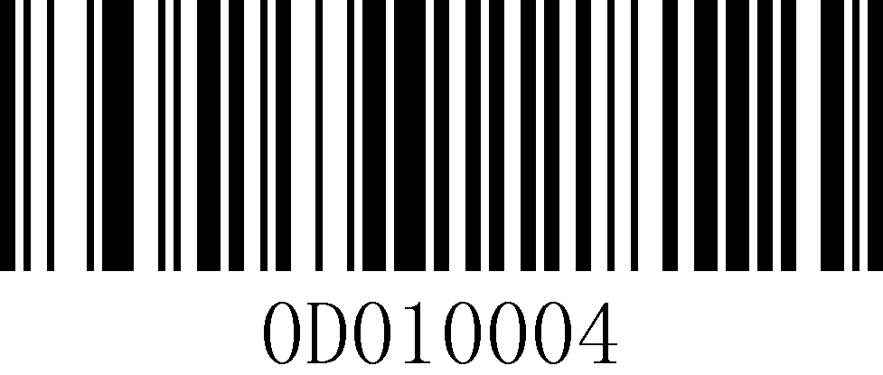
Tab
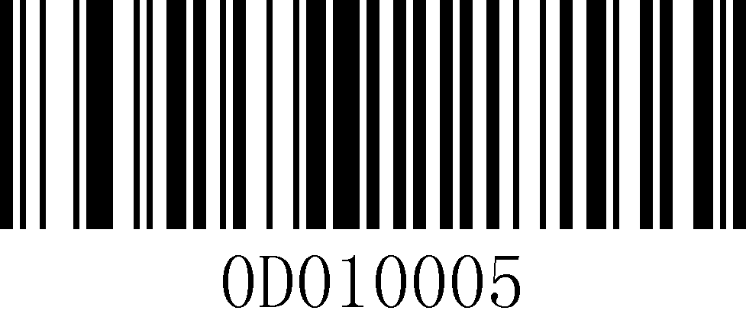
ETX

Case output settings
Case conversion for characters in a string, prefix and suffix have no effect.
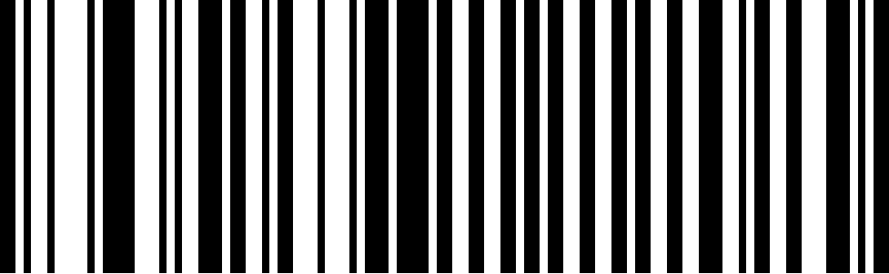
Normal output (default)
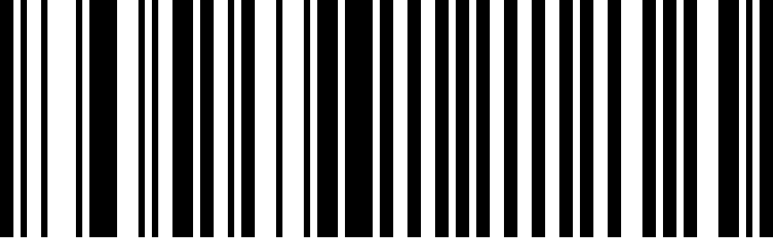
Convert Case
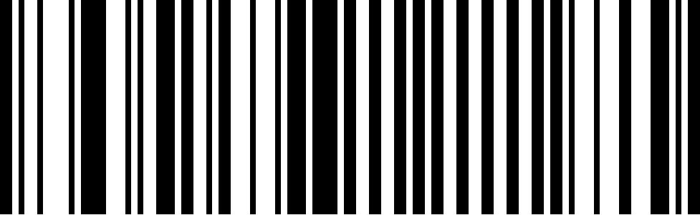
Convert all to Uppercase
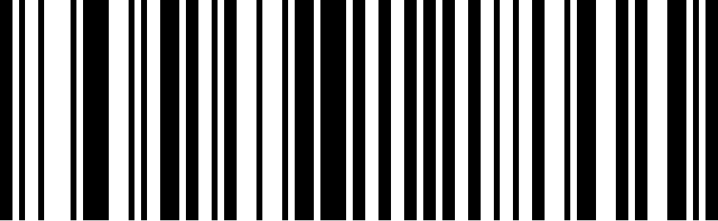
Convert All to lowercase

Data output settings
ATT | Note: The prefix and suffix are not processed, and the prefix and suffix are output normally.

Data output options
Raw data output (default): No modification is made to the literate data.
If the set length is longer than the length of the read string, the original data will be output. For example, if the length of the string "1234567890" is set to 3, the final output data will be "123".
Intermediate data output: output according to the range of data limited by the "previous data length setting" and "next data length setting", if the sum of the two length values is greater than the length of the read string, the output is empty. For example, if the length of the string "1234567890" is read, and the length of the start/end fields are set to 3 and 4 respectively, the final output data will be "456".
If the set length is longer than the length of the read string, the original data will be output. For example, if the length of the string "1234567890" is set to 3, the final output data will be "890".
Start and end data output: The output data is limited according to the data of "previous data length setting" and "next data length setting", if the sum of the two length values is greater than the length of the read string, the original data is output. For example, if the length of the string "1234567890" is read, and the length of the start/end field is set to 3 and 4 respectively, the final output data will be "1237890".
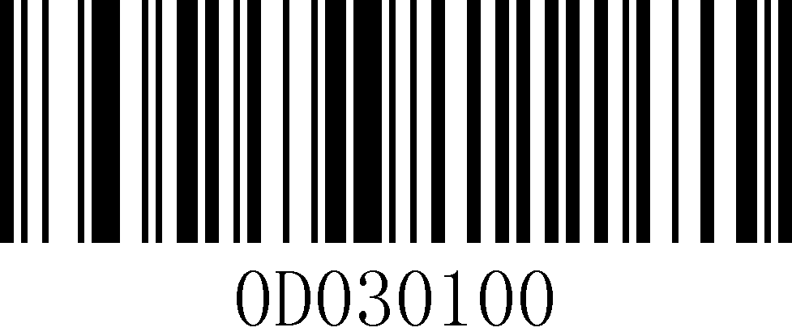
Raw data output (default)
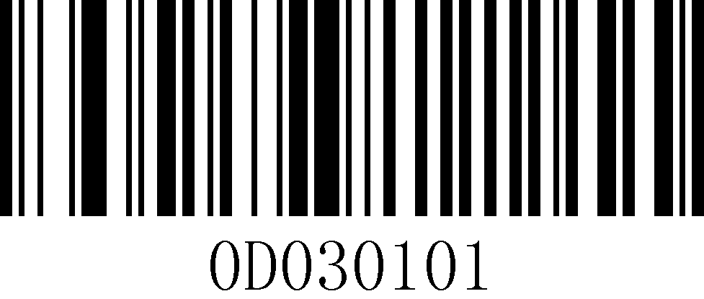
Front-end data output
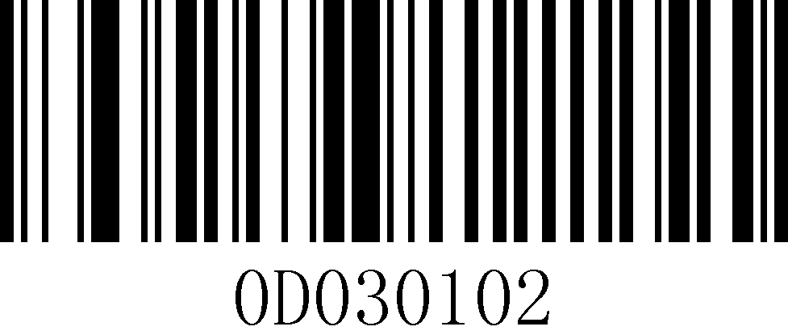
Intermediate data output
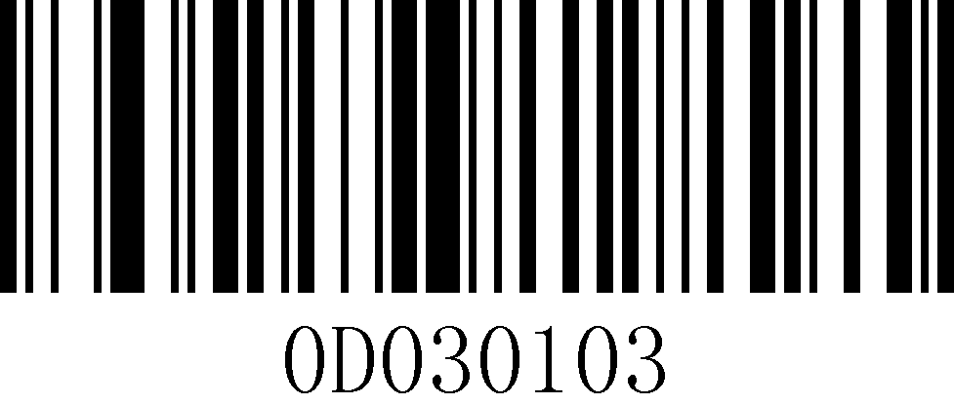
Back-end data output
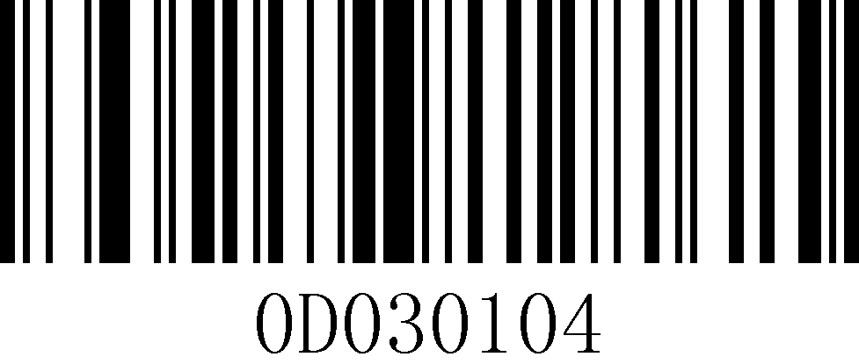
Start and end data output

Pre/Post data length setting
The default value is 1, the length should be set with the appendix, the setting range: 1 to 7900. when the length is set to 0, it is equivalent to the function is not enabled.
For example, if you want to set the "Pre-segment data length setting" to 12, steps: Read "Pre-segment data length setting"->"1"-> "2"->"Save".
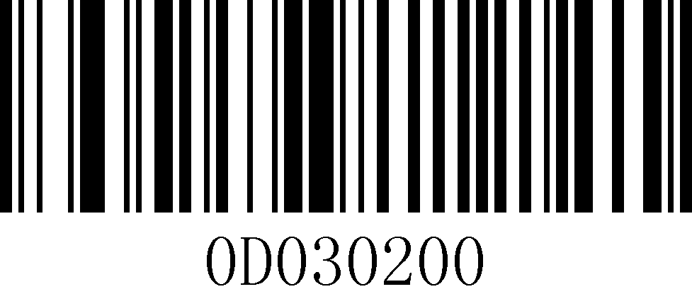
Pre-segment data length setting
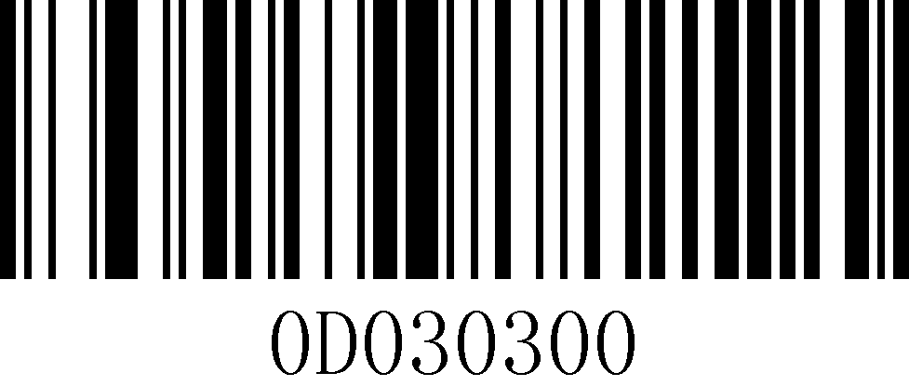
Back-end data length setting

Chapter 6 Symbologies

Introduction
Each type of barcode has its own unique properties, and the setup codes in this chapter allow you to adjust the scanner to accommodate these property changes.

The fewer barcode types that are turned on, the faster the scanner will Scan. You can turn off the barcode types that will not be used to improve the performance of the scanner

All barcodes
Turn off all barcodes: the scanner will only be able to Scan the setup code, all barcodes other than the setup code will not be Scan.
Open all barcodes: the scanner will Scan all barcodes that can be Scan.

Close all barcodes

Turn on all barcodes

EAN8 Settings

EAN8 on/off setting
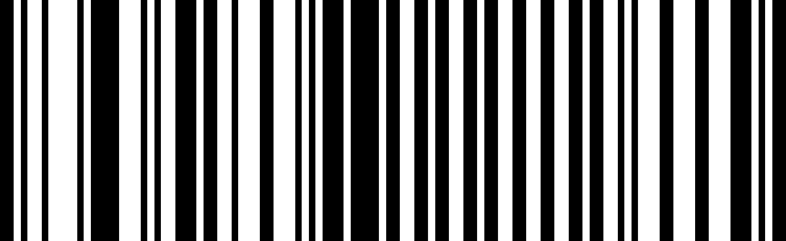
EAN8 on (default)
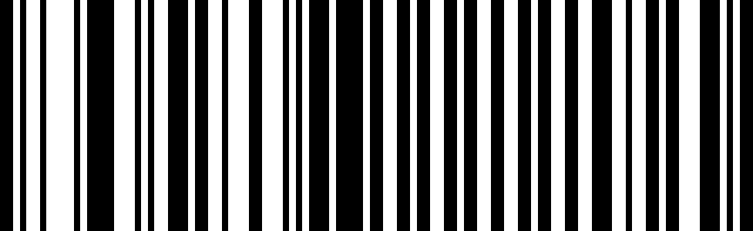
EAN8 off

EAN8 Check Character settings
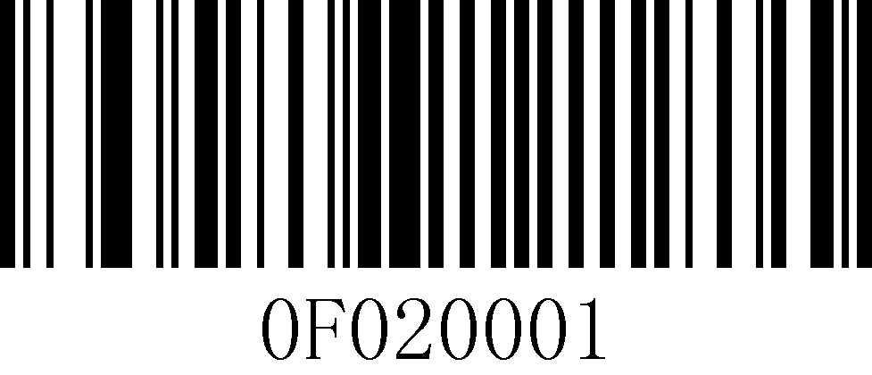
Enable EAN8 transmission Check Character (default)
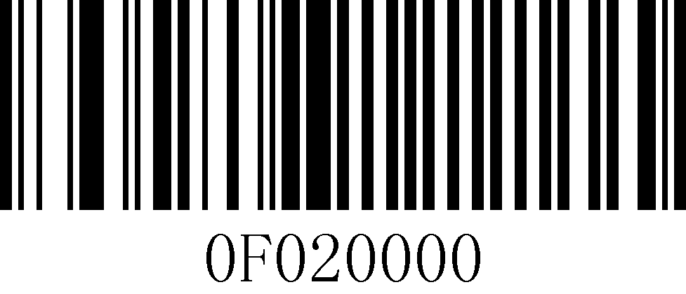
Disable EAN8 transmit Check Character

EAN8 transcoding settings
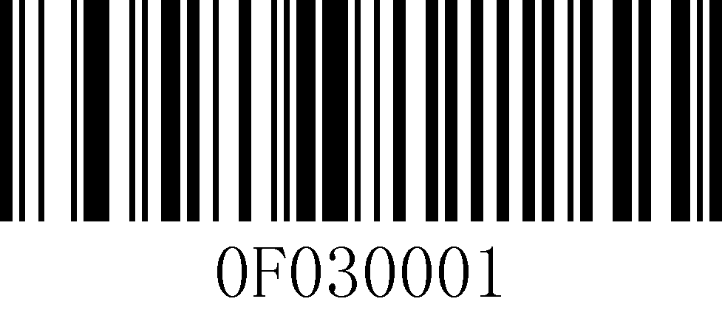
Convert EAN8 to EAN13
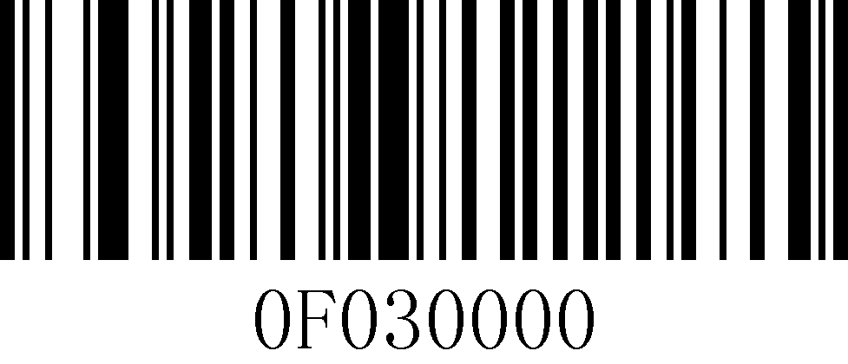
Do not Convert EAN8 to EAN13 (default)

Add-on code setting
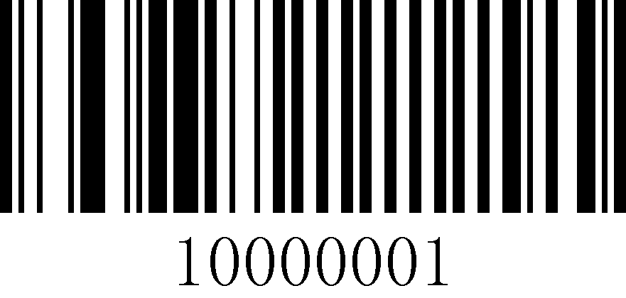
Adaptive UPC/EAN add-on codes

Only Decode UPC/EAN Add-on codes

Ignore UPC/EAN add-on codes (default)

EAN13 Settings

Turn on/off settings
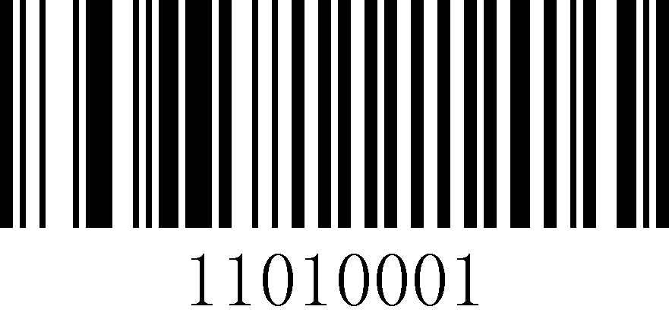
EAN13 on (default)
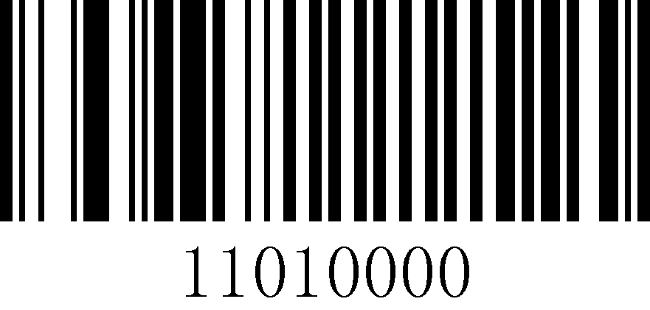
EAN13 Off

Calibration settings
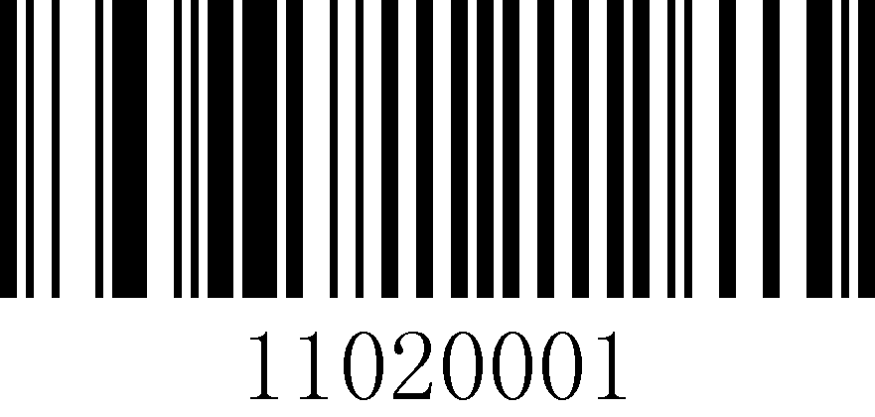
Enable EAN13 transmission Check Character (default)
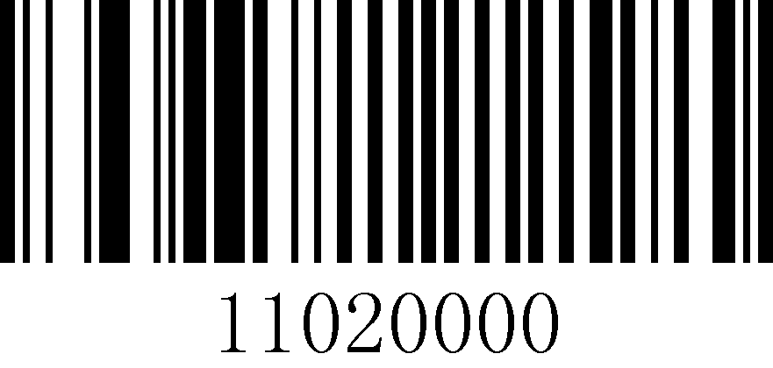
Disable EAN13 transmission checks

Sysmte Character Setting
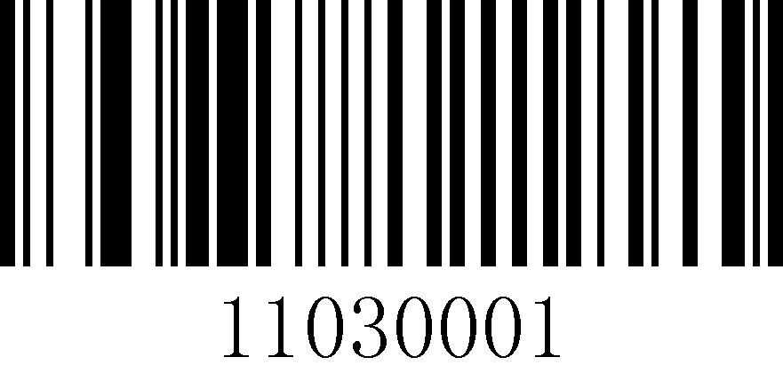
Transmit EAN13 System Character (default)
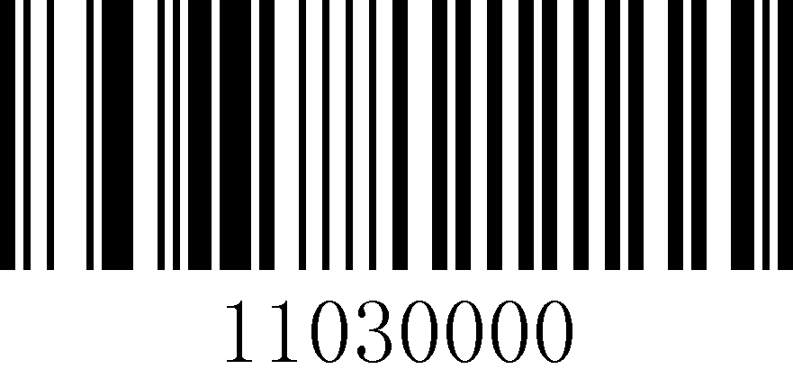
Do not Transmit EAN13 System Character

ISSN Settings

Convert EAN-13 to ISSN

Do not Convert EAN-13 to ISSN (default)

ISBN setting

Data bit setting
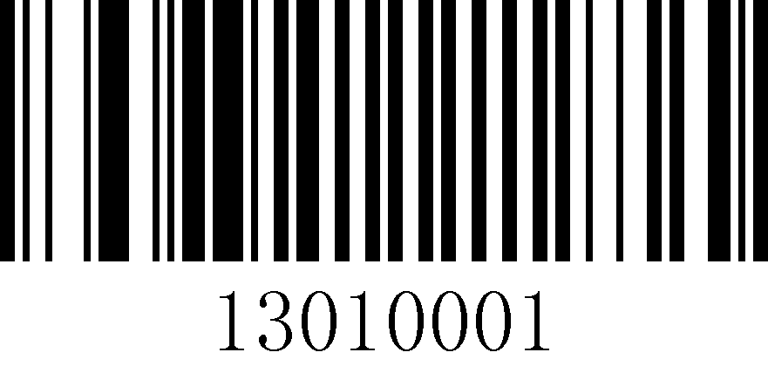
Set the ISBN data bits to 13 bits
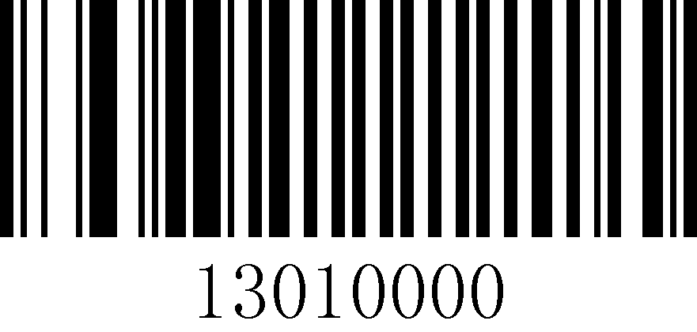
Set ISBN data bits to 10 bits (default)

Transcoding settings
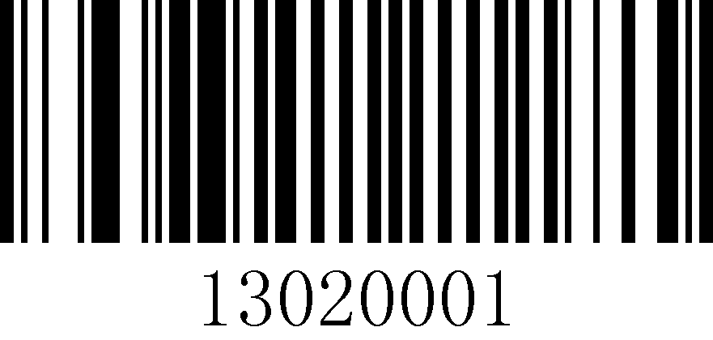
Convert EAN13 to ISBN
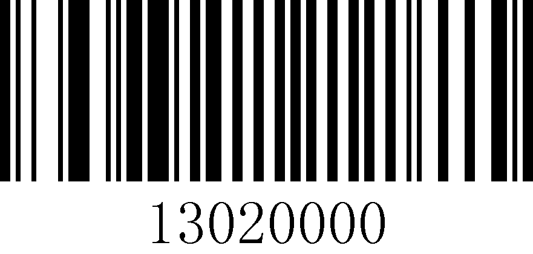
Do not Convert EAN13 to ISBN (default)

UPC-A Settings

Check Character setting
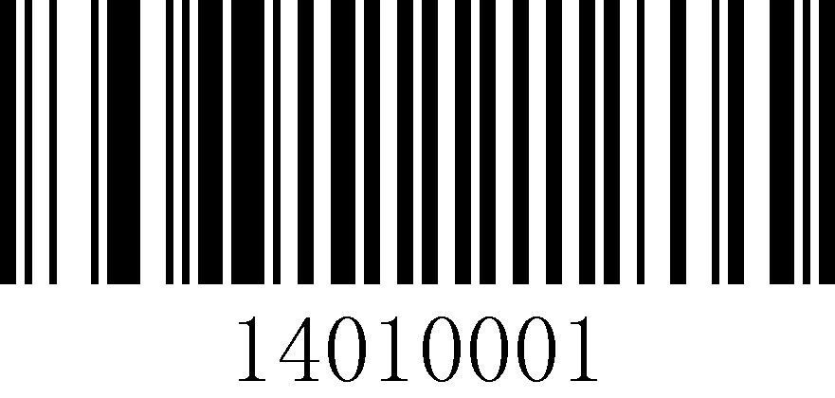
Transmit UPC-A check character (default)
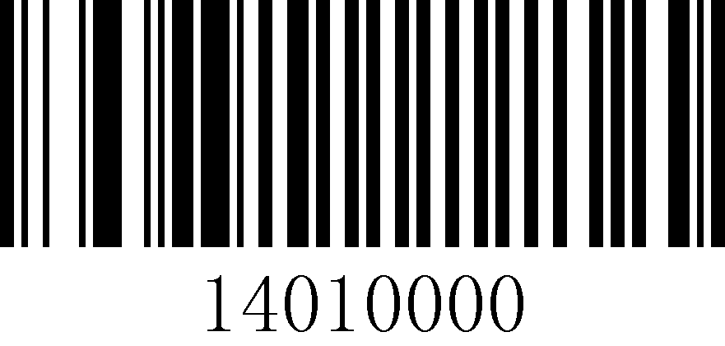
Do not Transmit UPC-A check character

Transcoding settings
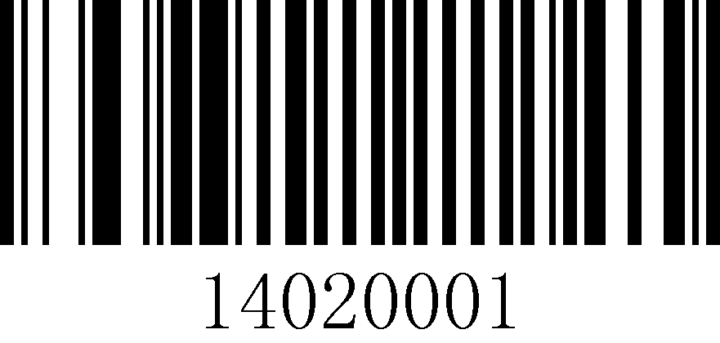
Convert UPC-A to EAN13 (default)
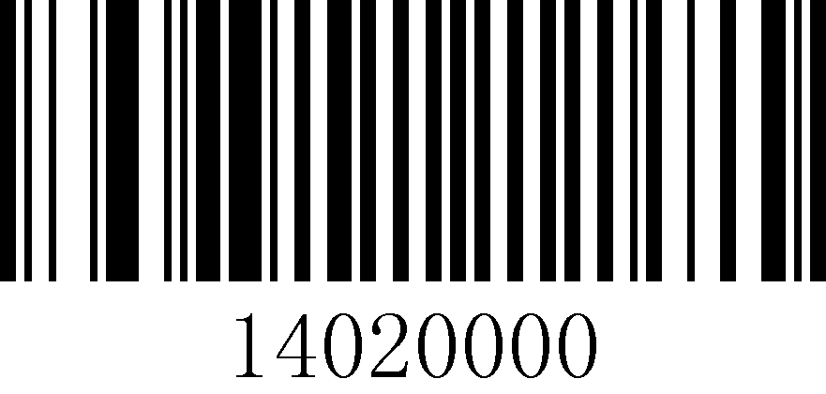
Do not Convert UPC-A to EAN13

UPC-E Settings

Turn on/off settings
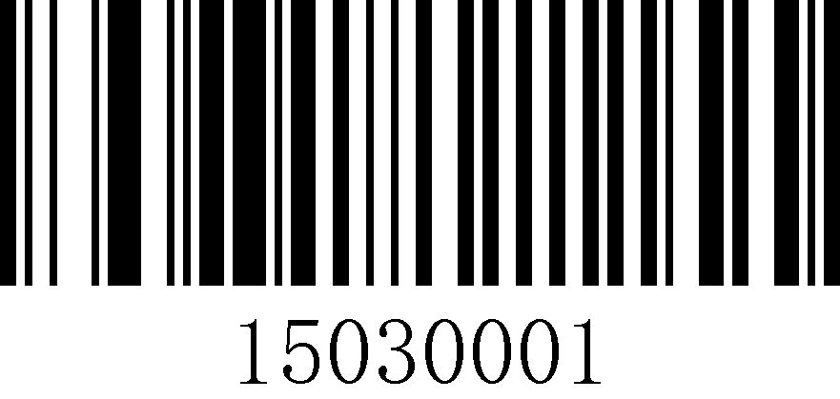
UPC-E on (default)
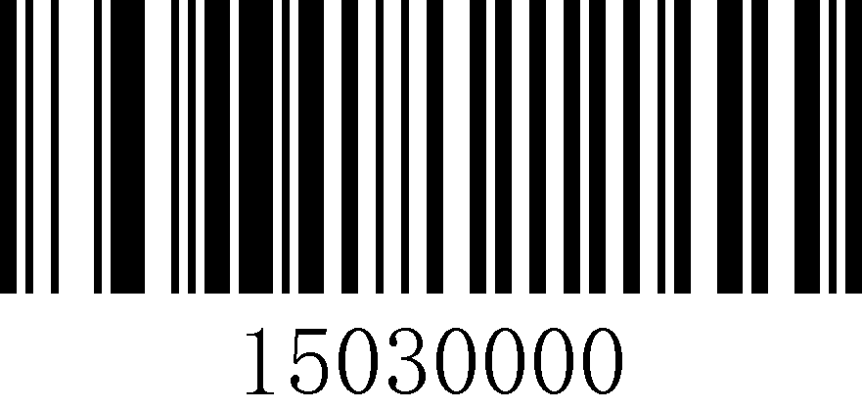
UPC-E Off

Check Character setting
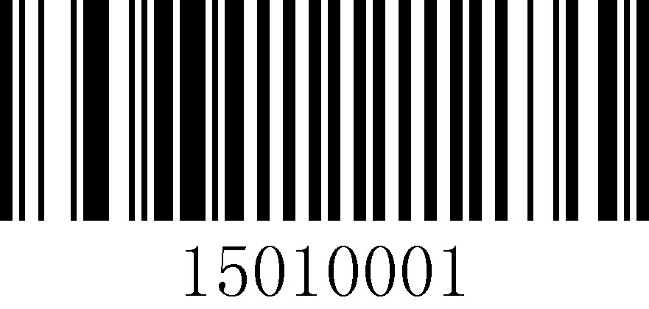
Transmit UPC-E Check Character (default)
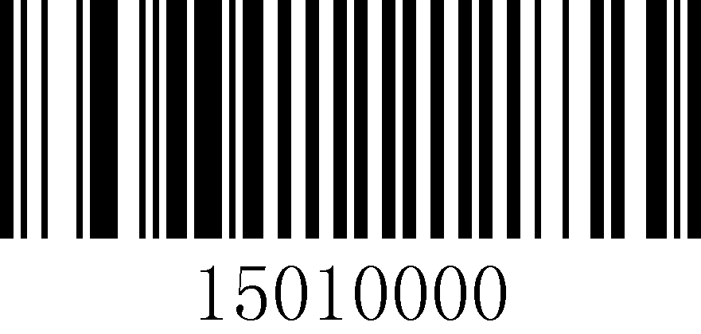
Do no Transmit UPC-E transmission Check Character

Transcoding settings
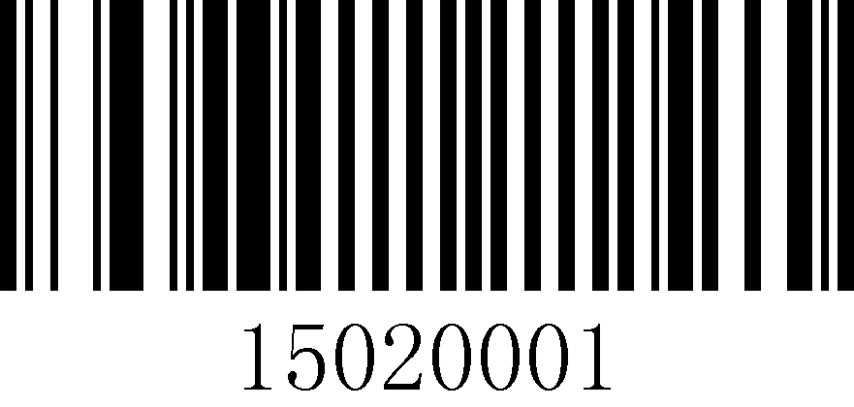
Convert UPC-E to UPC-A
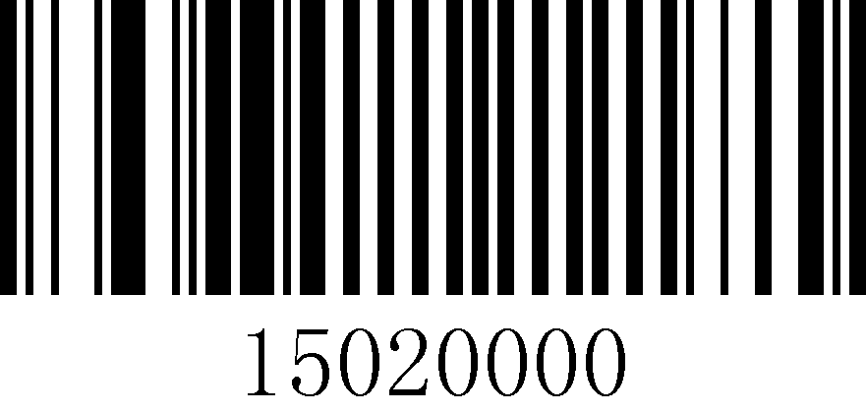
Do not Convert UPC-E to UPC-A (default)

Code 39 Settings

Turn on/off settings
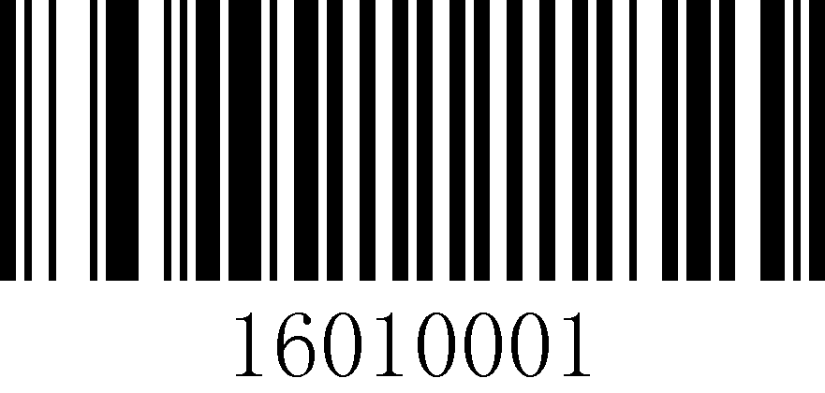
Code 39 on (default)
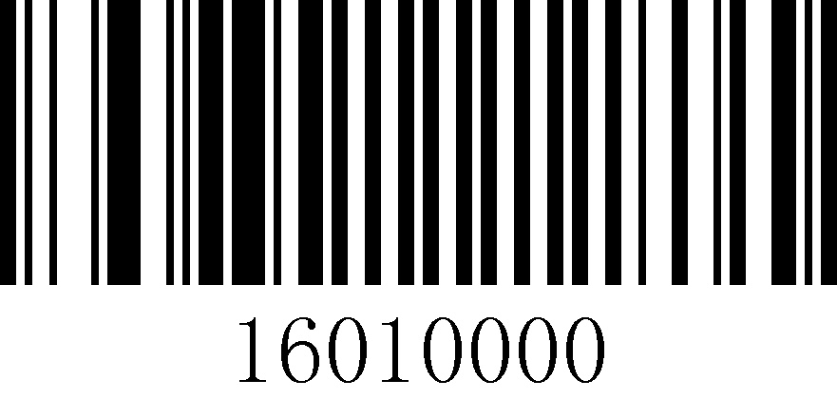
Code 39 Off

Check Character settings
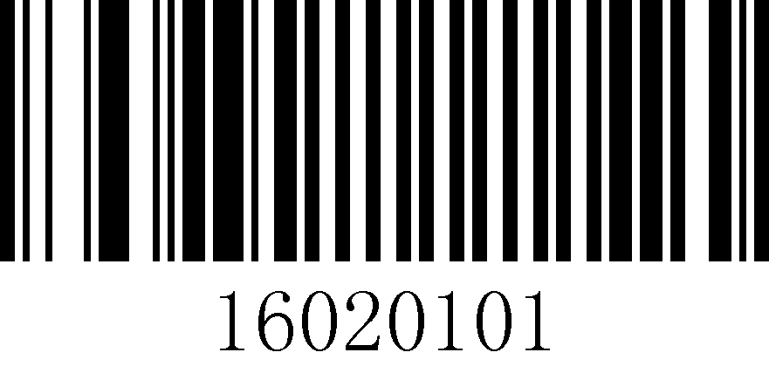
Enable Code 39 Check Character
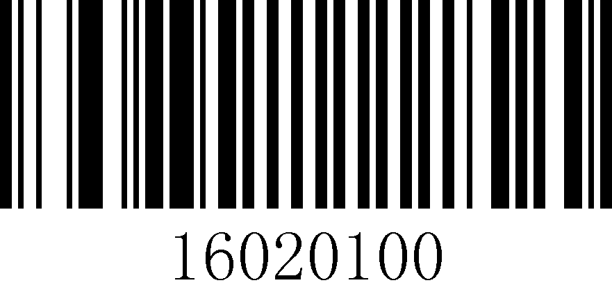
Disable Code 39 Check Character (default)
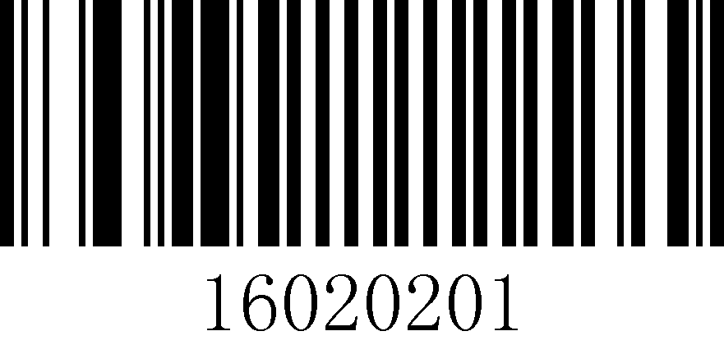
Transmit Code 39 Check Character
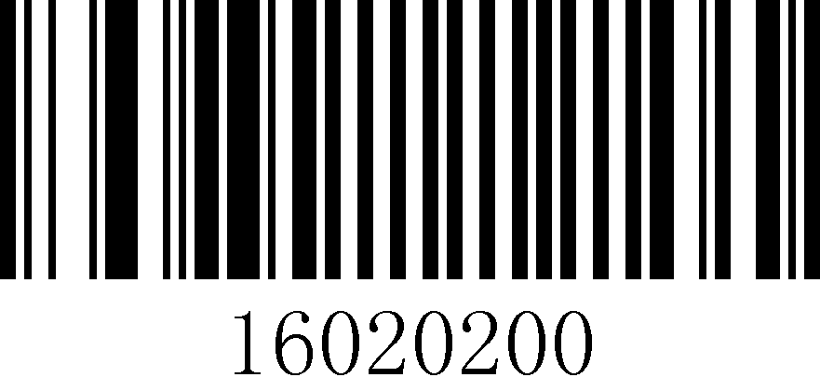
Do not Transmit Code 39 Check Character (default)

Start and stop character settings
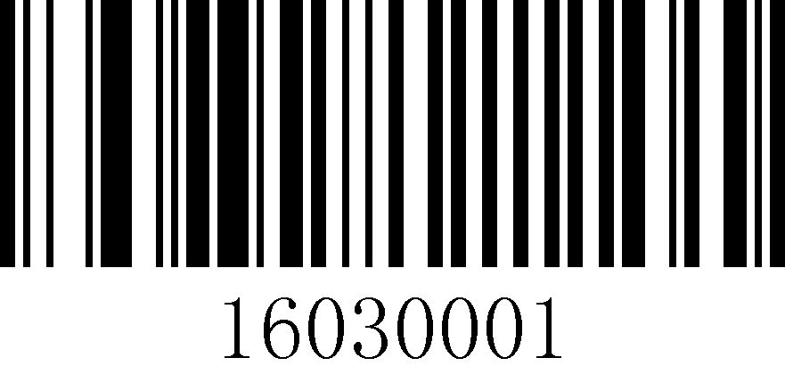
Transmit Code 39 start and stop characters
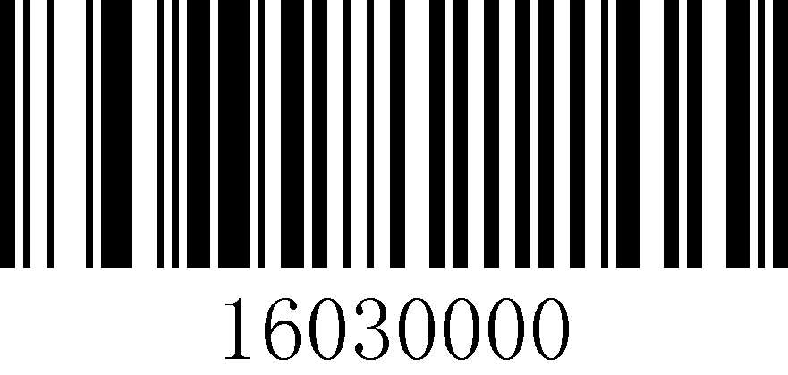
Do not Transmit Code 39 start and stop characters (default)

Code39 Full ASCII
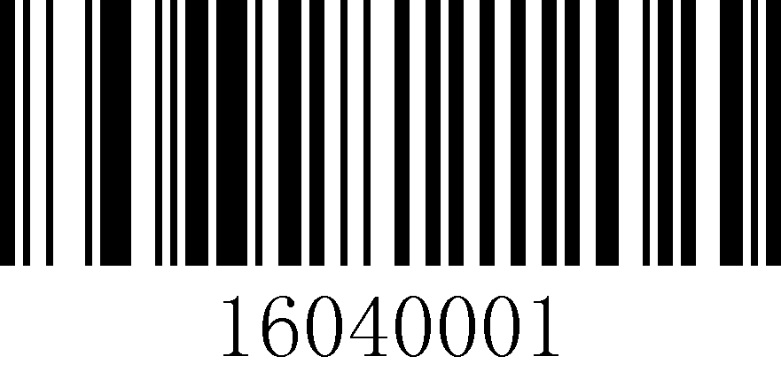
On
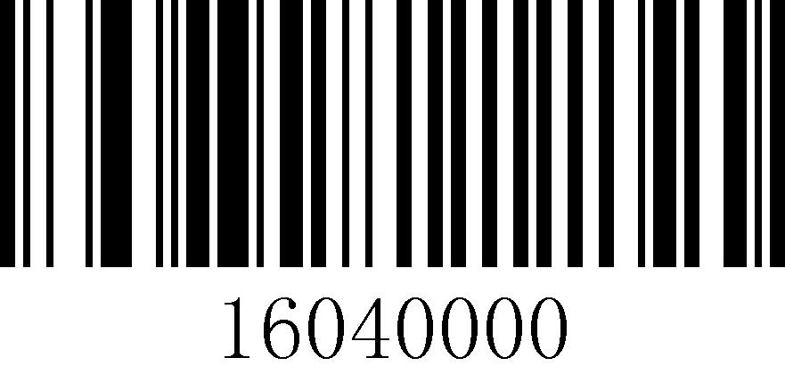
Off (default)

Code 39 Length Setting
Set the minimum and maximum length of Code 39 decoding, the value range is 4~255.
ATT | Note: If the maximum length is less than the minimum length, only the barcode of these two lengths will be Scan. If the maximum length is equal to the minimum length, only this length is supported.
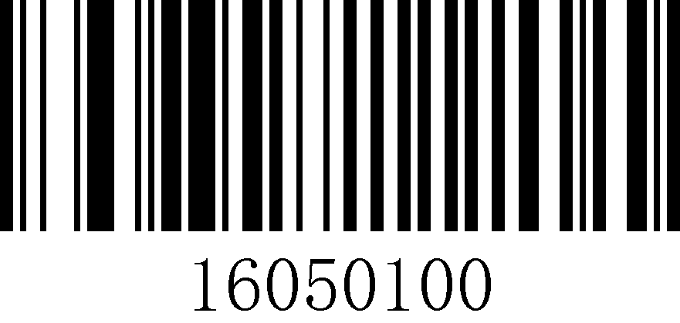
Minimum length setting

Maximum length setting
Example |  | Set the scanner to Scan only barcodes with a minimum of 8 bytes and a maximum of 12 bytes.  1. Scan "Startup Settings"  2. Scan "Minimum length setting"  3. Scan Digital Code "8" (see Appendix 1 for data and edit barcode)  4. Scan "Save" (see Appendix 1 to save or cancel)  5. Scan "Maximum length setting"  6. Scan Digital Code "1" "2" (see Appendix 1)  7. Scan "Save" (see Appendix 1 to save or cancel)  8. Scan "Exit Settings"

Code 32 settings

Convert Code 39 to Code 32
When Code 32 is Off alone, the code output will be Code 39, and if Code 32 needs to be Off, Code 39 needs to be Off at the same time. Code 39.
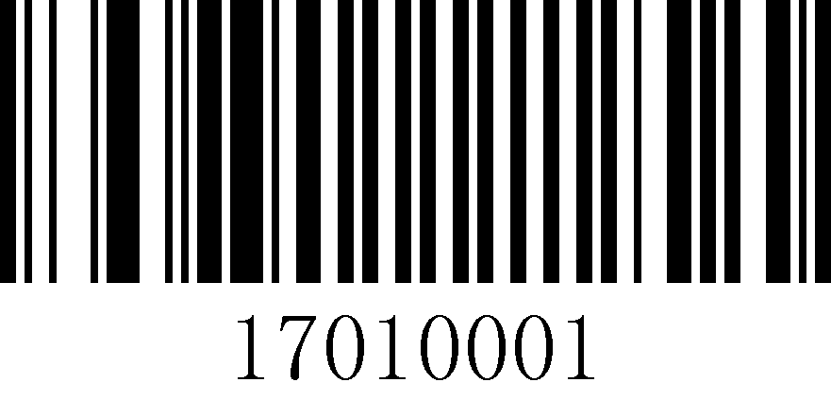
Convert Code39 to Code32
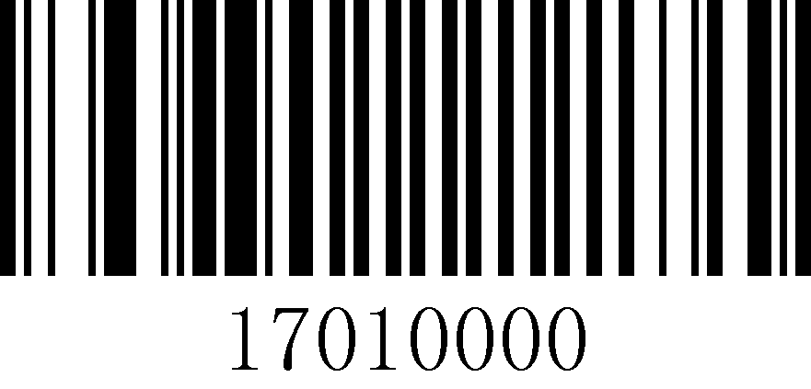
Do not Convert Code39 to Code32 (default)

Code 128 Settings

Turn on/off settings
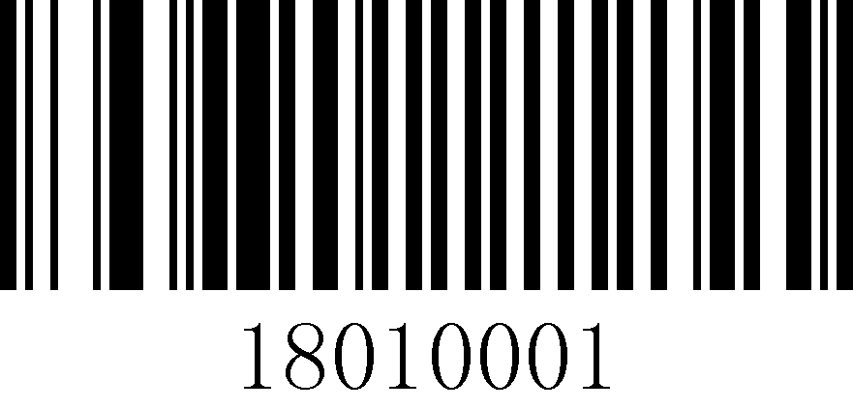
Code 128 on (default)
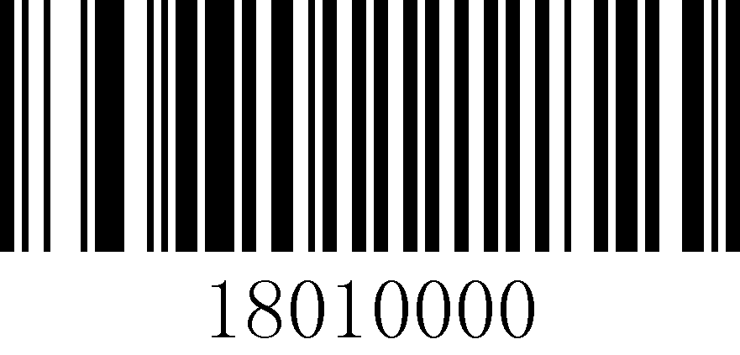
Code 128 Off

Check Character settings
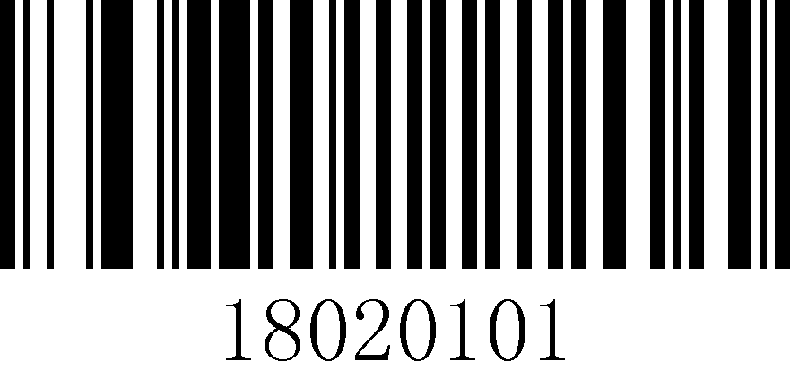
Enable Code 128 Check Character (default)
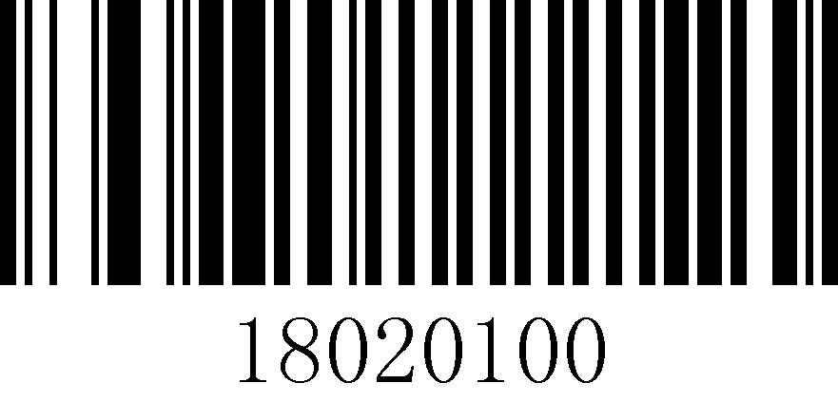
Disable Code 128 Check Character

Transmit Code 128 Check Character
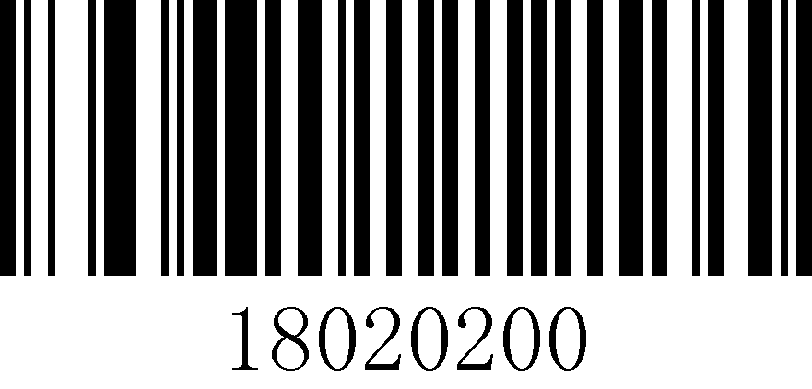
Do not Transmit Code 128 Check Character (default)

Code 128 Length Setting
Set the minimum and maximum length of Code 128 code decoding, the value range is 4~255.
ATT | Note: If the maximum length is less than the minimum length, only the barcode of these two lengths will be Scan. If the maximum length is equal to the minimum length, only this length is supported.
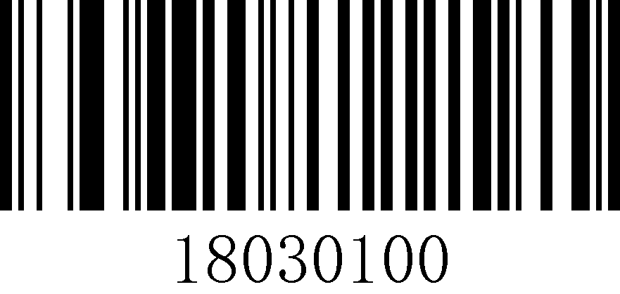
Minimum length setting
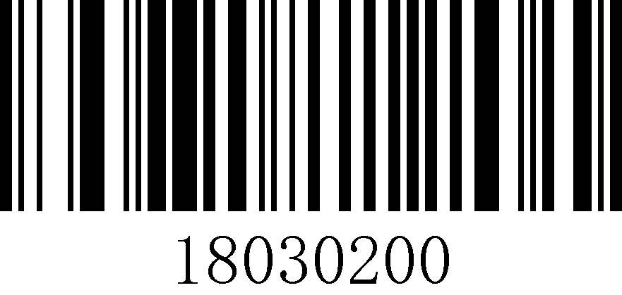
Maximum length setting
Example | Set the scanner to Scan only barcodes with a minimum of 8 bytes and a maximum of 12 bytes.  1. Scan "Startup Settings"  2. Scan "Minimum length setting"  3. Scan Digital Code "8" (see Appendix 1 for data and edit barcode)  4. Scan "Save" (see Appendix 1 to save or cancel)  5. Scan "Maximum length setting"  6. Scan Digital Code "1" "2" (see Appendix 1)  7. Scan "Save" (see Appendix 1 to save or cancel)  8. Scan "Exit Settings"

Code 93 Settings

Turn on/off settings
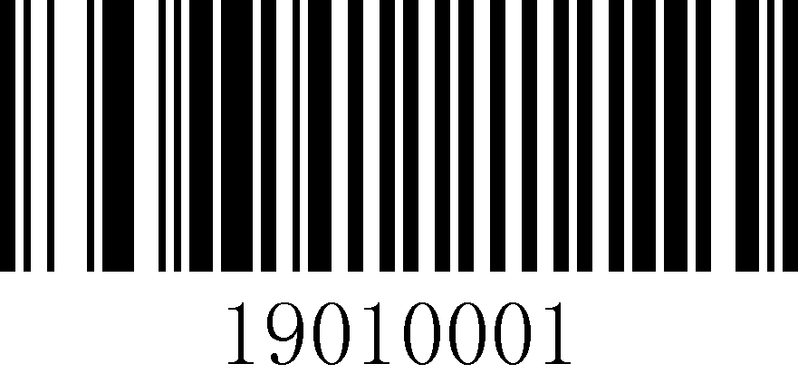
Code 93 On (default)
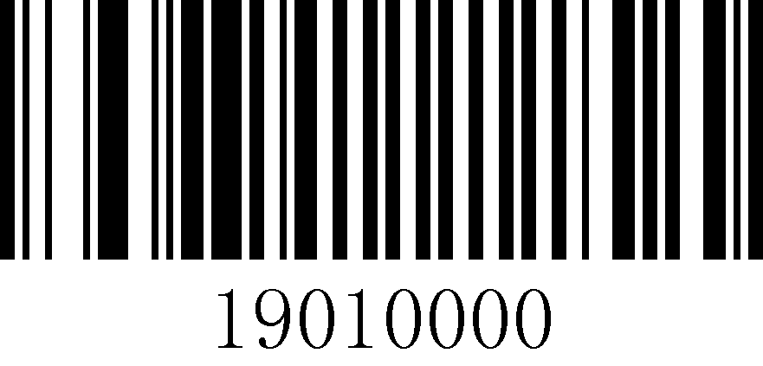
Code 93 Off

Check Character settings
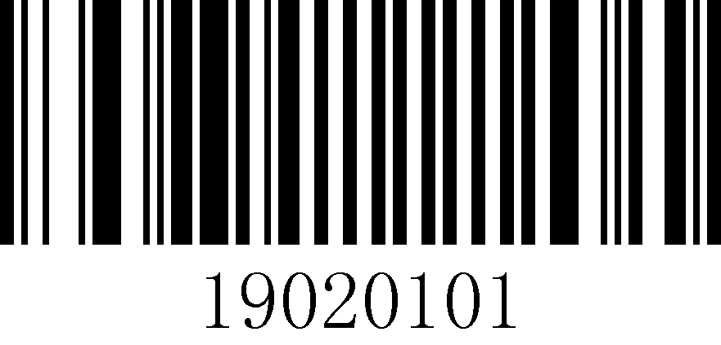
Enable Code 93 Check Character (default)
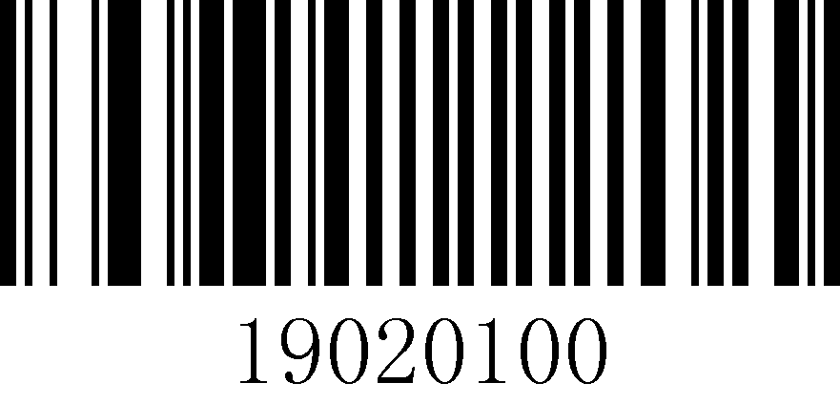
Disable Code 93 Check Character
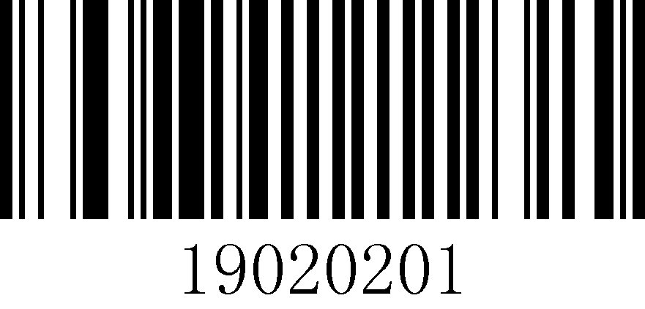
Transmit Code 93 check digit

Do not Transmit Code 93 Check Digit (default)

Code 93 Length Setting
Set the minimum and maximum length of Code 93 code decoding, the value range is 4~255.
ATT | Note: If the maximum length is less than the minimum length, only the barcode of these two lengths will be Scan. If the maximum length is equal to the minimum length, only this length is supported.

Minimum length setting

Maximum length setting
Example | Set the scanner to Scan only barcodes with a minimum of 8 bytes and a maximum of 12 bytes.  1. Scan "Startup Settings"  2. Scan "Minimum length setting"  3. Scan Digital Code "8" (see Appendix 1 for data and edit barcode)  4. Scan "Save" (see Appendix 1 to save or cancel)  5. Scan "Maximum length setting"  6. Scan Digital Code "1" "2" (see Appendix 1)  7. Scan "Save" (see Appendix 1 to save or cancel)  8. Scan "Exit Settings"

Codabar Settings

Turn on/off settings
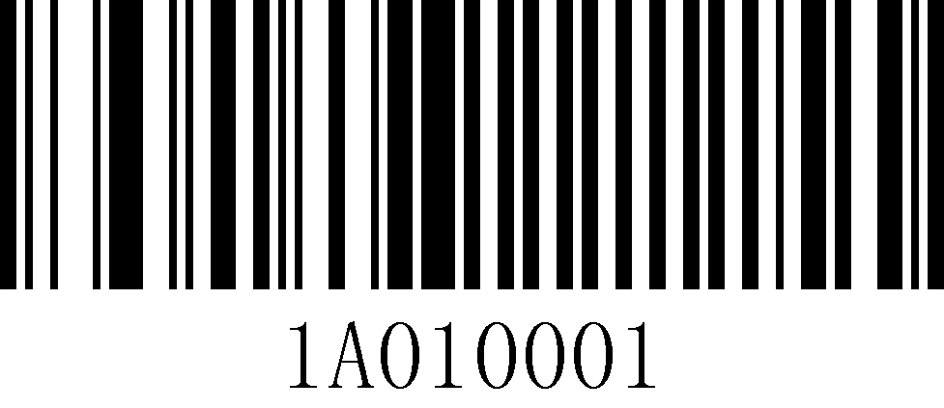
Codabar on (default)

Codabar Off

Start and stop character settings

Transmit Codabar start and stop characters

Do not Transmit Codabar start and stop characters (default)

Codabar length setting
Set the minimum length and maximum length of Codabar code decoding, the range of values is 4~255.
ATT | Note: If the maximum length is less than the minimum length, only the barcode of these two lengths will be Scan. If the maximum length is equal to the minimum length, only this length is supported.

Minimum length setting

Maximum length setting
Example | Set the scanner to Scan only barcodes with a minimum of 8 bytes and a maximum of 12 bytes.  1. Scan "Startup Settings" barcode  2. Scan "Minimum length setting" barcode  3. Scan Digital Code "8" (see Appendix 1 for data and edit barcode)  4. Scan "Save" (see Appendix 1 to save or cancel)  5. Scan "Maximum length setting"  6. Scan Digital Code "1" "2" (see Appendix 1)  7. Scan "Save" (see Appendix 1 to save or cancel)  8. Scan "Exit Settings"

Interleave 2 of 5 (ITF5) setting

Turn on/off settings
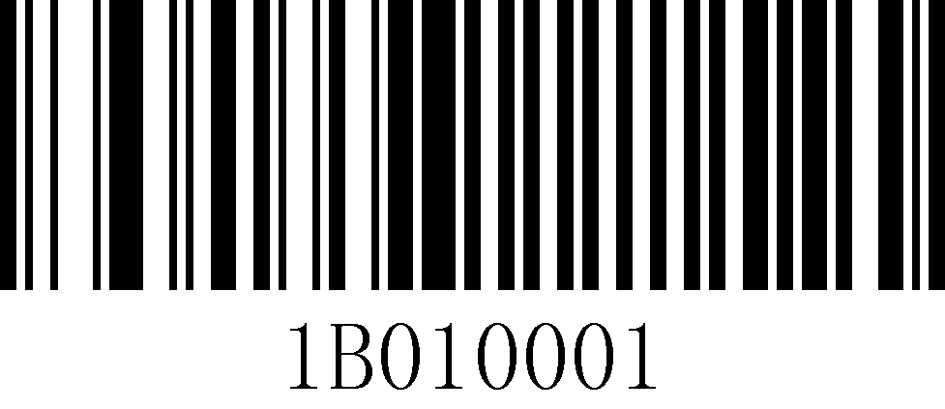
ITF5 on (default)
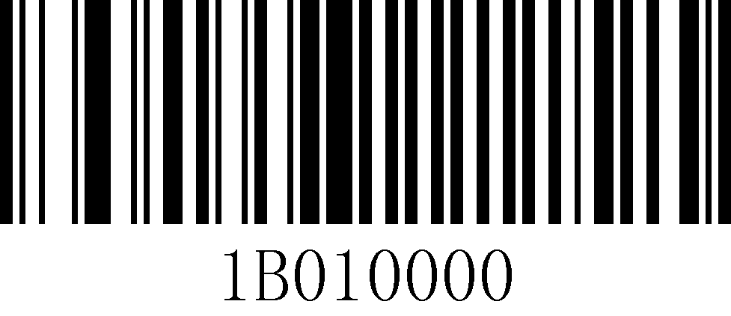
ITF5 off

Check Character settings
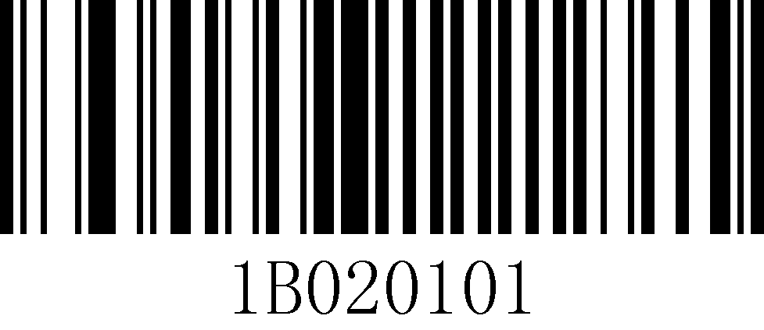
Enable ITF25 check character (default)
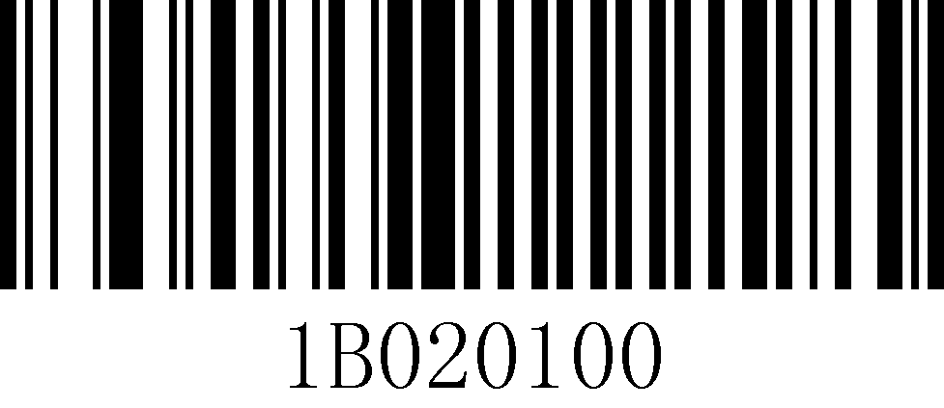
Diable ITF25 Check Character
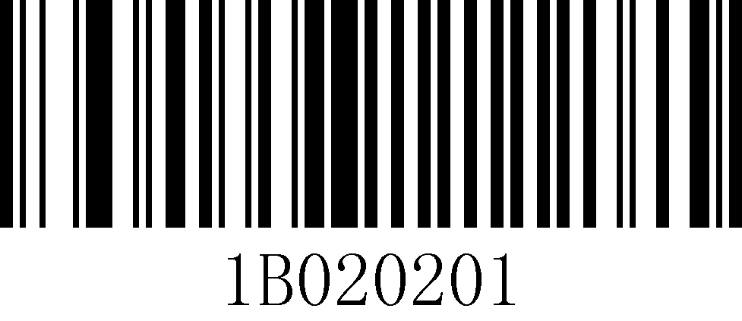
Transmit ITF25 Check Character
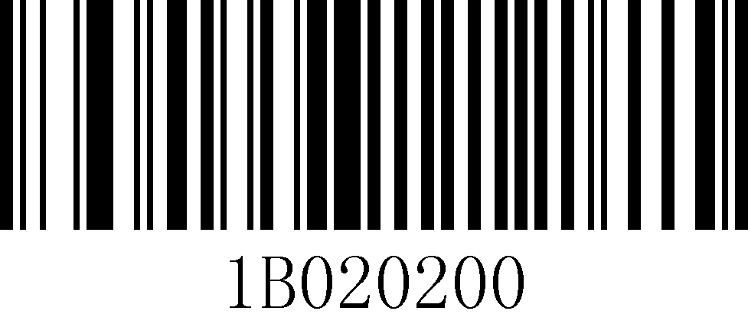
Do not Transmit ITF25 Check Charcter (default)

ITF25 length setting
Set the minimum length and maximum length of cross 25 code decoding, the value range is 4~255.
ATT | Note: If the maximum length is less than the minimum length, only the barcode of these two lengths will be Scan. If the maximum length is equal to the minimum length, only this length is supported.
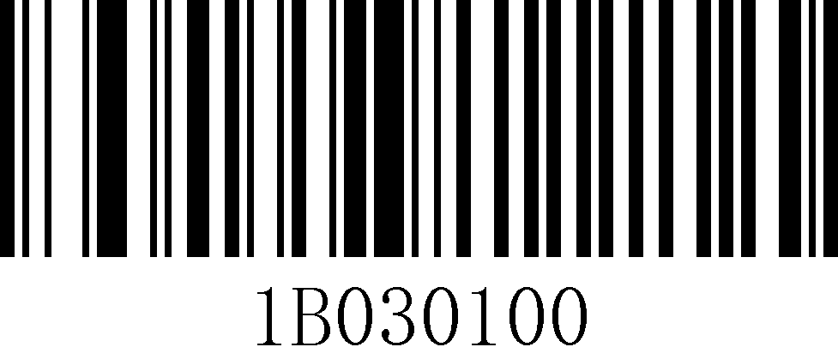
Minimum length setting
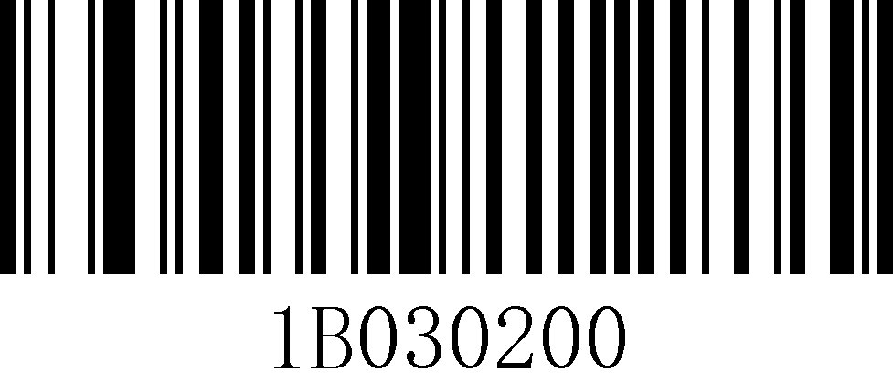
Maximum length setting
Example | Set the scanner to Scan only barcodes with a minimum of 8 bytes and a maximum of 12 bytes.  1. Scan "Startup Settings"  2. Scan "Minimum length setting"  3. Scan Digital Code "8" (see Appendix 1 for data and edit barcode)  4. Scan "Save" (see Appendix 1 to save or cancel)  5. Scan "Maximum length setting"  6. Scan Digital Code "1" "2" (see Appendix 1)  7. Scan "Save" (see Appendix 1 to save or cancel)  8. Scan "Exit Settings"

Appendix

Appendix 1 Data code table

0
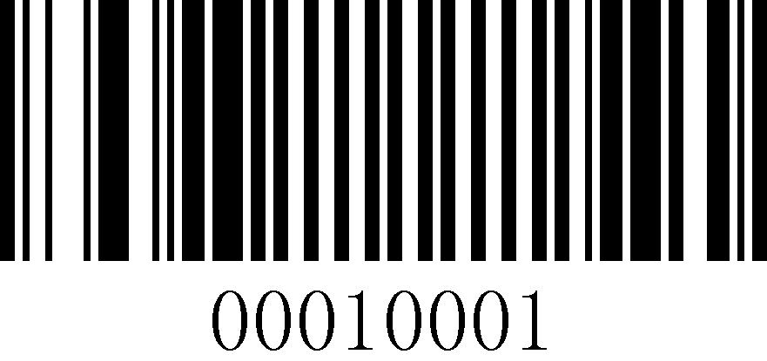
1
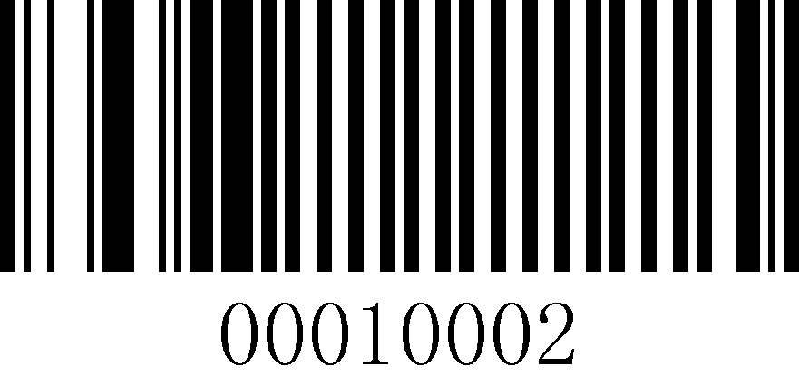
2
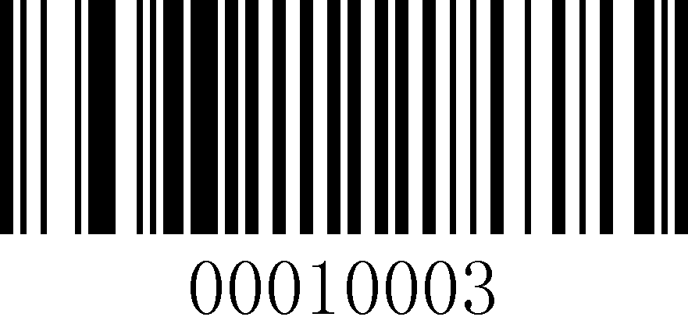
3

4

5

6
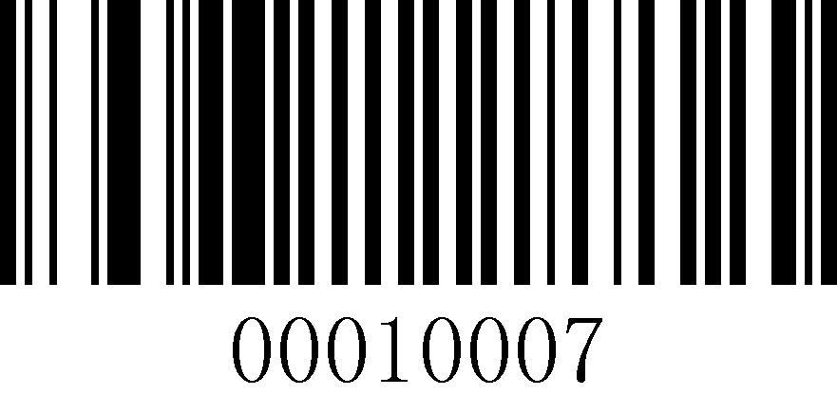
7

8

9

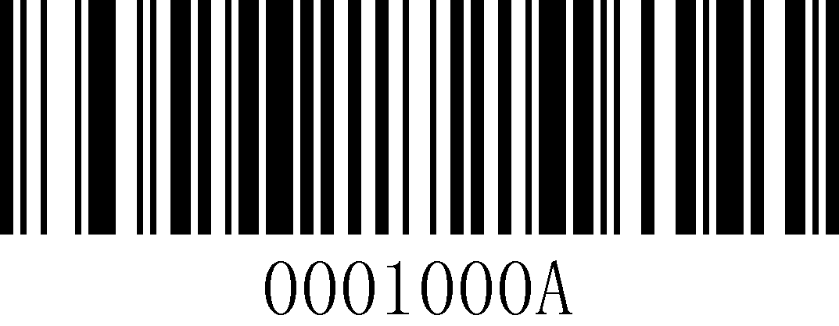
A
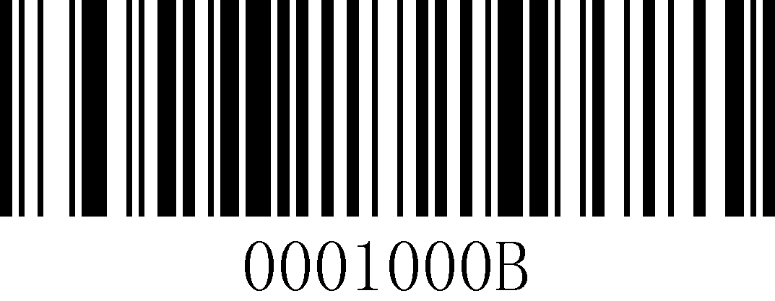
B

C

D

E

F
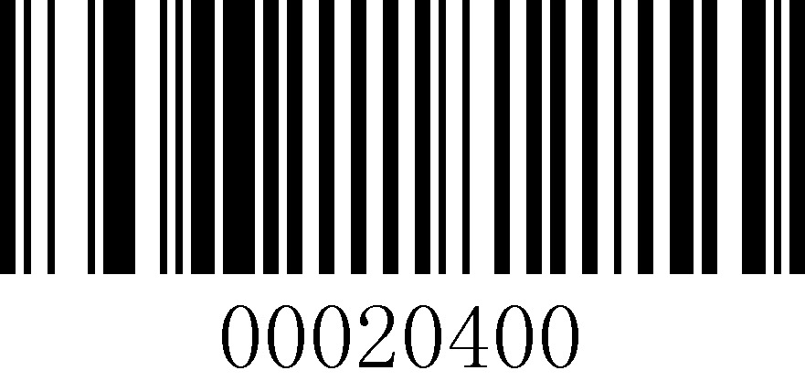
Cancels a string of data that was read earlier

Cancel current settings
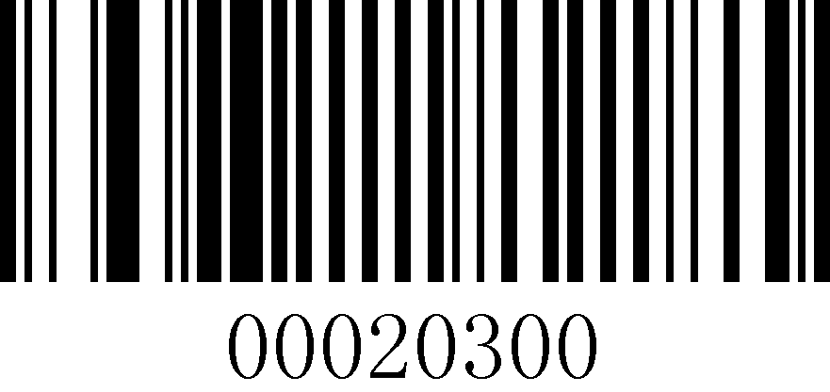
Cancel the previous read data
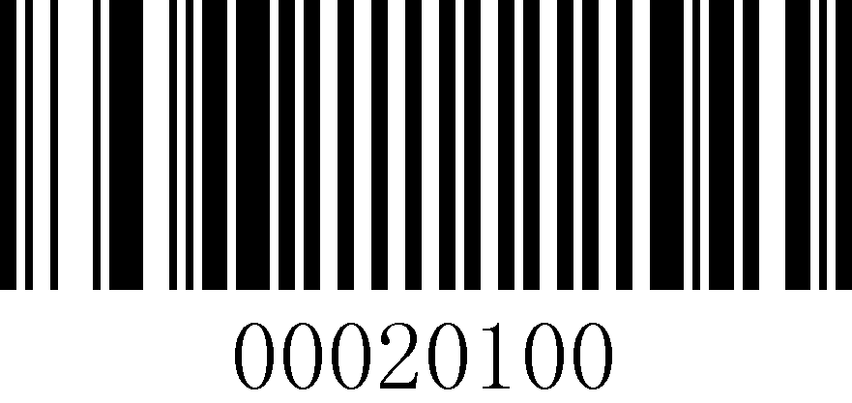
Save

Appendix 2 Code system support list
Code type | CODE ID
Code type | HEX | Corresponding characters
Codabar | 0x42 | B
Code 39 | 0x62 | b
Code 93 | 0x69 | i
Code 128 | 0x6A | j
EAN
EAN-8 | 0x44 | D
EAN-13 | 0x64 | d
ISBN-10 | 0x73 | s
ISBN-13 | 0x53 | S
ISSN | None | None
UPC
UPC-A | 0x63 | c
UPC-E | 0x45 | E
2 of 5
Interleaved 2 of 5 | 0x65 | e

Appendix 3 Control Characters Table
Character | Character Name | Value (decimal) | Value (hexadecimal) | Control character output Control + ASCII mode | Control character output ALT+Keypad mode
NUL (Null char.) | Zero Characters | 0 | 0x00 | Ctrl+@ | ALT+0
SOH (Start of Header) | Title Start | 1 | 0x01 | Ctrl+A | ALT+1
STX (Start of Text) | Text Start | 2 | 0x02 | Ctrl+B | ALT+2
ETX (End of Text) | End of text | 3 | 0x03 | Ctrl+C | ALT+3
EOT (End of Transmission) | End of transmission | 4 | 0x04 | Ctrl+D | ALT+4
ENQ (Enquiry) | Inquiry | 5 | 0x05 | Ctrl+E | ALT+5
ACK (Acknowledgment) | Confirmation | 6 | 0x06 | Ctrl+F | ALT+6
BEL (Bell) | Ringer | 7 | 0x07 | Ctrl+G | ALT+7
BS (Backspace) | Backspace | 8 | 0x08 | Ctrl+H | ALT+8
HT (Horizontal Tab) | Horizontal Tabs | 9 | 0x09 | Ctrl+I | ALT+9
LF (Line Feed) | line feed | 10 | 0x0a | Ctrl+J | ALT+10
VT (Vertical Tab) | Vertical tabs | 11 | 0x0b | Ctrl+K | ALT+11
FF (Form Feed) | Format feed to | 12 | 0x0c | Ctrl+L | ALT+12
CR (Carriage Return) | Carriage return | 13 | 0x0d | Ctrl+M | ALT+13
SO (Shift Out) | Move out | 14 | 0x0e | Ctrl+N | ALT+14
SI (Shift In) | Move in | 15 | 0x0f | Ctrl+O | ALT+15
DLE (Data Link Escape) | Data transfer code change | 16 | 0x10 | Ctrl+P | ALT+16
DC1 (XON) (Device Control 1) | Device Control 1 (XON) | 17 | 0x11 | Ctrl+Q | ALT+17
DC2 (Device Control 2) | Equipment Control 2 | 18 | 0x12 | Ctrl+R | ALT+18
DC3 (XOFF) (Device Control 3) | Device Control 3 (XOFF) | 19 | 0x13 | Ctrl+S | ALT+19
DC4 (Device Control 4) | Equipment Control 4 | 20 | 0x14 | Ctrl+T | ALT+20
NAK (Negative Acknowledgement) | Negative characters | 21 | 0x15 | Ctrl+U | ALT+21
SYN (Synchronous Idle) | Synchronized idle | 22 | 0x16 | Ctrl+V | ALT+22
ETB (End of Trans. Block) | End transmission word group | 23 | 0x17 | Ctrl+W | ALT+23
CAN (Cancel) | Cancellation | 24 | 0x18 | Ctrl+X | ALT+24
EM (End of Medium) | End of Media | 25 | 0x19 | Ctrl+Y | ALT+25
SUB (Substitute) | Alternative | 26 | 0x1a | Ctrl+Z | ALT+26
ESC (Escape) | Exit | 27 | 0x1b | Ctrl+[ | ALT+27
FS (File Separator) | File separator | 28 | 0x1c | Ctrl+\ | ALT+28
GS (Group Separator) | grouping symbol | 29 | 0x1d | Ctrl+] | ALT+29
RS (Request to Send) | Record separation symbols | 30 | 0x1e | Ctrl+6 | ALT+30
US (Unit Separator) | Cell separator | 31 | 0x1f | Ctrl+- | ALT+31

Appendix 4 ASCII code table
(Light yellow background for control characters, white background for displayable characters.)
Binary | Decimal | Hexadecimal | Characters/abbreviations | Explanation
0 | 0 | 0 | NUL (NULL) | null character
1 | 1 | 1 | SOH (Start Of Headling) | Title Start
10 | 2 | 2 | STX (Start Of Text) | Start of main article
11 | 3 | 3 | ETX (End Of Text) | End of text
100 | 4 | 4 | EOT (End Of Transmission) | End of transmission
101 | 5 | 5 | ENQ (Enquiry) | Request
110 | 6 | 6 | ACK (Acknowledge) | Response/response/notification received
111 | 7 | 7 | BEL (Bell) | Ringer
1000 | 8 | 8 | BS (Backspace) | Backspace
1001 | 9 | 9 | HT (Horizontal Tab) | Horizontal Tabs
1010 | 10 | 0A | LF/NL(Line Feed/New Line) | Line feed key
1011 | 11 | 0B | VT (Vertical Tab) | Vertical Tabs
1100 | 12 | 0C | FF/NP (Form Feed/New Page) | Page change key
1101 | 13 | 0D | CR (Carriage Return) | Enter key
1110 | 14 | 0E | SO (Shift Out) | No need to switch
1111 | 15 | 0F | SI (Shift In) | Enable switching
10000 | 16 | 10 | DLE (Data Link Escape) | Data Link Escape
10001 | 17 | 11 | DC1/XON | Device Control 1/ Transmission Start
10001 | 17 | 11 | (Device Control 1/Transmission On) | Device Control 1/ Transmission Start
10010 | 18 | 12 | DC2 (Device Control 2) | Equipment Control 2
10011 | 19 | 13 | DC3/XOFF | Device control 3/transmission interruption
10011 | 19 | 13 | (Device Control 3/Transmission Off) | Device control 3/transmission interruption
10100 | 20 | 14 | DC4 (Device Control 4) | Equipment Control 4
10101 | 21 | 15 | NAK (Negative Acknowledge) | No response/abnormal response/rejected
10110 | 22 | 16 | SYN (Synchronous Idle) | Synchronized idle
10111 | 23 | 17 | ETB (End of Transmission Block) | End of block transfer/block transfer termination
11000 | 24 | 18 | CAN (Cancel) | Cancellation
11001 | 25 | 19 | EM (End of Medium) | End of Media / Media Storage Full / Media Break
11010 | 26 | 1A | SUB (Substitute) | Substitute / Replacement
11011 | 27 | 1B | ESC (Escape) | Escape/Cancel
11100 | 28 | 1C | FS (File Separator) | File splitter
11101 | 29 | 1D | GS (Group Separator) | Group separator / grouping character
11110 | 30 | 1E | RS (Record Separator) | Record separator
11111 | 31 | 1F | US (Unit Separator) | Cell separator
100000 | 32 | 20 | (Space) | Space
100001 | 33 | 21 | !
100010 | 34 | 22 | "
100011 | 35 | 23 | #
100100 | 36 | 24 | $
100101 | 37 | 25 | %
100110 | 38 | 26 | &
100111 | 39 | 27 | '
101000 | 40 | 28 | (
101001 | 41 | 29 | )
101010 | 42 | 2A | *
101011 | 43 | 2B | +
101100 | 44 | 2C | ,
101101 | 45 | 2D | -
101110 | 46 | 2E | .
101111 | 47 | 2F | /
110000 | 48 | 30 | 0
110001 | 49 | 31 | 1
110010 | 50 | 32 | 2
110011 | 51 | 33 | 3
110100 | 52 | 34 | 4
110101 | 53 | 35 | 5
110110 | 54 | 36 | 6
110111 | 55 | 37 | 7
111000 | 56 | 38 | 8
111001 | 57 | 39 | 9
111010 | 58 | 3A | :
111011 | 59 | 3B | ;
111100 | 60 | 3C | <
111101 | 61 | 3D | =
111110 | 62 | 3E | >
111111 | 63 | 3F | ?
1,000,000 | 64 | 40 | @
1000001 | 65 | 41 | A
1000010 | 66 | 42 | B
1000011 | 67 | 43 | C
1000100 | 68 | 44 | D
1000101 | 69 | 45 | E
1000110 | 70 | 46 | F
1000111 | 71 | 47 | G
1001000 | 72 | 48 | H
1001001 | 73 | 49 | I
1001010 | 74 | 4A | J
1001011 | 75 | 4B | K
1001100 | 76 | 4C | L
1001101 | 77 | 4D | M
1001110 | 78 | 4E | N
1001111 | 79 | 4F | O
1010000 | 80 | 50 | P
1010001 | 81 | 51 | Q
1010010 | 82 | 52 | R
1010011 | 83 | 53 | S
1010100 | 84 | 54 | T
1010101 | 85 | 55 | U
1010110 | 86 | 56 | V
1010111 | 87 | 57 | W
1011000 | 88 | 58 | X
1011001 | 89 | 59 | Y
1011010 | 90 | 5A | Z
1011011 | 91 | 5B | [
1011100 | 92 | 5C | \
1011101 | 93 | 5D | ]
1011110 | 94 | 5E | ^
1011111 | 95 | 5F | _
1100000 | 96 | 60 | `
1100001 | 97 | 61 | a
1100010 | 98 | 62 | b
1100011 | 99 | 63 | c
1100100 | 100 | 64 | d
1100101 | 101 | 65 | e
1100110 | 102 | 66 | f
1100111 | 103 | 67 | g
1101000 | 104 | 68 | h
1101001 | 105 | 69 | i
1101010 | 106 | 6A | j
1101011 | 107 | 6B | k
1101100 | 108 | 6C | l
1101101 | 109 | 6D | m
1101110 | 110 | 6E | n
1101111 | 111 | 6F | o
1110000 | 112 | 70 | p
1110001 | 113 | 71 | q
1110010 | 114 | 72 | r
1110011 | 115 | 73 | s
1110100 | 116 | 74 | t
1110101 | 117 | 75 | u
1110110 | 118 | 76 | v
1110111 | 119 | 77 | w
1111000 | 120 | 78 | x
1111001 | 121 | 79 | y
1111010 | 122 | 7A | z
1111011 | 123 | 7B | {
1111100 | 124 | 7C | |
1111101 | 125 | 7D | }
1111110 | 126 | 7E | ~
1111111 | 127 | 7F | DEL (Delete) | Delete

