Recipe for a turkey of 8 kg
Preparation time: 12 hours minimum
Cooking time: between 3 hours 45 and 4 hours 30 minutes for a turkey between 4.5 kg and 8 kg
Total recipe time: 16 hours minimum
Customers reviews: 4.3 / 5 - 2902 reviews

Ingredients for Thanksgiving turkey
•a turkey
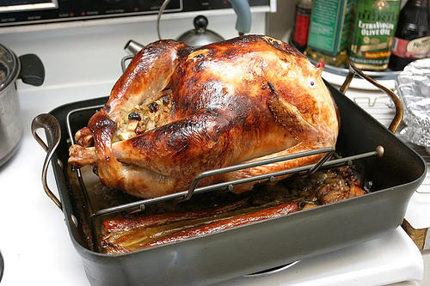
• 115 g of butter
•Some water
• 500 g of salt
• 2 carrots
•1 onion
• 2 celery stalks
• two branches of thyme
• a bay leaf
• stuffing

Steps :
• The night before, wash the turkey and recover the offal
• Rub the turkey with salt
• Place the turkey in a container large enough to cover
• Cover with water
• If you wish, add black pepper, brown sugar, thyme and rosemary
• Refrigerate for the whole night
• The next day, take the turkey out of its container
• Wash it thoroughly
• Let it dry before continuing the recipe
• Preheat the oven to 175 degrees C (350 degrees F)
• Put the turkey in its baking dish, chest down
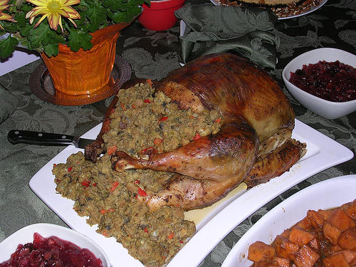
• Melt half the butter and brush the turkey with
• stuff turkey with stuffing

• Add a sprig of thyme and rosemary leaf
• Tie the legs of the turkey
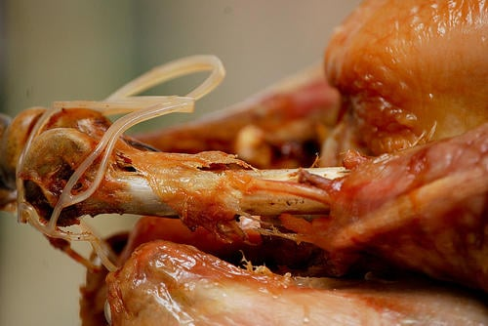
• Divide the chopped vegetables into the bottom of the dish
• Add 1 glass of white wine to the bottom of the dish to add flavor if you wish
• Cook until the turkey has an indoor temperature of 85 ° C (180 ° Fareinheit)
• With two-thirds of the cooking, gently flip the turkey and brush the breast with the remaining melted butter
• Let stand for 30 minutes before starting to cut
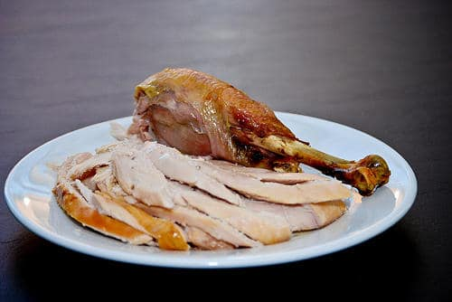
That's it, this recipe is a bit long and complex, but be sure it's worth it, since it's been done like that for generations, and it's a highly anticipated event of the year.

