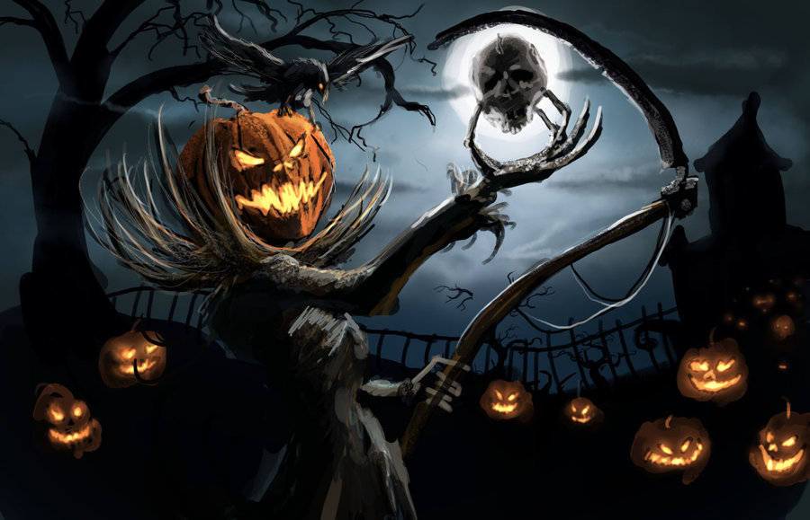

|  |  |
| --- | --- |
| ***LA FORET HANTEE*** | |
| **CHARADE** |  |
| **REBUS** |  |
| **MOTS CASES :** | |
| **1** |  |
| **2** |  |
| **3** |  |
| **4** |  |
| **5** |  |

Commentaire et suggestions :