In-Depth Analysis

A trade-off study was then conducted for both 3U and 6U CubeSats with the following key mass components:
 | 3U | 6U
Attitude and Determination Control System (ADCS) | 0.5 | 1.4
Electric Power System (EPS) | 0.3 | 0.58
Communication System | 0.25 | 0.5
Structure | 0.5 | 1.1
Thermal | 0.4 | 0.9
Payload | 0.54 | 3
Thruster | 0.01 | 0.01
Fuel | 1.5 | 6.51
Dry Mass | 2.5 | 7.49
Total Mass | 4 | 14
Figure 47 - Subsystems Masses
The range of values chosen for this trade-off analysis was based on the approved and reviewed electrospray thrusters:
- 1160 < Isp (s) < 5800
- 0.000075 < Thrust (N) < 0.00045

3U CubeSats

Starting with 3U CubeSats, only 16.6% of the simulations have been successful for a mission to Mars Orbit, as shown in Figure X below: a very high specific impulse of 5800 s allowed the mission to be successfully accomplished with a fuel mass of 1.5kg, allowing a payload mass of 0.54kg.
Figure 48 - Burn Duration for varying thrust at different specific impulse (Yellow boxes: Unsuccessful Mission)

16.6% of the simulations did not complete due to an ephemeris issue, that mainly appeared from a very low thrust of 75microNewtons.
68% of the simulations were unsuccessful due to insufficient fuel in the propellant tank, which emphasised the importance of miniaturising subcomponents in order to fly small CubeSats to such interplanetary missions. Along with the thruster, the power components, and their masses and sizes, are of essential consideration in a CubeSat design and is believed to be one of the biggest challenge. The power requirements of a CubeSat are met by the power subsystem which generates, conditions, regulates power using solar panels and stores energy during eclipse operation with a small battery. Industries are now focusing on sizing these essential components down: companies such as GomSpace, Clyde Space or DHV have taken up this challenge to provide products that are specifically manufactured for small platforms.
Despite incomplete missions, these 3U CubeSats were still able to reach Earth Orbit Escape: Figure X shows a significant decrease in time taken to escape the Earth orbit as the thrust increased from 75micro Newton to 0.045milli Newton. As the specific impulse decreased, the escape was accomplished quicker.

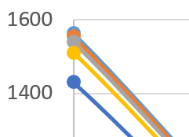
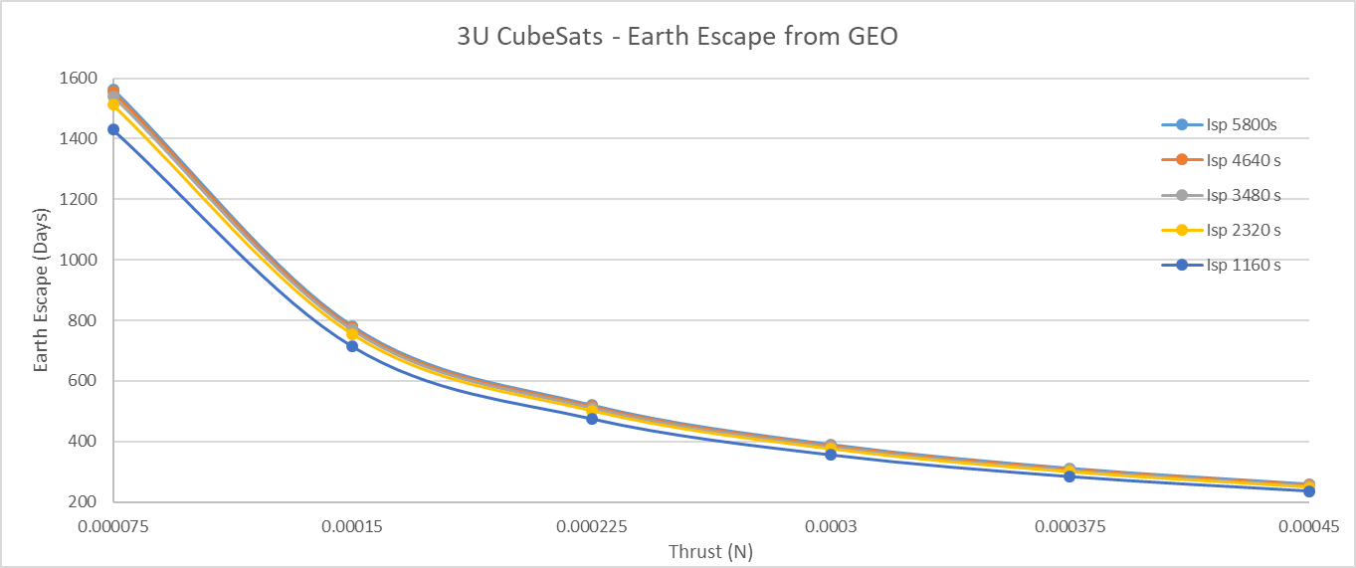
Figure 49 - Days taken for 3U CubeSats to escape Earth orbit with varying specific impulse

However, the variation between the time values were not significant except for the lowest specific impulse of 1160 seconds as shown in Figure X below. The target being a high specific impulse, in order to obtain a high delta V, the value of 5800 s could be thought to be highly desirable. A thrust value of 0.00045 N would be thought to be suitable for Earth Orbit Escape, being a value considerably low compared to all other types of thrusters reviewed. However, a thrust of 0.00045 N did not allow the CubeSat to reach Mars Orbit due to higher fuel requirement.
Figure 50 - Values for Earth Escape 3U CubeSats (Yellow - incomplete missions after Earth Escape)

As 68% of the simulations did not lead to the 3U CubeSat to reach the Mars Orbit target, the final fuel masses were values of the remaining fuel after Earth Orbit Escape. As shown if Figure X, the lowest specific impulse of 1160 seconds demonstrated the highest fuel usage up to Earth Orbit, consuming over 50% of the propellant, which justified that all of the 3U CubeSats at 1160 seconds did not reach Mars Orbit. Again, this low specific impulse was least optimum.

Figure 51 - Percentage of Fuel Usage up to Earth Orbit Escape – 3sU CubeSats
The fuel usage percentage was also noticed to slightly increase with higher thrust values.
A similar trend to the time taken for Earth Orbit escape was noticed, the lowest specific impulse generated results that were significantly different to the higher specific impulses. As the specific impulse increased, the fuel usage decreased considerably, justifying again the completed and successful missions with the highest specific impulse of 5800 seconds.
Regarding the successful 3U CubeSat mission to Mars, the below was obtained:

Figure 52 - Percentage of Fuel Usage up to Mars Orbit - 3U CubeSats
Clearly, the highest specific impulse led to the least fuel consumption for the complete mission, whereas a lower specific impulse of 2320 s led to over 90% usage. The lowest fuel usage for the complete mission was seen to be with a thrust of 0.00225 N.
The successful mission produced some very high delta V, as required for the target completion, shown in Figure X.

Figure 53 - Achieved Delta V by successful 3U CubeSats
The highest delta V was seen to be achieved by the second highest specific impulse of 4640 seconds with a value of 17755.61204 m/s. Isp of 5800 seconds produced considerably high Delta V of 17315.66884 m/s but also the lowest of 8390.40999 m/s compared to 9542.312519 m/s for the lowest Isp. While a thrust of 0.000225 N and Isp of 5800 s led to a commendable low fuel usage of 36.6%, it also generated the lowest delta V value.
REMAINING ANALYSIS:
Based on the above analysis, fix Isp and T as 5800 s and 0.000225 N or whichever is the most suitable, to then conduct a trade-off between PAYLOAD RATIO AND FUEL RATIO.
But, this is difficult with a 3U 4kg CubeSat due to the other mass restrictions.

6U CubeSats

The same analysis conducted for 3U was done for 6U 14kg Cubesat. 85% of the simulations did not work due to a software errot (GMAT Ephemeris Error).
How to proceed?
Discussing the Earth Escape only is not sufficient but would still be included.
In the case I get more successful simulations, trade-off between payload/fuel, burn duration/power would be included.

