Hi ! First, i apologize for my terrible english, i'm french.
I got there a request and an idea. Due to Sony restrictions, we cannot use external assets for PS4 mods. However, i think we could use the game textures to create new things.

1 - The Capes​
Several armors and outfits got capes integrated. Would that be possible to remove everything except the cape, and create a new item with it ?
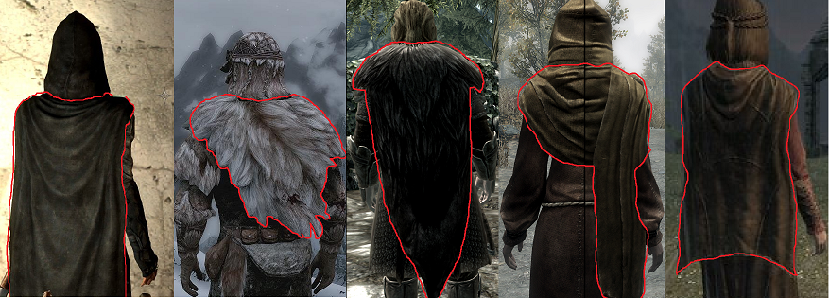
Nightingale Armor Fur armor Ulfric’s outfit Priest robes Serana’s outfit

2 – Bags, satchels and bandoliers
Now, how about wearables backpacks, satchels and bandoliers pounches? The textures already exists on the game as well. These could be considered as armor parts with the Fortify Carry Weigh enchantment.
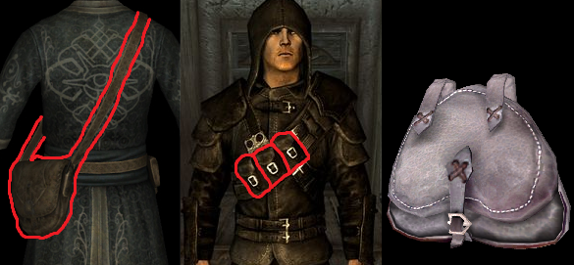
Master robes of alteration Thieves guild armor Klimmek supplies (…just a bag)
3 – Wearable lantern
Well, this mod already exists for PC and it shouldn’t be a problem to make it for PS4 because, one more time : The texture of the lantern is vanilla !
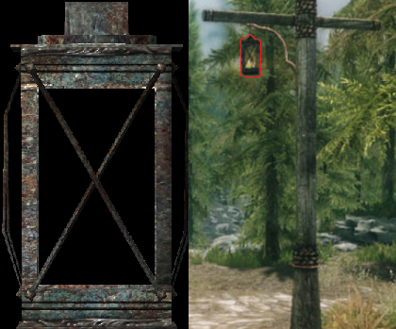

Thank you for reading,
And thank you so much if you decide to create one of these mods for me and the whole PS4 Skyrim Community.
Gabriel

