Interview with Erika Strobel, who wrote for Blazing Dragons

[I added illustrations that weren’t in the conversation ; it’s funny, it was supposed to be a real interview, serious and all, but we both ended to fangirl together so it looks like any chat conversation, I love her a lot already, she’s so funny and so nice !]
Erika: Hello!
Natacha: Oh hello !
Erika: I wanted to see if this link worked - sorry I'm early
Natacha: How are you ? Are you ready ?
Natacha: Oh no it's alright !
Natacha: In fact I've been waiting for 2 hours in front of my computer XD
Erika: I'm great. Yes, all set ... I had to brush up on my BD history a bit...
Erika: Thanks for having me...
Natacha: You're welcome, it's a real pleasure to me, and to us all, BD fans !
Erika: The pleasure is all mine!
Natacha: So before talking about BD, let's talk about you first. What studies did you follow to become who you are now ?
Erika: Well, this will sound strange - but none! My career in writing was "by accident" ... (of course it feels like fate now) but at the time it was not what I was studying at all. I was studying to become a "recording engineer" in the music industry.
Erika: But into my 2nd year of college (a private music school) I realized it was not for me...
Erika: This was in 1992. I was going to school at night and going to work (at Nelvana animation company in Toronto) by day.
Natacha: What made you realize you were made for animation writing ?
Erika: I worked as a Script Coordinator in the writing department of Nelvana (from 1988-1994). I wasn't thinking about writing at all, I just loved cartoons and it was an amazing job. But I used to write "funny little fairy tale stories" on the side for my boyfriend. Kooky stuff. In 1992 when my music dream died I was all bummed out thinking "what should I do now?" My boyfriend (who was reading one of my silly fairy tale stories and laughing) said... "Why don't you write! You're good at it."
Erika: I wasn't thinking about writing animation though... because everyone in the writing department had University Degrees at Sheridan College (Canada's best animation college)
Erika: So I decided to write "children's books". I went to the library to learn how to do this (since the internet wasn't around back then!)
Erika: I spent 2 years studying "how to write novels" and practicing writing when my boss in the Writing Dept. noticed the books and asked me if I wanted to write a script.
Erika: I was SUPER NERVOUS and said NO!
Erika: He pestered me for about 6 months... and finally I said yes...
Erika: My first script was for a series called TALES FROM THE CRYPTKEEPER. This was in 1994.
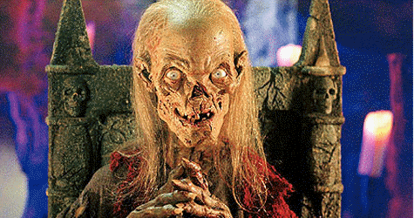
Erika: Sorry for such a long answer... it needed some explanation.
Natacha: Amazing !
Natacha: Tales from the cryptkeeper... amazing !
Erika: Yes, it was the perfect series to start... because there was no comedy. Writing comedy is very intimidating!
Erika: I was able to learn the craft of story writing without the pressure of "being funny".
Natacha: Now, what was your professional path like ? Do you have any future project ?
Erika: Do you mean right now? Today? ... or back then?
Natacha: I meant right now, but yeah, back then too ! What did you think and do then ?
Natacha: Describe your path.
Erika: Ok - I will try to give the short version, since you are covering almost 20 years!
Natacha: Ha ha XD
Erika: I kept the Script Coordinating job for a year - and wrote 3 Tales scripts... then I was asked to make a decision; write full time or stay as a coordinator. My boss (who was my writing mentor) said... "the script coordinator is a JOB... writing is a CAREER"... wise words. I was very scared though. I loved my script coordinator job sooooo much. Fun! Easy! Paid very well. And I didn't know if I could write 5 days a week, 8 hours a day. But I took the leap. It was very hard work in the early days.
Erika: I started as a Junior Writer (only coming up with story ideas and writing outlines) for one year. I worked on the German TV series NEVERENDING STORY.
Erika: Then I was promoted to STAFF WRITER (coming up with stories, outlines and taking them to script). That's when I worked on Season One of BLAZING DRAGONS.
Erika: Then I was promoted to ASSISTANT STORY EDITOR. I worked on Season One of DONKEY KONG COUNTRY; another co production with France and Nintendo and Nelvana.
Erika: Then I was promoted to STORY EDITOR in 1997 and had my * DREAM JOB * - working full time on Blazing Dragons, Season Two!
Erika: When Blazing Dragons Season Two ended in Spring of 1998 I quit Nelvana and went freelance. (I loved working at Nelvana! I didn't quit because I wanted to, I had to. They had gone PUBLIC (trading on the Toronto Stock Exchange) and freelance writers could no longer work in-house. LONG STORY.

Erika: I then worked freelance from 1998-2012 when I stopped writing for animation.
Erika: I went back to my "old dream" (from 1994) and wrote my first novel. It is currently being shopped around NY publishing houses and I am waiting to hear if I will realize this dream from 2 decades ago!
Erika: That is the whole story.
Natacha: Fascinating ! In short, writing is your life.
Erika: Yes... as it turns out! (Thanks to that boyfriend...) ha ha...
Erika: The animation business changed dramatically from these early days... so I don't miss it. Back then, everything was super fun and the broadcasting model was much different. Now it's very corporate and not as much fun.
Erika: Yes, I have many novels ready to write!
Natacha: What genre(s) ?
Erika: I am writing for "middle grade" (8-12) comedy.
Erika: Still wacky - like Blazing Dragons.
Erika: Monty Python is my favorite type of comedy. ALL BRITISH COMEDY, really...
Natacha: So it was predestined, then XD
Erika: I never thought of it that way... but yes, maybe. Writing animation taught me all about the craft of writing and structure, so it was a great experience.
Natacha: Before talking about BD, any piece of advie for animation and writing students, or at least people who, like you, were/are studying something else but are interested in cartoons and/or writing more ?
Natacha: *advice
Erika: Well, I would tell anyone interested in animation to try to get a job in an animation studio - no matter WHAT the job is, because it's very hard to understand the entire production cycle unless you can see it first hand. The best training in the world is "first hand". If you can read scripts (from premise to outline to first draft) you can see the process as it unfolds. There is no better way to learn to write. Otherwise you are writing in isolation. If you learn what everyone else's job is (in animation) you also get the full spectrum of appreciation.
Natacha: Woah...
Erika: Also, most studios always hire "within" ... so if you want a job as a writer, it's very hard to get to know the writers/story editors if you are on the outside.
Erika: You can write a "spec" script and send it to story editors, of course --- but how do you learn to write the spec script on your own???
Natacha: So you mean that, even studying animation or not, we should try to enter a studio ?
Natacha: Before everything for any job, I mean ?
Erika: Well, I can only go by my own experience and all the other story editors/writers I know. No one really cared if you "went to University and had an English degree". They cared if you were "funny" and could take direction and comments well. NOW - I'm not saying education isn't important, of course. I think if you want to write animation you will have been watching cartoons like crazy and already have a really good sense of how to write a script anyway. You don't need a university degree to write a script if you have passion and you are watching every episode of FAMILY GUY. You know what I mean?
Natacha: Yes I do.
Erika: You will learn more in one year of working at an animation studio (as a production coordinator) than any "formal education". I promise you.
Natacha: Can't wait to see that. X)
Erika: If, after you work at the studio you decide you want to become an animator or writer or whatever... you can always go back to school.
Natacha: Alright. Thank you for the pieces of advice.
Erika: Even if you work one summer FOR FREE (internship is what we call it) at a studio to see if that is what you want to do!
Erika: I just think - in general - kids rush off to University with no clue what the JOB is actually like!
Erika: Look at me with the music industry!
Natacha: He he
Erika: What I thought it would be... and what it was... were two very different things. If I had worked in an engineering booth for a summer I could have saved myself 2 years of schooling and $$$$$
Erika: But if you work (even one summer) in the job environment that you "think" you want to be in - you will know 100% if you want to study it in school for 4 years and then if you do go to school you are PASSIONATE about it.
Erika: Plus, if you work in the job first, even for one summer, you will meet people there and maybe have a "job" to come to when you graduate. You will also know exactly what courses to focus on and what is a waste of time. I just think it's a smarter way to go about it. Work experience trumps education in my opinion, because education on the job is better.
Erika: It's real life ... not just a text book....
Erika: Once you know what real life expects from you, then you can go get the proper education.
Erika: Even if you KNOW you need the education, like in your case - art studies...
Erika: If you work in a studio you can see ALL THE JOBS related to art and maybe you'll see something you really love - or don't love - and change your mind.
Erika: Wouldn't you rather know in advance of 4 years of training?
Natacha: Why yes
Erika: This is just my opinion... I'm sure parents will hate me for saying it... ha ha... but it's what I've seen in life.
Erika: Sorry to ramble...
Natacha: No no no it's alright, on the contrary it gives me hope !
Erika: Great!
Natacha: Now, let's start with the main subject of this conversation. So you said Terry Jones only created the concept and wasn't very present. Did you still get to meet him or to hear one of his opinions about the show ?
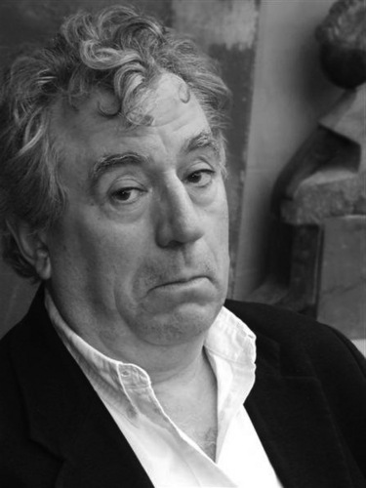
Erika: No, with great sadness I didn't get to meet Terry Jones (one of my comedy idols!). No one in the writing department got to meet him. I think only the president of Nelvana and a senior producer did. There were meetings in England as the deal was put into place. Then, once the series idea was "optioned" by Nelvana to produce, Terry Jones sent his writing partner Gavin Scott to Toronto. Gavin had written a series bible (concept, characters etc.) as well as a pilot script. But the Toronto team weren't happy with the writing (which sounds shocking since he was Terry's buddy) but none of us thought it was funny. So the producers asked Terry to let him go and see if we could come up with something better.
Natacha: You mean Terry Jones' friend himself didn't have funny ideas !? How ironic.
Erika: Well, from my understanding (Gavin might have even told us this... I can't recall)... but Terry Jones had come up with the basic concept where "history got it all wrong... there were dragons and knights, but the knights were actually the heroes of the story". I'm not sure how much else he had. Gavin was in charge of turning that idea into a script and bible. That is a TALL ORDER when a man of Terry's reputation is asking you to be funny. Very intimidating. Maybe Gavin was overwhelmed?
Erika: The pilot script (in Toronto) was a massive undertaking with several board room meetings and rewrites - every writer adding to it to make it better.
Natacha: Maybe. As for you, how did you react when you found out about the concept of dragon knights and human villains parodying Arthurian legends ?
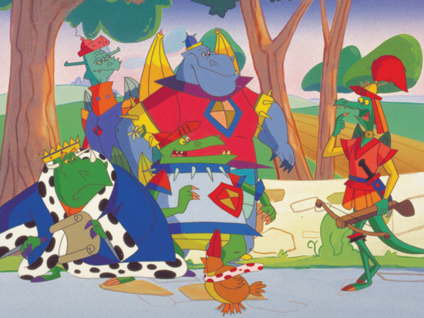
Erika: Well, I had a moment just prior to knowing that where I'd already fallen in love with Blazing Dragons. The director of the series, Larry Jacobs, had walked into my office holding a piece of art work with the title of the show. I fell in love with it INSTANTLY and told him (begged him) to be a part of it. This was before anyone even knew it was a Terry Jones project, I believe. Then about 6 months later we found out the origins and you can imagine how FREAKED OUT I WAS that Terry Jones (my hero) had come up with this idea. I loved medieval times.
Erika: I loved everything about the show - the characters - the concept - the art - and then later, the animation and voices (for Season One, anyway).
Erika: The animation for Season Two was dreadful.
Natacha: A lot of fans agree with you but I liked it actually XD
Erika: I really can't agree...
Erika: I disliked it immensely.
Natacha: Season 2 or season 2's animation ?
Erika: Season 2's ANIMATION only. I loved writing for Season Two because I was only a writer for Season One, I was the Story Editor and writer for Season Two
Erika: Ha ha... no I loved Blazing Dragons sooooo much - that's why I was sad about the poor animation in Season Two. It fell short of the writing and everything else...
Erika: The VOICE ACTORS were all amazing!!!!
Natacha: Were you sad 2 actors got replaced for season 2 ? Geoffrey's and Loungealot's, if I recall well.
Erika: I was sad about Geoffrey Season One going - because I loved his voice. It was more cartoony.
Erika: Sir Loungealot... I am drawing an embarrassing blank...
Natacha: What do you mean ?
Erika: I haven't watched the show for 18 years... I'm trying to remember "2" loungealots.
Erika:
Erika: I only remember one... sorry... Season One I LOVED.... so maybe he did change in Season 2... I'd have to watch them again.
[I give her 2 links with season 1’s Loungealot’s voice and season 2]
Natacha: He sounds exactly like him to me.
Erika: No Geoffrey is DEFINITELY I different actor... I remember that.
Erika: It's Loungealot I don't recall... let me see if I can find him in these 2 episodes and compare...
Natacha: No, I know Loungealot has 2 different voice actors between the 2 seasons. I meant, the second actor does a very good job with his predecessor's impersonation.
Erika: Yes - he does. But now that I hear it... the first actor is a little more "lounge-y" ha ha...
Natacha: Of course hahaha XD
Erika: Funny, I don't remember his replacement at all. I remember going to a first season voice recording... but I never went in season two because I was too busy.
Natacha: So you never really met the actors ?
Erika: I met the first season actors at the recording studio session for one of my own episodes ROBBING HOODLUM. But I never met the replacements in season two
Natacha: Did you get along ?
Erika: Queen Griddle gave the most hilarious performances. (A man; Steven Sutcliffe.)
Erika: Yes - they were all wonderful. Most voice actors are super "animated" funny people.
Natacha: Funny, she is voiced by a woman in French XD
Erika: I would love to hear a French version
Erika: I think they wanted a manly voice for Griddle since she's supposed to be like "Godzilla with mood swings"
Natacha: All the French actors do a very good job too.
[I give her 1 link with Griddle’s French voice.]
Natacha: OMG you guys described her like that ?!
Erika: Ha ha... those credits have my old married name (O'Reilly - that's the "boyfriend turned husband" who told me to get into writing!)
Erika: Yes, that is how Griddle was written in the series bible.
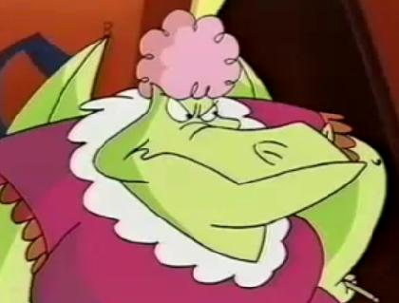
Erika: Ohhh... I have to watch this episode in full later and listen... can you send me the link in my email?
Natacha: I promise I will.
Erika: I'm so tech dumb.
Natacha: lol same
Natacha: A question I've always pondered. Who exactly came up with such an original, fun-looking drawing style for the characters ?
Erika: The design team at Nelvana, presumably... which is the art work I saw that day in my office. I'm not sure if Terry Jones had any ideas in mind or whether Nelvana came up with it from scratch, I'll have to ask Larry.
Erika: I can ask him if he'll do an interview for you as well.
Natacha: Oh if it doesn't bother the 2 of you, why not ! It'd be a honor then.
Natacha: Was any character modified or even removed or added from the concepts to the final result ?
Erika: Originally, in Gavin's bible there was a CHANCELLOR... I think he only appeared in one episode of Season One, then was cut. He was supposed to represent the "crooked church" of medieval times, but he was cumbersome to work with because of the political / religious angle, which didn't really have a place in children's cartoons.
Erika: Also Sir Galahot and Sir Hotbreath and Chef Turnspit were cut from Season Two - and (so sad) the Wandering Minstrel.
Natacha: No no, the Chancellor does appear. A very few times, but he does.
Natacha: As for the Minstrel, he appears one episode in season 2.
Erika: I can only remember one episode... Griddle's bday with Chancellor. I'd have to watch them again.
Natacha: "crooked church" ?
Natacha: He doesn't even look very religious in the final result.
Natacha: As for Chef Turnips, he appears from time to time in season 2 too.
Erika: Yes, all monarchs of the 'medieval' day were heavily influenced by the church... so the Chancellor's character was supposed to represent that type of character.
Natacha: I mean : [I link her to a pic of the Chancellor]
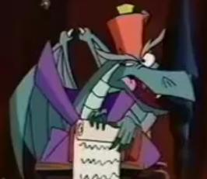
Erika: Yes - I just meant that Galahot, Hotbreath, Chancellor and the Chef were written as "prominent" characters in the bible, but never amounted to much in the actual series.
Erika: I think the chancellor's hate was an attempt at the POPE'S hat.
Natacha: Oh I would have never thought !
Natacha: Makes me think differently about him now XD
Erika: Let me open a writing file and see what I can find on the chancellor - give me a second.
Natacha: I'd have never thought he'd be religious.
Erika: HERE'S SOME NOTES FROM 1995 ON HIS CHARACTER. The Chancellor - over-educated - total bureaucrat - red tape times 10 - always the one to tie things up (i.e. "Fill out these 30 forms in triplicate, please.") - everything must be politically correct with this guy - He's the HUMAN RESOURCES of Camelhot! - he can be bought and bribed for the right price - the Corrupt Gov't official of Camelhot; or church representative
Erika: That's probably why he was cut as well. I vaguely remember a discussion about "too many characters". Some were ill-defined (hot breath only burped, nothing else) and Galahot didn't really have any character at all. The Chancellor probably was too close to Burnevere.
Erika: He was a little too boring, really
Natacha: Too bad, I liked them all, and to be fair, I thought Hotbreath wasn't that secondary and didn't just burp. He wasn't as much transparent than Galahot, had good ideas, funny lines, funny situations that weren't necessarily linked to burp or fire... He should have been a major character to me, he was a bit like Burnevere in season 1, who was secondary too.
Erika: Funny that you remember such details. More than me! (I meant the Chancellor was too close to Burnevere, not Hotbreath).
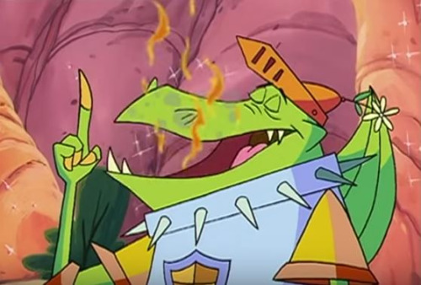
Erika: Only in so far as the "overly educated" part.
Natacha: No no I got what you meant, I just talk about Hotbreath because you mentionned him.
Natacha: I am one of the biggest fans this show ever had X)
Erika: I can see that! ha ha
Erika: Let me see what the old notes say about Hot Breath!
Natacha: Oh oh oh !
Erika: 1995 CHARACTER NOTES FOR HOTBREATH --- Sir Hotbreath "The Dyspeptic" - unable to control his burping (visually, he blasts fire everytime he burps) - Charles Bronson-type - obsessively tough - always working out - all business, no compromise
Natacha: (if it isn't too much, could you send me the notes for the characters, please ? I'll post them ONLY if you allow me to)
Natacha: "the dyspeptic" So his name changed to "the not-so proper", echoing to Galahot the Proper. I wonder why.
Erika: 1995 FOR SIR GALAHOT Sir Galahot "The Chaste" - (always chased by things) - glamorous, chivalrous - unaware of good looks - full of humility; easily embarrassed - dashing, daring, good company
Natacha: "always working out"
Erika: working out = exercising
Natacha: No no I got it, I just laughed, it reminds me of episode 11 in which he's macho XD
Erika: 1995 NOTES FOR SIR BLAZE - Sir Blaze "The Smartly Dressed" - Griddle's son, Allfire's stepson - highly fashion conscious - flamboyant (Richard Simmons) - over the top campy - name for everything personal to him (sword, horseskirt "Trixie", etc.) - always one who'd comment on colour, fashion, decoration, etc. - overabundance of personality, overly excited - His horseskirt is always a new fashionable colour. (For instance. One day it's neon pink with paisley pattern and a long pink mane that he can comb)
Natacha: So Galahot was "the Chaste". Echoing to Sir Galahad in Holy Grail, then. It's true he looks more chivalrous than the others. Is it me and other fans, or does he sound younger than he looks ?
Erika: 1995 NOTES FOR SIR BURNEVERE - Sir Burnevere "The Overly Educated" - scholar, intellectual - always speaks in BIG-mega-words that no one else can understand. - he can think of a dozen reasons why something is happening (possibly accompanied by history and entertaining parallel, but doesn't know what to do about it)
Natacha: Oh Trixie was supposed to appear many times ?
Natacha: Burnevere didn't change then XD
Erika: 1995 NOTES FOR SIR LOUNGEALOT - Sir Loungealot "The Queen's Favorite" - Selfish, self-satisfied, vain - lounge lizard - there for queen; shoulder to cry on, clip toenails - speaks to Griddle's romantic side, poetry, ballads - Flicker does everything but chew his food for him
Erika: 1995 NOTES FOR CINDER AND CLINKER - Cinder & Clinker (THE JESTERS) - two headed dragon - born comedy team - Cinder is the gag man, (big cheery voice), Clinker is the straight man (with slit eyes and monotone voice like Steven Wright.) - they show up in different roles all the time (The Court Jesters, Palace Heralds, Ladies-in-Waiting, Drawbridge Guards, Royal Trumpeters, Bartenders, Stableboys, etc. as needed) - they are comic relief and used to keep characters to a minimum - their lines are not always jokes.
Natacha: Ha ha, he didn't change either XD
Natacha: The poor jesters. lol
Erika: HA HA
Erika: Here's my fave...
Erika: 1995 NOTES FOR COUNT GEOFFREY - Count Geoffrey - ADDRESSED AS: "The Dreadful Count Geoffrey de Buillon, oppressor par excellence of the poor and the weak." - intensely cruel (esp. to serfs) - uses serfs as bait, bowling pins, catapult test, missing 12th step; saying: "There's always more where they came from." - only interruption to ruling land is the dragons - always abusing the peasants (taxes, damsels in distress) - uses Merle the Wizard for help - his castle is THREADBARE (literally) - wants the comforts of Camelhot! - Hates being called Jeff! - Angry about his missing 12th step -- hates Threadbare because it's falling apart - always refers to Griddle as another fat-variation, Her Royal Thunderthighs, etc.
Natacha: Was supposed to hate being called "Jeff" Okay.
Erika: 1995 NOTES FOR MERLE THE WIZARD.
Erika: Merle the Wizard - bottom of heap as wizards go - she can POOF in and out (acrid smoke as she does, everyone coughs) - hangs out in "Merle the Wizard's Cavern of Despair & Occult Museum" - a 70's art deco cavern complete with disco ball and her pet Yawgmort, Many Fanged Beast. - Her pad is complete with books, culinary spices cauldrons and racing forms - she plays solitaire with tarot cards in her spare time - she's cranky, sarcastic, low on enthusiasm and care zero about appearance - two wire-like hairs on her chin which she often scrapes at. - her spells are never 100-percent correct
Erika: We didn't necessarily use all these - they were just inspiration - but a lot of it came true
Natacha: I see, her spells are always correct XD

Erika: 1995 NOTES FOR EVIL KNIGHTS 1, 2, 3 - Evil Knights #1, #2, #3 - Keystone Kops - go to tremendous lengths to fulfil Geoffrey's evil plans - not too bright, always tend to get it wrong - forever bickering among themselves
Natacha: They were supposed to bicker ? They get along well in the final result XD

Erika: Yes, like I said we didn't use everything.
Erika: 1995 NOTE FOR GRIDDLE -- Queen Griddle - wife to King Allfire, stepmother to Princess Flame, mother to Sir Blaze - wears the pants in family - heart of romantic - giggly, flirty, cooing - "it's tough being a Queen" attitude - tries to be dainty, but has short fuse, she'll turn on a dime - capable of anything her mind wants - always trying to match Princess Flame up with a Beefcake Knight - demanding, relentless, tough as nails - loves poetry, music and flattery! (gets all that from Loungealot; her fave) - Lounge plumps her cushions, showers her with attention, listens to her problems, strokes her ego.
Natacha: That's fascinating to read !
Natacha: Was Flame's mother never going to be mentionned at least once ?
Erika: 1995 NOTES FOR ALLFIRE - King Allfire - still powerful, the leader - has set up "boys club" (Knights of Square Table) - takes great pleasure in calling on his knights personally - He is militant towards the knights, soft and sweet to Flame and oblivious to wife, Queen Griddle, claims she's "Always in a mood" - He's always adding to Code of Chivalry; which is "ideal but not practical" - his new chivalry codes/laws inevitably handcuff the dragons later - very sidetracked, preoccupied, misses obvious - has common good at heart - "good will triumph" (attitude) - purveyor of truth, justice and the dragon-way (all the above is why the knights follow him)
Erika: I can't remember whether Griddle as stepmother was in Gavin's bible or not??
Natacha: The good-hearted idiot, the king.
Erika: All of the above 1995 stuff was notes I took in our "big meeting" (Post Gavin Scott's leaving) where all the writers, directors, producers sat around putting the show together in our minds.
Erika: So some of these notes were likely part of Gavin's bible. I don't have a copy of that anymore.
Natacha: Alright. Fascinating anyway.

Erika: 1995 FLAME NOTES - Princess Flame - daughter of King Allfire, stepdaughter of Queen Griddle - fairminded beauty - keen sense of dragon equality - thinks Knights/Square Table thing is juvenile - many many suitors after her hand - Flame always manages suitors by sending them off on ridiculous errands - not passive, but not as aggressive as Griddle - helps/loves Flicker, wants to marry him one day.
Natacha: She was one of my examples as a kid !
Erika: 1995 FLICKER NOTES Flicker - Squire to Sir Loungealot - always inventing things - good & honest, like a boy scout - wants to be knight but Loungealot won't teach him - loyal, eternal optimist, quoting sacred Code of Allfire - A "bumbling kind of genius", can always spot Evil Geoffrey's plans - Loungealot ignores him, so Flicker takes matters into his own hands - Flicker likes Flame but is unaware of Princess Flame's attraction
Erika: 1995 WANDERING MINSTREL NOTES - Wandering Minstrel - Designed to look like RINGO STARR - will possibly have a Liverpoolian accent to go with his design - a total COMIC character - always INTROS/EXTROS show with bad limerick - steps into scenes with wisecracks, sarcasms, comments, asides - anything goes with this guy - can bridge scenes with funny remark, or to intro. new characters or re-establish villains goals - a running gag could be his constant use of different instruments
Natacha: LOL, Flicker knows she loves him XD

Erika: That's it for the character notes.
Natacha: So the Minstrel was supposed to have several instruments. Interesting X)
Erika: That's funny that a cartoon character was one of your examples.
Erika: Yes, I don't remember that... I like the Ringo Starr reference - I forgot about that.
Erika: Yes, Flicker totally knew she liked him but was embarrassed
Natacha: Among many others cartoon characters, yes, I've always felt close to cartoons XD I found she was smart, strong, cunning and independant yet she was calm, nice, girly and romantic anyway. Really, with Blaze, Burnevere and Hotbreath, Flame is one of my favorite characters.
Natacha: Oh like he is in the show. Poor lovers.
Erika: I'm surprised you liked Season Two animation then - Flame's art was HORRIFIC!
Natacha: I do find her cuter in season 1, I admit I was shocked too at first, but I got used of it.
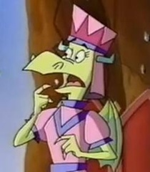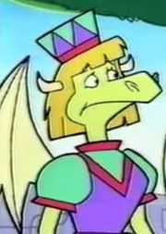
Natacha: And she's still cute. Not as cute, but cute.
Erika: You can't convince me - ha ha
Natacha: I know, fiiine XD
Erika: Unfortunately they had to come up with a new style to fit the thicker lines, so some previous designs didn't work - like Flame.
Natacha: Why did they come up with thick lines ?
Erika: I don't know enough about art (Larry could probably answer this) but somehow, using thicker lines is a budget thing? I guess they don't have to be as "precise" with the art???
Erika: If you compare Bugs Bunny to (cheaper) Flintstones (thicker lines) it's the same principle I guess... ??????
Erika: I really disliked the thick line look... it looked so cheap.
Natacha: Maybe. Too bad for Flame. To be honest I don't care, it's the occasionto see 2 different styles for the characters.
Erika: Spoken like a true fan! ha...
Natacha: Buuuuut once again it's just me XD
Natacha: I am I am ! 8D
Erika: Well, you are an artist too - so you would appreciate it.
Natacha: What does Larry do and did exactly ?
Natacha: Oh, I have my likings and dislikings X)
Erika: He was the animation director. He was in charge of everything - approving designs, storyboards, etc.
Erika: He went to all the voice recordings to ensure the essence of scripts was captured.
Erika: He's a wonderful guy.
Natacha: I see.
Natacha: By the way, what was your favorite episode to work on ?
Natacha: No exact details, I know you haven't watched the show in years.
Erika: Of my own scripts? or others?
Natacha: I was asking about your own scripts, but others too, then. Just do 2 categories, then.
Erika: My favorite script for Season One was "Knights & Knightresses" because of the feminist angle with Princess Flame, but moreso because of the silly "Sir Delores" (Flicker dressed in drag) and Sir Loungealot having the HOTS for him! I had so much fun with that! ... But I liked Robbing Hoodlum too because I love Errol Flynn's old Robin Hood movies.
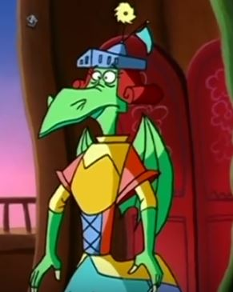
Natacha: Knights and Knightresses is one of my favorites too
Erika: In Season Two, I loved writing "Excalibroke". I liked beating up Sir Loungealot on that quest and ending on the brother who's a monk.
Natacha: It was funny to see his mother was the Lady of the Lake. Was this thought even before or only for this episode ?
Erika: I wrote "Attila's Hot Buns" the fastest. It was almost a first draft over a weekend with almost no revisions. Not sure why it was so easy to write.
Erika: No, I thought it would be funny to make the Lady of the Lake be his mother - after Flicker carries on about what a "sacred" legend she is ... to make her be a grisly old Mom who is crotchety and yelling at him.
Erika: The hardest script to write was "Seven Dragon Sins". It nearly killed me.
Natacha: Oh so you created the fact he was the Lady's son ? GREAT !
Natacha: Seven Dragons sins is one of my favorites XD
Erika: Oh thank God! At least the hard work paid off...
Erika: As for other scripts...
Erika: I loved "The Stone of Wisdom" (Dale Schott writer) in Season One; I thought the spoof of a shopping mall was hilarious.
Natacha: This episode was so hilarious, and we got to see Flicker as a knight and my favorite aspects of the other characters, so it was great XD
Erika: I still remember a line that Loungealot had - something like "What devil merriment, be this!" when he sees a rotating door.
Natacha: I did too, once again one of my favorites too !
Natacha: And one of my favorites gag with Hotbreath, when I tell you he wasn't minor
Erika: In Season Two I loved both of John Slama's episodes: Macbreath and The Reign in Spain
Natacha: Once again : MacBreath is one of my favorites.
Erika: I also loved all of Hugh Duffy's scripts. He was my staff writer and one of the funniest guys I know!

Erika: There's a scene with Eric The Well Read about a dining room table from IKEA... that kills me
Natacha: Oh God, I loved that episode too.
Natacha: You're talking about all the episode I love the most XD
Erika: And he wrote The Isle of Dwight! OMG that was funny...
Natacha: THIS ONE TOO ! With Blaze's father ! I so wanted to see more of him. Poor man.
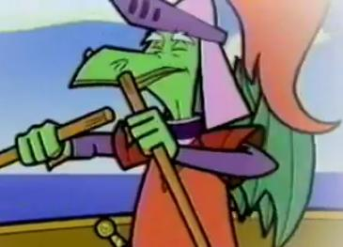
Erika: We were all working "around the clock" on this series. We had to deliver 26 episodes in 26 weeks!!!
Natacha: Oh my God ! O.O
Erika: It was an insane schedule... by the end of it I had two "ticks" (one in each eye) and my eyeballs were literally SWOLLEN.
Natacha: I can imagine...
Erika: So Hugh was my right hand... he worked soooooo hard.
Erika: There was only myself and Hugh full time ... the rest were freelance writers; so a lot of rewriting.
Natacha: Oh poo, lik would say Blaze.
Natacha: *like
Erika: Not because they weren't good writers, but they just weren't as close to the series as we were.
Erika: Yes - Oh pooh!
Natacha: I see.
Erika: John Slama was an exceptional writer.
Natacha: Like a mentor ?
Erika: No, just a great freelance writer. It's hard as a freelancer to come into a show, only reading a few scripts and the bible and being able to understand "everything". He just GOT it.
Natacha: He was just like me : a fan XD
Erika: He must have liked season one to write such strong scripts in season two, yes.
Natacha: By the way, what were the episodes you didn't really like to work on ?
Erika: Hmm... let me think...
Erika: I remember Hugh not enjoying THE INFERNAL FLAME. He wanted to do an Olympic origin story, but later regretted it... he didn't have fun with it. I actually barely remember it... except that information, so it's likely one of the weaker episodes. I didn't like SPHINX JINX. It was an episode rushed through to replace another story that got killed, so I recall that it wasn't strong.
Erika: I also didn't care for GEOFFREY'S EVIL PANCAKES. Just a thin story.
Erika: But it was toward the end... and I was exhausted.
Natacha: Aw, I loved Spinx Jinx ^^' As for Infernal Flame, it was good to me. And Geoffrey's evil pancakes... It could have been better, but it was a bit too rushed. It was good anyway.
Natacha: Too bad.
Erika: What is your least fave episode?
Erika: You can say one of mine! ha ha !
Erika: And your fave?
Erika: I hated Bleepin' Beauty from Season One.
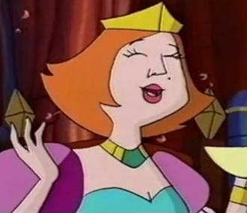
Erika: It was a "one note" gag that went on forever (her chatting)
Natacha: Aaaaaw it was one of my favorites, I laugh so much everytime XD
Erika: But you were how old? ha ha
Erika: Which episode is your favorite and least favorite
Natacha: My favorites, precisely, are Knights and Knightresses, The Stone of Wisdom, Hermits and Heroes, Bleepin' Beauty (sorry XD), Whine and Roses, The Isle of Dwight, Seven Dragons Sins, 3 dragons and a baby, The Chainmail letter and McBreath, and maybe the Robin Hood parody too XD
Natacha: As for how old I was I watched all season 1 from ages 9 to 10, I don't know why season has never been broadcasted back then, I only found out about it this year when I found about the sow by pure fate last March. I watched them all (both seasons) in 3 days and remembered why I loved this show so much.
Erika: Well it was an ellipse co-pro, so it must have aired in France back in 1998? But you weren't born!
Natacha: I was born this year XD
Erika: It's funny because I was looking to see when I edited my last script and it was February 1998 - and I was think, "I bet Natacha wasn't even born yet."
Erika: So weird that you have come out of the Youtube world to find me , almost 2 decades later...
Erika: It's been really nostalgic for me to relive all these great memories!
Natacha: My least favorites ? I think Achy Breaky Mace was awful X) Very close to it, I think Attila's hot buns was a bit too... "whaaaaaat ?" to me, and Ice try wasn't interesting to me. As I said, Geoffrey's evil pancakes had a very good concept but it go too far. I don't dislike it, I'm "meh" to it. As for season 1, Merle's Mirror is oddly irritating to me, I can't stand how Allfire is more stupid than ever in it.
Natacha: He he, yes, what a fate ! And just because I was bored and was rewatching the video. I found you ! 8D
Natacha: LOL XD
Erika: Well, now I know why Attila was written in a weekend - ha - not so good!
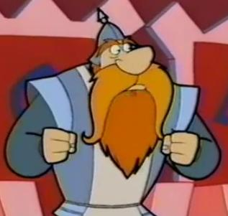
Natacha: You're welcome, and I'm really honored XD
Erika: Achy Breaky... yeah... not the best...
Natacha: I didn't dare to tell you ^^'
Erika: Oh, please... I have worse critics , believe me!
Natacha: Oh ^^'
Erika: As a writer, you quickly learn you can never please everyone.
Natacha: Oh, as a fanartist and fanwriter, I know.
Erika: Writing is "subjective"; especially humour. What one person finds funny - another thinks is dumb.

Erika: I think the nicest part of this interview, for me is...
Natacha: Yes.
Natacha: ?
Erika: When you are working in isolation like this, writing scripts for an audience of 8-12 year olds, you have NO IDEA how they are going to view it... how the jokes will work... so it's incredible to me, all these years later, to hear from a child (who is now full grown) reminiscing about this show and that it made you laugh.
Erika: That really warms my heart...
Erika: As writers (especially in TV animation) you never know what kids thought...
Erika: ... so this is really heartfelt to me.
Erika: Thank you!
Natacha: Aaw, you're welcome, we are several people like that, believe me ! We all love you guys' work and remain faithful to it !
Erika: Well you can know that everyone who worked on it loved it too!
Natacha:
Erika: It was a wonderful team. I wish every experience was like that.
Erika: I wonder if Terry Jones liked it??????
Erika: We never heard....
Erika: I wish I could meet him and ask!
Natacha: I wanted to ask you that before you told me you never met him.
Natacha: Also, talking about Arthurian Legends, who do you think Blaze and Hotbreath were supposed to parody ? Some fans think Blaze was Kay, other a mix of Kay and Mordred.
Erika: I think Blaze is Guinevere! ha ha ha!
Natacha: Ha ha ha XD
Natacha: Oh God XD
Erika: It's funny you ask - I actually never even thought about the actual knights parody! Except Loungealot/Lancelot.
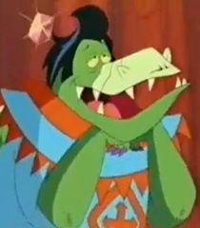
Natacha: Hotbreath is Bohort, to me, because it sounds like a burping sound to me XD
Erika: ha ha!
Natacha: Well, Galahot is Galahad, Griddle is precisely Guinevere, Burnevere is Bedivere, and some fans think that Blaze's cousin, the unseen Gasflame we ony hear about in Knights and Knightresses, is Gawain.
Natacha: *only
Erika: I seriously don't think anyone in the development meeting even considered the actual legend... we were just thinking of funny characteristics.
Erika: I'm sure Terry put some thought into this... but we didn't... we just wanted to create a funny "anachronistic" show.
Natacha: Well, others fans thought that Excaliburn wasn't just a parody of Excalibur, but a clever mix of Arthur's 2 sword. Caliburn, his first one, and then Excalibur.
Erika: No - I promise you - that no amount of in-depth thought went on with names like this... we were just spoofing FIRE (burn) with as much as possible.
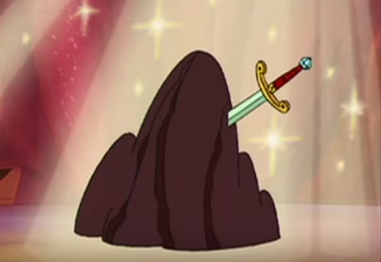
Natacha: I read Terry Jones and the other Monty Python knew a lot about Arthurian legends and they either could be considered like historians or WERE historians before becoming comedians, if I remember well.
Natacha: Ooooooh it ruins a theory lol XD
Erika: I don't doubt it with THE HOLY GRAIL
Erika: ha ha ... sorry!
Natacha: the Holy QUAIL
Natacha: *HEAVEN CHORUS*
Erika: I wrote EXCALIBROKE just because it broke. Pete wrote EXCALBURN just to mock fire.
Natacha: Alright.
Erika: Yes - of course, when it was obvious, we spoofed names as much as possible.

Natacha: Well it was a good coincidence then with Excaliburn XD
Erika: It was!!!
Natacha: By the way, did you create a name or a character or a memorable line ?
Erika: Fans are often more clever than the writers
Natacha: Lol not always, we just try to keep alive the writer's work by feeding it
Erika: I might have been the first writer to say "Oh Pooh" for Blaze in Knightresses... (I absolutely did NOT think I'd get away with calling King Allfire an S.O.B.!! -- gasp ! - "Son of a Briton".
Erika: ha ha...
Natacha: OH MY GOD IT WAS YOU ?!?
Erika: Yes.
Erika: It's either in Knightresses or Robbing Hoodlum...
Natacha: It was one of my favorite moments when I found this show again last March !!!
Natacha: It's Knights and Knightresses !
Erika: I wrote that as a gag - thinking 100% the censors at broadcaster would cut it ... but nope!
Erika: I'd have to re-read my scripts (or watch the shows) to see what my favorite lines were.
Natacha: I didn't remember this line at all, it jumped over my head (it was translated in French too, "FDP" "Fils de pute" but the "P" was for "Pendragon" which was clever from the translators) and I was jawdropping "OH GOD DID THEY JUST ?!?..."
Erika: But S.O.B. is one of them, because it's soooo crazy.
Erika: ha ha!
Natacha: So you also created "Oh pooh". Bravo !
Erika: There's another bit that is UNBELIEVABLE that they kept in...
Erika: (I hope so! re: oh pooh)
Erika: A design shot that is GASP worthy.
Natacha: When Griddle has her corset on ?
Erika: I'm not sure what episode it's in (Season One). Flicker is building an invention and he is talking to Flame...

Erika: And he points to a metal "stove" contraption off in the distance - and it's a mini wood burning stove - with an ENORMOUS PENIS!!!!
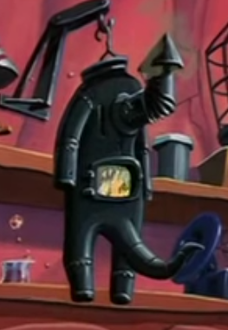
Erika: How the designers got away with that....
Natacha: WHAT ?!? I DON'T REMEMBER !!!
Erika: Larry would DEFINITELY have left it in...
Erika: Oh - look for it!
Natacha: Let me check...
Erika: I remember it CLEARLY!!!!!
Natacha: I SEE NOW !
Erika: Let me see if Word will find it searching through script files...
Natacha: Until you made realize I didn't even notice it !!!
Natacha: Oh boooooy
Erika: Oh sorry, I can't check Season One - I only have my own scripts and I definitely DID NOT put that in my script.
Erika: It's right at the beginning of one of the episodes, because in Season One we started each episode with a "Flicker invention". So it would be in the first five minutes. Maybe Griddle's gift??? Or Tournament Day???
Natacha: It was Excalibroke XD
[I meant Excaliburn. Darn]
Erika: Did you see it!
Natacha: Yes, I saw it, I told you ! I can't believe it XD
Erika: Oh - sorry. I missed that line of text above. ha ha
Erika: At first glance, it just looks like a wood stove - but it's clearly "more".
Natacha: I can't believe it XD
Natacha: By the way, talking about sexual references, this show was full of that kind of gag. I even heard there was an uncut version. How much the censors hated you all ?
Erika: Yes, well...back in the late 80's and early 90's most of the designers, animators, etc. were men.
Natacha: Oh, I am a girl, I do a lot of risky jokes too X)
Erika: No, we had no problem with sexual references, believe it or not. (As long as they were tongue-in-cheek). We were writing EXCLUSIVELY for Britain (not even Canada) and they are so liberal with their sexuality. We had more notes about violence.
Erika: I mean - they didn't cut S.O.B.! in a children's sho!
Erika: show
Erika: So we got away with a lot.
Natacha: Violence ? Oh, like the censor bar hiding Geoffrey-as-Allfire shock in King for a day ?
Erika: Yes, we had to be careful with Geoffrey. He was only allowed to use weapons that were impossible to recreate... medieval torture devices were okay... but even then, sometimes we went too far.
Natacha: At least it helped with the wacky atmosphere.
Erika: Often the poof of Merle's stench cloud or some other dust cloud would hide the "beatings".
Natacha: Ow, I see.
Erika: It's usually funnier to "hear" the pain instead of see it.
Erika: Like I remember a "bear in the cave" eating Geoff and E.K. #1,2,3 - and it was just torn clothes flying, which was funny and their screams.
Natacha: Yes, and more shociking because it's up to our imagination.
Erika: Yes. Exactly.
Erika: I don't think this show would get past the censors now - certainly not in Canada.
Natacha: Oh !!! By the way, a lot of fans are craving to know : does Geoffrey die in the Golden Thimbe of Theodora as he falls, we don't see him on the ground after that and we never see him again ?
Erika: So maybe it's lucky it only had a British sale at the beginning. It preserved the British humour that we were all aiming for.
Natacha: Too sad, this show is watchable by kids. Bloody censors.
Natacha: So did Geoffrey die, as I asked ?
Erika: No way! I'd never kill off Geoff. It just worked out that way story-wise. It was in my contract to write 6 scripts. I'd written "Shamrocks and Shenanigans", "Excalibroke", "Attila's Hot Buns" early on... and now I had to write three more. I had ideas for "Griddle's Sleepless Knights" and "Quest To Success" (and the dreaded) "Seven Deadly Sins" but we killed a script at the last minute so I had to come up with another idea... which was the Thimble story. Then all my shows were packed in toward the end... and I guess Geoff was just never part of the story.
Natacha: What were examples of stories that never made it, if you remember well ?
Erika: No - I don't. I'd have to look them up. I can tell you later...
Erika: I'm just looking up the Geoffrey last scene script to see what I wrote... hang on
Natacha: Alright.
Erika: So the scene has Loungealot grandstanding....
Erika
LOUNGEALOT
There is only ONE THING strong enough to pull the Golden Thimble free. The hardest substance known to Dragonkind. Griddle’s Fruitcake!
Erika
The Knights nod in agreement as Loungealot pulls out a bricklike cake. He puts on a bib then bites down on it. CHOMP! Beat then all of his crumble into a jagged line, leaving only the gold capped tooth intact! LIVID, Loungealot and throws the cake out the window just as Geoffrey pokes his face in to take a peek.
LOUNGEALOT
What could be more USELESS!
Geoffrey gets nailed with the brick/cake and plummets, landing in the moat with a <SPLASH>​
GEOFFREY
OOOF! --- YAAAAAAA!!!
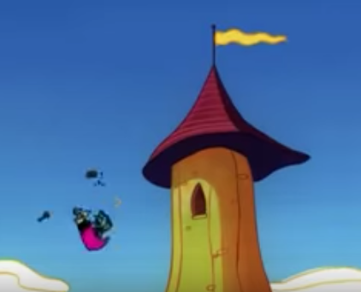
Erika: So there should have been a shot of him LANDING IN THE MOAT. Maybe it was cut ???
Natacha: It was. That's why all the fans thought so and were confused. Even the wiki talks about that.
Erika: No... that wasn't my intention. I'd never have killed him off because we were hoping for a Season Three pick up!!!
Natacha: Oh no, a season 3 that never made it ! D'8 Why hurting me this way...
Natacha: Was this 3rd season supposed to be more like season 1 or like season 2 ?
Erika: I know... even the UK didn't want it.
Natacha: Whyyyyyyyy
Natacha: :'(
Erika: I don't know.
Natacha: No I was crying "whyyyy" to myself x')
Erika: Oh ... ha ha.
Erika: Well, it was a great show while it lasted.
Natacha: Do you think, as it happened to old show recently, that it would one day know a continuation ?
Erika: I was very lucky to be a part of it. I'll be forever grateful.
Erika: No, I doubt it.
Natacha: I mean, if the whole fan community shows itself ?
Natacha: We're pretty numerous.
Erika: Well, it's not on DVD, so that should tell you something.
Erika: Really?????
Natacha: I don't have them but they exist !
[I link her to French DVD covers]
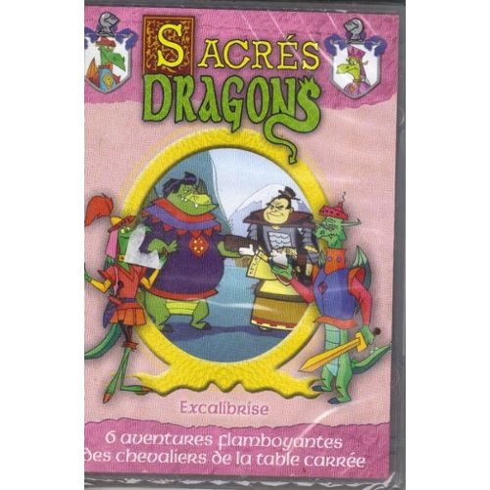
Erika: Are they official Terry Jones (c) or some fan based "burn" job???
Erika: The DVD sales would have to be substantial before anyone approached Terry Jones to do another series. If they did - I'LL BE STANDING IN THE FRONT OF THE LINE to write for it.
Natacha: I don't think so, what's written on the description sounds really like any DVD's commercial, saying only "one title" and having the same jingle "3/4/8 famboyant adventures of the Knights of the Square Table"
Erika: Wow. I'm surprised. I haven't seen anything here. Why don't you try to contact Terry Jones?
Erika: He must have a TV agent.
Natacha: Yeah, sure. But now I talked about the DVDs on Tumblr, maybe some collector fans would buy them. As for Terry Jones, I've thought of talking to him through Twitter but I don't have an account ^^'
Natacha: That would be great if I, a single fan, convinced him.
Erika: Yes - what a legacy for you as a FAN!
Natacha: It'd be cool to be helped, though ^^'
Natacha: Also, maybe not a season 3, but comics or a movie ?
Erika: Why not try???
Erika: I have an idea, but I do not want to post it on this FAN FORUM. I will email you a contact.
Natacha: Oh. Great ! 8D
[HOLY SHIT]
Natacha: I thought of continuating this show one day. First I become famous with my own work, then I use my fame to make something out of the franchise.
Erika: I should be going now anyway...
Erika: We can talk again and keep in touch.
Erika: THANK YOU for inviting me to chat. It was so much fun.
Natacha: Oh, now ? I didn't finish to ask questions !
Natacha: Just 2 or 3 and I was done !
Erika: Okay!
Natacha: Well, I was keeping 3 "colorful" questions for the end, I am sorry but I am a fangirl X)
Erika: Alright... go ahead.
Natacha: Okay... So, Blaze is gay, as you told so, and was hated by the censors for that, was still loved by all etc... But was it just me and the other fans, or was it implied at ONCE a knight they were bi too or something ?
Natacha: I mean, they were touchy, Burnevere and Hotbreath were always flustered at the sight of naked male dragons, Loungealot seemed VERY flustered when he met Ra, and Galahot by Blaze's stripping, and Burnevere is often staring at Blaze's butt in season 2 (ANIMATION ERROR ?!), so we were wondering...^^'
Erika: Well, as you saw from the early notes, Blaze was written as "flamboyant" and "campy". It was just understood he was "gay" without really saying it. But we wrote it more from the point of view that he had style, he was sensitive, etc. We never ever referenced his gayness with over sexuality towards another character.
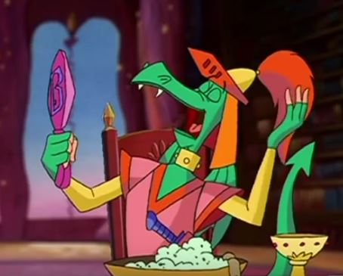
Natacha: Yes.
Erika: No - nothing intentional was ever written this way.
Natacha: Alright. X)
Erika: Flamboyant is the word we really rest on... but his VOICE just came out as feminine.
Erika: The actor had fun with it... and pushed it to the limit... so it came out gay. It was never meant to offend anyone; but to embrace his "style".
Natacha: His voice wasn't supposed to be so ?
Natacha: He's still one of the most loved character in the fandom, I assure you.
Erika: Well either Gavin (or the development team) I can't remember ... had his character as campy/flamboyant to offset the masculine knights for humour... also because he was a STEP CHILD, so we made him be "unlike" the others. Prissy. Then he was cast and his direction just leaned that way - to contrast the masculine voices of Lounge, Burn... etc.
Erika: I doubt anyway said - "play Blaze gay". But if you are a man and you are told to act "prissy" you just go an octave higher right?
Erika: Then as we wrote for him,,, he just became a lovable gay character... no one ever said it... it was just the way we wrote him.
Natacha: Yes, I would have too, I guess. I love how he contrasts with the manly other knights.
Erika: The more sensitive and silly and flamboyant and stylist he got... the more he was perceived as gay. It's a terrible stereotype, but he was so lovable we hoped we weren't offending anyone, but actually embracing him for standing apart from the alphamale knights.
Natacha: Naaaah, all the homosexuals I know love him, in fact. I'm thinking of someone in particular if he'll read that interview...
Erika: That's why I say - we never ever would have actually made a sexual reference in regards to Blaze or another character. That would have been inappropriate for any of the characters, gay or straight. It's still a kid's cartoon!
Natacha: Oh, other cartoons are risky about that, but I understand XD
Natacha: Yeah because the other question (oh, no 3 questions, actually, only 2, then) was about Arthurian legends once again. If Blaze was indeed a parody of Kay, some historians believe Kay and Bedivere were a gay couple as they always compliment each other and some of their actions are euphemisms, as teh Monty Python know Arthurian Legends, and as Blaze and Burnevere ALWAYS are together in season 2, staring at one's butt oe touching... Well, we fans think so, but it's just us, maybe it's like for Caliburn and Excalibur^^''
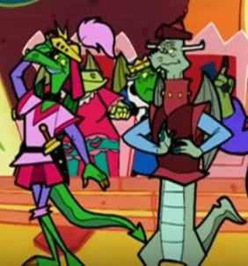
Natacha: But now I see XD
Natacha: Sorry, it was the last one I swear XD

Erika: No, ha ha ... you fans are going overdrive and reading way more into it than the writers ever imagined.
Natacha: Ha ha ha, that's what we work for XD
Erika: We used the historical time period more than the actual legend...
Natacha: ANACHRONIC historic time period
Natacha: So it's up to the fans ?
Erika: Yes - we tried to spoof that as much as possible, which is why the Stone of Wisdom works so well. Everyone got the SHOPPING MALL reference.
Natacha: And PANIC about a shopping mall. God, I loved that episode.
Erika: Unless the legend had obvious things - Holy Grail, Excalibur, Knights of the Round Table, Merlin, Lady of the Lake, Avalon, etc.
Natacha: What was known by all, indeed.
Natacha: Oh weren't you a bit sad the Holy Grail happened to really exist, in Excalibroke, as in the first episode, there a Holy Quail ?
Erika: We were running out of Arthurian ideas in Season One so that's why Season Two we branched out into Vikings, China, Greece, Spain, Scotland,
Natacha: (well, looks like there are 3 questions, then)
Erika: What do you mean?
Natacha: I see. Plus, kids wouldn't have got the hidden references.
Erika: Was I sad about what?
Natacha: I mean, Quest for the Holy Quail parod the Holy Grail, as if it was the only equivalent of the Holy Grain in this universe, but in the end of Excalibroke, there IS a Holy Grail. Did it break the parodic aspect to you ?
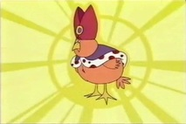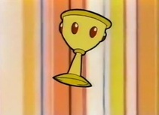
Natacha: *parodies
Erika: No... what happened was... in Season One I wanted to write a story about Excalibur "breaking" (a great Loungealot bit that leaves Flicker to fix it). But my boss, Pete needed a story and he was writing the actual "sword in the stone" angle. I was bummed out because it killed my idea. But later, in Season Two, when I was the Story Editor, I thought - it's still a good idea! So I'm using it. I knew that the Holy Quail had been used - but when you are writing - you are selfish sometimes and just want to do it YOUR WAY. ha ha...
Erika: We never think about FANS like you that remember every single detail !!!!
Natacha: Oh ! Oooooh ! Ho ho ho I understand ! We are birds of prey XD
Erika: And come back to haunt us with our ideas. Ha ha
Natacha: Yes, you wanted to give your touch I see
Erika: Well, it was a "different" story in my eyes... and it was far enough away (years!) from the other episode as far as the audience was concerned...
Natacha: So this episode was supposed to be from seaosn 1 ?! Amazing. So that's why we don't see the Lady in Excaliburn.
Erika: Don't forget this was BEFORE DVD'S! Only broadcast air dates mattered back then... who knew!
Natacha: Yes, I understand.
Erika: I only thought about "lady in the lake" being Loungie's mum when I was writing it...
Natacha: But you had to shorten your idea, as from 20 minutes episodes, the format changed to 10 minutes.
Erika: Yes - but it was only an IDEA in Season one, I hadn't written it yet... so I adapted to the new time.
Natacha: Oh, good then. It was a good episode, with Loungie being very jealous of his brother and being in conflict with his mother. Do you think they still do care for each other or no ?
Erika: The brothers, yes. Loungie and his Mom, barely. ha ha
Natacha: Aaaw, it's cute ^^
Erika: Did you get your fan fix from all these answers?
Erika: Like a cartoon junkie?
Erika: ha ha
Natacha: Loungie, actually, does seem, from time to time, although rarely, to show he does care to some other. Good.
Natacha: Oh sorry you answered. Yes yes I think that for now, yes !
Erika: No - he's pretty narcisstic.
Erika: Only cares about his own hide.
Erika: I will have to watch all the episodes now for old time's sake!
Erika: Thanks for helping me relive all this... they are good memories.
Natacha: Oh pooh, some moments I thought (I swear, he seems worried for others without saying a selfish reason, sometimes !), even though very discret even though he'd rather die than admitting it. X)
Erika: He has "regrets" for sure, but only for himself. Sorry.
Natacha: Aaaaw, theories crushed XD
Natacha: You're welcome, it was a pleasure ! We could talk other times too if you don't mind, it's not everyday I get to meet a discret idol (I didn't know your name back then, sorry XD) of my childhood, so I hope it won't be the last time !
Erika: It was a pleasure for me, too. Yes, keep in touch. Let me know how your search for Terry Jones goes... and your animation work!
Erika: I'm hardly an idol... just a writer. Terry Jones is the famous one. MY IDOL!
Erika: If everyone aspired to be as funny as Monty Python it would be a HILARIOUS world!!!!!
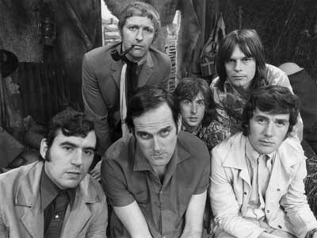
Natacha: I will try my best as you said for Mr Jones, maybe I will create a Twitter, we'll see, I'm determined. I'm determined for animation too !
Erika: Well, all you need is passion and determination - and you'll get there on both counts!
Natacha: Oh yes, you are right, he is so funny, he and the other Monty Python too.
Natacha: I do wish so
Erika: Especially JOHN CLEESE!
Erika: Take care, Natacha!
Erika: Send me the French show link - and I'll send you the contact. Bye for now, xx Erika
Natacha: Take care you too, I will post this, fans will thank you, I'll tell you what they thought. Thank you so much for your time and your answers, I am very excited and stil can't believe I, for the first time interviewed someone of a show I care, so yes, tahnk you so much, and I sent you the link.
Natacha: Bye now, xoxo Natacha.
[End.]
