Nowadays, mountain meadow biodiversity is threatened by two increasing trends: agriculture intensification and land abandonment. Both trends lead to drastic changes in the species composition occurring in these grasslands. For my master thesis, I take part in a long term project that started in 2010, which main goal is to investigate which management intensification level allows preservation of biodiversity while providing sufficient yields for farmers [link to project: http://www.cb.iee.unibe.ch/content/research/by_research_field/community_ecology/alpine_grassland/index_eng.html#e7704]. I am personally interested in the land snail community response to management intensification. Indeed, snail fauna is composed of habitat generalist and habitat specialist species. The latter appearing to be especially sensitive to land use changes, they might therefore be used as a bioindicator for habitat alterations or/and quality and help to develop optimal management strategies. We sampled the belowground snail fauna in each of the six management treatment plots of each meadow (5 cm deep soil cores), once before the experiment started (in 2010) and once in 2015 (after five years of application). Snails are currently sorted out of the samples and identified to species-level in order to assess the snail community present in each plot before and after the application of the treatments.



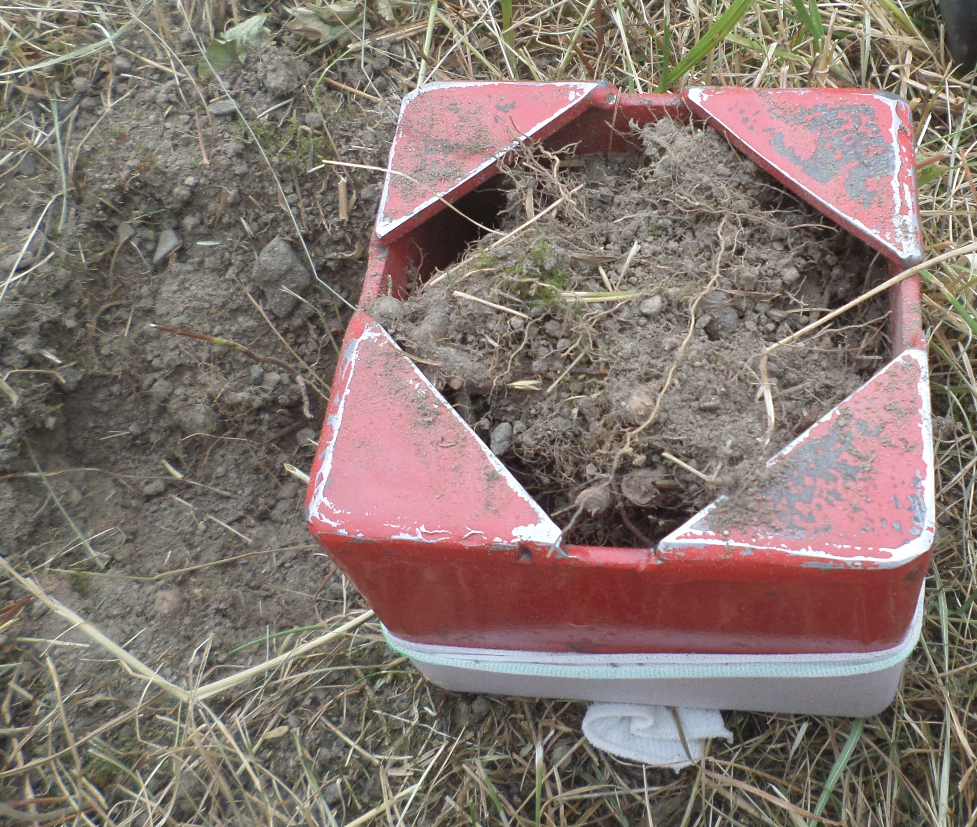

Soil sampling

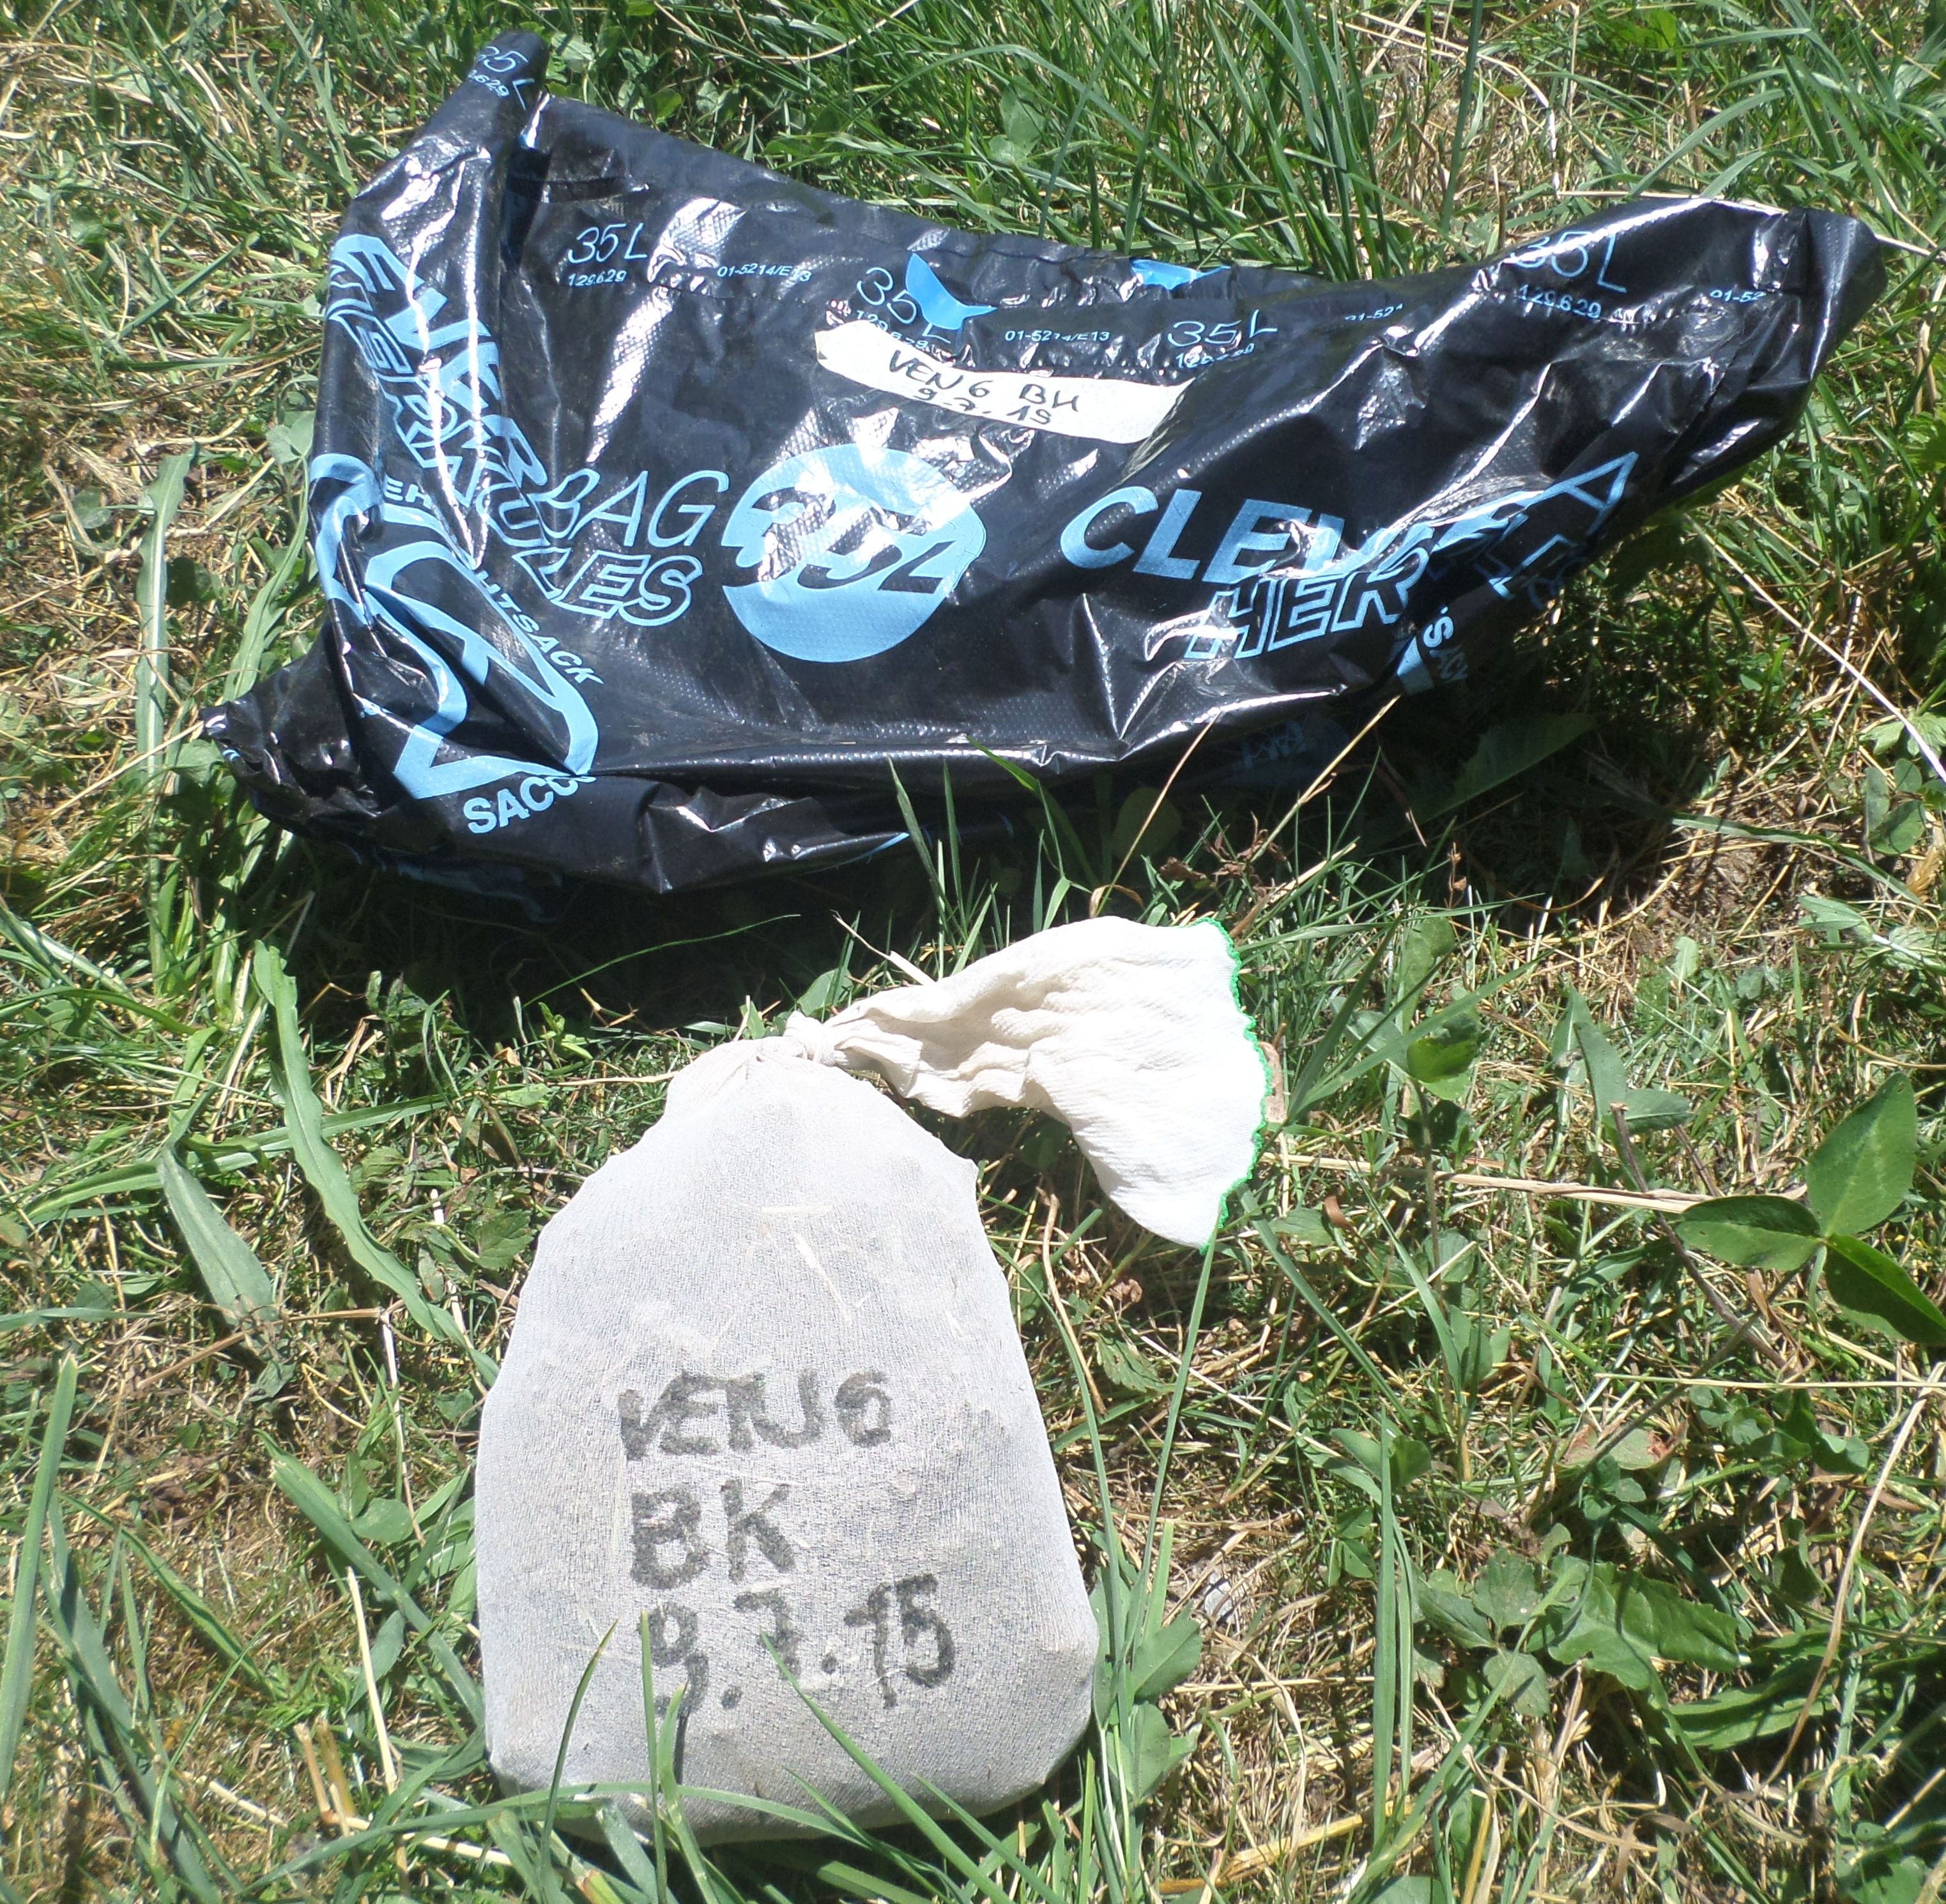
Soil sample

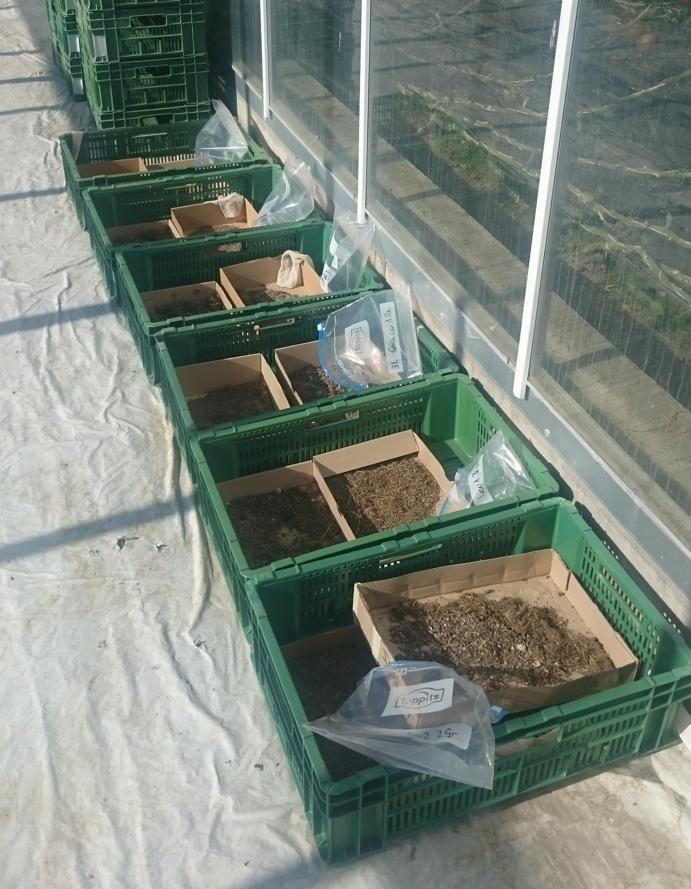
soil sample after sieving, being dried in a greenhouse

