

Institut für Textiltechnik der RWTH Aachen University
Univ.-Prof. Prof. h.c. (RU) Dr.-Ing. Dipl.-Wirt. Ing. Thomas Gries
Dr.-Ing. Dipl.-Wirt.-Theol. Anton Mustermann

Scope and limitations analysis of a reinforcement spacing alternative for Textile Reinforced Concrete

Project type: Bachelor thesis
By: Malo Méloux

Supervisors: Dr. Udityasinh Gohil
Dipl.-Ing. Till Quadflieg

Aachen, July 2015

Abstract
In the purpose of saving time and having more accuracy during Textile Reinforced Concrete plates manufacturing processes, it has been proposed to use thermoplastic three-dimensional mats to space the textile reinforcement layers within the plate. In order to know the scope and limitations of such materials for this use, this research proposed to analyse their behaviour while heated and put under pressure in terms of thickness fluctuation, adhesion to glass fibre reinforcements and flowability.
After a literature research work about TRC and its already existing spacing solutions, first experiments have been done to understand the material behaviour and the influence of each parameter. Once this step was done, samples have been produced in view of different kind of tests like T-Peel tests, flow tests and thickness measurements before proceeding to the actual concreting step.
The analyses have shown important differences, especially depending on the used textile reinforcement structure. They have also revealed promising results for the adequacy of this solution.

Key words: Textile Reinforced Concrete, Enkamat, Spacer

Table of contents
1 Introduction 1
2 State of the Art 2
2.1 Textile Reinforced Concrete 2
2.1.1 Matrix 2
2.1.2 Reinforcement 2
2.1.3 Structural stabilization 5
2.1.4 Composite 6
2.2 Spacing solutions 7
2.2.1 The “layer by layer” process 7
2.2.2 The Disttex system 8
3 Methodology 9
4 Results 11
4.1 Analyse of the material behaviour 11
4.2 Influence of the variables 14
4.3 Search for suitable solutions 20
4.3.1 Peeling tests 20
4.3.2 Thickness measurements 22
4.3.3 Flow tests 24
4.4 Concrete testing 27
4.4.1 Combinations selection 27
4.4.2 Concreting 29
4.4.3 4-point bending tests 31
4.4.4 Samples cutting 33
5 Conclusion 34
6 Bibliography 35
7 Statement of academic honesty 37
List of figures
Figure 2.1 Production process for glass multifilament yarns [Butler] 4
Figure 2.2 Overview of the most used textiles for concrete reinforcement 5
Figure 2.3 Bending moment schematization 7
Figure 2.4 Disttex system 8
Figure 3.1 Enkamat [12] 9
Figure 4.1 Overview of the experimental design 11
Figure 4.2 Waviness due to the PA6 shrinkage 13
Figure 4.3 Experimental design 14
Figure 4.4 Influence of temperature on samples thickness 18
Figure 4.5 Influence of pressure on samples thickness 18
Figure 4.6 Influence of time on samples thickness 19
Figure 4.7 Dimensions of a sample for a T-Peeling test (DIN EN 1392) 20
Figure 4.8 Average adhesion (1st type of Enkamat) 21
Figure 4.9 Average adhesion (2nd type of Enkamat) 21
Figure 4.10 Measured thicknesses (PP Enkamat) 22
Figure 4.11 Measured thicknesses (PA6 Enkamat) 23
Figure 4.12 Scheme of the complexes superposition within a concrete plate 23
Figure 4.13 Flow test device 24
Figure 4.14 Flow test results through Pillar Stitch complexes 25
Figure 4.15 Flow test results through Tricot complexes 26
Figure 4.16 4-point bending test scheme (DIN EN 1170-5) 27
Figure 4.17 Preparation of the concreting step 29
Figure 4.18 4-point bending test bed 31
Figure 4.19 Appearance of the first crack 31
Figure 4.20 4-point bending test results 32
Figure 4.21 Samples cutting 33
Figure 4.22 Cross sectionnal view of the concrete samples 33
List of tables
Table 4.1 First experiences recap 12
Table 5.1 Second serie of tests recap 15
Table 5.2 Thickness measurements (in millimeters) 17
Table 7.1 Recap of the selected combinations for concreting tests 28
Table 7.2 Component proportions of the used concrete 29
List of abbreviations
TRC Textile Reinforced Concrete
PA6 Polyamide 6
PP Polypropylene

Introduction

Concrete is a composite material that is composed of aggregates and water that are mixed together and later embedded in a hard cement matrix that helps to fill the space among the aggregate particles and glues them together [www14]. This material had been used for the first time by the Greeks in 1400-1200 BC and is still used nowadays as it guarantees a high compression strength, thanks to its components that carries the compression load. [15]
However, concrete has poor tensile strength. To overcome this weakness of the material, François Cognet, a French industrialist of the nineteenth century, decided to use iron as a reinforcement technique for concrete. This technique consists in using a material that has a high tensile strength material and will provide this strength to the concrete so it levels concrete tensile weakness issue. This has been considered as a revolution in the construction industry as it has become possible to build stronger structures. [16]
Nowadays, scientists and researchers are trying to find more efficient ways to reinforce concrete that would resist better to corrosion and cut off the overall costs. This is where Textile Reinforced Concrete (TRC) comes in. This innovative reinforcement way of concrete led to low-weight concrete products of still unmatched thinness with high compression and tensile strength such as permanent formwork elements, facades or tanks. [3] [17]
Furthermore, TRC turns out to be an ecological alternative to Steel Reinforced Concrete. Among the ADEME, production of first cast steel represents 3193kg CO₂/ton and production of recycled steel represents 1101kg CO₂/ton. The glass fibre production represents 2129kg CO₂/ton. It does not seem that better but, obviously, glass fibre is much lighter than steel and one ton of glass fibre allows the construction of more walls than one ton of steel. Moreover, it also allows to use much less concrete as the structures are thinner which production is about 862kg CO2/ton. And less concrete also means less water that is vital for life. Thus, TRC offers a way forward for the environment. [18]
Textile Reinforced Concrete is the core subject of this project and this thesis will deal specifically with a new way of spacing the textile reinforcement layers within the concrete structures using a thermoplastic three-dimensional mat already marketed under the designation of Enkamat.

State of the Art

Textile Reinforced Concrete

Matrix
The matrix is where the reinforcement is embedded. For Textile Reinforced Concrete (TRC), concrete or cementitious paste is applied. Concrete matrices are essentially consisting of hardened cement paste, aggregates and pores which make this a heterogeneous material. So concrete is already a composite material in itself.
The matrices used for TRC have to fulfil certain criteria regarding production processes, mechanical properties of the final product and durability of the reinforcement material. Indeed, the concrete matrices have to be highly flowable consistencies. That can be achieved by using a small maximum grain size, high binder contents, and adding plasticizers. The maximum aggregate size is about 2 mm. This allows the penetration of the matrix into the reinforcement as the average space between yarns is about 10 mm. Moreover, the matrices are designed to increase the stability of AR-glass rovings as it is a very alkaline medium. This increased stability is reached by selecting appropriate binder systems in which the level of a clinker content called Ordinary Portland Cement is reduced via substitution with by-products such as fly ash or silica fume that reduce the alkalinity of the concrete matrix. But for reason of workability, the amount of silica fume added is limited as it is not possible to achieve a flowable consistency of concrete when large quantities of silica fume are added.

Reinforcement
For TRC, reinforcement is produced with multi-filament yarns of high performance fibres. The properties, the amount and the arrangement of the used fibre material have a great influence to the characteristics of the composite the textile reinforced concrete. To be really effective, the reinforcement must have a much higher elasticity modulus than that of the concrete matrix as well as high fibre tenacity and breaking elongation.
But as mentioned before, not every type of fibre can work with the high alkalinity of the concrete matrix. To ensure a life-long reinforcing effect, the fibre material has to withstand the alkaline medium permanently and without losing its properties. Further requirements on the fibre are: small relaxation under permanent load, a good and constant adhesion between reinforcement and concrete, low cost and the possibility of processing them easily on textile machinery.
The use of alkali-resistant glass fibres (AR-glass), carbon and aramid as textile reinforcements essentially meet these requirements. Some at least partly suitable polymers like polypropylene, polyvinyl alcohol, polyethylene and polyacrylnitrile are also known as short fibre reinforcement for concrete. Reinforcing fabrics made of metal yarns are also possible but their costs are too high compared with their performance. Nevertheless, they are widely used in steel fibre concrete.

Glass fibres
Actually, glass fibre is a glass filament. Even if it was patented in 1930, it is only recently that it revolutionized the glass industry with the development of composite materials with its high strength. Its production cost is also quite low. That is why it is one of the most used fibres today.
Durability of the original E-glass fibre was a big issue for glass fibre reinforced concrete. This issue has mostly gone away since the emergence of AR-glass filament yarns that were designed in the seventies for the reinforcement of concrete matrices. To resist the corrosive alkaline solution in the concrete, AR-glass contains more than 15% in mass of zircon. Another cement resistant glass is Z-glass, which includes higher shares of silicon dioxide and zircon oxide.
Glass filaments are produced with the nozzle pulling procedure. The basic materials silica sand, clay and limestone are melted at temperatures up to 1350°C and pulled of the spinning nozzle with a speed between 25 and 150m/s and diameters ranging from 9 to 27µm. After spinning, a size is applied on the filaments to combine up to 6600 of them to yarn without twisting.
The size is important for the subsequent processes and improves the yarn properties as well as the stress transfer between filaments and matrix material. Depending on the yarn fineness, the basic mechanical properties of AR-glass are tenacity up to 1400N/mm², linear elastic elongation up to 2%, and modulus of elasticity between 70 and 80 kN/mm². The density of 2,8kg/dm³ is relatively high compared to carbon or aramid but regarding the good adhesion to concrete, AR-glass shows a good cost-performance ratio.

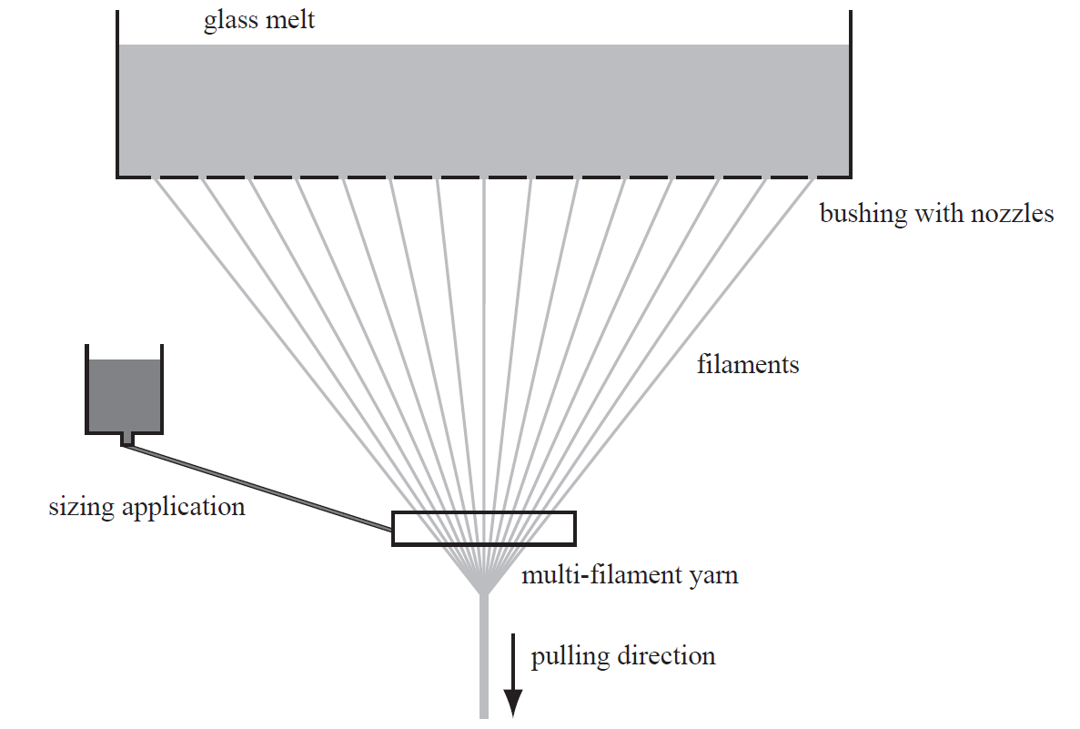
Figure 2.1 Production process for glass multifilament yarns [Butler]

Fabrication of textile reinforcement
Only a few from the variety of available textile fabrication processes can be used for concrete reinforcements. The most important criterion to be fulfilled is the possibility to get open structures with high displacement stability. That can be provided by an open grid structure. To ensure satisfactory handling, there must be no displacement of the threads. Certain manufacturing methods – such as warp knitting with insertion of reinforcing threads- are therefore better suited than others like braiding. The most common textile fabrics for reinforcing concrete are shown in Figure 2.2.
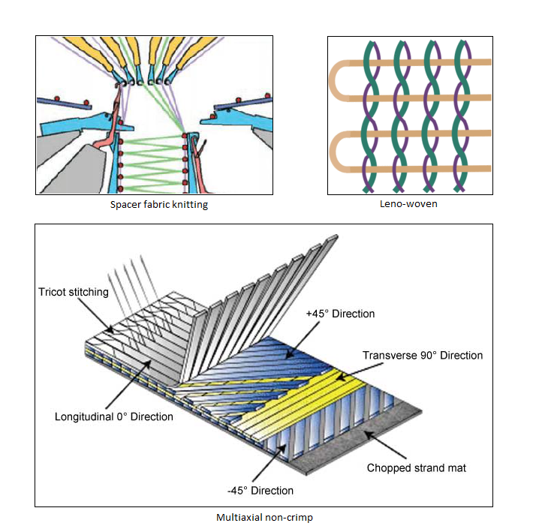
Figure 2.2 Overview of the most used textiles for concrete reinforcement

Structural stabilization
It is necessary to secure the geometry of the reinforcing fabric after the manufacturing process in order to use as much as possible the whole potential in the building component. To realize it, an additional fixing may be advisable.
The textile structures have to be fixed in their ideal position, which is best done during the production process. Coating, impregnating and the insertion of an additional backing are possibilities of implantable suitable binding agents.

Composite
The TRC composite is obtained when the reinforcement fabric is embedded in the cementitious matrix. As the reinforcement yarns are composed of many filaments which are densely packed, one may wonder how the yarns are penetrated with the matrix. The diameter of the filaments (10 – 20 μm) and the distance between them lead to filtration effects. It can be expected that aggregates are completely prevented from intrusion and also the cement paste only reaches into an outer layer of the yarns because of its relatively high viscosity.
Thus, there are two bond zones in a yarn. The outer ring zone of the yarn, also called fill-in zone, is where the matrix has a continuous contact to the filaments. There is a strong adhesive bond between the matrix and the filaments in that area. Matrix hardly intrudes in the core of the yarn and it leads to frictional loads between the filaments but these are lower than the adhesive bonds in the fill-in zone. The size and the ratio be-tween the fill-in and the core zones mostly depend on the geometry of the yarn and the packing density of the filaments.
The embedding of the reinforcement is performed before the matrix is hardened. So, the yarn could disturb the crystallization of the cement paste during its hydration while providing or withdrawing water to or from the matrix. This would weaken the stiffness and the strength of the yarn vicinity zone.
The reinforcement ratio in the TRC is also important. If there is not enough reinforcement, the stresses will not be sufficiently retransferred to the matrix. They will focus on one area and a single crack will be formed. Otherwise, an “overcritical” reinforcement ratio leads to multiple cracking as the stresses are retransferred to the entire surrounding matrix. However, further stress increase in the composite can be observed after the final crack pattern. The “critical” reinforcement ratio corresponds to a multiple cracking of the matrix with no further stress increase but this case is not possible in reality.

Spacing solutions

A horizontal beam supported at the ends and loaded downwards tends to deform due to the bending moment. As shown is Figure 2.3, it appears that the material at the over-side of the beam is compressed while the material at the underside is stretched. Thus, there are compressive stresses at the top of the beam and tensile stresses at its bottom. Failure in bending will occur when the bending moment is sufficient to induce bigger tensile stresses than the yield stress of the material throughout the entire cross-section. That is why it makes sense to strengthen mainly the upper and lower surfaces as far as possible with reinforcement fabrics as they are the more exposed zones to tensile stresses. Thus, it is necessary to space the reinforcement layers within the concrete plate.

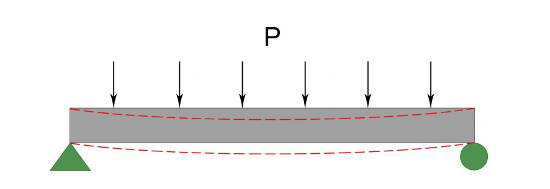
Figure 2.3 Bending moment schematization

The “layer by layer” process
The first solution – which is the more natural – consists in depositing alternating layers of concrete with textile reinforcement in between. Although it is the easiest way to do, it has nevertheless some disadvantages. Indeed, there are downtimes between each layer and – as the concrete surface cannot be perfectly even, it leads wavy forms of the textile reinforcement. It is not very acceptable as processes have to be fast and repeatable nowadays but it is still the most widely used process as it is the most relevant process in terms of time and costs.

The Disttex system
To deal with the lack of spacers for fixing the textile reinforcement in the formwork, a new system has been developed at TU Dresden so the position of the textile reinforcement remains the same during the casting process. It allows vertical manufacture of textile reinforced concrete plates – so it represents a gain of space – and apparently does not reduce the load bearing capacity of the final products. All in all, that system is very good in terms of performance. But is it complex to set up and it takes much more time than the “layer by layer” process. This makes it not acceptable in an industrial setting. Thus, efforts have still to be made to find a solution that would be at once fast, repeatable and leading to esthetically pleasing final products.
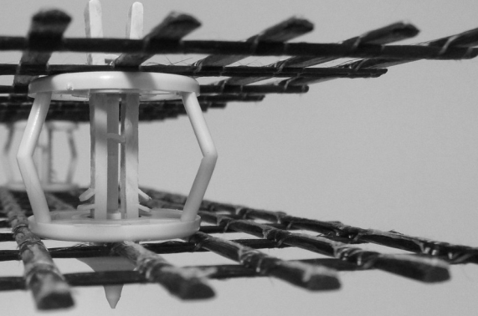
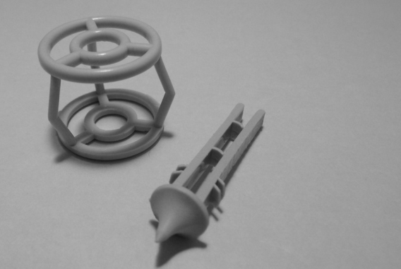
Figure 2.4 Disttex system

Methodology

The methodology that will be followed for the realisation of this project involves:
- Defining the project context and objectives
- Understanding the general material behaviour
- Identifying and classifying all of the experimental parameters
- Realising samples and analysing their performance
- Realising concrete plates and analysing their performance

- Defining the project context and objectives
Regarding the limited number of spacing solutions for reinforcement layers within concrete plates, this project consists in studying a new alternative and to analyse its scope and limitations.
The considered solution is a three dimensional thermoplastic mat marketed as a geotextile called Enkamat. This product has a defined thickness and a defined mass per unit area. Thus, it has to be modified to manage to get spacers of different thicknesses while ensuring it is workable for textile reinforced concrete. Furthermore, a way to bind the Enkamat to the reinforcement layers has to be found. Solutions such as stitches or the use of glue can be considered even if it is more advisable to create the complex – i.e. to link both textile structures together – during the modification process of the Enkamat.

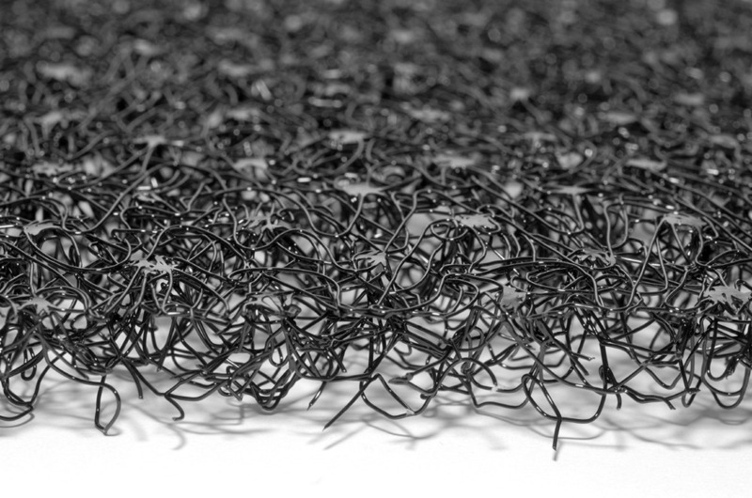
Figure 3.1 Enkamat [12]

- Understanding the material behaviour
This step consists of observing what is happening while the Enkamat is heated and pressed. During its transformation, the Enkamat thickness is likely to be reduced and shrinkage effects may occur. This will induce an increase of the material density and might make the penetration of the concrete through it more difficult because of concrete high viscosity.

- Identifying and classifying all of the experimental parameters
The following step aim will be to determine which variables are at play, how important are their influence so it is possible to classify them as control or treatment variables. This classification will help by reducing significantly the number of further experiments.

- Realising samples and analysing their performance
Once the treatment and control variables will be set, it will be time to do actual samples with Enkamat products bonded to glass fibre reinforcements. Then, adhesion tests will have to be carried out to determine if they are not too fragile to manipulations as well as thickness measurements and flow tests to get to know which samples are workable and which ones are not.

- Realising concrete plates and analysing their performance

So, it will be necessary to check that there is no air voids inside concrete plates or honeycombing at their surface.

Results

Analyse of the material behaviour

First, it is important to grasp how the material reacts when it is heated and pressed. According to the Enkamat data sheet [19], the roll of Enkamat that is already available at the ITA would be made of polyamide 6, whose glass temperature is about 60°C and melting point is 220°C. To analyse the material behaviour, experiences have been realised as follows:
- An aluminium plate is put on a heating plate and preheated so the surface temperature gets homogeneous;
- A glass fibre fabric is put on top of it to be preheated as well;
- When the temperature is set, the Enkamat is put under pressure between the glass fibre fabric and another aluminum plate that plays the role of the press;
- The complex is taken off after a defined amount of time.

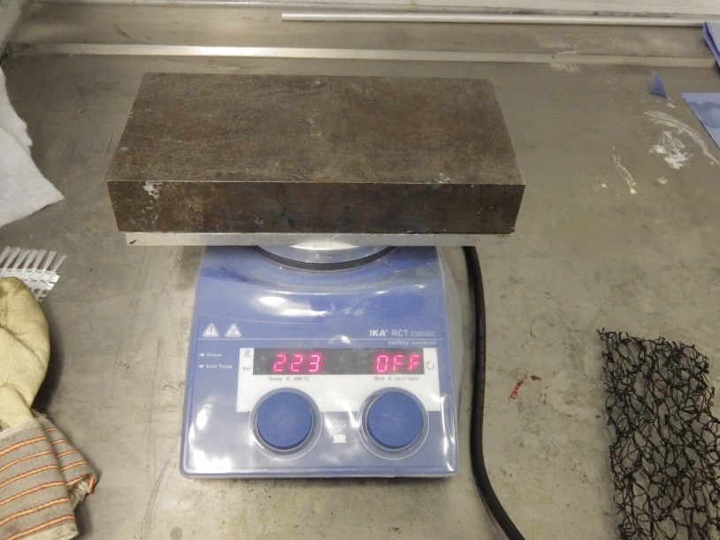
Figure 4.1 Overview of the experimental design

Experiences have been carried out between 60 and 140°C without any notable modification of the mat. The table below shows the experiments that have been made thereafter. Here, temperatures indicated in this table are those showed by the heating device as there were problems with the infrared thermometer emissivity settings. Indeed, the thermometer seemed to show the right temperatures below and around 180°C but was becoming unstable above this temperature. It explains the presence of an experience made at 270°C as the thermometer was displaying temperatures between 190 and 220°C.
Exp. number | Set temperature | “Press” weight | Operating time
1 | 270°C | 9,3 kg | 5 min
2 | 200°C | 9,3 kg | 5 min
3 | 200°C | 9,3 kg | 30 s
4 | 200°C | 9,3 kg | 10 s
5 | 200°C | 1,7kg | 10 s
6 | 150°C | 9,3 kg | 30 s
7 | 150°C | 9,3 kg | 1 min 30
8 | 150°C | 9,3 kg | 5 min
9 | 150°C | 9,3 kg | 20 min
10 | 180°C | 9,3 kg | 30 s
11 | 180°C | 9,3 kg | 1 min 30
12 | 180°C | 9,3 kg | 1 min 00
13 | 180°C | 9,3 kg | 45 s
Table 4.1 First experiences recap
Observation:
- Heating this three-dimensional mat up to 270°C is obviously too much. The presence of this experience is only due to the fact that the thermometer was displaying a much lower temperature. However, it also shows that it is possible to bind the Enkamat to the textile reinforcement while heating it up.
- Contrarily to what was expected, the Enkamat melted quickly at a temperature of 200°C. This result is surprising as the melting point of polyamide 6 is 220°C but it is not explainable regarding the data sheets of the commercialised product.
- The most promising results occur when the Enkamat is heated at a temperature of 180°C. It sticks to the textile reinforcement while its density does not seem to have increased to the naked eye.
- Generally, the material tends to retract while cooling down. In five to ten seconds time, the final structure becomes wavy as shown on Figure 4.2. This phenomenon is happening because PA6 filaments are oriented fibres as they have been stretched during their spinning process. While being heated, the carbon chains can change and naturally tend to be shorter so the material shrinks. This shrinkage is more or less important depending on the heating temperature: the higher the temperature, the stronger the shrinkage.

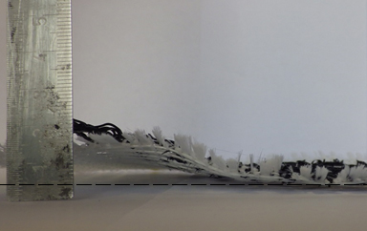
Figure 4.2 Waviness due to the PA6 shrinkage
In conclusion of these first experiments on the material, results can be considered as promising. Indeed, it has been proved that it is possible to bind the Enkamat to glass fibre reinforcement simply while heating it and pressing it to the textile structure. Moreover, a wide range of complex thicknesses looks possible to reach, so it is likely several combinations of complex can be used within Textile Reinforced Concrete plates.

Influence of the variables

It has been previously showed that it was possible to stick the three dimensional mat to glass fibre reinforcements. The influence of each parameter has now to be determined in order to sort variables in two distinct groups: treatment variables, which will be the ones that will vary, and control variables, which will be the ones that will be fixed. To do so, three different textile reinforcements will be tested: a structure called “Tricot” and another one called “Pillar Stitch” to analyse the influence of the reinforcement openness, especially on the adhesion between it and the Enkamat. The third type of textile reinforcement is a coated Pillar Stitch structure so it is possible to see if the use of coated textiles is practicable.
In addition to that, the Enkamat will be tested at two different temperatures, pressures and pressing times as follows:
- Textile structure: Uncoated Pillar Stitch / Coated Pillar Stitch / Tricot
- Temperature: 170°C / 190°C
- Pressure: 1,2 kPa / 6,7 kPa
- Pressing time: 30 s / 5 min
The experimental design remains the same as previously and is illustrated in Figure 5.1. However, the presence of an aluminium foil is noticeable in view of peeling tests.
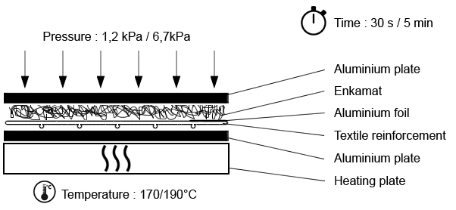
Figure 4.3 Experimental design

Regarding the high number of different samples to be made, it has been necessary to use a nomenclature in order to find them easily in the future. It is recapitulated in the Table 5.1.
Sample | Textile structure | Temperature | Pressure | Pressing time
C-170-7-030 | Coated PS | 170°C | 6,7 kPa | 30 s
C-170-1-030 | Coated PS | 170°C | 1,2 kPa | 30 s
C-170-7-500 | Coated PS | 170°C | 6,7 kPa | 5 min
C-170-1-500 | Coated PS | 170°C | 1,2 kPa | 5 min
C-190-1-030 | Coated PS | 190°C | 1,2 kPa | 30 s
C-190-1-500 | Coated PS | 190°C | 1,2 kPa | 5 min
C-190-7-030 | Coated PS | 190°C | 6,7 kPa | 30 s
C-190-7-500 | Coated PS | 190°C | 6,7 kPa | 5 min
Tr-190-7-030 | Tricot | 190°C | 6,7 kPa | 30 s
Tr-190-7-230 | Tricot | 190°C | 6,7 kPa | 2 min 30
Tr -190-1-500 | Tricot | 190°C | 1,2 kPa | 5 min
Tr -190-1-030 | Tricot | 190°C | 1,2 kPa | 30 s
Tr -170-7-500 | Tricot | 170°C | 6,7 kPa | 5 min
Tr -170-7-030 | Tricot | 170°C | 1,2 kPa | 30 s
Tr -170-1-500 | Tricot | 170°C | 1,2 kPa | 5 min
Tr -170-1-030 | Tricot | 170°C | 1,2 kPa | 30 s
PS-190-1-030 | Pillar stitch | 190°C | 1,2 kPa | 30 s
PS-190-1-500 | Pillar stitch | 190°C | 1,2 kPa | 5 min
PS-190-7-030 | Pillar stitch | 190°C | 6,7 kPa | 30 s
PS-190-7-230 | Pillar stitch | 190°C | 6,7 kPa | 2 min 30
PS-170-1-500 | Pillar stitch | 170°C | 1,2 kPa | 5 min
PS-170-1-030 | Pillar stitch | 170°C | 1,2 kPa | 30 s
PS-170-7-500 | Pillar stitch | 170°C | 6,7 kPa | 5 min
PS-170-7-030 | Pillar stitch | 170°C | 6,7 kPa | 30 s
Table 4.2 Second serie of tests recap

Observations:
- The first noticed thing is that the Enkamat does not stick to coated textiles. When it does, it is only in rare and isolated points, as shown in Figure 5.3, and the bonds are so weak that the reinforcement falls under its own weight when the complex is hold by the Enkamat.
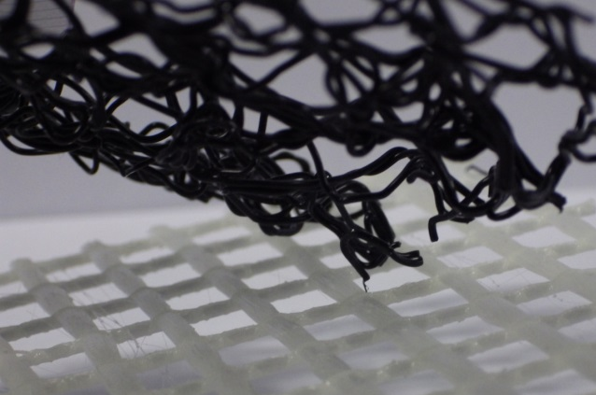

Figure 4.2 Adhesion problem (sample C-190-1-500)

This result can be explained by the fact that the coated textile has a more important thickness that remains unchanged under pressure because of the hardness conferred by the epoxy resin. Thus, there are air pockets that play a role of insulation between the Enkamat and the heating plate as shown in Figure 5.4. So, the Enkamat cannot melt and no bonds occur with the reinforcement textile. Another explanation would simply be a bad adhesion between polyamide 6 and epoxy.

Figure 4.3 Scheme of the presence of air pockets betweeb the Enkamat and the heating plate
- As expected, the three dimensional mat stuck quite strongly to Tricot and Pillar Stitch structures while heated at 190°C. Like in the previous tests, some waviness occurs on the Tricot structure during the cooling stage. However, this phenomenon is not observable on Pillar Stitch structures. Two reasons can explain this. First, Pillar Stitch textiles have a stronger structural stability than Tricot textiles, so they can withstand higher stresses. Moreover, Pillar Stitch structures are more open than Tricot structures. Thus, there fewer contact points between the reinforcement and the Enkamat, making the stresses weaker.
- Except for the Tr-170-7-500 sample, no bonding is seen when the samples are heated at 170°C. We can simply conclude that this temperature is not high enough to partially melt the material so it can stick to glass fibre reinforcements.

Thickness measurements:
As there is no machine to measure textile thicknesses according to the DIN EN ISO 5084 standard, samples thicknesses have been measured using a caliper. Mean thicknesses of each sample are shown in the Table 5.2 below:
 | Enkamat(ref.) | 8,56
 | C-170-1-030 | 7,78 |  | C-190-1-030 | 7,83
 | C-170-1-500 | 6,68 |  | C-190-1-500 | 6,36
 | C-170-7-030 | 6,89 |  | C-190-7-030 | 8,25
 | C-170-7-500 | 6,3 |  | C-190-7-500 | 5,54
 | PS-170-1-030 | 7,45 |  | PS-190-1-030 | 5,7 |  | Tr-170-1-030 | 8,54 |  | Tr -190-1-030 | 5,13
 | PS-170-1-500 | 7,4 |  | PS-190-1-500 | 4,25 |  | Tr -170-1-500 | 7,17 |  | Tr -190-1-500 | 4,16
 | PS-170-7-030 | 7,44 |  | PS-190-7-030 | 4,52 |  | Tr -170-7-030 | 6,06 |  | Tr -190-7-030 | 3,28
 | PS-170-7-500 | 6,71 |  | PS-190-7-500 | 3,55 |  | Tr -170-7-500 | 5,24 |  | Tr -190-7-500 | 1,38

Table 4.3 Thickness measurements (in millimeters)
To avoid any data overload, only the Pillar Stitch samples results will be compared. Influence of temperature, pressure and pressing time are given in the graphs below:

Figure 4.4 Influence of temperature on samples thickness

Figure 4.5 Influence of pressure on samples thickness

Figure 4.6 Influence of time on samples thickness

Regarding the general curve slopes of each graph, it clearly appears that temperature is the most influent variable. However, it may be more judicious to class it as a control variable. That is to say it should be set and should not change in next experiments. Indeed, 170°C is too low to melt the Enkamat whereas 200°C is already too high as it has been previously showed. Thus, it seems wise to set the temperature between 180 and 190°C.
Influence of pressure and time are comparable even if time looks a bit more influent. So, it is quite conceivable to class those two parameters as treatment variables.
Even though Pillar Stitch is a more adapted structure than Tricot for a use in Textile Reinforced Concrete, it has been decided to class this variable as a treatment variable as well. Furthermore, in between those tests and the next ones, new rolls of Enkamat but of a different type have been received. Thus, a new variable is added, the type of Enkamat, that will also be a treatment variable.

Search for suitable solutions

Variables are now sorted, 16 kinds of samples will be subject to peeling tests, flow tests and thickness measurements. As a reminder, here are the different variables:
- Temperature: 185°C
- Pressure: 1,2 kPa / 6,7 kPa
- Time: 1 min / 5 min
- Textile structure: Pillar Stitch / Tricot
- Type of Enkamat: 10 mm (1st type) / 18 mm (2nd type)

Peeling tests

It is here about T-Peeling tests in accordance with DIN EN 1392 standard. All in all, 80 samples will be prepared according to the Figure 6.1 below:
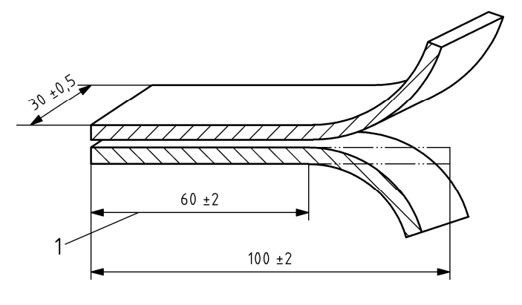

Figure 4.7 Dimensions of a sample for a T-Peeling test (DIN EN 1392)

Difficulties have been encountered during the preparation of the samples using the second type of Enkamat. Indeed, it started to melt only at 210°C whereas the first type of Enkamat was quickly melting at 185°C. This corresponds better to polyamide 6 properties as its melting point is around 220°C. Since that moment, the material nature of the first type of Enkamat has been put into question. It finally turned out to be polypropylene instead of polyamide 6.
In a first time, a new temperature has been set for the seconde type of Enkamat to 210°C to see what would be the peeling tests results. Afterwards, depending on them, the temperature setting may be discussed.
For the tests, the peeling speed is set to 10 mm/min and the five first and last millimeters are discarded to compute the average adhesion strength. Results are shown in the graphs below:

Figure 4.8 Average adhesion (1st type of Enkamat)
Figure 4.9 Average adhesion (2nd type of Enkamat)

A minimum adhesion of 0.11 N/mm has been arbitrarily set as a decision threshold. As an order of magnitude, this represents 3 times the force needed on a push-button of a pen.
It clearly appears that the adhesion between the polyamide 6 Enkamat (2nd type) and the textile reinforcements is not sufficient. This is very likely because of an insufficient heating temperature to melt the polyamide 6 efficiently. A temperature of 225°C will be set for the upcoming flow tests and thickness measurements. The adhesion of the polypropylene Enkamat (1st type) is satisfying in every setting.
It is also noticeable that standard variations may look very high. This is due to the fact that contacts between the Enkamat and the reinforcement are not over a whole surface but only punctual as the reinforcement structures are open and the Enkamat has very big pores.

Thickness measurements
Thicknesses have been measured with the same way as in chapter 5. The results are shown below:

Figure 4.10 Measured thicknesses (PP Enkamat)

Figure 4.11 Measured thicknesses (PA6 Enkamat)

It appears here significant differences between samples thicknesses. This is a promising result as it is desired to make 20 mm thickness concrete plates. Indeed, several combinations of complexes seem to be practicable in this objective following Figure 6.7. As expected regarding its original thickness, thinner structures can be made with the first type of Enkamat.
Figure 4.12 Scheme of the complexes superposition within a concrete plate

Flow tests

Absence of standard
One difficulty to overcome was here the absence of standard about flowing concrete through textile structures. Even if there are standards for concrete flowability, none of them deal with obstacles that can be considered as filters.
Hence, a system has been imagined based on the sand clock principle. It does not use concrete but only sand so the tests are quick, easy, do not require any cleaning step and can still give an idea of which complexes can be expected to work with concrete and which ones cannot. Basically, the system consists in two PMMA tubes screwed together with a complex placed in between. The Figure 6.7 shows the overview of the final product on Autodesk (a), the technical drawing of the device (b) and its working principle (c).

Figure 4.13 Flow test device

Realisation of the tests
Now that a comparison tool is available, we can measure the time it takes for a certain amount of sand of defined fineness to go through the complex. As the position of the reinforcement might have an influence on the flowing time, it has to be placed as the upper part of the complex as it will be placed this way within the formwork.
The amount and the fineness of the sand are given below. This is again an arbitrary choice as there is no standard about it.
- Amount: 700 g
- Grains size: 0.2 – 0.6 mm
Measures have been done 5 times on each sample to have reliable results and have also been done on reinforcement textiles only to compare with what is already used.

Figure 4.14 Flow test results through Pillar Stitch complexes

Figure 4.15 Flow test results through Tricot complexes

It is apparent that complexes made with Tricot textiles seem to be an important flow barrier for sand compared to complexes made with Pillar Stitch textiles. This observation can also be done considering only the two references. It takes about 50 seconds for the sand to go through a Tricot textile whereas it only requires five seconds with a Pillar Stitch textile.
While adding the Enkamat, sand takes even more time to go through the complex that is an expected result. The workability of the use of complexes using Tricot textiles as spacing solution within Textile Reinforced Concrete can be put into question because sand can sometimes take up to two minutes to flow through the complex. Regarding the high viscosity of concrete, one can think that problems might occur.
Complexes using Pillar Stitch textiles seem to be suitable as sand requires less than ten seconds to go through them, whatever the sample is.

Concrete testing

Considering the work that has now been done, it is possible to select some sample combinations in order to try to produce concrete plates. In view of 4-point bending tests, those plates have to respect specific dimensions according to DIN EN 1170-5 standard:
- Length: 200 mm
- Width: 50 mm
- Thickness: 20 mm
Each sample will have to be made in five copies for the 4-point bending tests and one more copy has to be done in order to cut it so it is possible to check the non-presence of air voids within the plate.
Figure 4.16 4-point bending test scheme (DIN EN 1170-5)

Combinations selection
According to the flow tests, it seems wise to prioritise complexes using Pillar Stitch reinforcements. However, no final conclusion about Tricot reinforcement can be given yet. That is why a combination should deal with this kind of reinforcement structure.
Peeling test results about the PA6 Enkamat have become obsolete as a higher temperature has been set to manipulate it. Adhesion between this kind of Enkamat and the reinforcement textiles looks now suitable as the complex can be handled safely without the reinforcement falling down on its own. However, tests will have to be done in the future to quantify the adhesion strength.
It remains therefore to consider complex thickness to determine the possible combinations. Reinforcement layers have to be as close as possible to the surface and to respect as much as possible the material symmetry so their positions optimise their performance.
Thus, three combinations are selected and are shown in Table 7.1 below:

Table 4.4 Recap of the selected combinations for concreting tests

Concrete
6 mm
8 mm
Concrete + Enkamat
Concrete + Enkamat
6 mm
Concrete
6 mm

Concrete + Enkamat
8 mm
Concrete + Enkamat
6 mm

Concrete
4 mm
4 mm
Concrete + Enkamat
12 mm
Concrete + Enkamat

Concreting
Before proceeding to the concreting step, formworks have to be made. They are realized with wooden boards and strips so we get moulds of 200 mm in length, 50 mm in width and 20 mm thick. A coating is applied on them and dried as shown in Figure 7.2a to facilitate unmoulding. Then, complexes are superposed in the moulds so concrete can be poured onto them.
Like it has been previously said, five copies of each combination will be subject to 4-point bending tests and an additional copy will be cut with a circular saw to check the non-presence of air voids. All in all, there will be 18 concrete plates to be made. This will require 3.6 L of concrete. There are only nine moulds available, so 1.8 L of concrete will be needed twice. Considering potential concrete losses, it is actually 3 L of concrete that will be prepared each time while respecting the proportions given in Table 7.2.

Figure 4.17 Preparation of the concreting step
Component | Cement | Fly ash | Silicate | Quartz | Sand | Water | Glenium
Quantity (g) | 1470 | 525 | 210 | 1500 | 2139 | 735 | 21
Table 4.5 Component proportions of the used concrete

The concrete samples have been unmoulded after cure time of 24 hours. As it has been observed during the casting step, complexes tend to float a bit to the surface. It led to a poor surface quality on the upper face of many samples as shown in Figure 4.18 (a) whereas the surface quality of the lower face was really good as it was smooth and presented no air bubbles or only a few as shown in Figure 4.18 (b). Some small black points may appear due to the presence of the Enkamat.

(a)
(b)
Figure 4.18 Surface quality of the concrete samples

4-point bending tests
These tests are carried out in accordance to the DIN EN 1170-5 standard with a preload of 5 N and a test speed of 10 N/s. The experimental designed is illustrated on Figure 7.1 and 7.3. The end of each test is marked by the appearance of the first crack as it is shown on Figure 7.4.
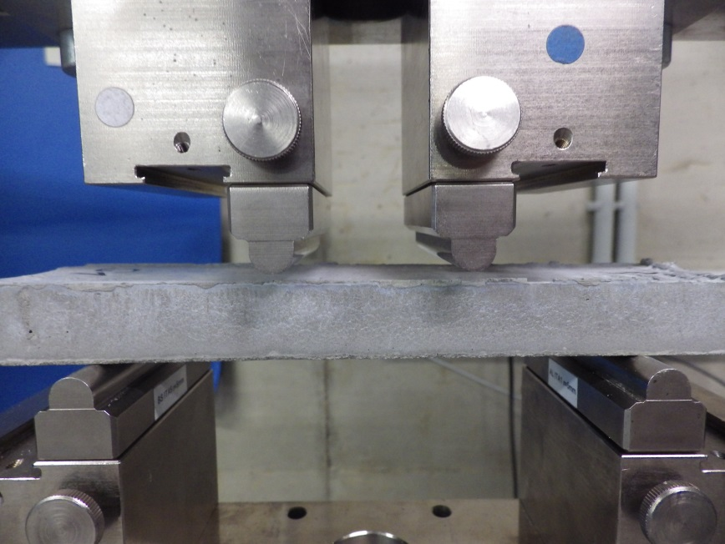
Figure 4.19 4-point bending test bed
2 cm

Figure 4.20 Appearance of the first crack
First crack

The results are shown on Figure 7.5. It appears that all of the average bending resistances are between 6 and 9 N/mm². Compared to normal and steel fibre reinforced concrete [13] [14], this is two to three times as much it is quite satisfying.
The difference of performance between the two first combinations could be explained by the density difference of the lower layers. The one that is in the combination 2 is originally heavier per unit surface and thicker than the one in the combination 1. As they have both been brought to the same thickness, it is possible to say that the lower layer in combination 2 is denser. Thus, the thermoplastic fibre content is higher in combination 2 and might weaken it.
During the concreting process, it has been observed that it was much longer for the concrete to flow through both complexes and the shaking table had to be used for several minutes. This was expected regarding the flow tests results and as the complexes structures in this combination were not as opened as in the two other ones. Thus, concrete might have not penetrated every part of the plate or, to a lesser degree, have not penetrated the reinforcement enough so the bonds are not as good as in combinations 1 and 2. That is why the combination 3 concrete plates are globally weaker.
Figure 4.21 4-point bending test results

Samples cutting
It is now necessary to check the non-presence of air voids within the plates that might affect their performance and durability. To do so, the sixth sample of each combination while be cut into 4 pieces of 5 cm x 5 cm as shown in Figure 4.21. Thus, one side only is observable on the end pieces and two sides on the middle pieces so it is possible to estimate how good the concrete has flowed in the mould.

Figure 4.22 Samples cutting

As all of the complexed used were quite dense, this final step in the project was crucial. Whether the results were good or bad, it was not possible to know what to expect. Thankfully, they turned out to be really good as not any single air void could be observed on the first two combinations samples. However, only one air void can be observed on the combination 3 sample, that is the one using complexes made with Tricot textile structures. Even if it is the only one, this air void is not meaningless as it is about one centimetre large. This may be due to the fact that melted parts of the Enkamat have partially plugged holes of the Tricot structure, thereby stopping the concrete flow in this area. This is only possible on Tricot structures due to their lower openness. Thus, regarding these results, the concreting time, the flow tests results and waviness that can occur on Tricot structures, it seems better to consider this structure in the future.
Figure 4.23 Cross sectionnal view of the concrete samples

Combination 3

Combination 2

Combination 1

Conclusion

TRC is nowadays one of the most innovative solutions for the construction industry. Very thin concrete elements can be built with the use of glass fibre fabrics embedded in a cement matrix. TRC provides many other advantages compared to the conventional reinforced concrete in terms of weight, ecology and mechanical performance. But efforts can still be done to improve its manufacturing process.
This work aimed to define the scope and limitations of the use of thermoplastic polymer based three-dimensional as a spacer within Textile Reinforced Concrete structures. This turned out to be quite successful as concrete plates using this kind of spacer have been made which were showing good surface quality and tensile performance as well as no air voids for one kind of the used textile reinforcements.
The textile reinforcement plays a major role in the workability of this solution. It cannot be coated as it has been seen in this work and its openness has to be considered as it is the biggest barrier to concrete flow in this setup. For example, Tricot cannot be used as its holes are likely to be clogged by melted polymer because of its small openness.
It has also been showed during this study that the temperature has a very important influence on the thermoplastic mat modification and that it is better to define an ideal temperature for each kind of polymer that is expected to be used. A too high temperature will lead to a very quick modification of the thermoplastic material that will be very often uncontrollable whereas a too low temperature will not lead to any modification of the mat.
As the experiments were manually done, it is possible that the same experiments could lead to slightly different results when done by someone else. That is why it might be wise to think now about a more mechanical process to gain in repeatability and precision in the results.

Bibliography

[1] Dipl.-Ing Jens Hartig
Numerical investigation on the uniaxial tension behaviour of Textile Reinforced Concrete
Germany, TU Dresden, 2011
[2] M. Legrand Xavier
Cours de matériaux composites
France, ENSAIT, 2012
[3] Brameshuber
State of the Art, Report of RILEM Technical Committee
[4] https://fr.wikipedia.org/wiki/ciment_a_renfort_fibre_de_verre
[5] Butler M
Zur Dauerhaftigkeit von Verbundwerkstoffen aus zementgebunderer
Matrices und alkaliresistenten Glasfaser-Multifilamentgamen
Germany, TU Dresden, 2009
[6] Neroth G, Vollenschaar D,
Wendehorst Baustoffkunde : Grundlagen, Baustoffe, Oberflächenschutz
27. Aufl. – Wiesbaden : Vieweg + Teubuer, 2011
[7] A. Berthereau, E. Dallies
Techniques de l’ingénieur : Fibres de verre de renforcement
[8] Dipl.-Ing. Tobias Walther, Dr.-Ing. Frank Schladitz, Pr. Dr.-Ing. Manfred Curbach
Textilbetonherstellung im Gießverfahren mit Hilfe von Abstandhalten
Beton – und Stahlbetonbau 109, 2014
[9] https://en.wikipedia.org/wiki/Bending_moment
[10] Dr.-Ing. U. Pachow
Textilebewehrter Beton – Neue Prozesstechnologien und Anwendungen
[11] www.disttex.com/bilder-pictures
[12]www.geomuanyag.hu/en/products/enkamat_flatback_erosion_protection_mat
[13] Joaquim A. O. Barro,
Steel fibre reinforced concrete for elements failing in bending and in shear
[14] http://www.cantillana.com/fr-BE/products/masonry.aspx?cid=4&product=d4db7f3c-3903-440c-9020-921da1433fef&pdf=1
[15] https://en.wikipedia.org/wiki/Concrete
[16] James K. Wight, James G. MacGregor
Reinforced Concrete: Mechanics and Design
5th Edition, 2009
[17] http://www.beton.org/wissen/beton-bautechnik/textilbeton-leicht-tragfaehig-nachhaltig/
[18] Bilan CarboneTM ;
Guide Méthodologique – Introduction et facteur d’émission
[19] http://colbond-geosynthetics.de/materialien/Enkamat,%20EM-10-D-A-10-2006.pdf

Statement of academic honesty

I hereby declare to the best of my knowledge that this thesis contains no material previously published or written by any other person. The work submitted in this thesis is the product of my own original research, except where I have duly acknowledged the work of others.

Aachen, 31/07/15

