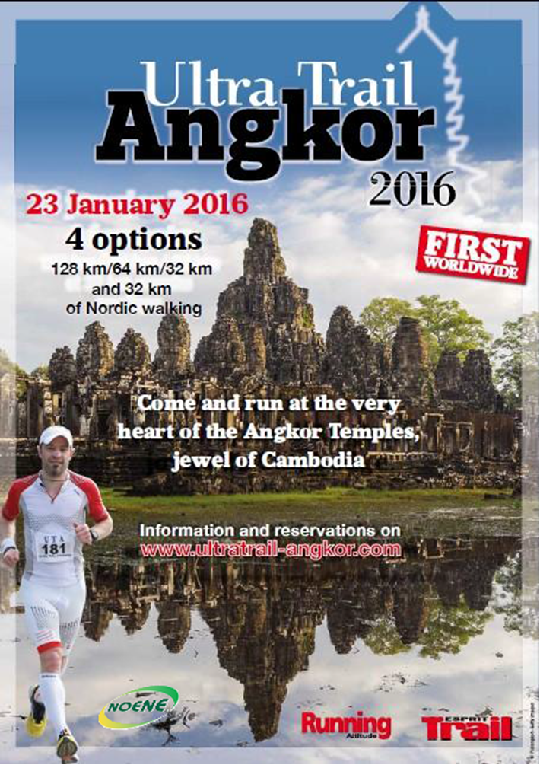

Summary

- PRESENTATION OF THE TRAIL
  - The Angkor Ultra-Trail
  - Race informations
  - Itineraries

- THE OFFICIALS PARTNERS & SPONSORS
  - Committed sponsors
  - Partnership application (7-8 pages)

- REGISTRATIONS & PARTICIPANTS
  - Countries
  - Key figures

- TENTATIVE PROGRAM
  - Day 1
  - Day 2
( retroplanning etc ….)

- SUGGESTIONS
  - Welcome party
  - Others proposals

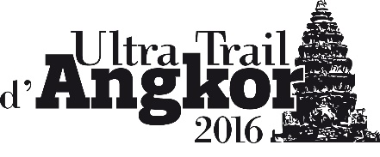
- PRESENTATION OF THE TRIAL – JC doc Word
  - The Angkor Ultra-Trail

THE ANGKOR ULTRA TRAIL: a world premier!

Initiated by Jean-Claude Le Cornec and his team, an unprecedented sport event will be held on the 23rd January 2016 in Cambodia! In the program, it is 128 km of a breathtaking race in an exceptional surrounding. Explanations:
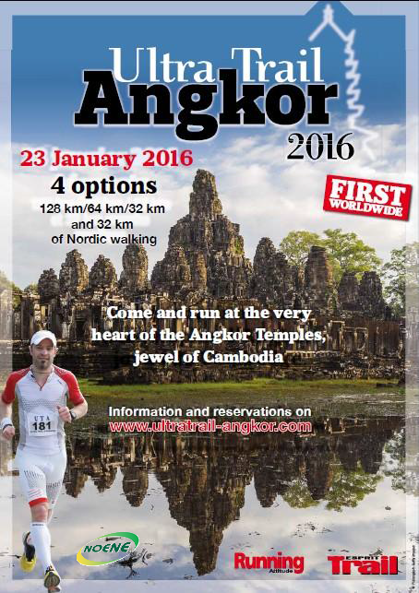
A specialist of races overseas, Jean-Claude Le Cornec just launched a new challenge by creating the “Angkor Ultra Trail”, a singular race of 128 km in Siem Reap, the Cambodian archeological site ranked as a World Heritage by UNESCO.

An unforgettable challenge
“A worldwide event for the world’s first”: Runners will cross several exceptional sites dominated by mountains and temples, evolving through impressive landscapes over a vast area where rice fields, forests, villages offer panoramas of surprising diversity. Moreover, four races are scheduled according to the levels of difficulty: the 128 km Ultra Trail, the 32 km Trail or 64 km trail and 32 km Nordic Walking. It is, without a doubt, one of the most wonderful races in the world set in an amazing location in which everyone is free to participate.

THE ANGKOR ULTRA TRAIL

After China, we are the first organization in the world to create an event on the Silk Road, in India, Laos, Vietnam and Indonesia… We continue our journey in Asia, specifically in Cambodia for 2016.

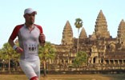
Many of you having experience the Ultra Trails are asking us to organize this type of event in surroundings and context that you are used to enjoy through those long years of running on the “Foulées de la Soie”. Based on our experience in races overseas, we have listened to you and so, we are now launching the first “Angkor Ultra Trail” in Siem Reap, the Cambodian archeological site ranked as World Heritage by UNESCO.

The desire of Jean-Claude Le Cornec, organizer of the race, is not only to promote contacts and interactions between runners and walkers but also with the local population. The visits of the famous sites, meetings with local personalities, sharing with the minority tribes of Cambodia…. It is through this innovative program that the first edition of the Angkor Ultra Trail is structured.

This first and unique edition in Angkor will allow all competitors to challenge their physical ability while keeping an open eye on the historical, cultural and human aspects of the region. Competitors will tread the most prestigious tourist sites of the world.

4 races scheduled, to each of this challenge
- 32 km of Nordic Walking
- 32 km Trail
- 64 km Trail
- 128 km Angkor Ultra Trail

Nordic Walking – MNA 32
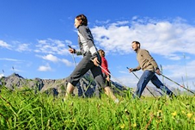
The Angkor Ultra Trail is also open to Nordic Walking. This exercise is an outdoor sport consisting of accelerated walking with specific walking sticks, usually made of composite material.
On this occasion, SDPO will be glad to welcome in Cambodia one of the pioneers of the Nordic Walking: Arja Jalkanen Meyer, a Finish woman living in France for 25 years, now a consultant for the FFA.

Beyond the temples, this trail will allow you to move within lush vegetation and cross many villages and rice fields. The Cambodian people will also accompany you along the trails!

The temples and nature form one setting combining charm and serenity!

  - Race informations

Participants will have the privilege to evolve in the prestigious site of the Angkor temples, true jewel of Cambodia.

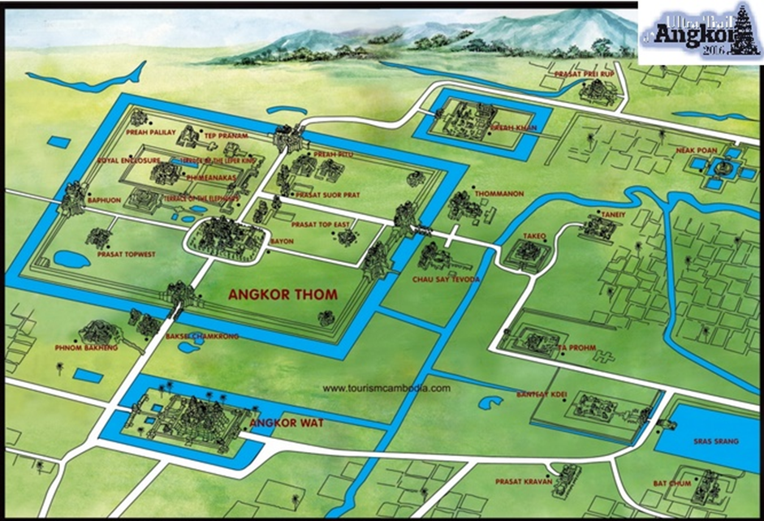

The Angkor area is fairly flat and The Ultra Trail should be quick.
The main difficulties of the courses will be the many passages in the soft sand and the midday heat: 80,6 F to 86 F ( 27 to 30 Celsius).
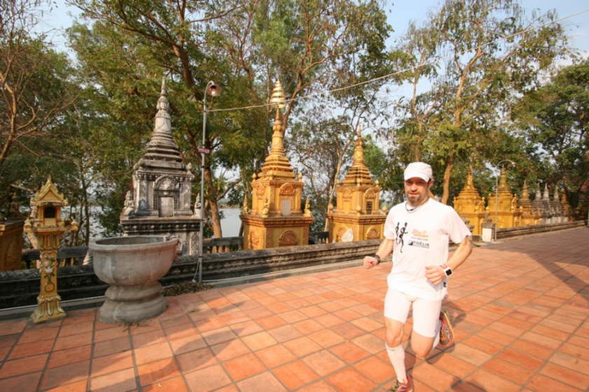
The month of January is a dry period in Cambodia and the runners will not suffer at all of the moisture.
Important information:
The heat felt in Asia is not the same as that experienced in Europe and it is much more bearable.

SDPOrganisation offers a touristic trip around the course event which will allow to acclimatize with the local heats.
Concerning the race event, the different routes pass through temples including the Bayon’s temple where runners will run on its ramparts.
Depending of the chosen race, they will discover different temples away from tourist areas, " lost" in the forest overgrown with wild roots.
Attendees will also run on sandy tracks, on soil, on laterite tracks, and it will be very few tar ( right now estimated less of 5 %)
The landscapes are very different from one area to another with drill passages, country, rice fields, sometimes bush landscapes, savannah, many villages crossings where children and people will encourage them.
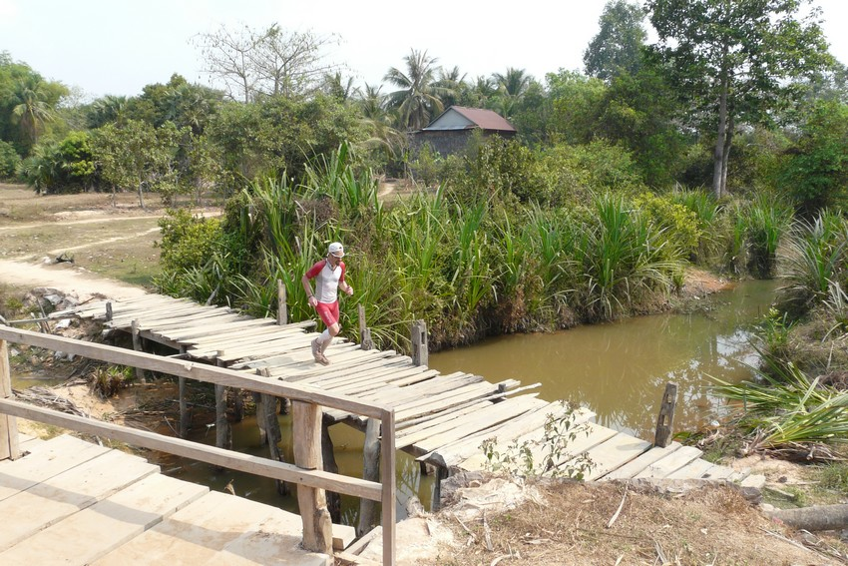
It will be a nice cocktail dose and it should not let the participants indifferent to this intense moments.
Concerning the uneven here is a first estimation and will be affined in details later:
On the Trail and the Nordic Walking of 19,89 miles (32 km) : 0,094 miles (150 meters )
On the Trail of 39,77 miles (64 km) : 0,156 miles (250 meters)
On the Ultra Trail of 79,54 miles ( 128 kms) : 0,559 miles (900 meters)

  - Itineraries

Ongoing. Planned to be done for end of June 2015…

- THE OFFICIALS PARTNERS & SPONSORS
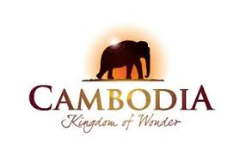
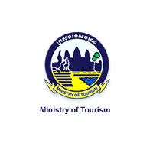

Picture of Organization staff and ministers

The Cambodian ministry of tourism does us the honour of being our privileged partner for the event…

  - Committed sponsors

FIDELIA (long term partnership with SDPO for 20 years)


FIDELIA Assistance is the assistance company of Covéa (MAAF, MMA, GMF), the 1st French insurance group on the individual market which employs 20.000 people to serve more than 10 million customers. Its activity is to intervene 24h/24h in France and around the world to help its customers and subscribers. More than 500 employees spread over 2 sites, in Tours (37) and Saint-Cloud (92) have managed more than 3 million calls and opened 400.000 assistance cases in 2006.

Its fields of activity: medical assistance (repatriation, medical evacuation), vehicles assistance (breakdown services), home assistance, services to individuals and psychological assistance.
Whether on the ground, in extreme conditions or facing emergency calls, FIDELIA Assistance is keen to put its expertise at the service of human crisis.

More than 12 million customers can call FIDELIA Assistance with customer satisfaction rate of 97,6% demonstrating a high level of services quality.

The RIVA Editions


The RIVA’s companies (Riva Editions, Riva Corporate, Riva Media) offer several journals and magazines on many topics such as sports… RUNNING ATTITUDE, RUNNING COACH, ESPRIT TRAIL, RUNNING pour ELLES, have already relayed the information about our new event offering us full pages.

All these magazines, from the tracking trip planned in January 2015, will also feature stories to their readers.

Created in April 2000 by a team of passionate, famous coaches, doctors and nutritionists, Running Attitude has become today a reference in the running press. Road racers, trailers, beginners, regulars or experienced, appreciate its good workout plans, the advice of its coaches and its presence on the ground in the middle of the field all throughout the year.

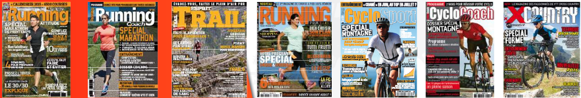

NOENE

The NOENE Company supported Jean-Claude Le Cornec back from the late 80’s, at the time when Jean-Claude was involved in an unprecedented competition with the team AEROSPATIALE at the 8000 km non-stop running PARIS-GAO-DAKAR. A test driver of the brand, Jean-Claude has never stopped his role as Ambassador for this outstanding product.

NOENE® are high-tech soles designed with a revolutionary material able to absorb and dissipate the shock waves generated at each step and each jump. Its regular use, both in the practice of sport and in the daily life or at work, protects your joints and prevents any painful lesions.

PHOENIX Travel Group


Phoenix Voyages Group is an inbound travel agency created in 1999 in Vietnam, and it is now also established in Myanmar, Cambodia, Laos, Thailand and both Koreas. It specializes in tours for individual as well as Incentive events and sport tours.
In fact, SDPO has appointed Phoenix Voyages as a regional partner for its editions « Les Foulées » in Laos and Vietnam in 2000-2012 and 2014

Phoenix Voyages is a team of more than 120 people, made-up of local and expatriates staff, trained to deliver high quality standard of services in English, Spanish and French. These professionals have an extensive experience in the tourism industry around the globe.
Phoenix Voyages Group - 82-83 Street 7, An Phu - An Khanh, District 2, Ho Chi Minh City – Vietnam
TEL +84-8 6281 0222 – FAX +84-8 6281 0333
www.phoenixvoyages.com - info@phoenixvoyages.com

The Medias

In addition to the RIVA Editions, other sports newspapers have already made a request to accompany us. Thanks to the support of all our partners and their press officers, we will conquer the other European countries, others continents and Asia in particular.

Our current relays

In France and French speaking countries: Various websites in France, including those of RIVA Editions, SDPO and ULTRATRAIL-ANGKOR, the AEIFA, facebook, etc.

Exhibitions and presentations including the one from Paris Marathon, from Médoc, from Beaujolais, from Gendarmes et des Voleurs, from Marseille-Cassis, from UTMB, to mention only the major ones, will be featured through our booths during the event.

  - Partnership application


At a time when sport becomes a need or even a necessity in today's world, many racing events and expeditions emerge from everywhere, the high-tech equipment and the achievement at all costs ignoring too often the human, relational and cultural aspects.

This event is very promising. It is one illustrating adventure and rigid training, perseverance and determination. It is one sporting achievement, straightforward running, skills and strength.
This is also an impression of a journey, an encounter with the culture, more real because the people that you will come across may also run with you.

It is not only in the mind in order to succeed, but the team must be self-reliant, united and organized.

The "ULTRA TRAIL OF ANGKOR" race felt the need to enjoy differently a new sporting adventure based on friendliness in meeting the Cambodian villagers, discovering their lifestyles and exploring the archaeological site of Angkor listed as a World Heritage by UNESCO in 1992, a multi-millennium civilization and its impressive diversity.

Through sport, the ULTRA TRAIL OF ANGKOR helps to reinforce the friendship bound between Cambodia and France.

The ULTRA TRAIL OF ANGKOR in Cambodia will be an important support and will create media attention for the country through several official ceremonies and coverage of the world's media. Therefore we have established close contacts with the Cambodian authorities.

We are convinced that this adventure will be a significant "corporate" image vehicle for your company.
It also represents a particular and highly effective means to develop and intensify contacts with the government and economic authorities of the country.

Some of our sponsors such as FIDELIA, RIVA edition and NOENE Company, have already understood this and partnered with us since several years… 20 years already.

The ULTRA TRAIL in its sporting and cultural approach is taking an extra dimension with increasing media coverage in both Europe and Asia.

The intensity and speed with which Asia is opening to the western world is far beyond the perception commonly described in Europe.

Running represents millions of practitioners worldwide; in France alone, more than 9 million..

Your company alongside the ULTRA TRAIL OF ANGKOR is to be associated with an event that will soon have a global impact going beyond our borders.

"If running is our only goal, we would miss the unforgettable moments."

Since 1996 SDP Organization, specializing in adventure racing with a sportive and cultural vocation, has built a solid reputation in Asia.

For 20 years, we have established a firm network throughout Asia where long-term is the essential key to beneficial and confident exchanges. Our position and preferential environment in Cambodia enable us to offer specific and media events in symbolic landmarks with business sectors and government officials.

At a time when human relationship is associated with the well- being of the company, why not actively enhance the image of your company.

The ULTRA TRAIL OF ANGKOR is looking for new partnership to accompany the organization along this event.

The first edition of this event looks very promising and it is fabulous opportunity for you to communicate, both internally with your staff and externally with your customers, prospects and the media. It is essential to spread your image in France and countries where your company operates.

EXAMPLES OF PARTNERSHIPS / Several options are available

Several options are available: Partnerships are diverse and may be subject to exchange of goods and technology on the organizational needs (sponsorship of air tickets, accommodation expenses, communication support by the journalists of your choice, support for the organization’s facilities and equipment for volunteers, timing during the event, on-site logistics, such as road signs, etc.) or:

- Visuals Before, During and After the event:
- Availability of our booths at the trade shows to promote your image;
- Your logo with your company presentation will be featured in our Newsletter (sent to thousands);
- Your logo on all press releases;
- Permanent presence of your logo on our posters and website of the event;
- Your logo on the bibs of participants;
- Your logo on the jersey which will be offered to participants;
- Your logo on the volunteers’ jersey who are spread all along the race’s route;
- Your logo on DEPARTURE and ARRIVAL banners;
- Your logo along the race’s route;
- The presence of your company in the village of racers (bibs and during the event);
- Micro ads on site during the event;
- Your logo on the corporate film of the race.

- A participating and innovative partnership:

As a reward to an employee, incorporation of one or more members of your staff within the organizing team for the duration of the event may be considered. For each member included in the staff, your company will take over three integral members of SDPO (air Transfer and hotel accommodation with full board).

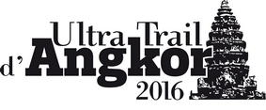

WHY BECOME A PARTNER?

There are several reasons to become a sponsor.

Sport is a powerful image.
The French attitude towards sport evolves, they practice more and more. 75% of French people aged from 12 to 65 years old do at least one sport.
Those who do not play sports still retain their sensitivity towards it since over 50% of them watch, at least occasionally, sports broadcasts on television or buy sports magazines.

It is enough to say that sport is an activity in which the French are concerned and that its image is strong.

Sport is a mean of communication.
Sports sponsorship is not new. The “Tour de France”, football teams and all the great sport events have always received financial support from private businesses and public authorities.

Today, communication is an essential part of business and more and more people recognize effective communication through sports.

The most common form of communication is external communication for commercial purposes.

External communication can have a second aim: institutional communication. The aim is not to directly withdraw a financial benefit but allows the company to occupy a rightful place in the society. Instead of sponsoring, we talk about philanthropy (Cartier Foundation for example). This type of action is also growing but focuses more towards on artistic and humanitarian fields.

The third type of communication is internal communication. It focuses on improving staff motivation, training and relationships within the company.

Sponsorship is proving to be also a great way to motivate employees around a challenging project. Having a good "team spirit" becomes paramount. The objective is primarily intended to raise the enthusiasm of the company's staff. This same staff through internal communication of the company will manage the preparation of HIS team.

Sponsorship operations are growing and often proven to be very useful when properly utilized.

This event is very promising. It is one illustrating adventure and rigid training, perseverance and determination. It is one sporting achievement, straightforward running, skills and strength.
This is also an impression of a journey, an encounter with the culture, more real because the people that you will come across may also run with you.

It is not only in the mind in order to succeed, but the team must be self-reliant, united and organized.

This world premiere through media partners which are already in place will have an immediate impact in France. Since October 2014, advertisements in full screen have increased in all kind of specialized press.

- Many websites relayed the information and regularly receive written or visual stories....

- This event will undoubtedly be a popular success as it deserves...

- The ULTRA TRAIL OF ANGKOR is organized within Angkor archeological site, top privileged tourist spots are attracting millions of visitors each year; which guarantee a global impact.

- SDPO’s, the official organizer of this event which is also specialized in running races in Asia and around the world guarantees a high organizational quality.

- And finally, this event will be very popular and can only convey a positive image of your company, thanks to your sponsorship because in helping the ULTRA TRAIL OF ANGKOR, you are contributing to the humanitarian actions that will be undertaken in parallel with the event.

Upon your request, proposals for partnerships and associated prices can be studied specifically in terms of the feasibility of your projects.

Examples :

- Participation in sponsoring a trophy or special Challenge with the brand of your company;

- Set up receptions in your premises with the prominence of your participation via documentary photos or videos.

We really want to make this ULTRA TRAIL OF ANGKOR a key global event and the goal, of course, is to attract for many years hundreds of "trailers" and hikers from around the world.

IN ORDER TO BUILD A REAL PARTNERSHIP
SDP ORGANIZATION will not bargain over the size of a booth but remains at your disposal, for a favorable dialogue and will execute to the best of its ability all matters related to the proposals that can promote effectively the image of your company.

In addition, SDP Organization and the ULTRA TRAIL OF ANGKOR is thinking about the future and wants a lasting partnership with your Company by offering a 3-year renewable contract.

WHAT WE HAVE DONE ALREADY AND WITH WHOM !! ... only to mention the mains one…

16 years in China with “Les Foulées de la Soie”, 16 years of partnership with:

- EUROCOPTER, known as AIRBUS Helicopters is now the world's leading helicopter factory and leading exporter of civil helicopters and its international network of subsidiaries and representations.
- FIDELIA Assistance, assistance company of GMF
- TDCom, a leading distributor of radio communication equipment, is our preferred technology partner for our broadcasts. The reports of the race are relayed daily to the media.
- France TELECOM Inmarsat
- CITS, China International Travel Service
- La Maison de la Chine

Airlines:
- AIR CHINA
- CHINA EASTERN AIRLINES
- AIR FRANCE

Prestigious support:

- French Senate;
- French Ministry of Youth and Sports;
- French Embassy and Chinese Embassy;
- His Serene Highness Prince Albert of Monaco has also sponsored the event.

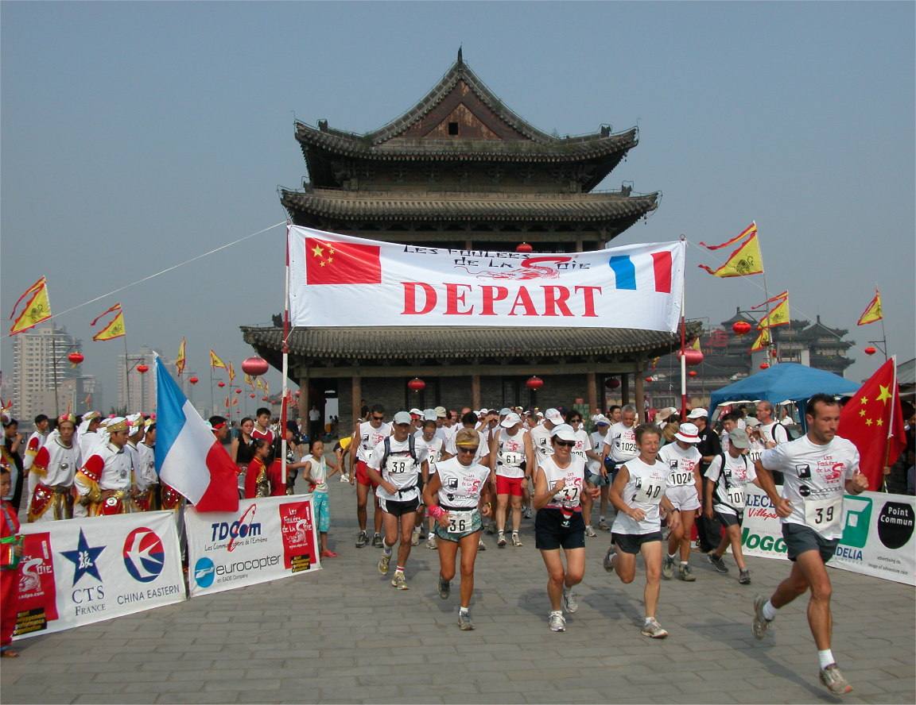

For 20 years, other event have been organized by SDPO: “Les Foulées” of Yunnan (China), “Les Foulées” of Cappadocia (Turkey), “Les Foulées” of Sri Lanka, “Les Foulées” of Samarkand (Uzbekistan), “Les Foulées” of Havana (Cuba)… all successful.

SDPO and government officials…

Everywhere meetings are organized with the government officials of the countries crossed. SDPO events are always warmly welcomed and every time hundreds of local people comes to run along…

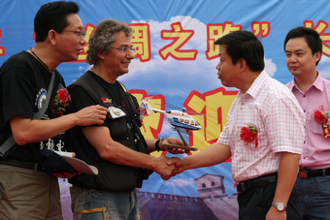
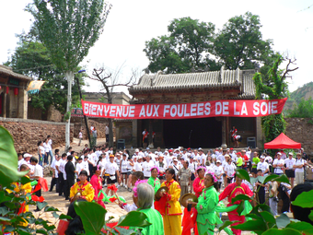
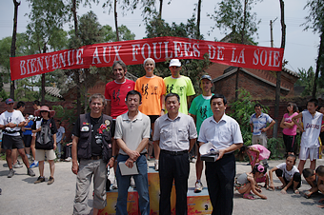
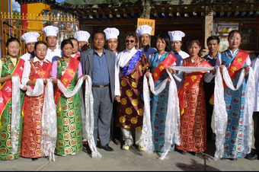

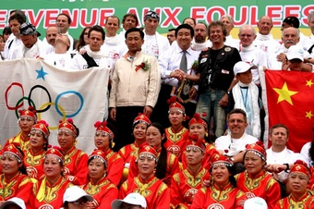
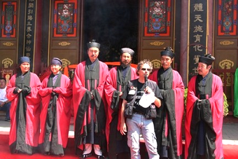

SDPO, a spirit of solidarity

SDPO is also committed to the solidarity and helps the local inhabitant of each country that has been crossed. SDPO was also mobilized as soon as the tsunami was announced, on December 26th 2004. In Sri Lanka, SDPO gave hope again to many villages, schools, temples, local companies by investing in the rebuilding of the country.

With the help of Eurocopter and its staff, of the Principality of Monaco, of FIDELIA Assistance, of TDCom, of the International Buddhism Centre and lots of donors, we were able to carry through our humanitarian operations.

We build our Nation Back
Running for rebuilding

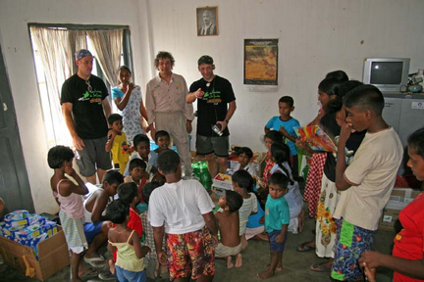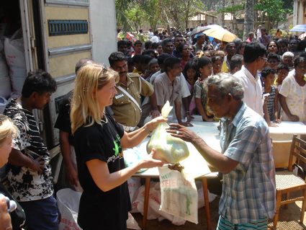
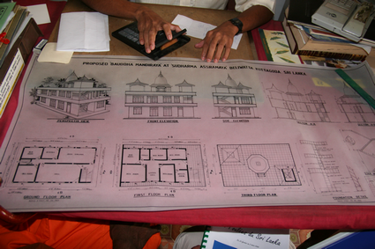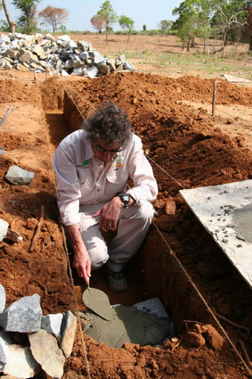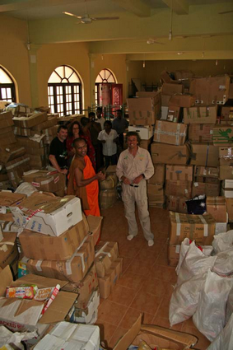
On the occasion of the ULTRA TRAIL OF ANGKOR in Cambodia, it is with the support of our partner companies and all the registered runners that we will carry through our humanitarian operations.

In France, it is with the Association of Mister Red Noise, who fights against rare Diseases, and Jean-Claude Le Cornec who is the “godfather’, that SDPO is committed.

"If running or walking was our only goal we would miss unforgettable moments, so we also offer our legs and our hearts for the sick children."
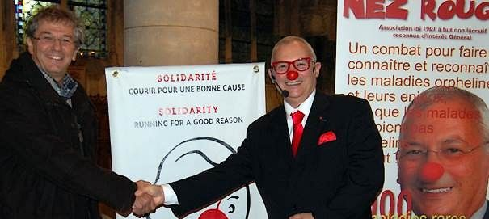

“Les Foulées de la Soie” on the front of the stage…

Within 20 years the event has acquired a non-debatable reputation. A recognition in sporting, cultural, professional, political...
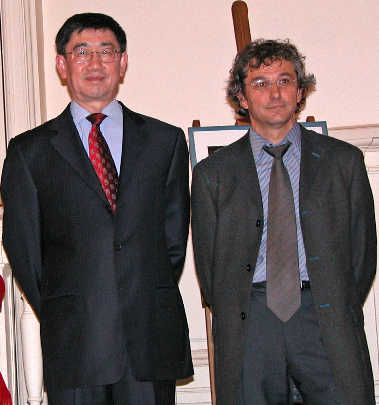
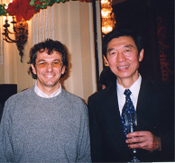
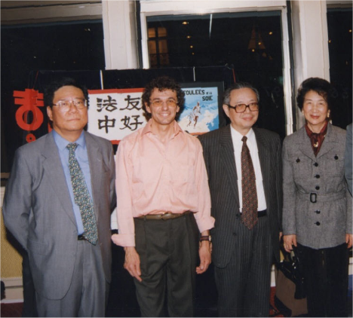

Function with
Mrs CAI Fang Bo (on the right), Mr WU Jiammin and ZHAO Jin Jun

Respectively Ambassadors of China in France since 1996

Exhibitions are held in the very prestigious venues such as the French Senate in 1996 in the presence of Mr MONORY. Conferences like UNESCO in 2012, and many municipalities and businesses...

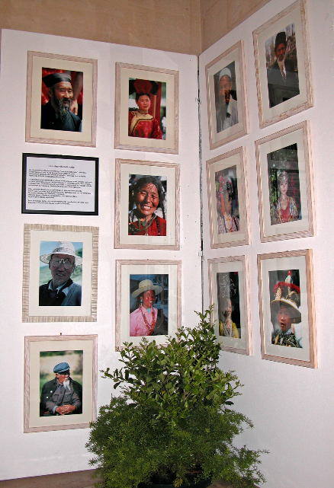
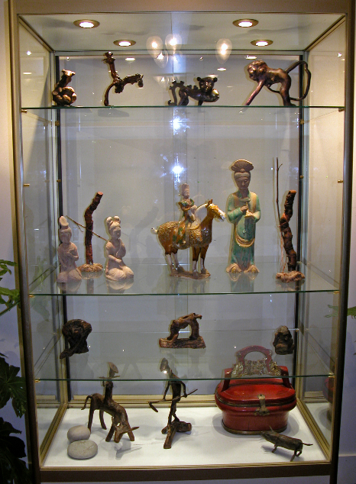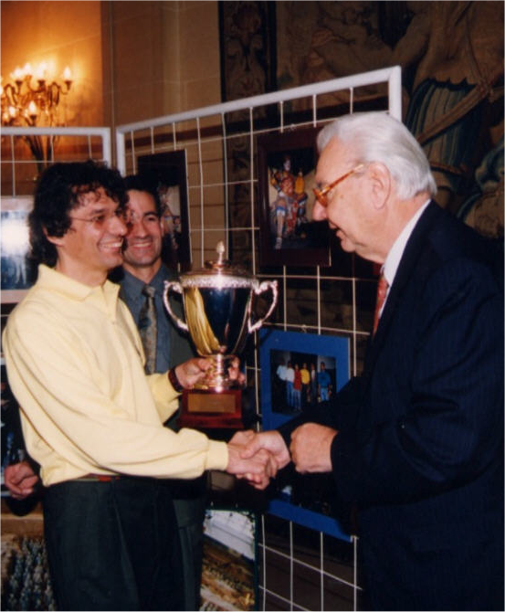

"Les Foulées de la Soie are also a symbol of the strong dynamism of our country that you highly represented in China. Through you, all the potential of France was put forward, its creativity, enthusiasm." From Patrick BONNEVILLE, Minister Counsellor at the Embassy of France in Beijing during an awards ceremony.

After China, SDPO organized two major events in Vietnam, Laos and another one will be held in Indonesia in August 2015. Now the story continues in Cambodia with ULTRA TRAIL OF ANKOR and we invite you to join us and make this event one of the best races in the world, an event that will be remembered ... an event where the runners will want to come back...

The International Olympic Committee and the Ministry of Tourism of Cambodia are already by our side, WHY NOT YOU!!


Courrier du ministère du Tourisme Cambodgien
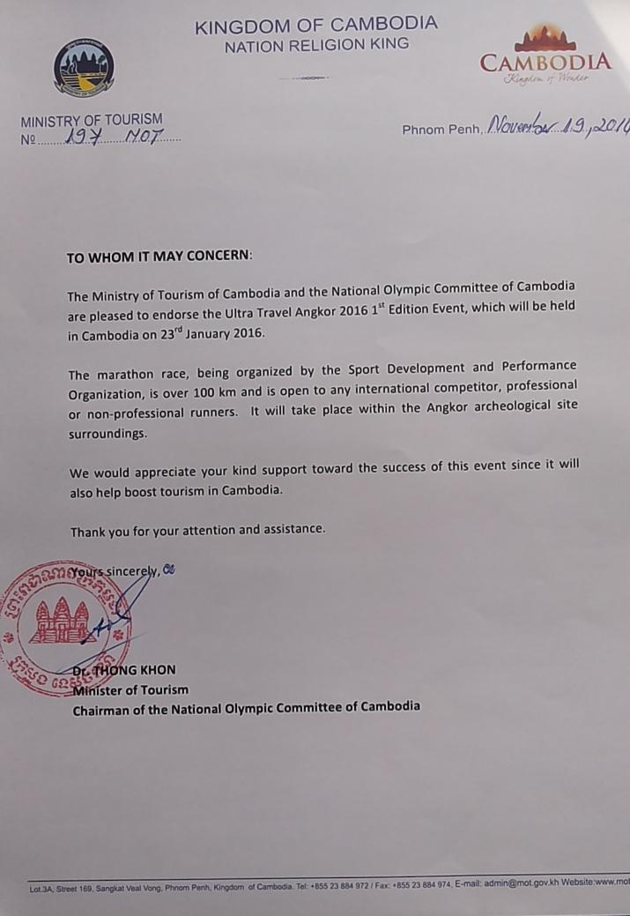
- REGISTRATIONS
  - Country

 | Nb agencies | Nb participant
Afrique du Sud | 2 | 6
Algérie | 1 | 3
Allemagne | 5 | 15
Argentine | 1 | 3
Australie | 3 | 9
Autriche | 1 | 3
Bélarus | 1 | 3
Belgique | 2 | 6
Bolivie | 1 | 3
Bosnie-Herzégovine | 1 | 3
Botswana | 1 | 3
Brésil | 3 | 9
Bulgarie | 1 | 3
Cambodge | 2 | 6
Canada | 3 | 9
Chili | 1 | 3
Chine | 3 | 9
Colombie | 1 | 3
Congo | 1 | 3
Corée, (République de) | 3 | 9
Costa Rica | 1 | 3
Côte d'Ivoire | 1 | 3
Croatie | 1 | 3
Danemark | 1 | 3
Egypte | 1 | 3
El Salvador |  | 1
Emirats arabes unis | 1 | 3
Equateur | 1 | 3
Erythrée |  | 1
Espagne | 5 | 15
Estonie | 1 | 3
Etats-Unis | 5 | 15
Ethiopie | 1 | 3
Fidji |  | 1
Finlande | 1 | 3
France | 5 | 50
Gabon | 1 | 3
Gambie |  | 1
Géorgie |  | 1
Ghana | 1 | 3
Grèce | 1 | 3
Grenade |  | 1
Guatemala |  | 1
Guinée | 1 | 3
Hongrie | 1 | 3
Inde | 3 | 10
Indonésie | 2 | 6
Irlande | 2 | 6
Islande |  | 1
Israël | 2 | 6
Italie | 5 | 15
Jamahiriya arabe libyenne |  | 1
Jamaïque |  | 1
Japon | 3 | 9
Kenya | 1 | 3
Kirghizistan |  | 1
Koweït | 1 | 3
Macédoine | 1 | 3
Lesotho |  | 1
Lettonie | 1 | 3
Liban |  | 1
Libéria |  | 1
Liechtenstein | 1 | 3
Lituanie | 1 | 3
Luxembourg | 1 | 3
Madagascar | 1 | 3
Malaisie | 2 | 6
Mali | 1 | 3
Malte |  | 1
Maroc | 1 | 3
Maurice |  | 1
Mauritanie | 1 | 3
Mexique | 3 | 9
Mongolie | 1 | 3
Mozambique | 1 | 3
Myanmar | 2 | 6
Namibie | 1 | 3
Nicaragua | 1 | 3
Nigéria | 1 | 3
Norvège | 1 | 3
Nouvelle-Zélande | 1 | 3
Ouganda | 1 | 3
Pakistan | 1 | 3
Paraguay | 1 | 3
Pays-Bas | 2 | 6
Pérou | 1 | 3
Philippines | 1 | 3
Pologne | 1 | 3
Portugal | 2 | 6
Qatar | 1 | 3
Laos |  | 1
République centrafricaine | 1 | 3
République dominicaine | 1 | 3
République tchèque | 1 | 3
Roumanie | 1 | 3
Royaume-Uni | 5 | 15
Russie, (Fédération de) | 3 | 3
Rwanda | 1 | 3
Sénégal | 1 | 3
Serbie-et-Monténégro | 1 | 3
Sierra Leone |  | 1
Singapour | 2 | 6
Slovaquie | 1 | 3
Slovénie | 1 | 3
Somalie |  | 4
Soudan |  | 1
Suède | 1 | 3
Suisse | 2 | 6
Thaïlande | 1 | 3
Tunisie | 1 | 3
Turquie | 1 | 2
Ukraine | 1 | 3
Uruguay | 1 | 3
Venezuela | 1 | 3
Zambie | 1 | 2
Zimbabwe | 1 | 2
TOTAL | 150 | 500

  - Key figures – don’t have yet

- TENTATIVES PROGRAM – JC – to determine later
  - Day 1
  - Day 2
  - Day 3
  - Day 4

- SUGGESTIONS
  - Welcome party

Date : 22rd January 2016
Hours : from 6 to 10pm
Schedule :
-6-7pm : Welcome guests - Food & drinks self service
-7pm – 8pm : Event Opening Ceremony
-Speech of ministry of Tourism
-Speech of Organisation team
-Event presentation
-From 8pm : Dinner and Free evening
Place : To determine
Category : Appetizer - Event Opening Ceremony
Number peoples expected : 100

  - Others proposals

