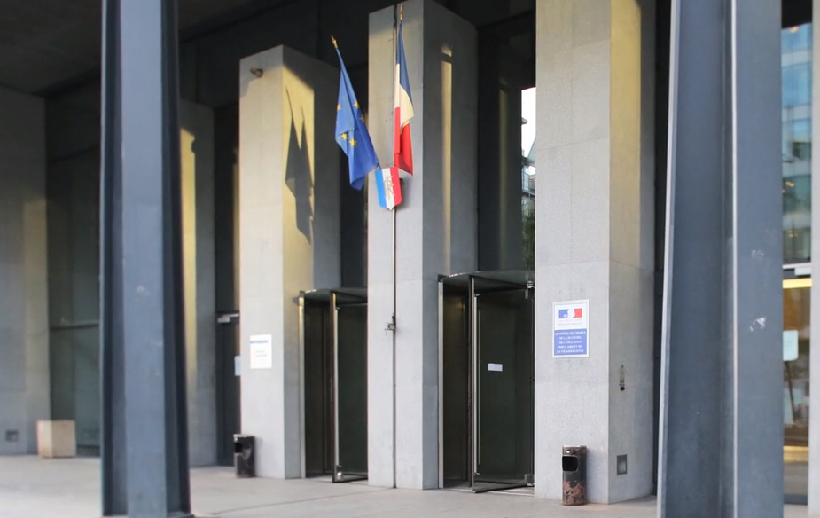
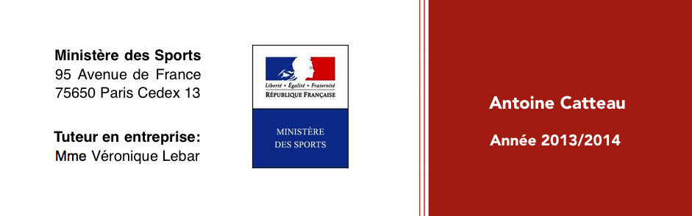

Mémoire de Stage
Antoine CATTEAU

ANNEXES

Mémoire de Stage
Antoine CATTEAU

