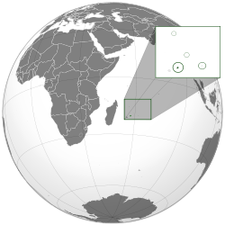
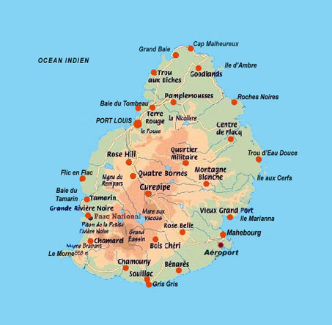
Mauritius officially the Republic of Mauritius is an island nation in the Indian Ocean that is situated at the southeast coast of the African continent. The capital and largest city is Port Louis.
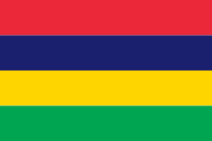
The flag of Mauritius consists of red, blue, yellow and green bands.
- Red: Representing the indian’s blood at the time of slavery and colonisation.
- Blue:The Sky & the Indian Ocean,
- Yellow: the new light of independence & the golden sunshine.
- Green: the vegetation of the island and the sugar cane.
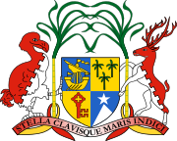 Armorial of Mauritius
“Stella Clavisque Maris Indici” meaning “The Star and the Key of the Indian Ocean“.
Speciality of Mauritius : Alouda
The Mauritius is not well known for having a lot of specialities because most of the food is a mix of british, french and mosty indian food. However, there’s a refreshing drink that is known for being a speciality of mauritius, the Alouda.
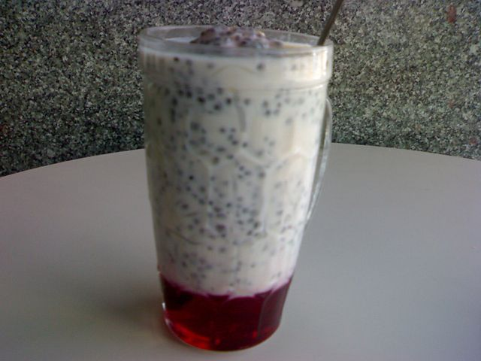
The alouda is a refreshing drink without alcohol native of Mauritius.

It is prepared with milk , sugar, and agar. Also made with extracts of vanilla and almond,or even syrups to give the " Alouda " a smooth and tasty texture.

Mauritius history
Mauritius was at start a colonie. The country has been colonised for the first time by the portugueses. It has also been colonised by the Dutchs but the most famous settlers of the country are the French and the British.
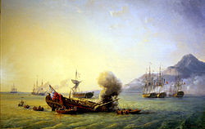 French Period
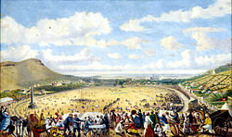 British Period : Champ de Mars, Port Louis

Some of the cities have english and french names. For example the capital of the city is Port Louis and there’s a town that is called Arsenal like the stadium in London in the North of Mauritius.
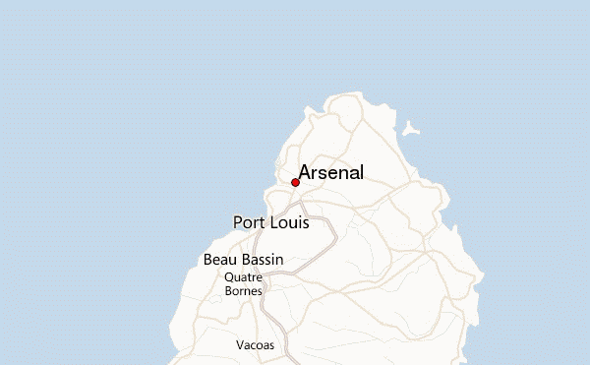
Republic : Twenty four years after independence, Mauritius was proclaimed a republic within the British Commonwealth.Political power remained with the prime minister.

Language : Being both an English-speaking and French-speaking nation, Mauritius is a member of both the Commonwealth of Nations and the Francophonie. The constitution of Mauritius are written in English, while some laws, such as the Civil code, are in French. The Mauritian population is multilingual; most Mauritians are equally fluent in English and French. Creole as mother tongue. French is mostly used in the media
Example of a french proverb : « Quand le chat n’est pas la, les souris dansent » in mauritian creole : « Quand chat pas la, Rat pe few bal »

The most famous and appreciated thing in mauritius : The BEACH
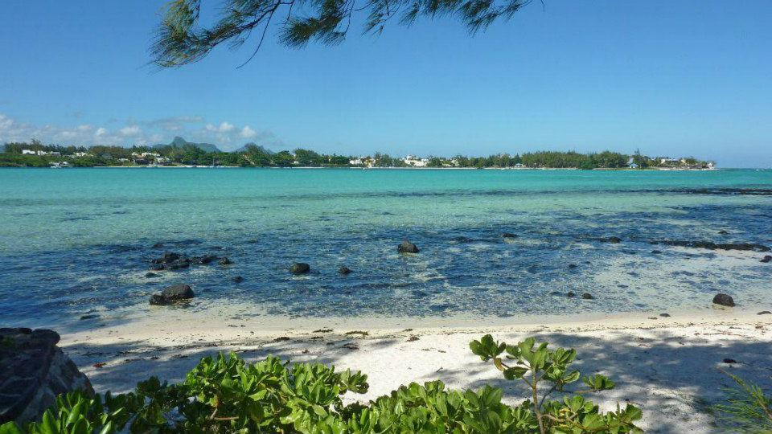 Picture of a Trou-Au-Biche beach that I personally took in my facebook
Mauritius Island is known for its amazing beaches which are part of the most beautiful beatches of the world. NEWS : The last group of Miss France 2014 went in Mauritius

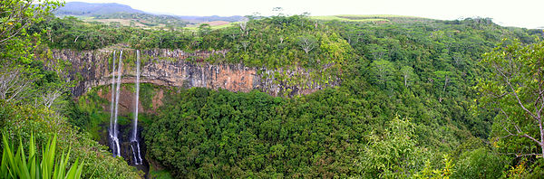
Mauritius is also known for a to have a significant amount of wildlife and flora all around the island.

