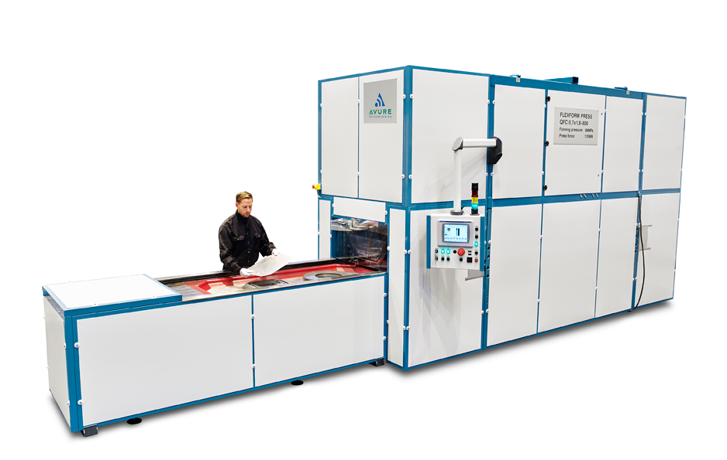
Sheet Elastoforming

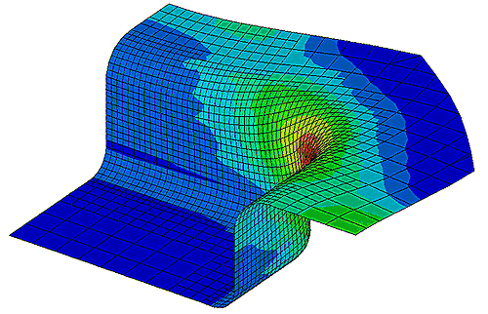
Noms ?
Michael
Marie
Oriol
Leo/Nouda
Zhou

Introduction
After studying the different technical aspects of our metal piece, we first let in place several objectives. In order to help us to answer to those goals, we have 3 books on disposition dealing with rubber pad forming or aluminum 2024-O properties. This report aims to summarize the answers of each learning objectives for the production of a sheet metal part according to the ASEA Quintus Process fluid cell. Those results came from the Maastricht Seven Step Approach.

Studying of the part

Dimensions and material specifications
Take the campus document with the problem for figures
Detailed design :
- Initial geometry for the machine
- Unfold dimensions

Deformation Modes
After reading the documents and getting back to our mechanical lessons, we identified several deformation modes we need to take in account in order to keep the specification sheet dimensions :

Springback
The spring bacK-Factor, commonly denoted by Ks, is the relation between the initial and final angles. A spring bacK-Factor of Ks=1 means there is no Spring Back, where a value of 0 means total Spring Back.

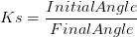
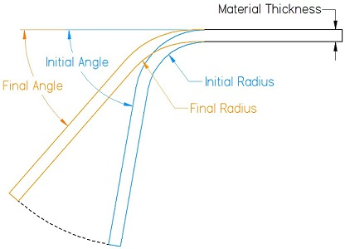
To calculate the spring back-Factor ahead of a test piece it is important to understand that the bend radius is affected as well as the angle. The radius of the bend will try and return in the same way the angle does meaning the initial radius (I.R.) will be slightly smaller than the final radius (F.R.). This relationship can also be used to define the spring back-Factor.
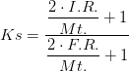
Given the ressources we have, we need to take this last step further so we can incorporate the yield stress and elastic modulus into our calculations by the ratio of the initial radius and final one.
$$\frac{Ri}{Rf}=4({\frac{Ri×Y}{E×t})}^{3}-3({\frac{Ri×Y}{E×t})}^{}+1$$
Where ;
$$Y=$$
$$E=Young Modulus of Al2024-O=73000MPa$$
The calculations give us the following results :
$$\frac{Ri}{Rf}=hence Ks=$$
Which means that our piece is expecting to unload until an angle of
We can also calculate the residual curvature :

Flanging
Shrink
Stretch

Bending Line
External
Internal

Friction stress
Rubber 2 aluminium sheet
Alu sheet to DIE

Thickness evolution during the process
Thickness of plate and elongation of sheet

Conclusion on a suitable tool : DIE

Geometry configuration

Holes to be positioned ?(defect holes ?)

Clamp ? (friction coeff)

Life time DIE (cycles temperature->fatigue)

Studying of the process

After studying the major deformation modes of our part, we were able to imagine an ASEA Quintus Fluid Cell process which can let us to manufacture our part.

Suitable Process types

ASEA Quintus hydroforming

Cold extrusion

Punching

Other
Maybe talking about the after heat treatment and surface treatment ?
Other idea : bending with rolls

Process parameters for our application

Pressure
Lubricant(type, characteristics) : rubber 2 metal or metal to die : friction
Table size
Temperature (hot ? Cold ?)
Hardness of rubber

Estimate the global cost of the process

Improvements

Quality inspection
Figure with every steps of the process + calculations step and quality inspection steps including
Rejet ?
Define tolerance (available in one pdf doc)

Process monitoring and controlling
Levels of action
Corrective and preventive actions
Other tools ?
Optimisation : in 1 shot ?

Conclusion and answers to the learning objectives

Thanks to the PBL Approach, we are able to propose a solution to manufacture a given part for our aerospace supplier. Below is a short summary of the answers we developed to each learning objective.

