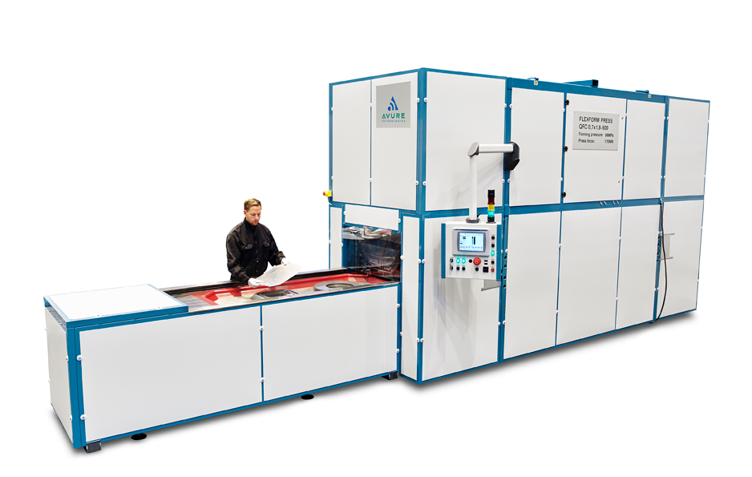
Sheet Elastoforming

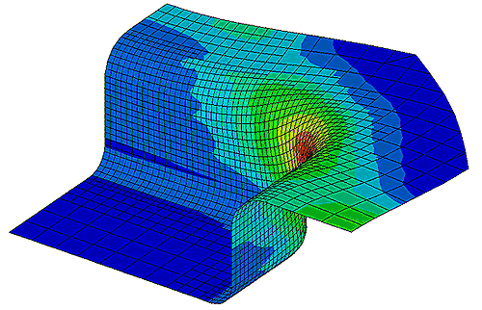
Noms ?
Michael
Marie
Oriol
Leo/Nouda
Zhou

Introduction
After studying the different technical aspects of our metal piece, we first let in place several objectives. In order to help us to answer to those goals, we have 3 books on disposition dealing with rubber pad forming or aluminum 2024-O properties. This report aims to summarize the answers of each learning objectives for the production of a sheet metal part according to the ASEA Quintus Process fluid cell. Those results came from the Maastricht Seven Step Approach.

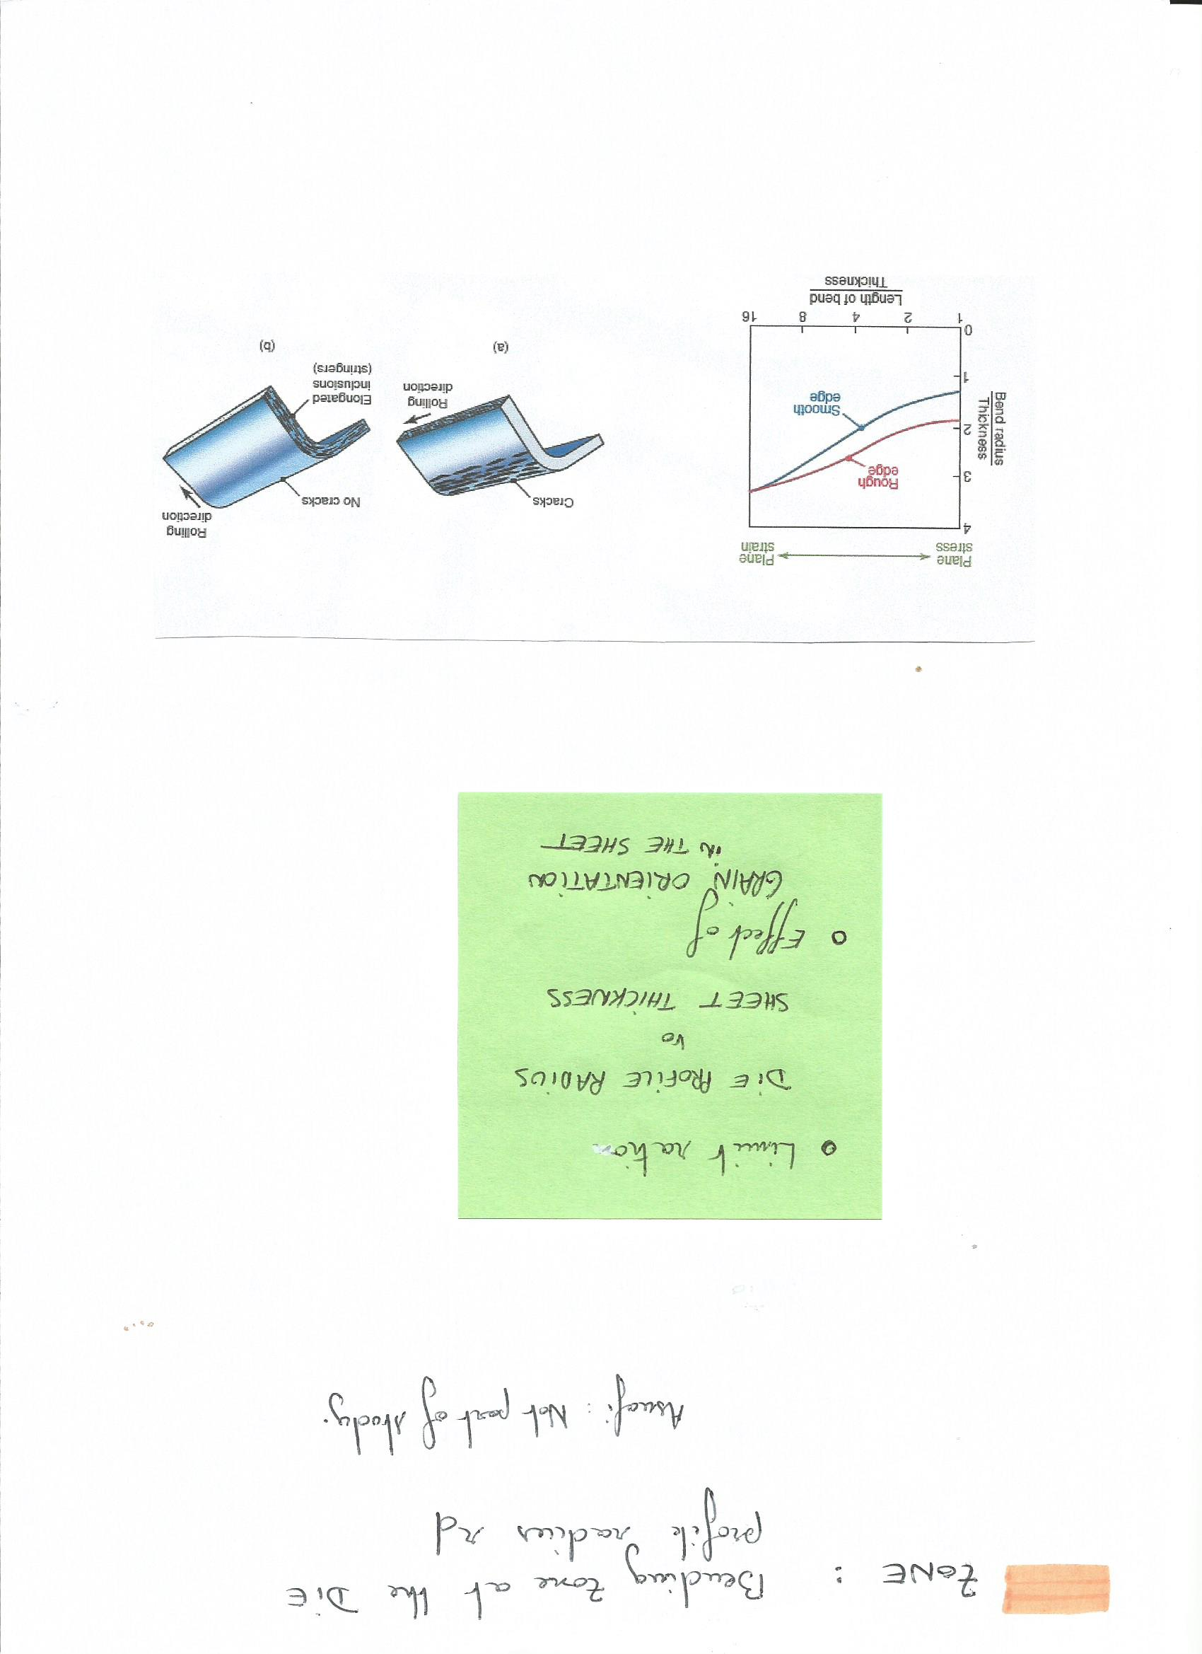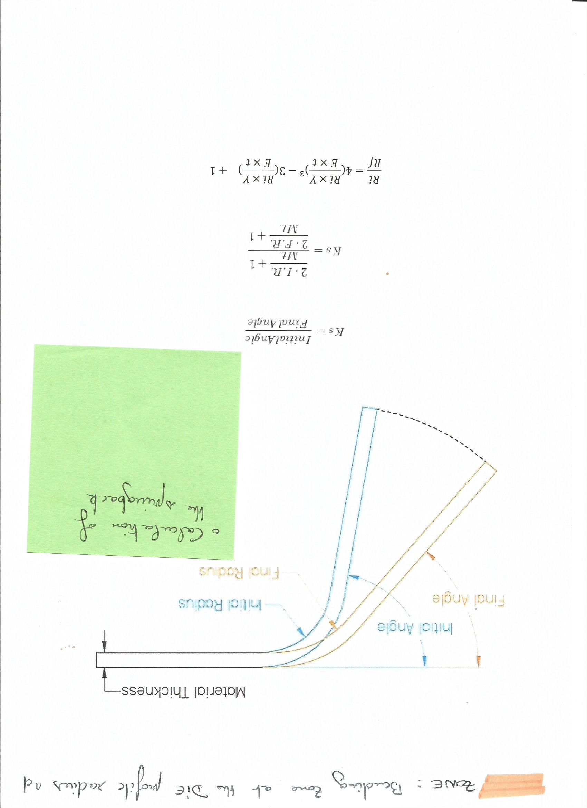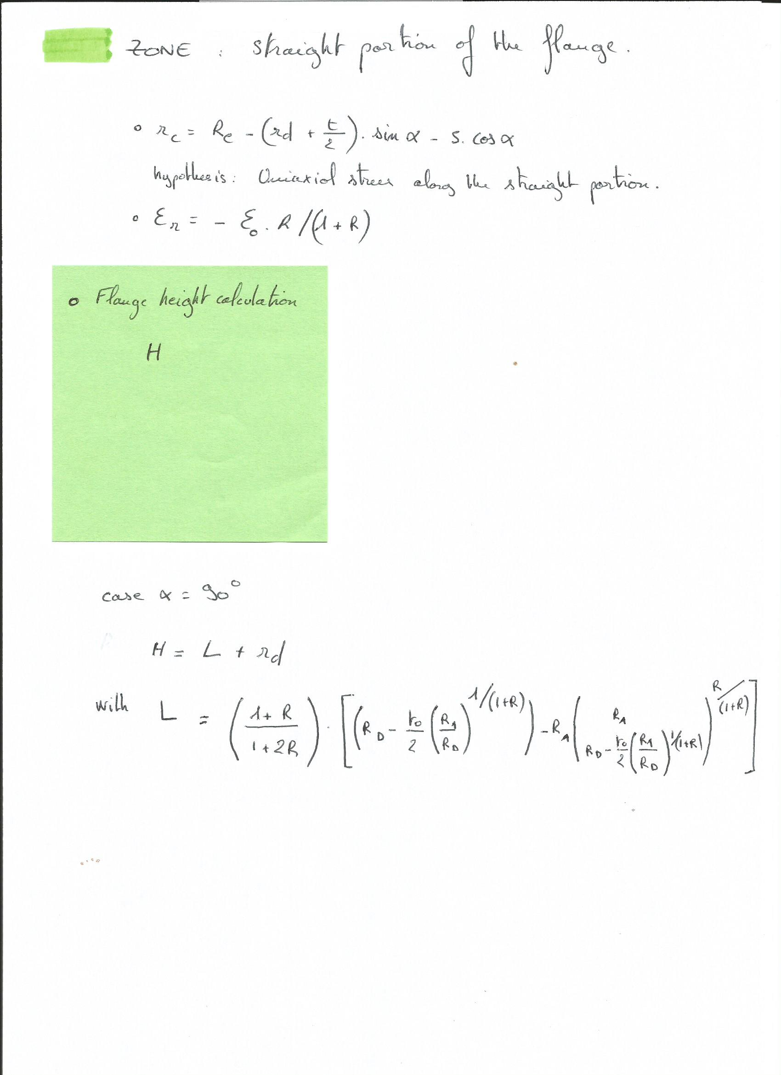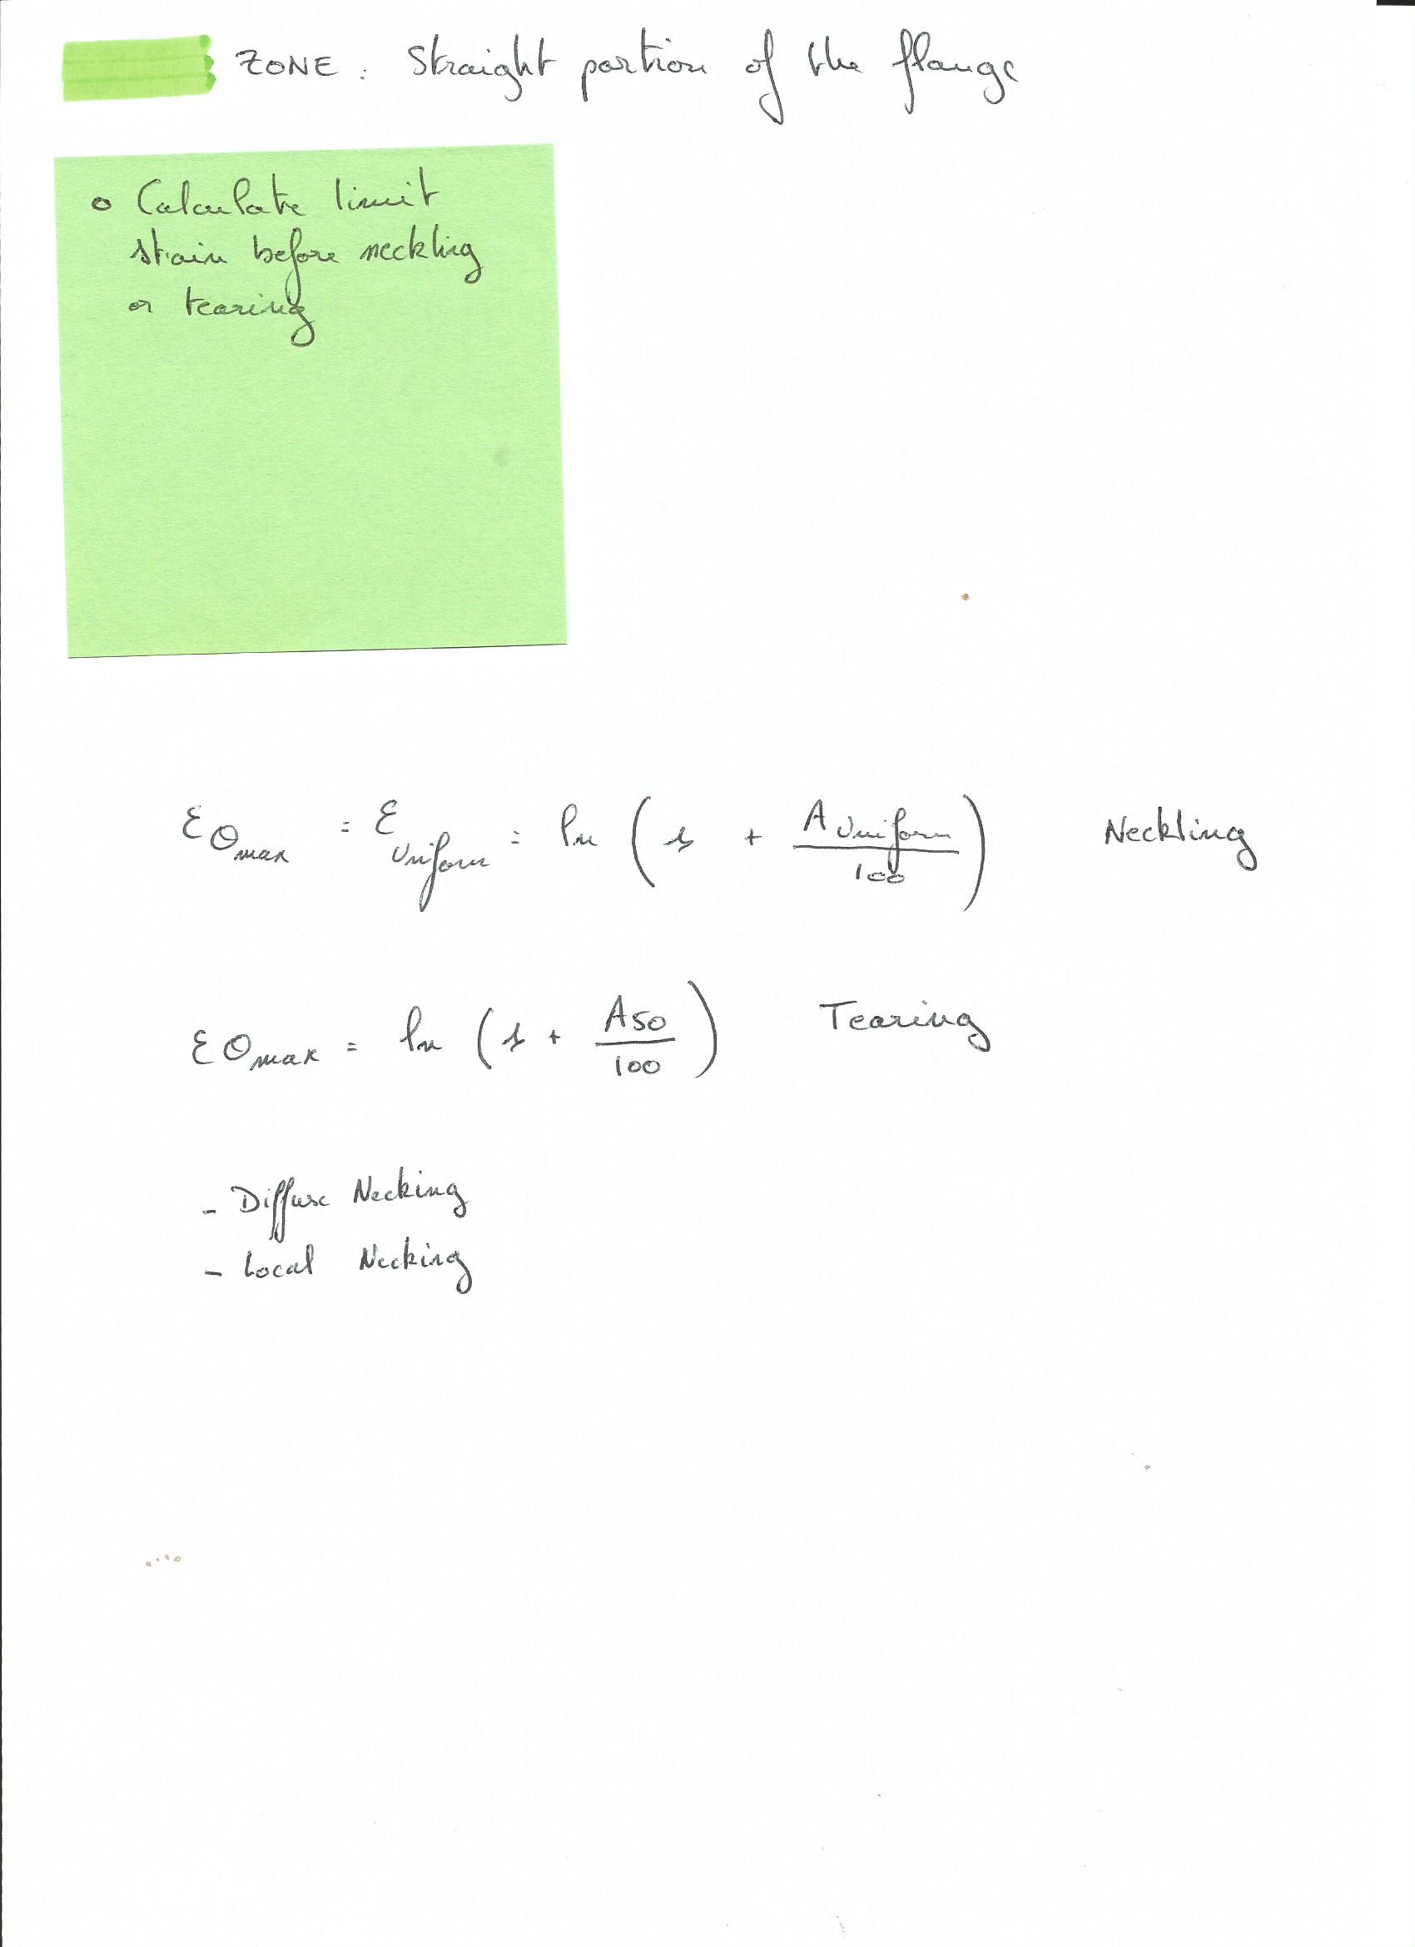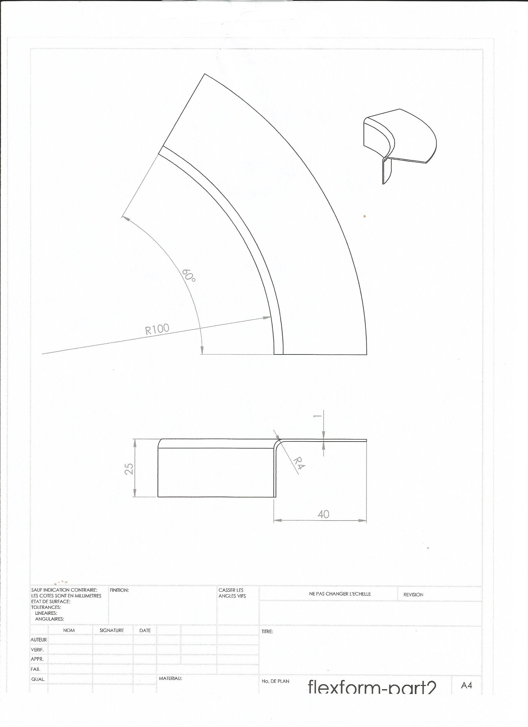 I. Studying of the part

Dimensions and material specifications
Nandja

Detailed design :
- Initial geometry for the machine
- Unfold dimensions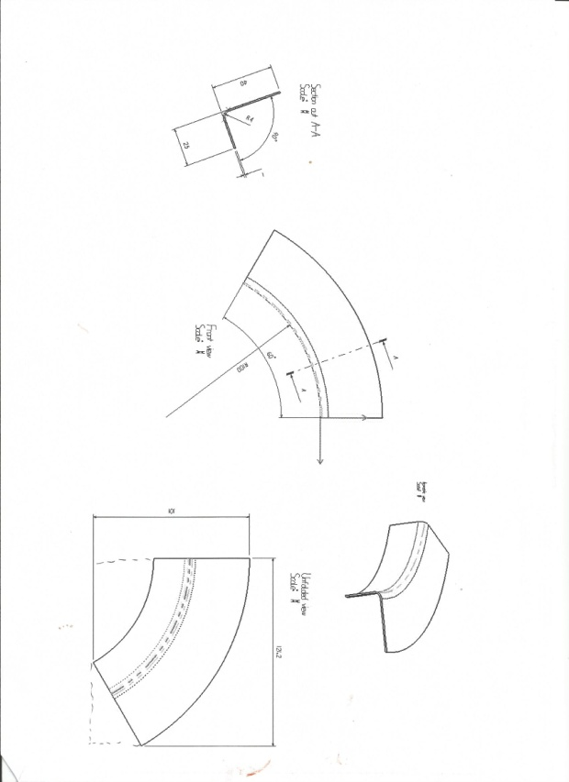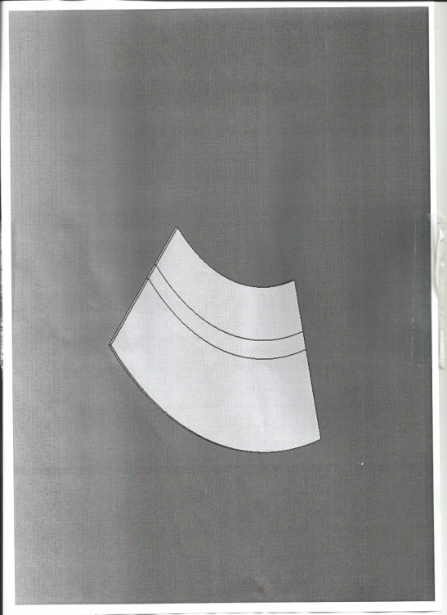

Deformation Modes
EVERYONE
After reading the documents and getting back to our mechanical lessons, we identified several deformation modes we need to take in account in order to keep the specification sheet dimensions. In order to describe those modes, we refer to the following figure where 2 specific zones have been identified in our piece :
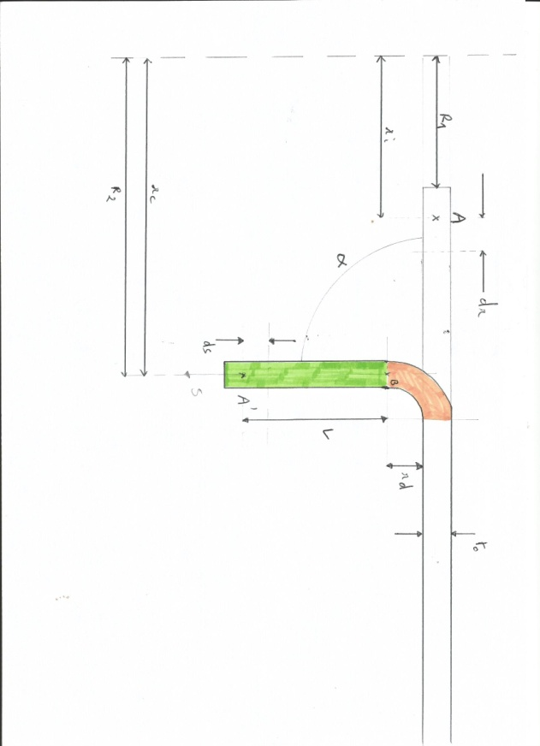

Springback
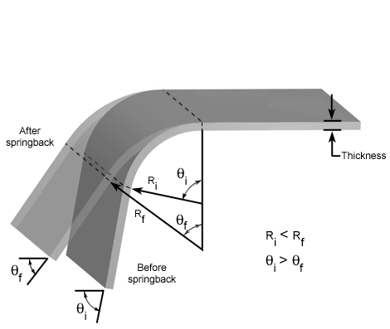
The spring bacK-Factor, commonly denoted by Ks, is the relation between the initial and final angles. A spring bacK-Factor of Ks=1 means there is no Spring Back, where a value of 0 means total Spring Back.
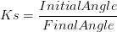
To calculate the spring back-Factor ahead of a test piece it is important to understand that the bend radius is affected as well as the angle. The radius of the bend will try and return in the same way the angle does meaning the initial radius (I.R.) will be slightly smaller than the final radius (F.R.). This relationship can also be used to define the spring back-Factor.
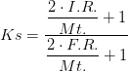
Given the ressources we have, we need to take this last step further sowe can incorporate the yield stress and elastic modulus into our calculations by the ratio of the initial radius and final one.
$$\frac{Ri}{Rf}=4({\frac{Ri×Y}{E×t})}^{3}-3({\frac{Ri×Y}{E×t})}^{}+1$$
Where ;
$$Y=Yield Stress = 324 MPa$$
$$t=Thickness in mm=1$$
$$E=YoungModulusofAl2024-O=73000MPa$$
The calculations give us the following results :$Ks=$ 0.97
Which means that our piece is expecting to unload until those values :
Final bend radius (in): | 4.111
Final bend angle (°): | 87.75

Flanging
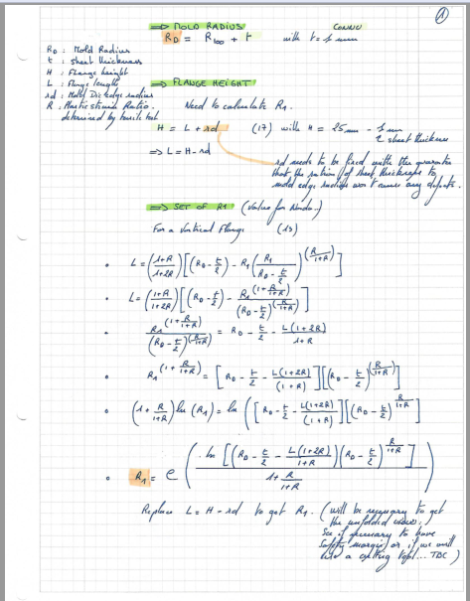

Bending Line
External
Internal

Friction stress
Rubber 2 aluminium sheet
Alu sheet to DIE

Thickness evolution during the process

Thickness of plate and elongation of sheet

Peak Strain
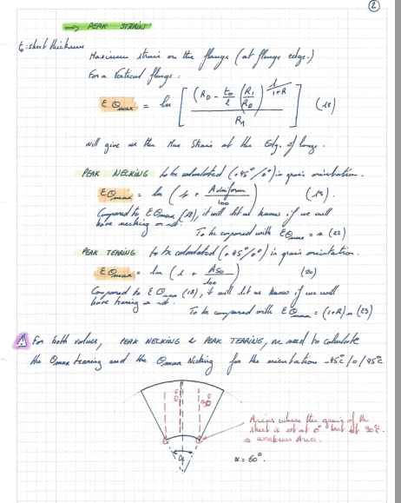

Conclusion on a suitable tool : DIE

Geometry configuration
Nandja

Holes to be positioned ?(defect holes ?)

Clamp ? (frictioncoeff)

Life time DIE (cycles temperature->fatigue)

Studying of the process

After studying the major deformation modes of our part, we were able to imagine an ASEA Quintus Fluid Cell process which can let us to manufacture our part.

ASEA Quintus hydroforming

Process operations and parameters for our application

Tableau 1: List of operations
OPERATIONS | TIME (TOTAL: 180min)
CUT PER GEOMETRY GIVEN | 15min
INSPECT THE CUTTING GEOMETRY | 15min
SHEAR THE PART GEOMETRY PER REQUIREMENTS | 15min
DEBURR | 5min
DRILL THE PRODUCTION HOLES PER DRAWING | 5min
DEBURR | 5min
FORM | 5min
CLEAN | 5min
HEAT TREATMENT | 60min
INSPECT THE GEOMETRY AND THE HARDNESS | 15min
PENETRANT TEST (NDT) | 5min
CHROMIC ACID ANODIZING | 15min
PRIMOR PAINT | 5min
PRIOR PAINT | 5min
IDENTITY AND FINAL INSPECT OF THE PART | 5min
PROTECION AND SEND TO WAREHOUSE | 5min

  - Detailed Process:
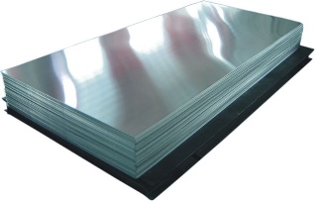
We will get the material from the warehouse, aluminium allow AW 2024-0. Because the raw material is an aluminum plate, we need to cut it into the smaller pieces before we can use it in the process.

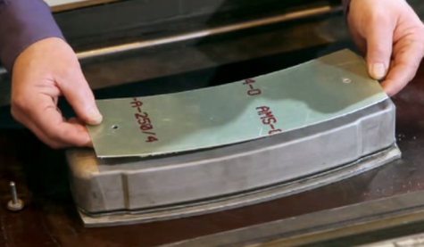
Before cutting, we will first inspect the material to make sure the standard and status is correct. We will also record its lot number for the traceability. After this step, we cut the material into small pieces. Then, we shear the part with the drawing requirements. After trimming, we will deburr the part. We drill the two production holes which are going to be used when forming.
Fixations of the part

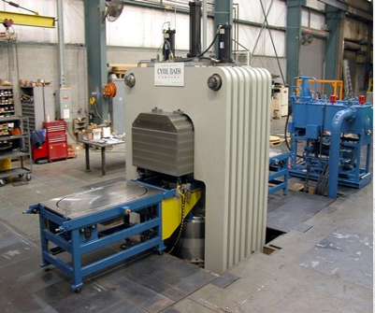
After drilling holes, we use a plastic diaphragm to protect the surface and prevent corrosion. And then, we put the part on the die, fixing it with two bolts to the die. We will use some lubricant which is mineral grease to prevent frictions between the part and die and frictions between the part and rub pad. We need to be careful in this step that we should even out the lubricant in order not to have burble or defect on the part.

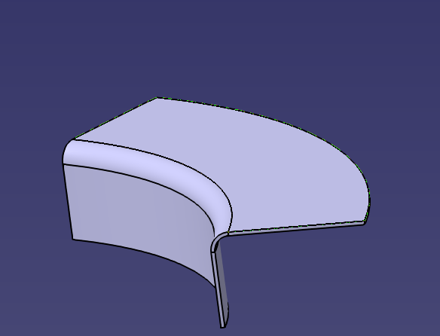
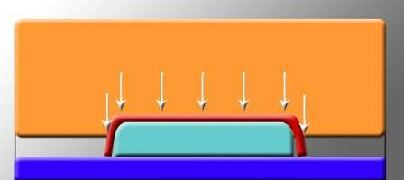
Then we start the forming process. Something needs to mentioned here is we normally use a blank holder to prevent wrincles on the shrink flange. And the blank holder is often made of hardwood that is perfect for the aluminium process because it has less friction. But in this case, our part does not have a shrink flange. So we don’t need a blank holder. Then we applying 1000 bar pressure to form the part into the final geometry. After forming, we will remove the plastic film on the part. Clean the surface of the part then going to the heat treatment step to increase the hardness of the part.
P=1000 Bar
When heat treatment is done, we will inspect the geometry and hardness of the part to see if there is any defects there. Next step is NDT test. We use penetrant test to ensure the part has not any cracks on the surface. Then we finish the surface protection, we will use chromic acid anodizing to lay up a chemical diaphragm on the part to prevent it from corrosion. After surface protection, we will move the part to painting workshop and paint with prior and primer paint. Before the part is sent into ware house we will perform the final inspection and stamp the part with its part name and date. At last, the part will be sent into warehouse with some protections outside of it.

Estimate the global cost of the process
Oriol

Improvements

Quality inspection
Figure with every steps of the process + calculations step and quality inspection steps including
Rejet ?
Define tolerance (available in one pdf doc)

Process monitoring and controlling
Levels of action
Corrective and preventive actions
Other tools ?
Optimisation : in 1 shot ?

Conclusion and answers to the learning objectives
Marie

Maybe talking about the after heat treatment and surface treatment ?
Other idea : bending with rolls

Thanks to the PBL Approach, we are able to propose a solution to manufacture a given part for our aerospace supplier. Below is a short summary of the answers we developed to each learning objective.

