PROBLEM DEFINITION
The goal of this Project is to study the possibility to manufacture a sheet metal part whose geometry has been defined by the customer. Material has been given as a requirement and forming operation has been suggested.
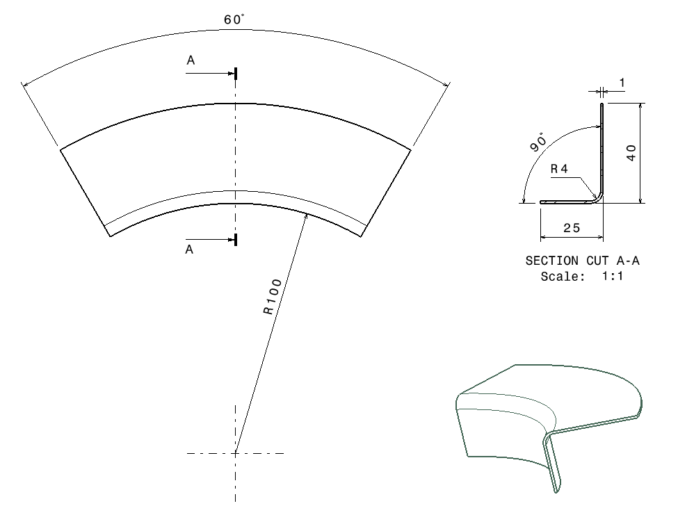
Figure 1 - Geometrical definition of the part

Material | t₀ [mm] | Direction [°] | R | N | K [MPa]
2024-0 | 1.02 | 0 | 0.839 | 0.182 | 319.3
 | 1.01 | 45 | 1.024 | 0.185 | 299.0
 | 1.02 | 90 | 0.710 | 0.182 | 302.3
 | 1.0 | X_{n} | 0.90 | 0.18 | 305
Table 1 - Material properties
In order to better organize the work, the problem was divided into two main topics described as follows.
Design Feasibility Analysis
The first question to consider is whether the part will be possible to manufacture or not. The specified geometry needs to be analysed to check for possible problem areas during manufacturing.
As a Process Engineering team, our focus is to manufacture the final part as it has been design by Product Engineers. Due to the lack of awareness of design considerations, geometrical modifications cannot be made without prior consensus of the Design Office. Nevertheless, the geometry needs to be verified, ensuring the feasibility of manufacturing. If that were not the case, a request for modifications, properly justified, should be submitted to the Design Team.
Two potential problem areas have been identified: the outer surface of the bending radius and the lower edge of the stretch flange.
Bending radius (BR)
When bending a flange on a sheet metal, the inner surface will be submitted to compressive stresses and the outer surface to tensile stresses, due to the application of a bending moment. The critical region is the outer surface, where crack formation may occur. It should then be verified that for the given material and thickness, the bending radius is large enough to prevent failure.

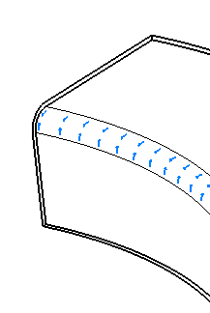
Figure 2 - Compression zone on bending radius
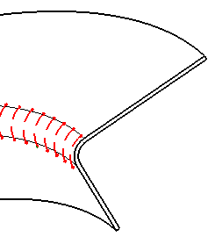
Figure 3 - Traction zone on bending radius

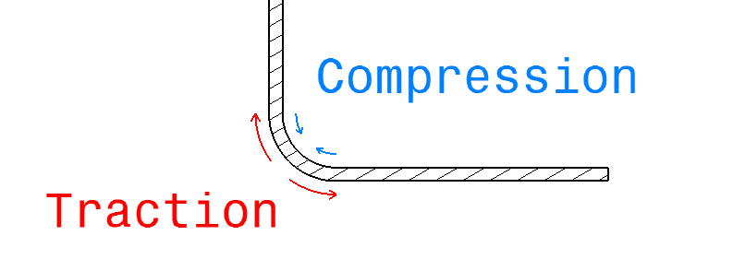
Figure 4 - Traction and compression on BR

Stretch Flange
Another critical zone to analyse is the lower edge of the flange. In order to achieve the desired geometry, the flange must stretch during the forming process. This could lead to crack formation in the lower edge, where stretching is the most critical.
To clarify this effect the concept of Outer Mould Line (OML) must be introduced. The OML is the line of intersection between the extrapolated outer surfaces of the web and the flange. (Fig. 5)
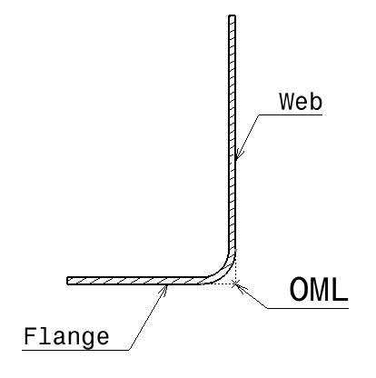
Figure 5 - Definition of OML
Considering this line as a reference, it can be observed that after forming, the lower edge of the flange stretches, to adapt to the final geometry, being equal in length to the OML. On the blank however, the same edge has a shorter length compared to the OML. This effect originates the name of stretch flange.
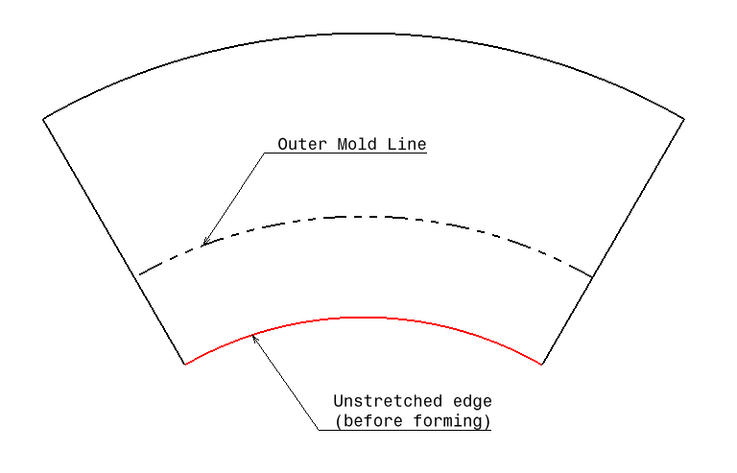
Figure 6 - Blank (edge before forming shorter than OML)

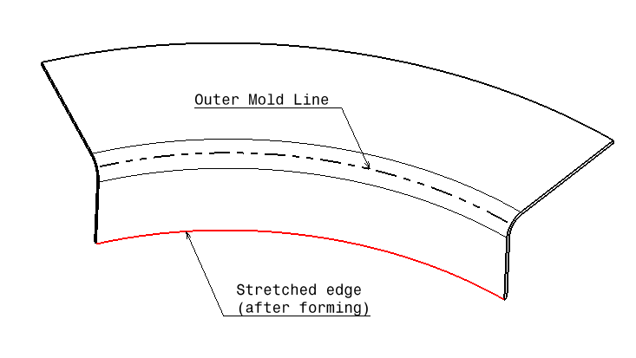
Figure 7 - Formed part (edge after forming of same length as OML)

Manufacturing Process Definition
Once the manufacturability of the part has been verified, the process has to be more clearly defined. This implies selecting the appropriate forming process, defining the geometry of the blank and designing the necessary tooling.
Selection of Forming Process
Selecting the manufacturing process is the first fundamental step to be defined. Advantages and drawbacks need to be analysed before deciding whether to use one process or another.
For the given geometry of the part, and considering the production rate required, a hydroforming process seems like the obvious choice, as it has been suggested by the customer.
The reasons for selecting the hydroforming process have to be clearly established at this stage, and if necessary, a more suitable process is to be selected.
Ease of operation, efficiency, quality, maintenance requirements and cost are some of the variables to be taken into account.
Blank Design
Before submission to a hydroforming process, the raw sheet metal has to be trimmed to create a blank. The trimming contour has to be defined so that the final part after forming achieves the desired geometry. This blank definition implies estimating the deformations on the different areas of the final part.
In principle, two main zones of deformation can be identified: the bending radius and the stretch flange. Both of them have been studied regarding stretching and the possibility of crack failure.
Initial estimation of the blank contour requires determination of the following variable:
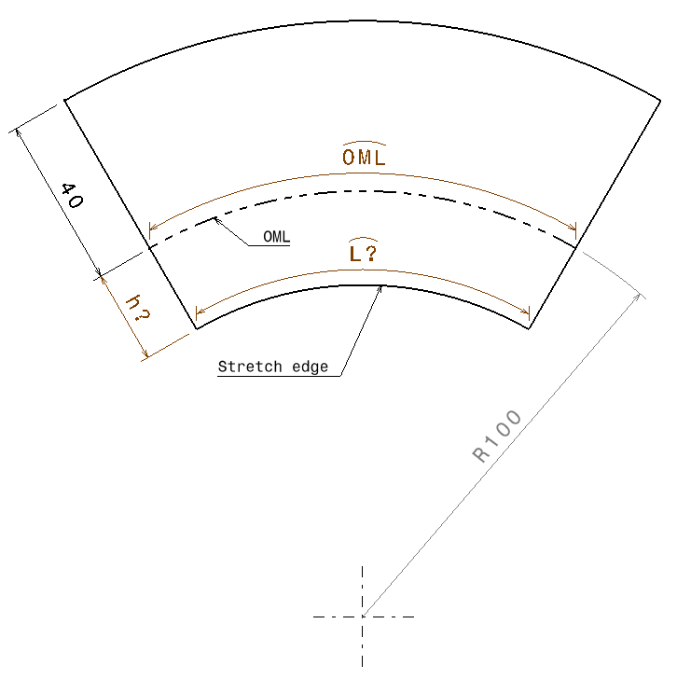
Figure 8 - Blank unknowns

Determining the initial length of the lower edge of the flange (L) implies defining the maximum deformation of the stretch flange. The final value should equal the length of the outer mould line (OML).
The final high of the flange and the deformation while bending the smaller radius are necessary to determine the initial length (h) from the OML to the stretch edge.
After defining the blank geometry, the trimming process has to be selected. Advantages and disadvantages of different process will be analysed to correctly justify the selection. The orientation of the material fibres is also to be defined and justified.

