Practice of PAM-RTM

Marie Jolly
Rafael Reyes

Pinj

Introduction

In this practical session, we aim to study the behavior of the resin injection through several parts and several configurations. We also want to see the effect of adding external components such as trigger or gravity force. This work allowed us to have a better understanding of the optimal parameters for a given geometry. The first part is dedicated to the study of a filling of a rectangular plate made by one material. Then we choose to study a different geometry which includes an inlet on the center. Finally, we will determine the influence of curved lines in a part.

Study

Linear injection of a rectangular plate
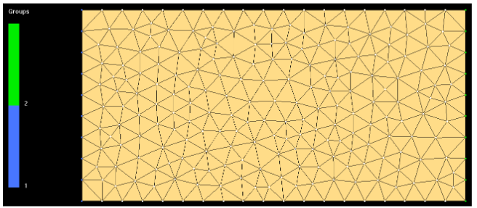
Figure 1 : Rectangular plate

Simple case
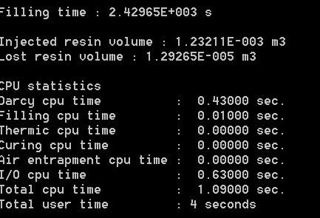
Figure 2 : Computational parameters case01a
Being the simplest of cases, case01a took a very short time to compute (4s). Filling time was 2429s. When the filling is complete, the simulation stops. That is why there is only about 1% lost resin volume.
Based on the expression of Darcy’s Law for 1D flow, the given material and process parameters, we are able to calculate the theoretical fill time of our part:
$$t_{fill}=\frac{μ\left(1-Vf\right)L²}{2KPinj}=\frac{0.1×0.5×1²}{2×{10}^{-10}×{10}^{5}}=2500s$$
This is very close to the simulation results.
Those results are not realistic. Indeed, we consider our mold has only straight edges and we ignore the race-tracking effects, responsible of the decreasing on the filing time. It can be observed that the flow front is uniform and the filling is even throughout the width of the laminate. We could improve those results about filling time by using a finer mesh.
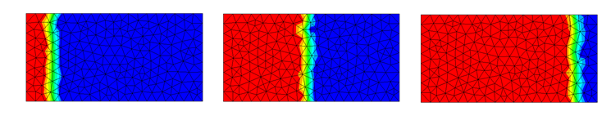
Figure 3 : Figure of the flow front at different times during the process
Pressure gradient is approximately constant by the end of the simulation, having the highest pressure near the inlet, and vacuum near the vent, as expected.
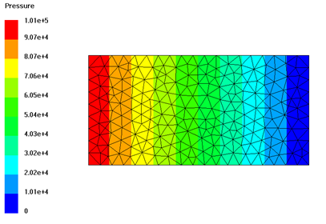
Figure 4 : Final pressure distribution case01a.

Effect of race-tracking

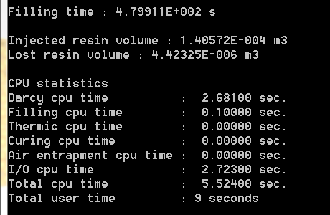
Figure 5 – Computational parameters case01b.
The second simulation added a new zone without fibers, representing a race-tracking channel, where resin will flow more easily.
The filling time with the previous case has decreased significantly, going from 2430s to 480s. While the preform permeability, inlet pressure and vent remain the same, the size is nearly 10 times smaller (1x0.5 vs 0.5x0.105). Moreover the race-tracking channel also contributes to reducing filling time.
Flow front is no longer uniform width-wise, but resin flows faster on the upper edge, where the race-tracking channel is located. This increases the resin lost since one edge reaches the vent before the other. The resin loss is about 3% of the injected resin volume, higher than in the previous simulation. Another channel on the lower edge would help reduce this effect by making the flow front more uniform, although there may still be some delay in the middle. If another channel is to be avoided, placing the vent on the lower right corner could be a possible solution.
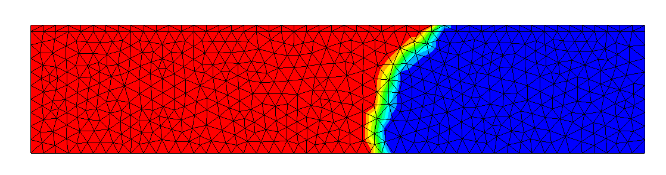
Figure 6 – Flow front case01b.

When comparing it to a case with the same geometry but no race-tracking channel, a decrease in filling time can still be observed, as well as a gradient of filling time in the width direction, increasing further away from the race-tracking area.
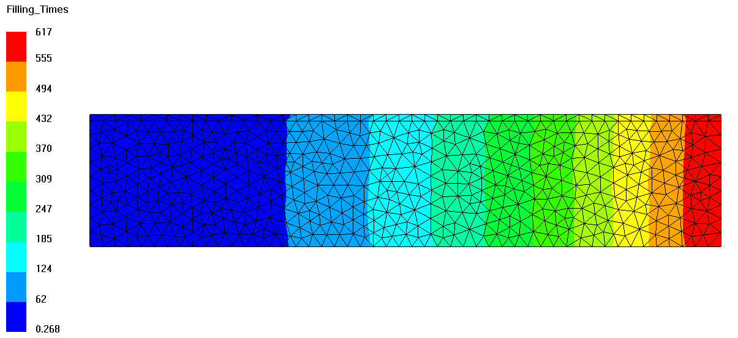
Figure 7 – Filling time case01b without race-tracking.
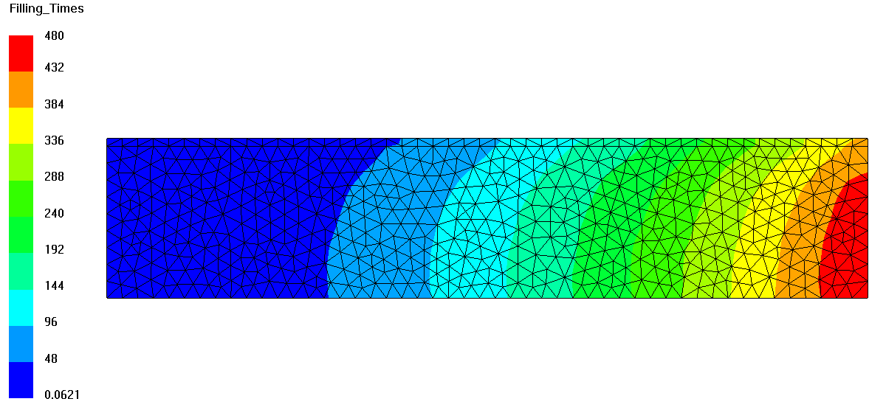
Figure 8 – Filling time case01b with race-tracking.

At any given period of time before filling is complete, the pressure decreases near the channel, as it can be seen in the figure.
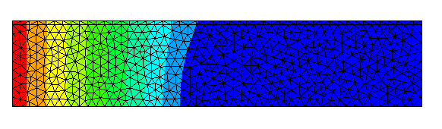
Figure 9 – Pressure distribution before filling is complete case01b.

Effect of race-tracking no vent
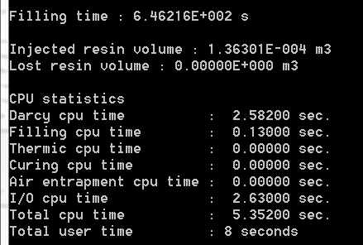
Figure 10 – Computational parameters case01c.
In this case, it can be observed that by removing the vent, the filling time increases, reaching about 650s. Obviously, there is no resin lost for this case.
Keeping the vent has the effect of homogenizing the pressure front at any given time of the process, making it remain constant width-wise.
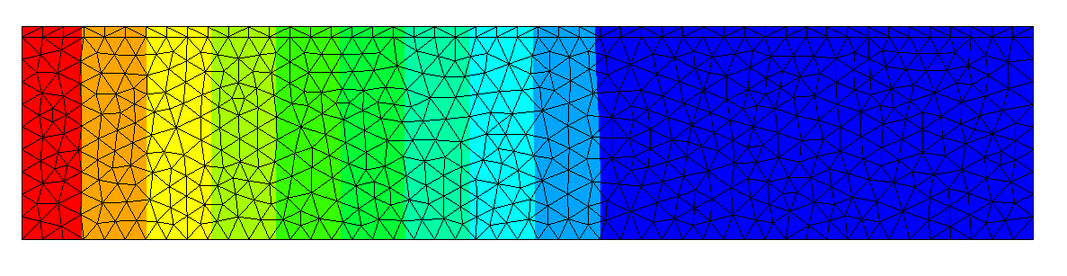
Figure 11 – Constant pressure width-wise case01c.
This pressure distribution tends to homogenize both the flow front and the filling time, reducing the variations induced by the race-tracking channel in the previous case.
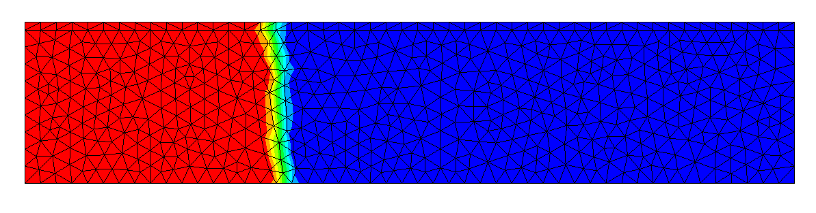
Figure 12 – Flow front case01c.
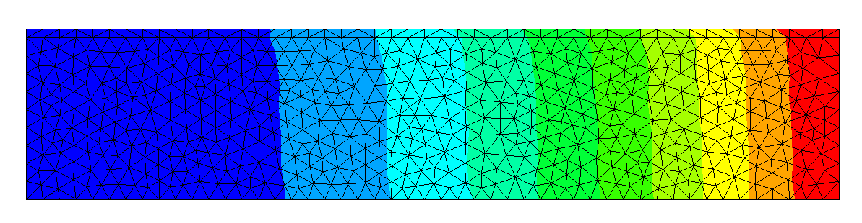
Figure 13 – Filling times case01c.

Effect of race-tracking, adding a runner

We now remesh our part in order to get more precise results and add a vent. In this case, a runner in the mold is created, to verify its effects on filling time. The runner is represented by a different zone with no fiber, similarly to the race-tracking example.
Unlike race-tracking, the runner is intentionally added to the mold. Nevertheless, its effects are expected to be similar.

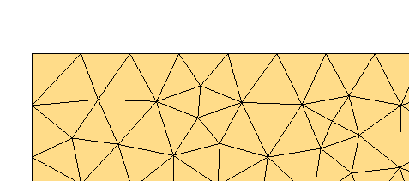
Figure 14 –Original mesh
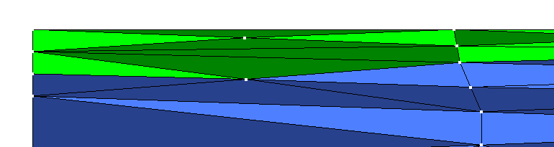
Figure 15 – Runner represented by newly meshed zone at the upper edge of the part (green).

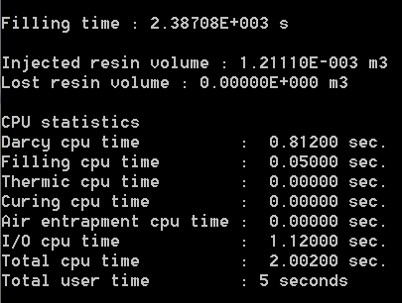
Figure 16 – Computational parameters case01d.
This example used the same geometry of case01a. The total filling time was 2387s. As it has been explained in case01c, removing the vent increases filling time. But in this case, race-tracking has a stronger effect, and overall filling time is shorter than in case01a (2429s).
Having the same geometry, it can be observed that the injected volume of resin is about the same as in case01a, while resin lost is 0, since there is no vent.
Observing filling times, the same uniform distribution (similar to case01c) caused by the lack of a vent can be found. No faster filling is observed near the runner.
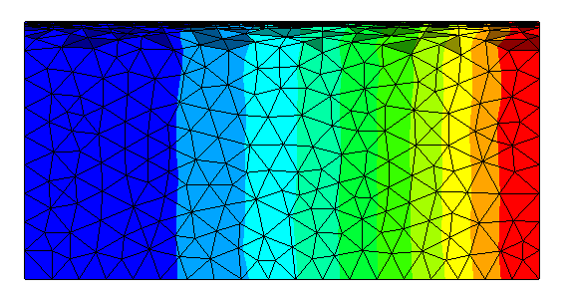
Figure 17 – Filling times case01d.

Effect of vent and air entrapment

The geometric configuration and injection pressure are identical to that of case01a. The difference is that the vent is closed at 2000s, and that air traps have been taken into account.
As air entrapment is considered, filling time and injected resin volume decrease slightly with respect to case01a, since air does not allow for 100% filling with resin.
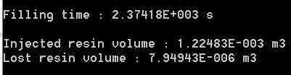
Figure 18 – Isolated effects of air entrapment
Once the vent is closed at 2000s, final parameters change more drastically. The simulation runs 22s beyond the closing of the vent, thus, there could be no resin loss.
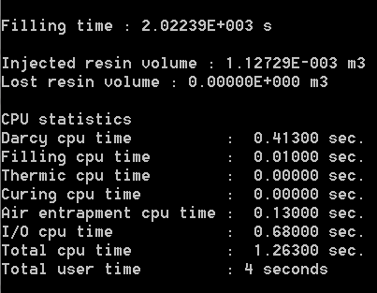
Figure 19 – Computational parameters case01e.
The decrease in the injected volume of resin and the filling time can be understood clearly by looking at the final filling times. We can also noticed that the mold is not completely filled because of what is called air trapped.
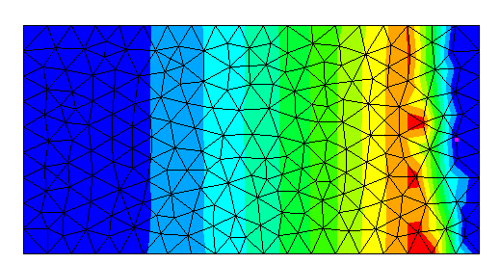
Figure 20 – Filling times case01e
It can be observed that the right side of the mold never filled completely. Looking closely at pressure variation can explain this phenomenon. It can be observed that when closing the vent, the pressure quickly becomes uniform throughout the length of the mold, thus making the flow stops.
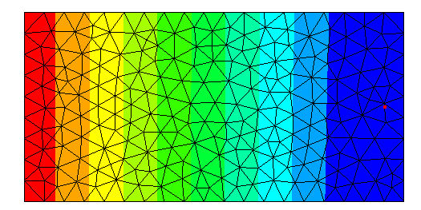
Figure 21 – Pressure distribution before closing the vent – case01e.
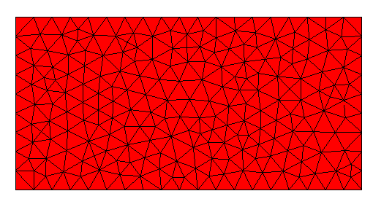
Figure 22 – Final pressure distribution case01e.
A sensor placed near the vent can show the rapid increase in pressure.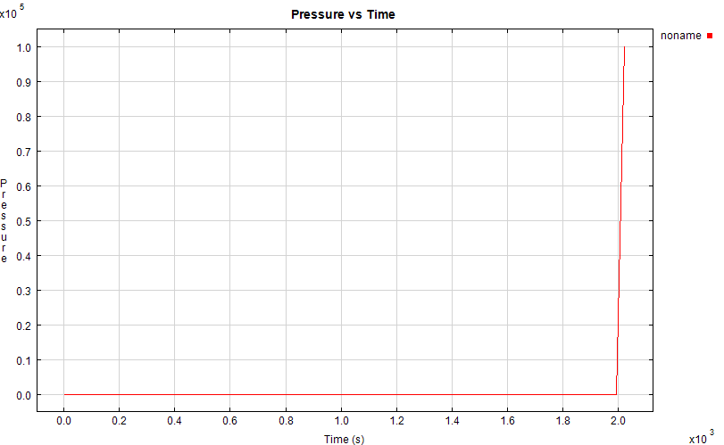Figure 23 – Pressure sensor measurements.

In real life, we never got a perfect vaccum in your cavity, leaving some air trapped. We can see them in the simulation case, where the flow front reaches a specific zone before the general average position. Nonetheless, we can notice a significant effect on the results.

Effect of gravity

To analyze the effect of gravity, two cases have been run. In the first case, the effect of gravity is favorable to the flow front. In the second, it is against it.
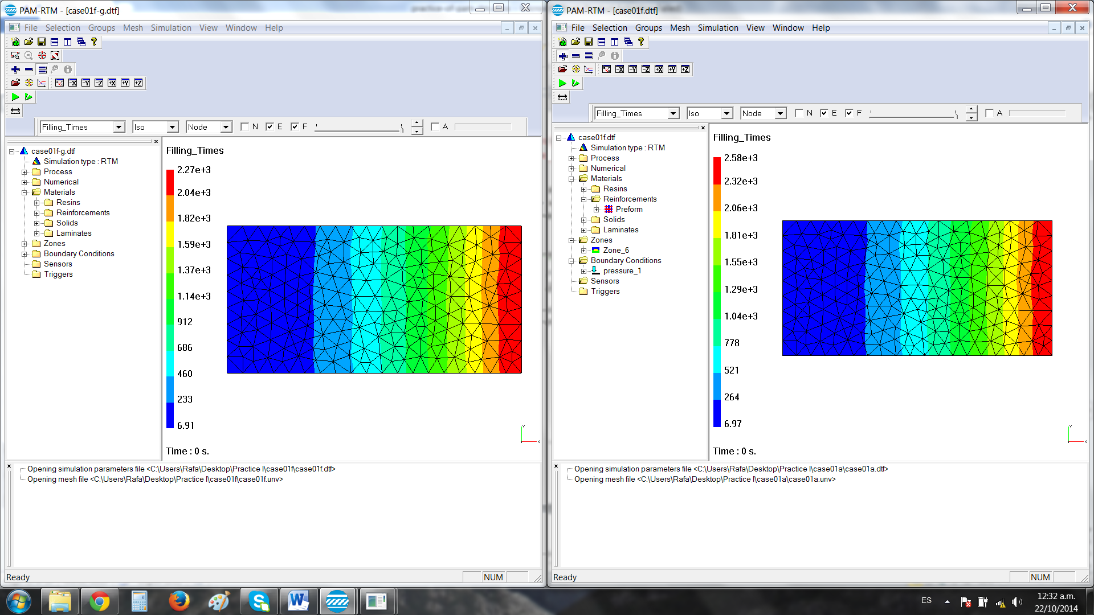
Figure 24 – Filling time with favorable effects of gravity.
Figure 25 – Filling times with opposing effect of gravity.
The effect of gravity on pressure distribution is also noticeable. Near the times for full filling, it can be observed that high pressure zones near the inlet are reduced when gravity is acting in the direction of flow; and are increased when gravity opposes resin flow.
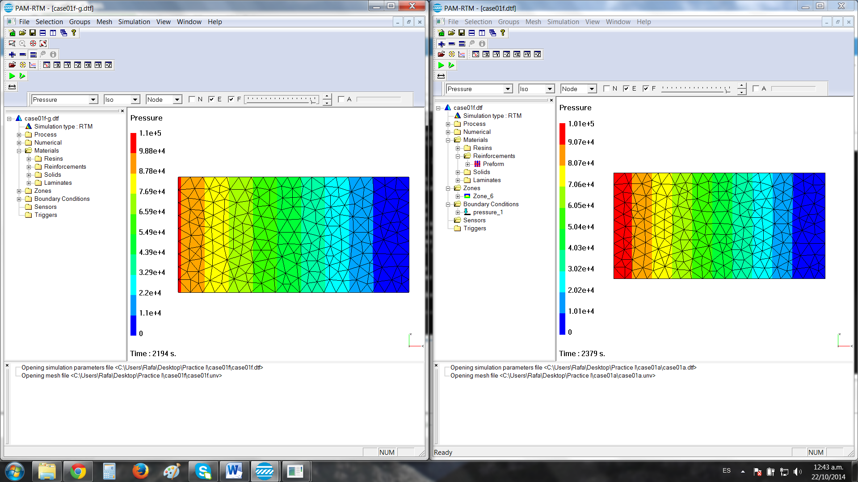
Figure 26 – Pressure distribution near full filling for gravity in the direction of flow.
Figure 27 – Pressure distribution near full filling for gravity against flow.
Analytically we can consider the gravity by adding a term to the calculation of filling time according to Darcy’s Law. In order to consider it, we calculate the filling time again by integrate with the parameters about pressure $∇p±ρg$ instead of $∇p$ only, according the fact if we are working the positive or negative $\vec{x}$ vector direction.
The math leads us to a new analytical formula for the filling time:
$$t_{fill}=\frac{μ\left(1-Vf\right)L²}{2KPinj}×\frac{1}{1±\frac{ρgL}{Pinj}}=\frac{0.1×0.5×1²}{2×{10}^{-10}×{10}^{5}}×\frac{1}{1±\frac{1000×9.8×1}{{10}^{5}}}=\left\{\begin{aligned}2275s if we are in the x positive sens \\ 2745s if we are in the x negative sens\end{aligned}\right.$$
The simulation results are presented as follows.
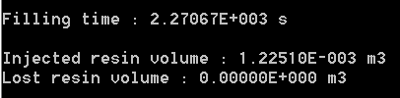
Figure 28 - Results injection aided by gravity
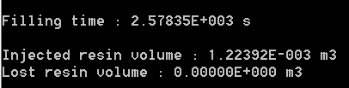
Figure 29 - Results injection opposed by gravity.
The simulation results are quite close to the analytical solution, which let us to conclude on a good model of filling time.

Those results let us to conclude on the fact that the effect of gravity will influence the filling process by skewing the flow front. In both cases, we have the same amount of injected resin but the filling time is higher in the first case because the gravity is going in the reverse direction of the filling process. Indeed in the positive direction, we found that the gravity helps the resin to flow in the mold.

Central injection of a square plate
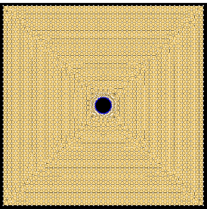
Figure 30 : Plain square mesh

Remeshing for injection port

In this case, a square laminate with an injection point at the middle and no vents is simulated.
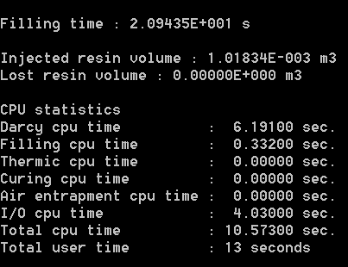
Figure 31 – Computational parameters case02a.
It can be observed that the flow progresses in a radial direction moving away from the inlet, until it reaches the edges of the laminate. From that point on, the corners begin filling with a flow front approaching from all directions.
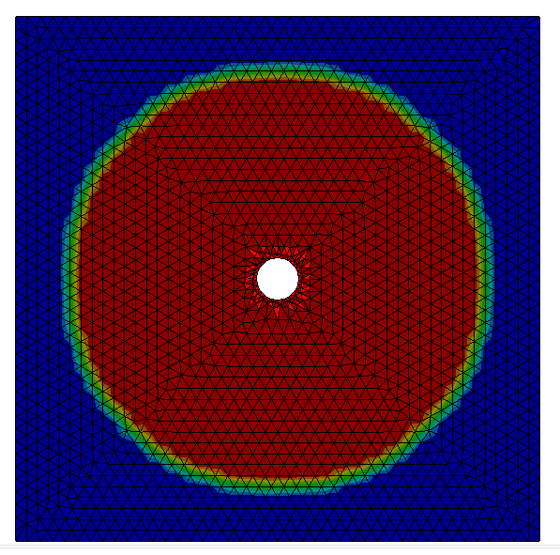
Figure 32 - Radial progression of flow front.
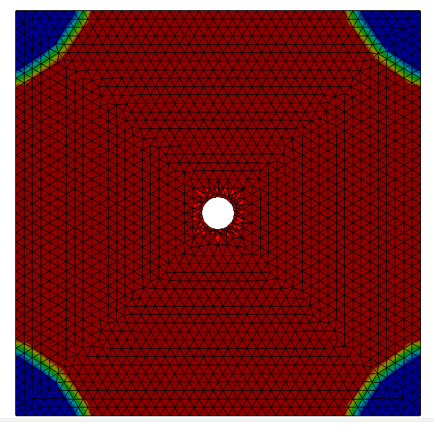
Figure 33 - Flow front converging to the corners after reaching edges.
The change in direction of the flow front can also be observed through filling times.
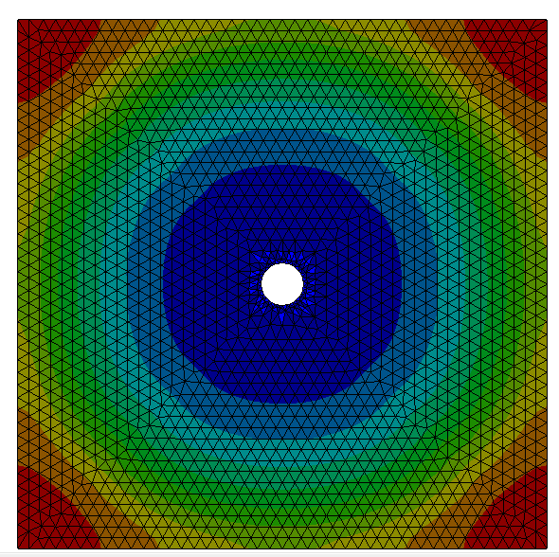
Figure 34 - Filling times case02a.
Pressure distribution shows a similar pattern to the filling results. Results are presented at a time before reaching the edges and just before the end, when it reaches a constant, uniform value throughout the whole laminate.
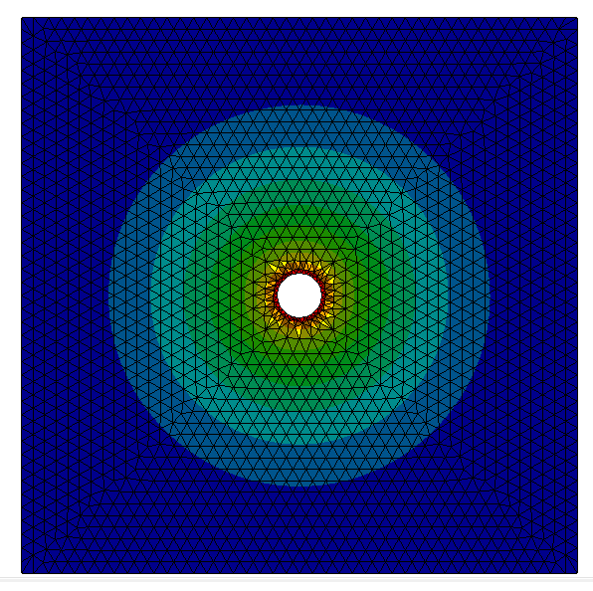
Figure 35 - Pressure distribution before the resin reaches the edges.
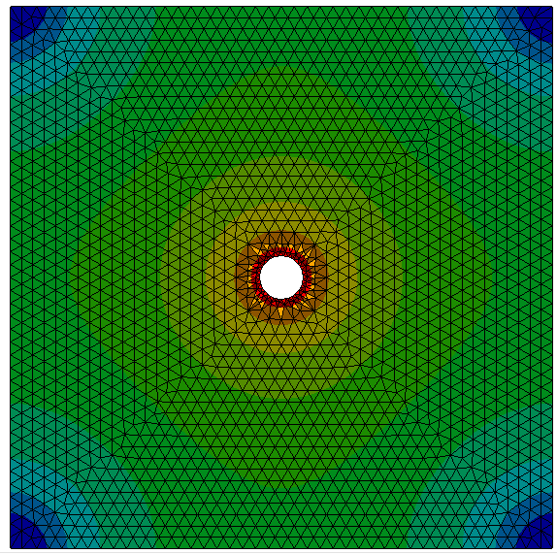
Figure 36 - Pressure distribution right before full filling.
Giving the shift in flow front direction, the flow cannot be considered 1D and Darcy’s law cannot be applied as it has been introduced cannot be used.
Analytically, considering L=0.25, the filling time until the edges is t_{a}=7.29s. Simulation yields t_{s}=15s. Results vary significantly, verifying the hypothesis that time cannot be calculated analytically, even if only until the resin reaches the edges. This is due to the fact that flow is not 1D, but radial. An appropriate expression of Darcy’s law for radial flow should be suitable for comparisons.

Central injection of an orthotropic square plate

In this case, preform permeability will change in different directions and its effects will be analyzed. Also, 4 vents have been added at the corners. Two of them at the 0° direction, and two at the 90° direction.
Naturally, as it is a more complex case than the previous one, simulation time (total CPU time) increased significantly.
It can also be observed that the raise in volume of resin injected equals the amount of resin lost at the newly placed vents.
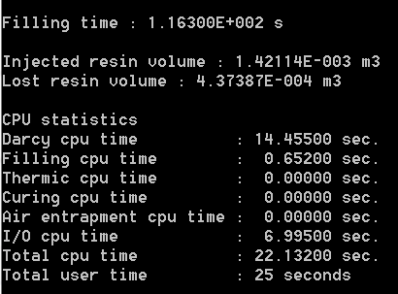
Figure 37 - Computational parameters case02b.
There was a huge increase in filling time, from 20s to 116s. In can be observed that in the 0° with the permeability equal to that of the previous case, the resin reaches the corner vent in just over 20s. This result is comparable to the filling time of 20s in case01a. The overall increase in filling time can then be attributed to the decrease in permeability in the 90° direction.
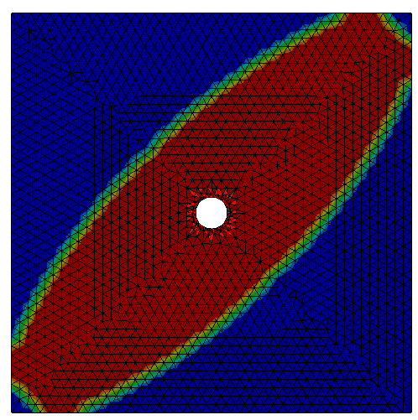
Figure 38 - Faster filling in the highest permeability direction.
It can be observed that the resin loss will be mainly through the two vents placed along the 0° direction of the fabric.
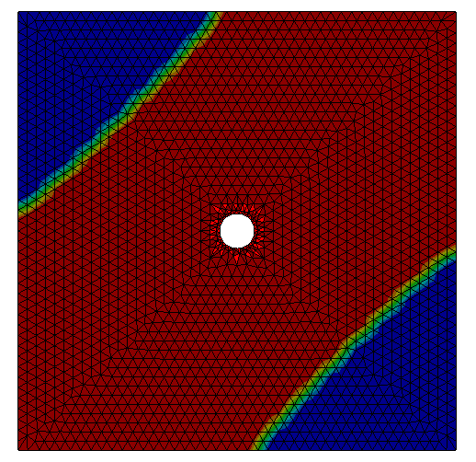
Figure 39 - Nearly constant flow front for lowest permeability direction, once filling has reached the vents in highest permeability direction.
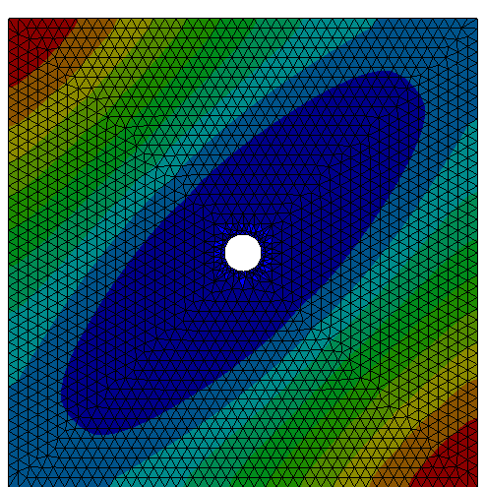
Figure 40 - Final feeling times give clear appreciation of flow front permeability effects.
Considering Darcy’s law for the 0° direction (highest permeability), the filling time obtained is t_{a}=14.6s. Simulation time is approximately t_{s}=20s. The time difference has decreased notoriously in this case. This is because the difference in permeability induces a somewhat 1D behavior of the flow during the first stages of filling. This filling case could be considered in between radial and linear.

Central injection of an orthotropic square plate use of trigger

In order to spare a waste of resin in the vents, we now want to use a trigger for automatic vent closing when the resin reaches a vent.
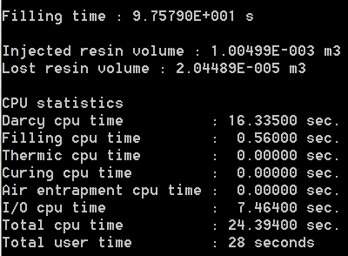
Figure 41 - Computational parameters case02c.
The first important observation is that by closing the vents once the resin reaches the vents in the high permeability direction, the resin loss is reduced to about 5% that of the previous case.
Filling time is slightly decreased (from 116s to 97s). The simulation is identical until the vents are closed. Then the greater gradient of pressure in the 90°, low permeability direction, helps to redirection the flow and accelerates filling.
This effect can be seen when comparing pressure distribution for both cases after the resin reaches the first two vents.
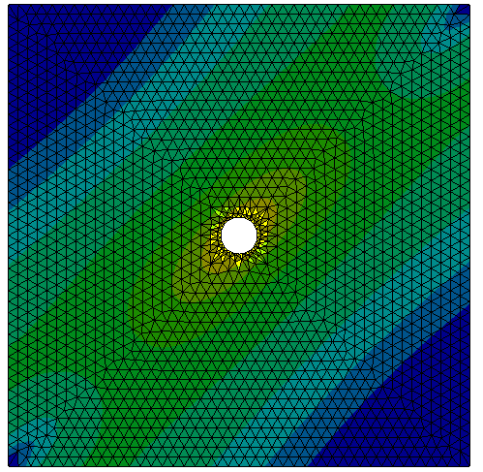
Figure 42 - Pressure gradients in two directions (0° and 90°) after resin reaches first two vents. Case02b.
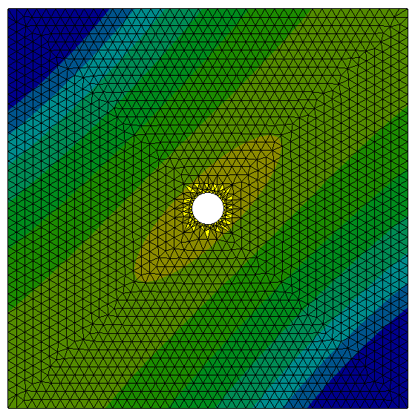
Figure 43 - Pressure gradient in 90° after the resin reaches the first two vents. Case02c.
Filling times are lower, but qualitatively similar to the previous simulation.
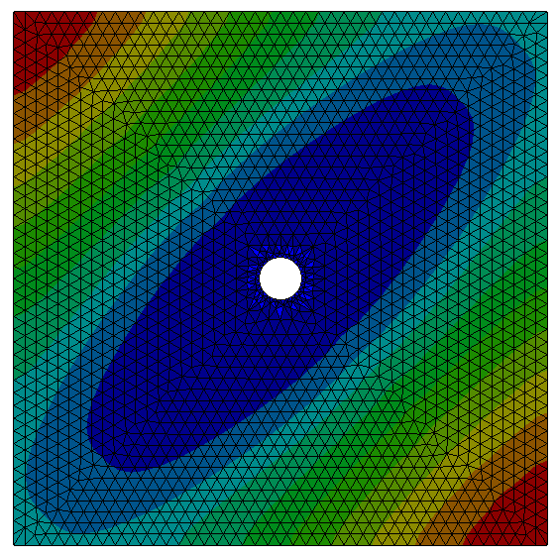

Injection analysis with 2D/2.5D/3D mesh
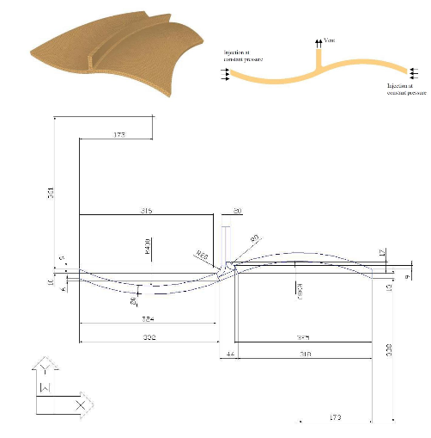
Now we are going to turn on a new curved surface reinforced by a central rib. We aim to study different approach to simulate an injection. The injection will be performed by the two lower extremities and a vent is placed along the top of the rib.

Results | Study of the 2D case | Study of the 2.5D case | Study of the 3D case
tfill | 13.58 | 16.15 | 40.28
Vinjected (mˆ3) | 3.95*10^(-5) | 1.88*10^(-3) | 7.139*10^(-3)
Vlost (mˆ3) | 2.976*10^(-8) | 6.85*10^(-5) | 7.22*10^(-5)
Flow front progression | 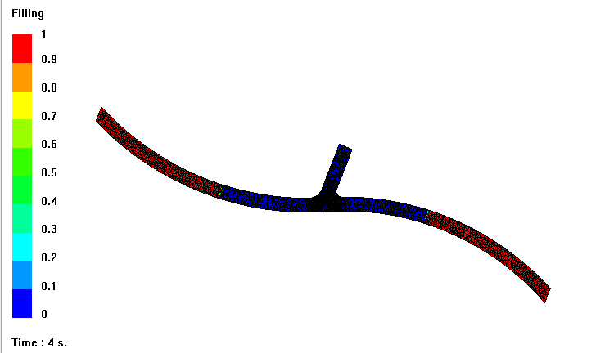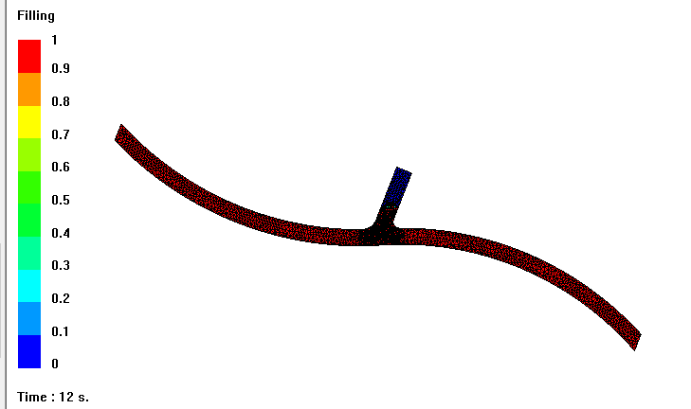 | 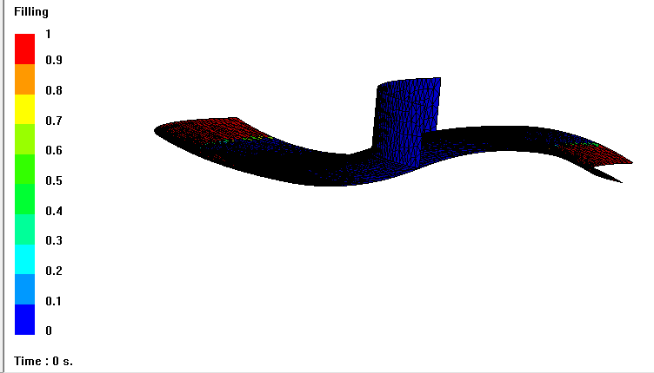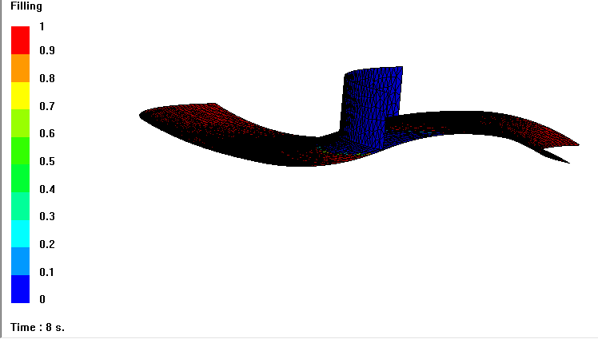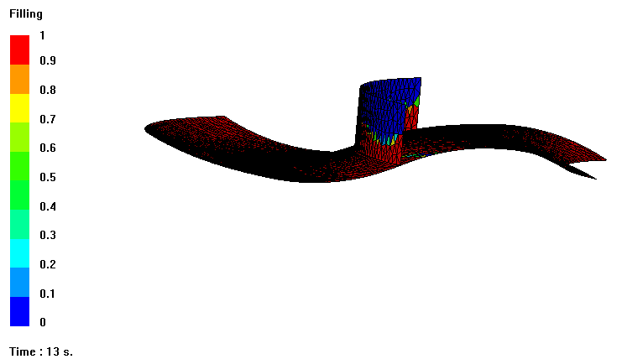 | 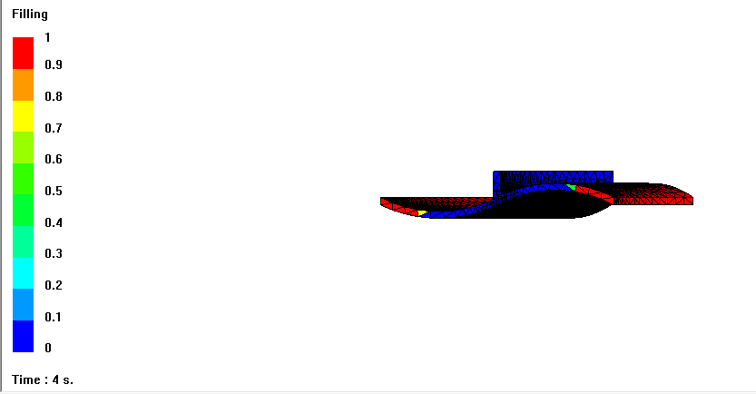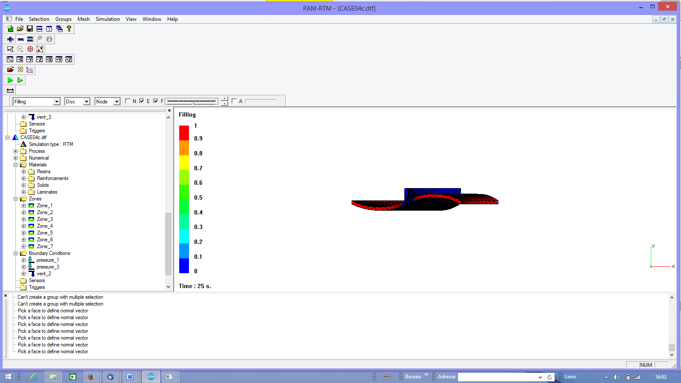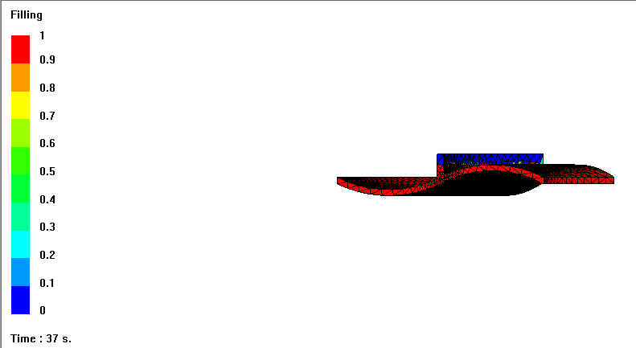
CPU Statistics
Darcy CPU Time(s) | 120.16 | 12.94 | 528.95
Filling CPU Time (s) | 1.485 | 0.74 | 16.16
I/O CPU Time | 134.72 | 5.772 | 177.61
Total CPU Time | 256.425 | 19.47 | 722.82
Total user time | 4min18s | 20 | 12min10s
Nodes | 1824 | 2071 | 8982
Elements | 3084 | 3979 | 35137
Role of the rib junction | Evacuate the flow | Get the same speed on the surface of the vent to avoid air trappement | Evacuate resin and avoid air trappement, get a minimum of resin loss
Effect of the convergent/divergent flow | None, we can notice almost the same speed | The flow speed is increased when the face is going divergent aside the rib | Evacuate the flow in the time for each side
Benefits | Studying the progression and the evacuation of the resin precisely | Studying the influence of the global geometry | Getting the most precise idea about
Drawbacks | No idea about the influence of curvatures of each side and of the rib | No idea about the influence of the thickness | Longer time to solve the case

Table 2 : Results of the simulation

Conclusion
Running different simulations on PAM-RTM we manage to gather a better understanding of the physical phenomena involved in RTM processes.
The effects of material properties, but also other variables such as gravity, air entrapments and even modelling techniques (meshing, 3D) have been analyzed to appreciate their impact in filling time, flow front position and resin lost.
Numerical analysis has been confronted in some cases to analytical models, allowing us to verify the consistency between both methods.
PAM-RTM has proven to be a powerful tool to predict and understand the behavior of the resin throughout the different cases run.

