Practice of PAM-RTM

Marie Jolly
Raphael

Pinj

Introduction

In this practical session, we aim to study the behavior of the resin injection through several parts and several configurations. We also want to see the effect of adding external components such as trigger or gravity force. This work let us to have a better understanding of the optimal parameters for a given geometry. The first part is dedicated to the study of a filling of a rectangular plate made by one material. Then we choose to study a different geometry which includes an inlet on the center. Finally, we will determine the influence of curved lines in a part.

Study

Linear injection of a rectangular plate
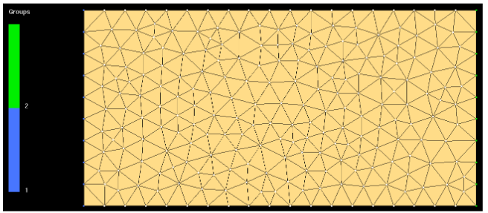
Figure 1 : Rectangular plate

Simple case
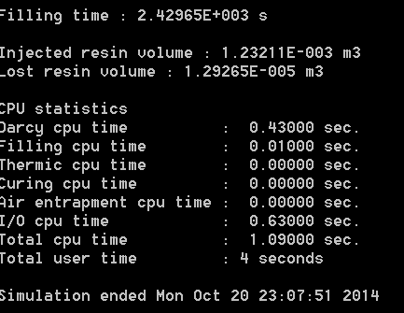
Figure 3 : Computational parameters case01a
Being the simplest of cases, case01a took a very short time to compute (4s). Filling time was 2429s. When the filling is complete, the simulation stops, that is why there is only about 1% lost resin volume.
Based on the Darcy’s Law in 1D and the given material and the process parameters, we are able to calculate the theorical fill time of our part :
$$t_{fill}=\frac{μ\left(1-Vf\right)L²}{2KPinj}=\frac{0.1×0.5×1²}{2×{10}^{-10}×{10}^{5}}=2500s$$
Which is very close to the simulation results.
Those results are not realistics. Indeed, we consider our mold as only straight lines and we ignore the racetracking effects, responsible of the increasing on the filing time. It can be observed that the flow front is uniform and the filling is even throughout the width of the laminate. We could improve those results by using a finer mesh.
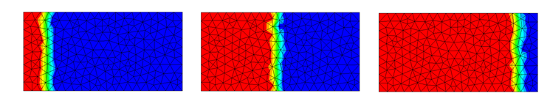
Figure 4 : Figure of the flow front at different times during the process
Pressure gradient is approximately constant by the end of the simulation, having the highest pressure near the inlet, and vacuum near the vent, as expected.
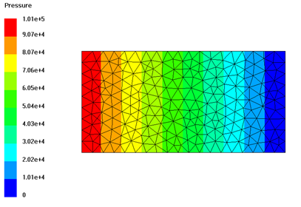
Figure 5 : Final pressure distribution case01a.

Effect of racetracking

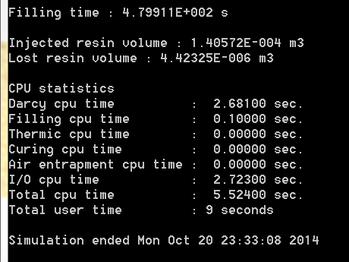
Figure 4 – Computational parameters case01b.
The second simulation added a new zone without fibers, representing a racetracking channel, where resin will flow more easily.
The filling time with the previous case has decreased significantly, going from 2430s to 480s. While the preform permeability, inlet pressure and vent remain the same, the size is nearly 10 times smaller (1x0.5 vs 0.5x0.105). Moreover the racetracking channel also contributes to reducing filling time.
Flow front is no longer uniform width-wise, but resin flows faster on the upper edge, where the racetracking channel is located. This increases the resin lost since one edge reaches the vent before the other. The resin loss is about 3% of the injected resin volume, higher than in the previous simulation. Another channel on the lower edge would help reduce this effect by making the flow front more uniform, although there may still be some delay in the middle. If another channel is to be avoided, placing the vent on the lower right corner could be a possible solution.
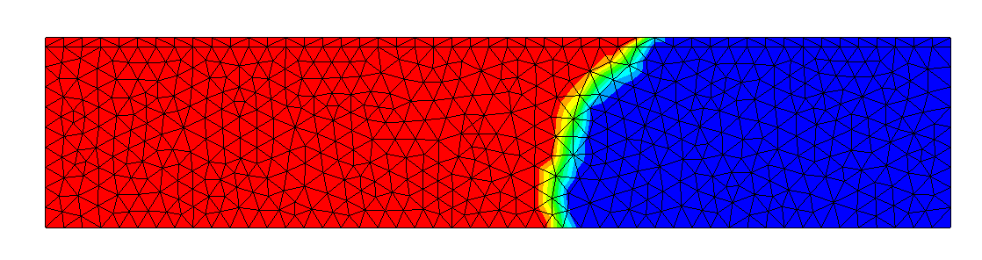
Figure 5 – Flow front case01b.

When comparing it to a case with the same geometry but no racetracking channel, a decrease in filling time can still be observed, as well as a gradient of filling time in the width direction, increasing further away from the racetracking area.
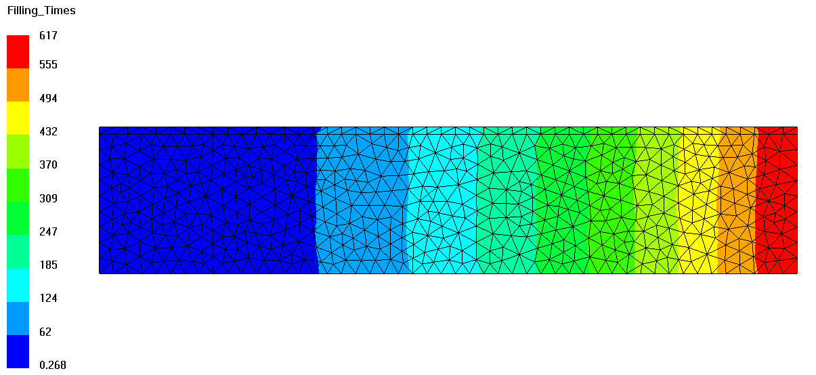
Figure 6 – Filling time case01b without racetracking.
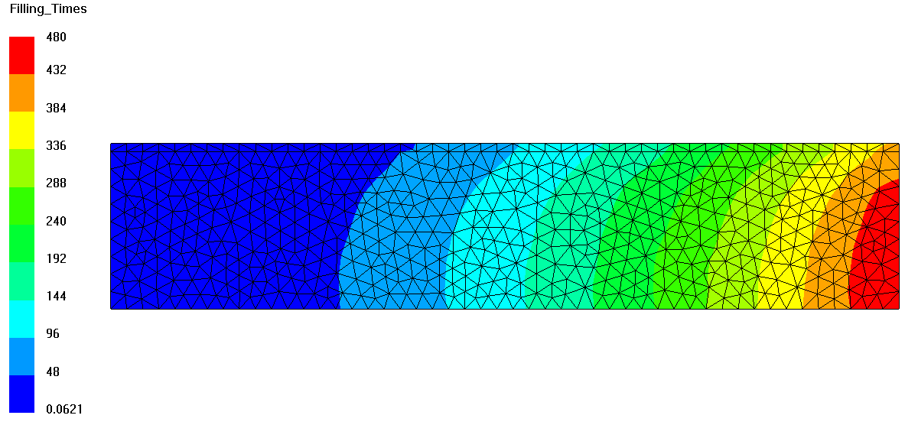
Figure 7 – Filling time case01b with racetracking.

At any given period of time before filling is complete , the pressure decreases near the channel, as it can be seen in the figure.
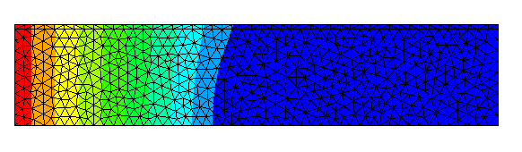
Figure 8 – Pressure distribution before filling is complete case01b.

In order to improve the process, we can eventually add a vent.

Effect of racetracking no vent
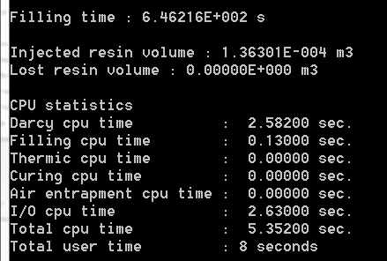
Figure 9 – Computational parameters case01c.
In this case, it can be observed that when by closing the vent, the filling time increases, reaching about 650s. Obviously, there is no resin lost for this case.
Closing the inlet has the effect of homogenizing the pressure front at any given time of the process, making it remain constant width-wise.
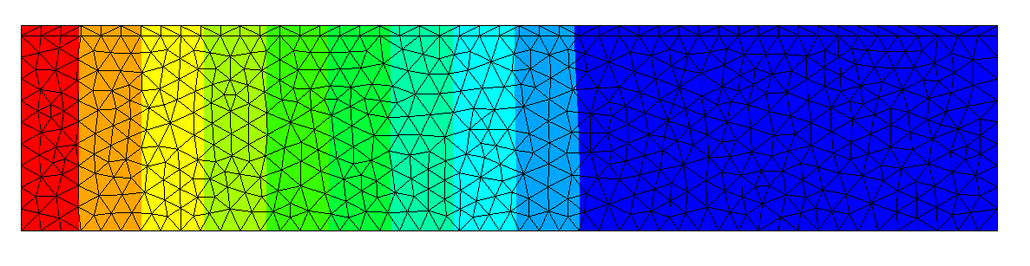
Figure 10 – Constant pressure width-wise case01c.
This pressure distribution tends to homogenize both the flow front and the filling time, reducing the variations induced by the racetracking channel in the previous case.
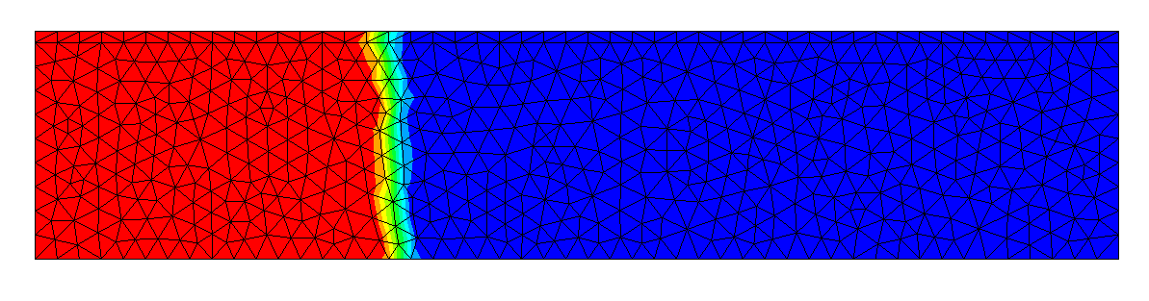
Figure 11 – Flow front case01c.
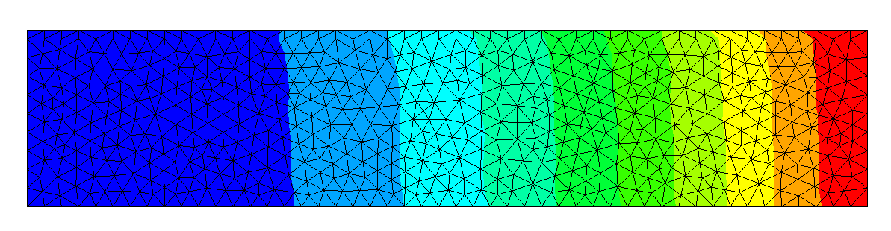
Figure 12 – Filling times case01c.

Effect of racetracking, adding a runner

We now remesh our part in order to get more précises results. The number of elements is now
Remesh picture
We find now a filling time of and an injected volume of resin

Effect of vent and air entrapment
Flow front
Pressure front
By applying more realistic conditions (not a perfect vaccum of 0PA), we have now a filling time of. We can also noticed that the mold is not completely filled because

Effect of gravity
Anatically we can consider the gravity by including in the calculation of filling time . In order to consider it, we calculate the filling time again by integrate with the parameters about pressure $∇p±ρg$ instead of $∇p$ only, according the fact if we are working the positive or negative $\overset{→}{x}$ vector direction.
The maths lead us to a new analytical formula for the filling time :
$$t_{fill}=\frac{μ\left(1-Vf\right)L²}{2KPinj}×\frac{1}{1±\frac{ρgL}{Pinj}}=\frac{0.1×0.5×1²}{2×{10}^{-10}×{10}^{5}}×\frac{1}{1±\frac{1000×9.8×1}{{10}^{5}}}=\left\{\begin{aligned}2275s if we are in the x positive sens \\ 2745s if we are in the x negative sens\end{aligned}\right.$$
Flow front
Pressure
Simulation results
The simulation results are grouped in the following table.
Table 1 : Comparison of the effects of the gravity
Direction | x positive | X negative
tfilling
Vinj
Total amount of resin lost

The simulation results are quite close to the analytical solution, which let us to conclude on a good model of filling time.

Those results let us to conclude on the fact that the effect of gravity will influence the filling process by skewing the flow front. In both cases, we have the same amount of injected resin but the filling time is higher in the first case because the gravity is going in the reverse direction of the filling process. Indeed in the positive direction, we found that the gravity helps the resin to flow in the mold.

Central injection of a square plate
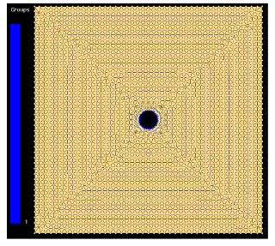
Figure 2 : Plain square mesh

Remeshing for injection port
Flow front
We found a filling time of and a injected resin volume
An analytical solution which can approach this would be

Central injection of an orthotropic square plate
Flow front
We found a filling time of and a injected resin volume
An analytical solution which can approach this would be

Central injection of an orthotropic square plate use of trigger
In order to spare a waste of resin in the vents, we now want to use a trigger for automatic vent closing.
Flow front
We found a filling time of and a injected resin volume
An analytical solution which can approach this would be

Injection analysis with 2D/2.5D/3D mesh
Now we are going to turn on a new curved surface reinforced by a central rib. We aim to study different approach to simulate an injection. The injection will be performed by the two lower extremities and a vent is placed along the top of the rib.

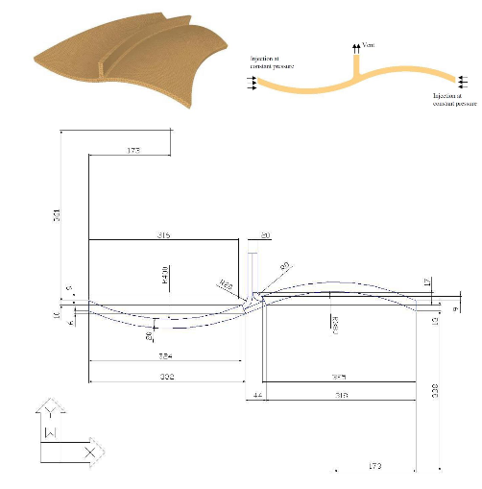

Table 2 : Results of the simulation
Results | Study of the 2D case | Study of the 2.5D case | Study of the 3D case
tfill | 13.58
Vinjected (mˆ3) | 3.95*10^(-5)
Vlost (mˆ3) | 2.976*10^(-8)
Flow front
CPU
Nodes
Elements
Role of the rib junction
Effect of the convergent/divergent flow
Benefits
Drawbacks

Table 3 :2d
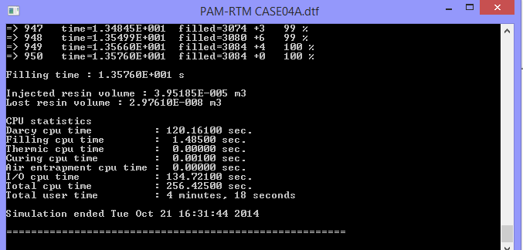

Conclusion
This first session of PAM-RTM let us to discover the

