

Manufacturing of a composite plate by resin infusion
Practical Session
Céline Blanchard, Marie Jolly

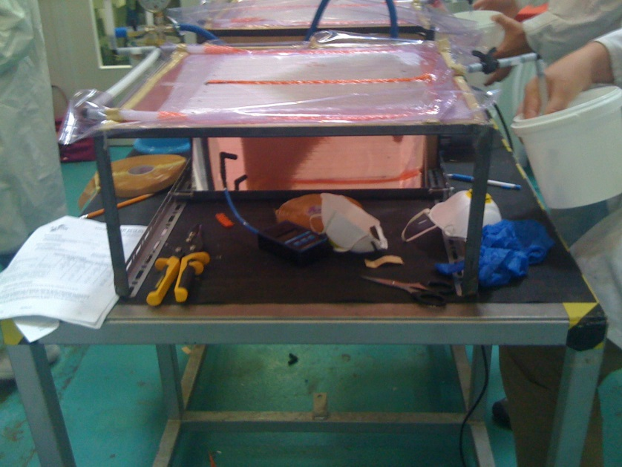

Contents
Introduction 2
I. Material specifications 3
II. Layup of the material 3
III. Resin infusion and permeability estimation 5
IV. Post-Filling 7
V. Analysis of the manufactured part 8
Conclusion 11

Introduction

In this practical session, we aim to manufacture a composite part using the resin infusion method on fiber glass layer. This process is divided in several steps :
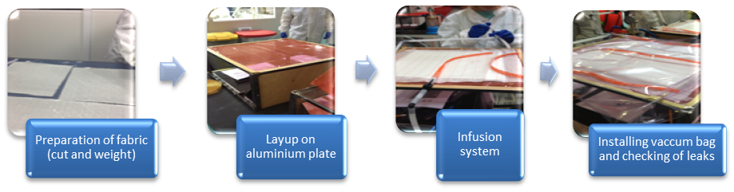

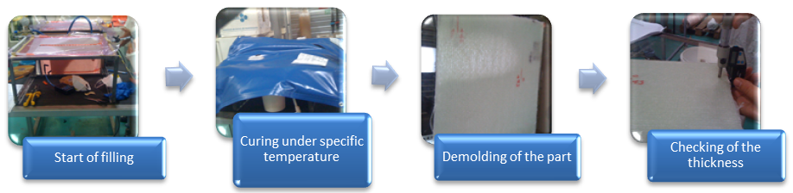
This represents the application of what we seen in class about the different techniques. In order to compare several injection configurations about vent and inlet, we propose to compare our results to other groups in terms of observations of filling and permeability.

Material specifications

The material used in this session is based on glass fibers. According to the data sheet and researches on the internet, we took a fiber density of 2.58. The stitching material is a zig-zag configuration. The areal weight of each direction is given by the following chart :
Direction | Areal Weight (g/m²)
0° | 288
-45° | 217
90° | 283
45° | 217
Table 1 : Areal weights
Given the fact that each quadriaxial layer is made by one fiber direction of each type, the total areal weight is 1005 g/m².
In order to get a mirror symmetry, we used two different kind of layers : 0° 45° 90° -45° and 0° -45° 90° -45°. The sequence is :
-45° 90° 45° 0° 45° 90° -45° 0° // 0° -45° 90° +45° 0° 45° 90° -45°

If the symmetry requirement is not respected, we create weaknesses and internal stresses in some directions, the material would not be isotropic. We can even create bending once the resin is cured.
The resin employed is a mix of hardener EPOLAM 5015 and epoxy resin EPOLAM 5015, 100g for 30g of hardener.

Layup of the material

Our group had to make the configuration 4 available below.

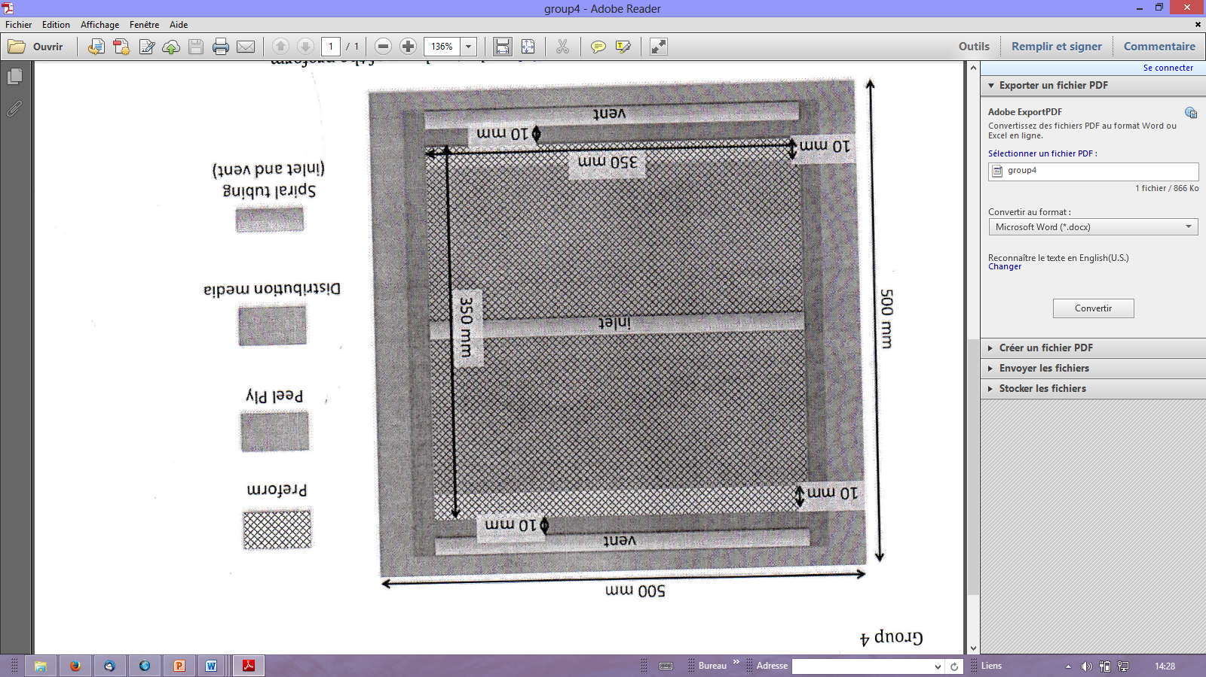
Figure 1 : Configuration of injection
- The fiber volume before infusion

In order to get this data, we weight our four cut layers of 350 by 350mm : 495g. We took for fiber density 2.58.
$$Vfiber=\frac{m_{fiber}}{dfiber}=\frac{495g}{2.58}=191.86{cm}^{3}$$

- The mix constitution

We know that the requirement includes a fiber volume fraction of 50% , meaning the resin mix volume would be the same. We have the following datas in order to get the exact proportions of the resin mix :

$$d_{mix}=1.10$$
$$d_{resin}=1.25$$
$$d_{hardener}=0.93$$
$$m_{mix}=0.77m_{resin}+0.23m_{hardener}$$
Calculations :

$$m_{mix}=V_{mix}×d_{mix}=191.86×1.10=211.05g$$

At this value, we need to add the quantity of mix which will be spoilt by remaining in the tube for injection. The tube diameter is 1cm and the total length is 33cm. The volume of the injection is therefore :

$$V_{injection }={π×\left(\frac{diameter}{2}\right)}^{2}×length of tube={π×\left(\frac{1}{2}\right)}^{2}×33=25.91{cm}^{3}$$
$$m_{injection }=V_{injection}×d_{mix}=25.91×1.10=28.50g$$
$$m_{mix total }=m_{injection}+m_{mix}=211.05+28.50=239.55g$$

Hence ;

$$m_{resin}=0.77×239.55=184.45g$$
$$m_{hardener}=0.23×239.55=55.10g$$

- Leak check

Once we have done the layup and put in place the vaccum bag, it is necessary to check the leaks in before injection. We placed a pressure gauge in order to get the difference between when the vent is clamped off and with vaccum pump. Those values must be the same (meaning no air goes out) and under 50mbar. We have obtained 34 mbar. Once this step has been checked and the mix rest for 5 minutes, we started the injection.

Resin infusion and permeability estimation
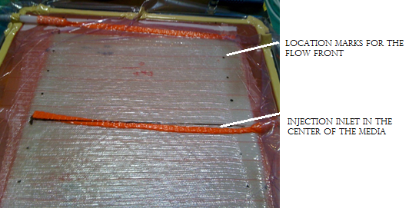
Photo 1: Resin injection and inlet position

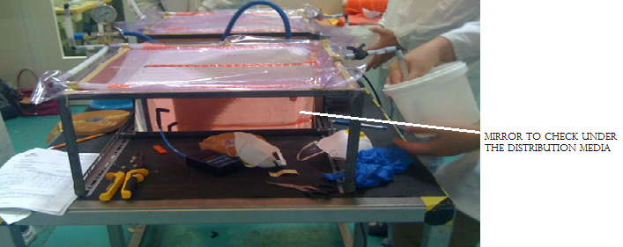
Photo 2: Resin injection, flow front

In order to get a flow gradient, we have a mirror below the plate and we also created location points every 5 cm from the inlet valve (in the center of the part for our case).
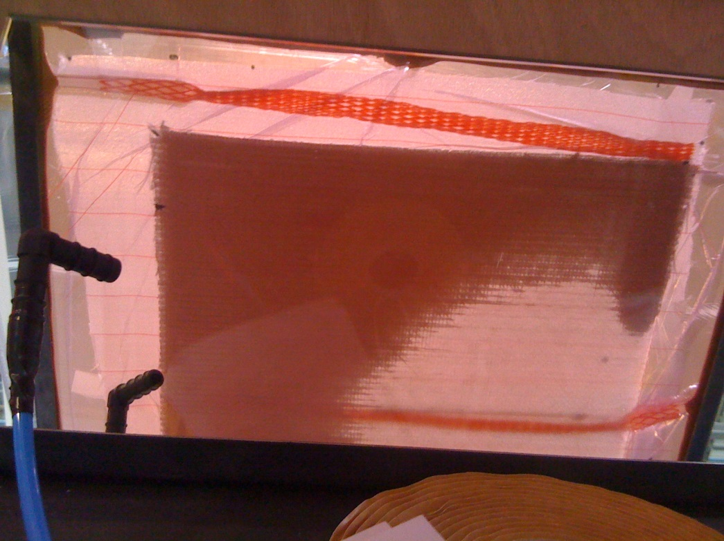
Photo 3: Flow front at the bottom of the part
5 cm
Inlet
Flow
Injection
1
3
2
4
5
6

Figure 2: Distribution of the flow front

Flow position | Time
1 | 32 s
2 | 1 min 14 s
3 | 1 min 30 s
4 | 2 min 30 s
5 | 3 min 49 s
6 at the top | 3 min 25 s
6 at the bottom | 5 min 43 s
All the part | 19 min 15 s

Table 2 : Time needed to reach each mark
Thanks to the Darcy’s law, we can now determine the permeability K of our part.

$$K=\frac{Qμ∆L}{A∆P}$$

$$μ :viscosity=0.30 Pa.s at 25°C$$

$$A=aera which is filled=0.12m^{2}$$
$$∆L :length of injection= 350mm$$

$$∆P :pression of injection=P_{ext}-P_{int}=P_{atm}-P_{vaccum}=P_{atm}=1bar=1,013·{10}^{5} Pa$$
$$Q :constant debit of injection=\frac{V_{filling}}{total time needed for complete filling}=\frac{191.86×{10}^{-6}}{3×60}=1.0666×{10}^{-6}m^{3}/s$$

That means ;

$$K=\frac{Qμ∆L}{A∆P}=\frac{1.0666×{10}^{-6}×0.30×350×{10}^{-3}}{0.12×1,013·{10}^{5}}=9332,8×{10}^{-19}m^{2}$$

When the resin has reached the end of the distribution media, it is aspirated by the vent to go in a collector. The time for filling twice sized part would be multiplied by 4.
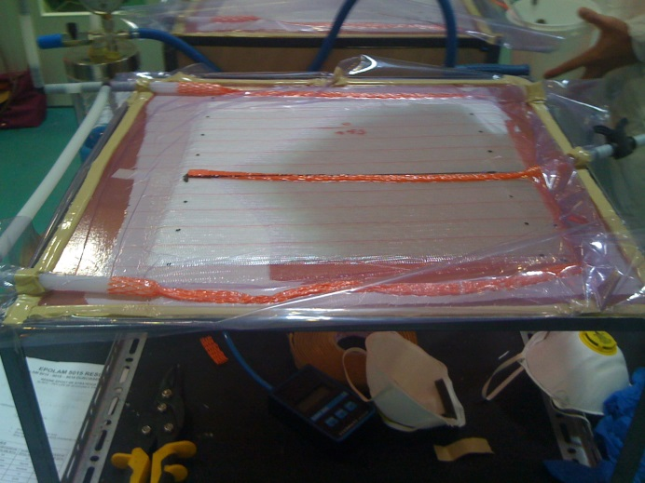
Photo 4: End of the filling

Post-Filling

At the end of filling, we applied the post filling condition (group 4): clamp the inlet and leave the vent opened once the resin has reached the vent. The vent allows to reduce the voids in the composite plate. According to the data sheet, the recommended curing conditions for the resin are:
- To steam to be unmolded (minimum 2 hours at 50°C
- The thermal treatment between 24 and 48 hours after the application of the hardener
- To work at a minimum temperature of 20°C

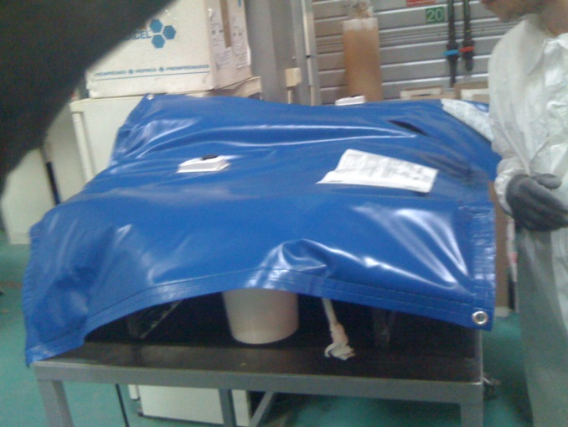
Photo 5: Curing

Analysis of the manufactured part

- Inspection of the manufactured part

After demoulding, we have inspected the manufactured part. First, we can see voids. The composite plate is not completely transparent and contrary to the other plates (group 1,2,3 and 5), it is opaque. The voids are due to the formation of bubbles when we mixed the resin and the hardener. Probably, we did not let the resin rest for 5 minutes after mixing. Then, an area of our plate was sticky (cloudiness). The resin and the hardener have not been properly mixed and the resin has not polymerized similarly. Finally, the injection in the plate was not uniform.
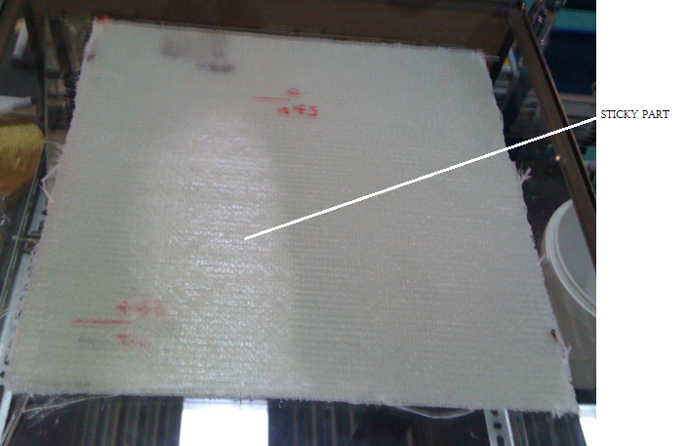
Photo 6: Manufactured part

- The fiber volume fraction

The final plate weighs $m=647g$. We will estimate the fiber mass fraction. We assume that there is no void in the plate.

$$x_{fiber}=\frac{m_{fiber}}{m}=\frac{495g}{647g}×100=76.5\%$$

Consequently, the fiber volume fraction is:

$$ω_{resin}=\frac{\frac{x_{resin}}{d_{resin}}}{\frac{x_{resin}}{d_{resin}}+\frac{x_{fiber}}{d_{fiber}}}=42 \%$$
Then,

$$ω_{fiber}=100-ω_{resin}=58 \%$$

The fiber volume fraction thanks to the final plate weigh does not take into account the voids in the composite plate.

The thickness of the part is different according to the locations. There is a thickness gradient. The average thickness is $d=3.087 mm$. Then, the total volume is $V=378.16 {cm}^{3}$.

Point | Thickness (mm)  1  2  3  4  5  6  7  8  9  10  11  12  Injection
1 | 3.132
2 | 2.889
3 | 2.984
4 | 3.181
5 | 2.897
6 | 3.187
7 | 3.226
8 | 3.090  Figure 3: The thickness of the part at various location
9 | 3.690
10 | 2.874
11 | 2.926
12 | 2.970
Table 3: Thicknesses of the manufactured part

The density of the glass fibers is $d_{fiber}=2.58 g/{cm}^{3}$. Consequently, the fiber volume is:

$$V_{fiber}= \frac{m_{fiber}}{d_{fiber}}=\frac{495}{2.58}=191.86 {cm}^{3}$$
Then,
$$ω_{fiber}=\frac{191.86}{378.16}×100=50.74 \%$$

The fiber volume fraction thanks to the thickness takes into account the voids in the composite plate. Therefore, the fiber volume fraction estimated from the weight of the part and from the thickness measurement is not similar. The difference estimations are due to the voids. These volume fractions give an indication of the amount of voids. Closer the values are, the better quality is.

Conclusion

We manufactured a composite plate by resin infusion and we analyzed the process. According to the group, we did not use the same inlet and vent positions. After the infusion, we shared the permeability calculations and the observations to conclude on the effects of the different parameters.

First, the quantity of voids is not constant. Indeed, contrary to us, the group 3 clamped the inlet and vent once the resin has reached the vent. The group 3 has more voids. Then, the local variation of a fiber perform and inappropriate inlet and/or vent positions are the cause of dry sport formation. Resin flows faster around the low permeability region and can cause the formation of dry spot around the high-permeability region.

