Main project: BC Testing Device design

Presentation of the project
I have been asked to improve a Buoyancy Compensator accelerating weathering chamber testing device where several groups of intern have already worked on. Indeed, the head of engineering is pretty satisfied with this device, but with the time, several structures problems appeared. The project involves to fix or think about another configuration of the UV’s boxes used for the light tests on BC’s, to improve the way these UV’s panels are set together and inside these boxes, working on other feature of the BC testing device like the lid or cycle test.
Previously, San Diego college students have worked on the building of this device according to the UV light direction and repartition but also about the strength of the device. Nonetheless, the materials which were used to build the UV’s boxes have bend under the water pressure and it becomes more difficult to put the UV panel inside these boxes. But the main problem stays the leaks which appear on the acrylite box joints.
Although Aqualung has one machine for the wash test and one for UV tests, this device remains needed to simulate at best weathering conditions: sunlight, chlorine and salt environment during a dive. That is why my mission consists on make this device more robust and easier to use.

Description of the device

Utility
In order to enhance materials which are used to build Buoyancy Compensators, the Aqualung team of engineering needs to know what behavior they have on diving conditions. This device was made in order to simulate real weather conditions by alternated chlorine wash and UV exposition cycles. Indeed, BCs are often these kinds of conditions with pool or ocean trainings. Before proposing a BC to a client or using a material to build a gear submitted to those conditions, Aqualung team needs to determine what will be the impact of those damages on the appearance and the weakening deterioration. From that step, they can review the product if it doesn’t succeed to the limits provided by their standards.

 | BEFORE | AFTER
MARES  ROVER | 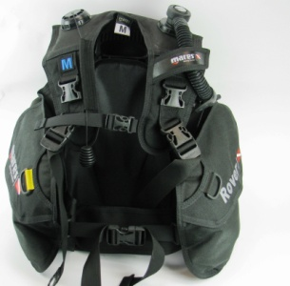 | 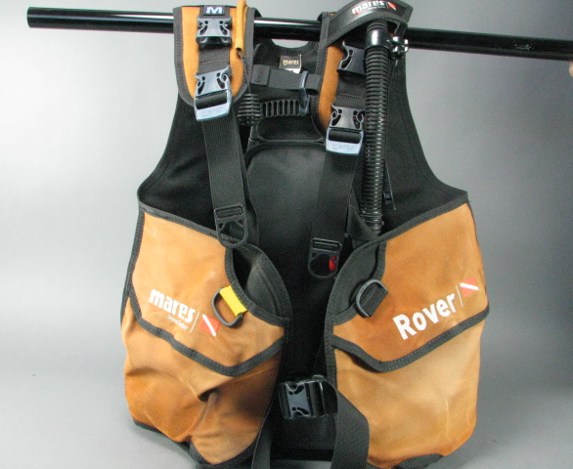
AQUA WAVE | 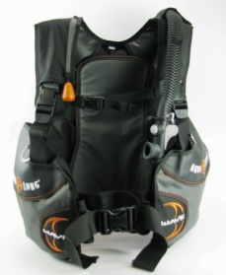 | 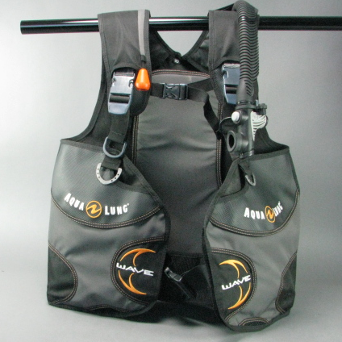
Table 1. Exemple of visual result on the BC testing device

Protocole of running

Methodology to lead the project

Preparation
To design the new features, it was essential to identify the framework. The very first mission consisted in learning on the BC testing device characteristics, applications and how it works. The design process began by looking closely at the former reports about current design and protocol of running. Indeed, I would not be able to work on it if I did not know the reasons why things lead to this configuration.
Then I also need to know what the requirements for this device are. I learned that it already exist a UV testing device and a wash test, but the BC testing device let the team to simulate better real conditions of using. According to explications of users of this device, I was able to identify the issues encountered with this device. The conclusion of the former reports were helpful too because I could find some idea of improvements identified by former interns. I submitted the list of issues during the very first weekly meeting about BC testing device we planned with the team.

Running the project
After studying the major axis of work for this project, it was time to turn to establish a way to work.
I guessed I don’t know all the details concerning this machine, so for each issue I have identified I talked to persons involved or refer to the protocol of running. According to that information, I was able to separate this project into different main tasks and subtasks available in the following Work Breakdown Structure (WBS) Appendix .This would help me to divide the project into several improvements and time to allow on each one to keep the control of the time available for my mission. Furthermore, because I have other projects aside, I built a Gantt diagram to help me on scheduling, available in Appendix 1.

Figure 3 : WBS of the project
By the way, I also set up a weekly meeting with the head of Engineering department, Eric Thorstenson, and the two engineers in charge of this project, David Sullivan and Jonathan Souder every Monday morning. I planned to submit all my suggestions during those meetings, but also make a regular follow up by e-mail about how things are going on. Finally, the team will be able to see my progress on designing or researches in my shared folder made for the BC Testing Device Project.

Problems to solve

Work realized
Reparer l ancienne machine
Fuites
UVs
Identifier les points critiques de dimmensionnement

A whole new UV Box

Reasoning to carry out the new structure
We now need to find a suitable waterproof and stress resistant material for the box and keep just one sheet of acrylite OP-4. Knowing that some people like Jeff or Ed have already work with constructions such as aquariums or kayaks, I asked them about their experience with building a sealant and pressure resistant device.

New Materials

Box material
This application of kayak definitely looked like my project. That is how we decided to turn on Marine plywood for our UV box, covered with a mix of epoxy resin and hardener, as if we would build a boat, so a sealed device. Marine Plywood is different from a classic plywood because of the waterproof glue used between laminates which is waterproof and more resistant to salt corrosion. Furthermore, Jeff and Ed have already worked on kayaks realizations, so they were able to help me on this part.

Window material
Type
Requirements of this material :
- High UV transmittance : target irradiance of 120
- Resistant to Temperature
- Not damaged by chemicals
- Strong enough to resist to the water pressure
The former we used was Acrylite OP4. Acrylite® OP4 UV Transmitting acrylic sheet is manufactured for use in indoor sun tanning equipment. It offers high levels of UV light transmission and strong resistance to degradation caused by UV light. OP-4 acrylic sheet transmits a high percentage of light in the UV-A 315 – 400 nm and UV-B 280 – 315 nm regions. Only a small portion of light in the UV-C region (200 – 280 nm) is transmitted.
According to our use and my researches, this is the best product but also the more expensive. We plan to only use one 98*46*1/4 sheet for the temporary solution and for the future final one if the temporary would have to be improved because the hole I have designed for the UV on the front face is 30”*43” (so this allows us to have at least three piece in one acrylite sheet). Furthermore, we are more interested in Cast acrylit than extruded because compared to cast acrylic, extruded acrylic has less optical clarity but offers exceptionally close thickness and diameter tolerances.
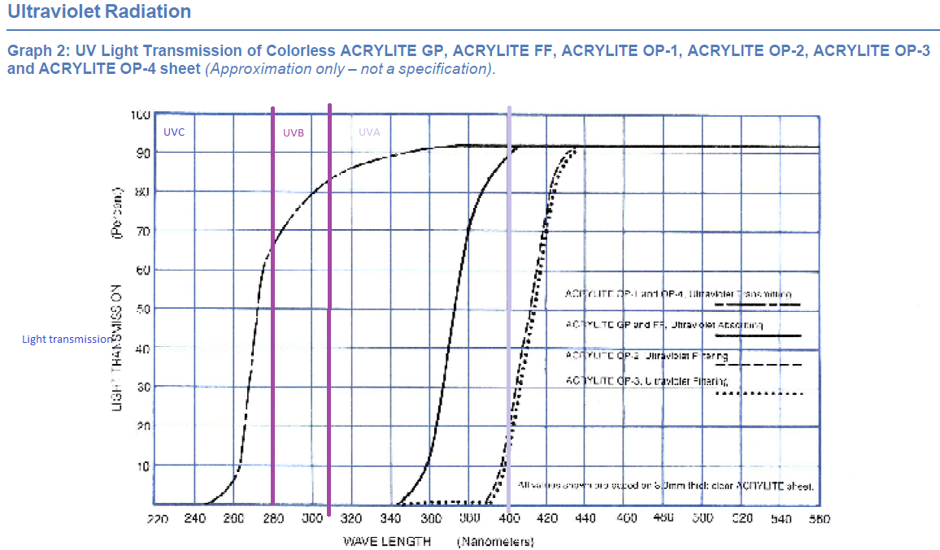
Figure 6 : target range for the Light Length

Work on Design

Box Design

My device is going to be submitted at high pressure of water in the front panel. Designing this side of the box for holding the acrylite is the tricky point of the project. Indeed, I need to have something enough robust, but which is not hiding too much the window for the UV transmittance.
Figure 7 :current box dimensions
Grid : We thought that a grid could help the acrylite to resist to the water pressure. In order to get the good grid shape, I run some stress analysis studies with Solidworks on the different configurations I proposed. For each of them I choose to run a static study with two forces: Gravity and Water pressure on the front side only and up to the top of the box. I based my values on the volume of the basin without the volume occupied by the other UV Box and the weight of Marine Plywood given by Frosthardwood, the supplier. Furthermore, I added fixtures on the side panels to simulate given the fact that the box is going to be attached to the basin. I indicate that I was wondering about sudden break under pressure and choose a suitable mesh. All those considerations give me those parameters for my comparative study:

The details of the calculations are available in the Appendix6 .You can find a short summary of the results in the chart below :
Configuration | Maximal Deplacement (URES) and location | Comments
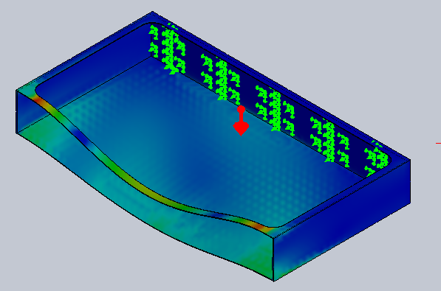 Without a grid | 2.2in in the middle of the top box | This configuration is too weak. We want to avoid the replacement due to the water pressure
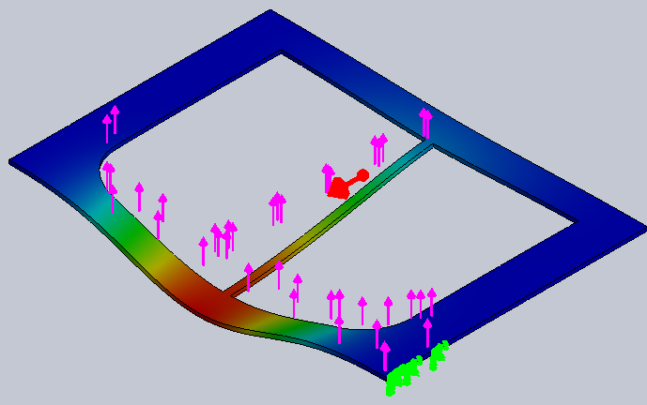  One vertical line | 1.236in on the joint between the grid and the bottom edge of the box | Added for reinforce the strength against water pressure
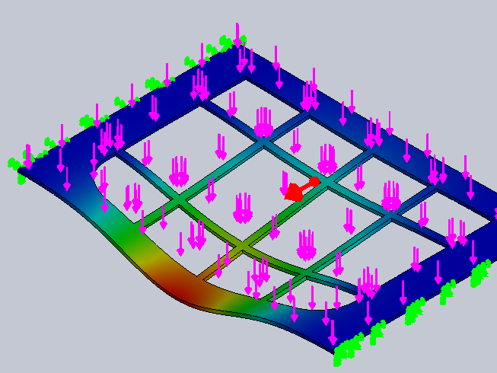  Grid with 3 vertical lines and two horizontal | 0.6in in the middle of the grid and the bottom edge | This design is based on the water level with 108 gallons inside the tank and the plan to add a UV vertical holder to avoid its swirl

Window design
Shape of the hole :
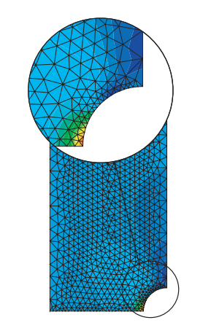
The stress concentration is a common problem in the mechanics of a mechanical component or design element. This phenomenon is a local increase in stresses in an area having a geometrical modification of the part. It appears in a part or discontinuity of a structure with the presence of a notch after machining for example. The stress concentration area is often the site of crack initiation. We have some requirements to use this coefficient as indicator :
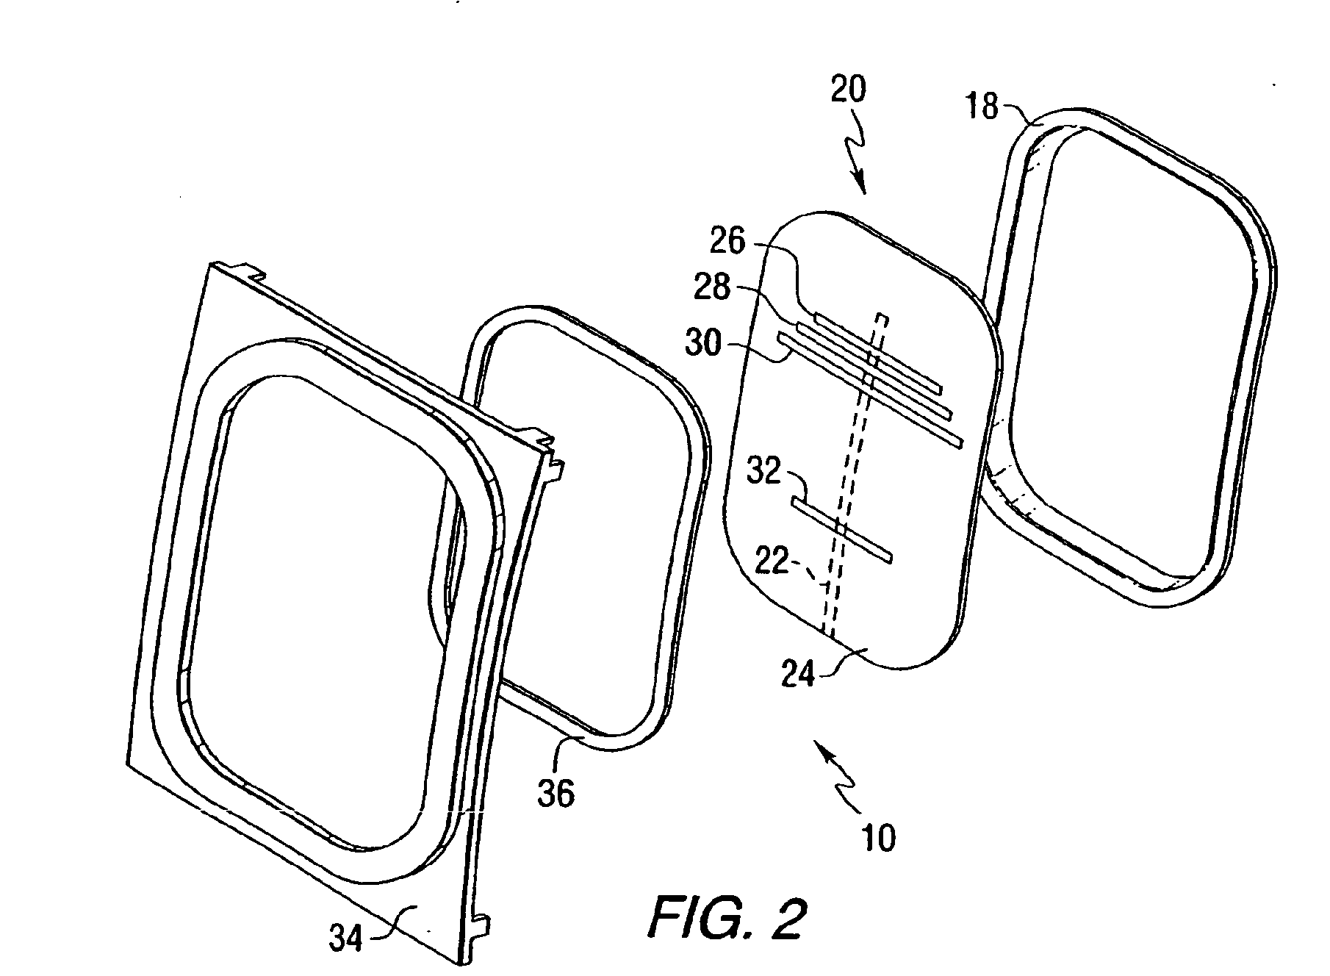
- Static study
Figure 8 ; Design of plane windows
- linear-elastic behaviour

Then, thanks to my knowledge on planes structures, I proposed to cut the parts which are under water pressure round and not square in order to reduce the stress coefficient factor Kt. Indeed, the window of the planes is used in quite the same application as my project, except the fact that my over-pressure is due to the water
Calculation of Thickness of the window required
Because we need to turn to another solution for the acrylite, I have to adjust the thickness of the holder. In order to determine that, I based my study on a building of an aquarium and its security factor.
$$Deflection=\frac{(α×P×0.00001×H^{4})}{E×t^{3}}$$
Here, Deflection =2.3mm=0.092”
So according to this value, the recommended use for the thickness would be
$$Deflection+0.14”≈1/{4"}$$

Mes calculs, sur le facteur de securite, disponibles en annexe m’ont amenee a choisir un feuille acrylite d epaisseur ¼ »

Bonding

Waterproof sealing for the wood
Knowing that Jeff already built a kayak, I discussed with him about the bonding of my box. For improved pullout strength and waterproof connections, the more efficient method is to put two coat of epoxy. Epoxy penetrates the wood fiber the very first time, effectively increasing the fastener diameter. Epoxy also provides a stronger interface with the fastener threads than wood fiber and keeps out water.

Sealing the window :
This is the tricky point of the design because the former experience shows that sealing such of device is very difficult because of different used materials and joints to be strong enough to resist at the pressure, chemicals and UV exposition. To design the fixture of this sealing system, I have to take in consideration several points and propose a way which can satisfy each of them.
Requirements | Knowledge/Former experience :
- Avoid empty spaces where water can go in  - Be strong enough to support the water pressure in the front | - Silicone is efficient but not really resistant to a UVs exposition in the long time perspective  - The clamp force is located where the hold system is placed  - Acrylite glue is not efficient if two different materials have to be stick together
Sandwich structure
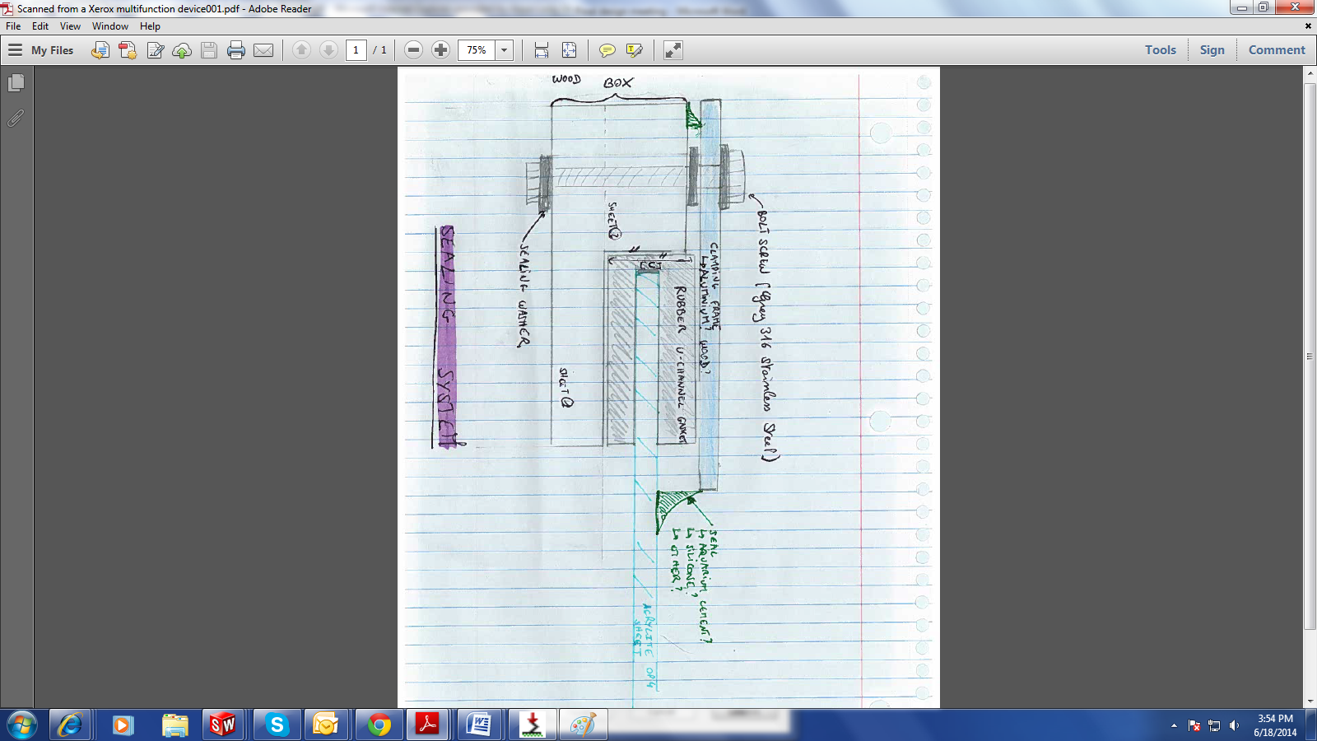
:I was inspired by the Sandwich structure of the boat windows to guarantee better sealing system. Indeed, those ones utilize an interior screw attachment by sandwiching the bulkhead between the window flange and clamp-ring.
I first thought about a sealing system which include replace silicone by a rubber gasket and add a spacer on the same size as the gasket to have a better contact. But by discussing with members of the team, we agree that the construction would be difficult.
So I turn on keeping the sandwich structure and adapt the spacer directly to the acrylite thickness. I sealed the space between wood and acrylite with silicone. It would not be exposed to the UV because of the size of clamping ring and front panel window.

Turn to the new conf

Establish the budget
Once the plan of building was established, we started to order our materials. I was confronted to a major problem with the OP-4 Acrylite. Indeed, none of the distributors of Evonyk Industries, the cheapest manufacturers, had OP-4 in stock. We had the choice to order at least 6 sheets from the distributor or one to Evonyk in the New Jersey with a high shipment cost.. So, We decided to find an alternative. I look after my very first suitable materials researches and see that the Solar Acrylite could be suitable too, even if it has less UV Transmittance than the OP-4 and is not as strong. The project would cost approximately 670$. The details this budget is available on Appendix 7.

Building of the box
In order to have a device ready, we decided to start building the temporary box with the same dimensions but using ideas already set in place.Those ideas came from different technologies ;
This way we would be able to see what improvements we can do on this temporary solution.

Test the new box and add Fixtures/improvements
Once the box was inside, I had to check its good working. To do that, I take two steps of thinking :
1st step : Dimensionning
- identify eventually leaks by filling with water
- Check if all the dimensions are suitable for the fixtures like electrical links, hold bolds, other box… This is the tricky point. Indeed, because the new wood box is a little bigger than the former one and the bending of the tank loses a lot of available space, the BC’s are very tight between the two boxes.
- Adapt the UV Panel to the shape of the grid
- Study a new way to hang the BC’s and where. I located the emplacements of holder for the tube to handle BC’s by ballast them and see how far they go along the tank. Indeed, they need to be whole submerged to get the effects of chemicals and UV exposure on the shoulders.
- Knowing that bold holes are not going to be removed and that you can not screw above the water line

2nd step : Simulate a test cycle to observe other problems which can have appeared with this new device:
After cleaning the tank of former chemicals and remove every free pieces on the bottom, I started to fill out the basin with water until the 108 gallons mark to see how the device works. This value has been determined by former interns: it corresponds to the amount of water to add to cover totally cover the BC’s with two boxes inside.
Once the right amount of water is inside, we put the right amount of chemical to get the good concentrate solution according to the protocol. We checked pH and adjust the right mix of acid and chlorine in the liquid

 | For 108 gallons
Sodium hypochlorite chlorine | 7.5 tablespoons
Hydrogen chloride (muriatic or hydrochloric acid) | 7.5 teaspoons
I also decided to simulate a short test cycle by turning on the machine, the water moves in order to simulate a wash test or moves from the diver. It also helps to mix the solution. This phase works well and I conclude that that no adjustments are needed.
- We turn on the pump system to get the water back in the storage tank. We noticed that a few amount of water still remain on the bottom of the basin at the end of the cycle because of the float pump device which is not following the water level right. To solve this problem, Jonathan made a too which let us to lift up the float device and make the pump continue to work.
- When we add water, the bending areas are pushed against the metal cage. This movement need to be prepared by the new configuration.
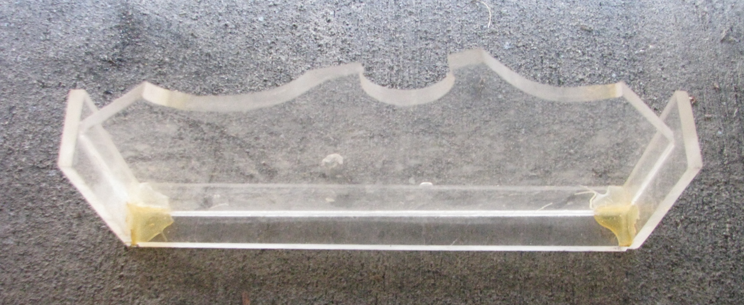
- As expected, the water has the bad effect to move up the box. It is comparable to a buoyant boat because of the empty air space that makes the box float. To solve this problem, Jonathan made plastic spacers in order to maintain the distance between the 2 UV Boxes when the tank is filled with water. This idea works well but it also moves a lot while the tank is empty because it is not attached. I suggested modifying this technical solution.
Figure 10 : Plastic spacer suitable for the former distance between the 2 Plexiglass boxes
- We finally checked the UV phase by putting the panel inside and turn the electricity on for a few minutes.
This global analyze leads me to create new designing tasks to complete my project which includes adding other pieces to carry out the test.

Getting the test READY with a new configuration
Now the new box is in place, I need to propose a new design which can take in consideration the modifications on dimensions and solve the problems I mentioned in the last section.

Work On the UV Pannel
The new UV Pannel has to be designed to fit in the grid to support water pressure and avoid the box to bend (3 Vertical holders for 3 vertical lines on the grid. The width has been adjusted to fit perfectly in the box and remove space for bending. An horizontal panel has been added to remove and put inside more easily. The drawing of the configuration with UV Pannel is available on Appendix 8.
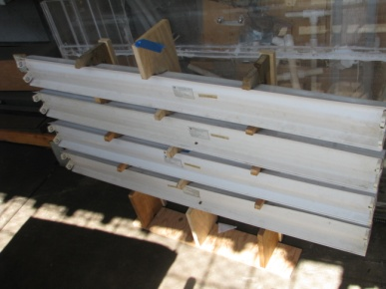
Figure 11 ; New UV Pannel building

BC Emplacement
In order to find the right configuration for each fixture, I figured out a test with one the biggest BC provided by Aqualung in terms of Materials and add-ins on it : The PRO LT. I shaped this BC as a rectangle of 25*18*6, dimensions measured while the BC is hung, with weight pocket because they are going to be ballasted during the test. I also measured the length added by the BC holder : 4.5 in.

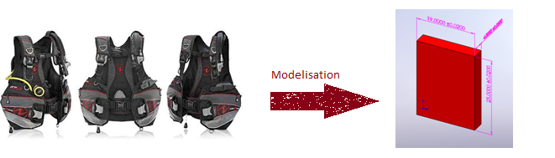
Figure 12 : Taking the BC Dimensions in consideration with the PRO LT
Then, I needed to determine the new water line level because of the new space taken by the new box. In order to do that, I needed to put my box inside, correctly ballast it and screwed it before putting the water in it. Indeed, this UV box has the same behavior as a boat : it is going to float if not correctly attached and ballasted. So I made the math about the weight and the volume displaced by my box in order to ballast it with the right amount of free weight to compense the Archimede force due to the water . Details of calculs en annexes

According to those measure, The box is expected to move up by the water pushing on the back. Furthermore, according to former experience, this kind of box actually move this way.
That is why I also drilled and screwed the back of the box in order to fix it to the basin before testing. A spacer correctly cut (15.75in of length) was added to avoid the front face moving up. 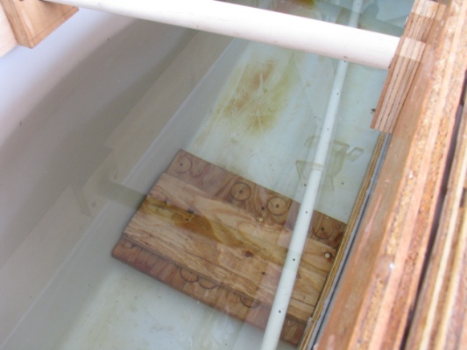
Figure 13 : Spacer for the bottom of the box
The width of the UV window is 41in. The test would be able to test 2 BC in the same time + the indicator swatch of 3in width. I placed my pipe holder system according to those observations.
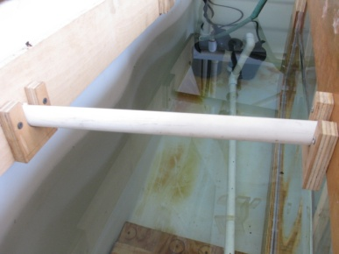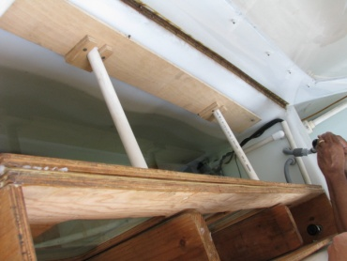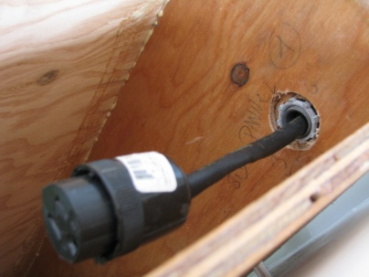
Details about the fixture of the Final Design are available in appendix 9.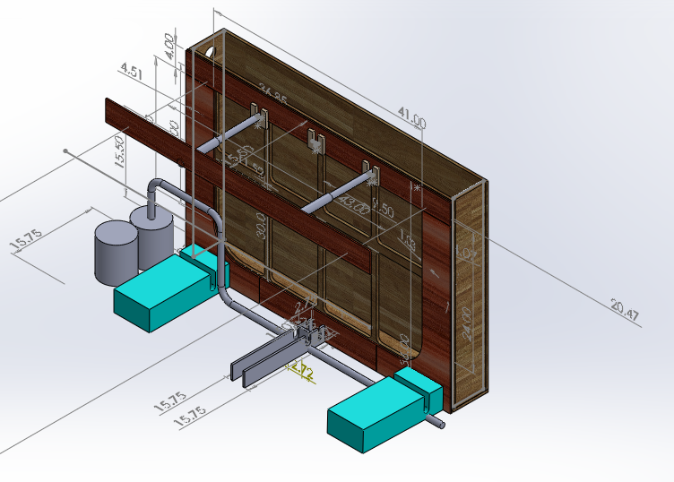

Adapt the protocol because of the new design
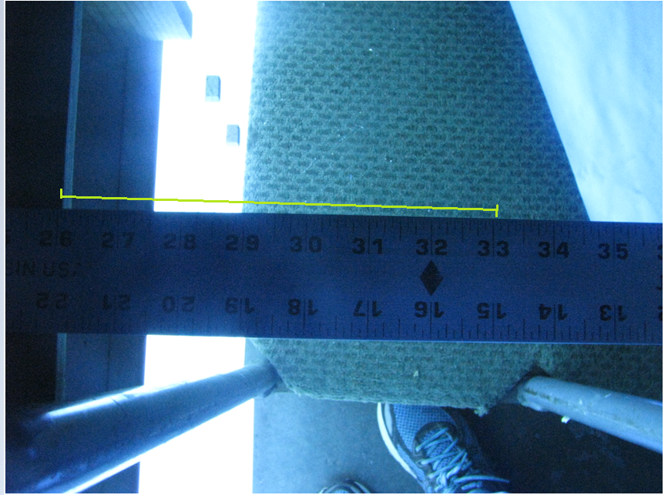
Because of the UV transmitting material modification, the protocol may need to be adjusted for the UV exposure time. Indeed, OP-4 and Solar Acrylite don’t have the same UV transmittance. Evonyk Industries indicate a transmittance of 70% for the Solar Acrylite and about 92% for the OP-4.
In order to prepare ajust the protocol, I run a UV transmittance test to determine the new transmittance of the box window once the UV Panel was repaired.
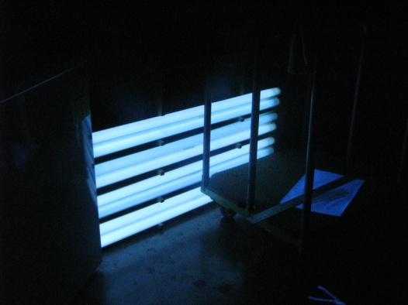
- To avoid parasite lights, I went to the Wash room chamber which is quite dark.
- I placed a ruler in order to have the distance between BC and window which is usually provided during the UV exposure phase.
Figure 14 : Distance between the BC and the UV lights during the test
- Thanks to the UV Light meter which mesure the UVA and UVB intensity, I was able to determine the light which is coming from the UV Panel at 5in of distance.
Figure 15 : Running the transmittance test in a dark room
- Then, I placed a piece of OP-4 acrylite on a vertical section directly on the lights and run the procedure again. I finally check by the same way the transmittance of the Solar 3000 Acrylite.
This test gives me the following results:
Table 3 : UV Transmittance Test results
 | None | OP-4 | Solar-3000
UV intensity (µW/cm^2) | 402-420 | 383-395 | 264-275
Transmittance | 100% | 95% | 66%

Conclusion ; in average, There is 29% less transmittance between the OP-4 and the Solar-3000. By reviewing the protocol, it may be useful to have a longer UV exposure time to get the same results (29% of 6 hours= 1h34 more time)

Work to continue

Add improvements features

Work about the lid

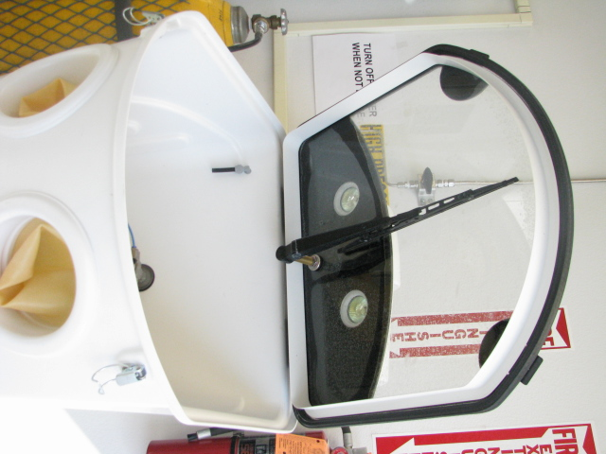
In order to make the UV box more waterproof, we talked about designing a new lid on the new UV light box to avoid moisture inside. According to my researches and for our purpose, we have several solutions. We also have some restrictions regarding the fact that the UV box is inside the basin and very close to the edge of it. Furthermore, while the device is running, we have to close the lid of the basin over.
Figure 16 : Lid Inspiration
To Design this part, I was inspired by the sealing of the Wash Machine for 3D Piece system.
By looking at the lead of this device, I noticed that the rubber is very sealant and the lead only needs to be connected with pivots. This solution needs to buy more materials (stainless steel pivot+rubber) and to build an extra edge on the UV light box
A solution which includes those features would be quite easy to build. Furthermore they could eventually include to insert the hanging system on the lid.
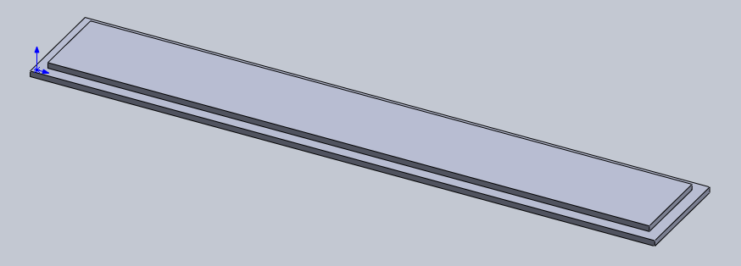
Figure 17 : Drawing of the new lid

Handler for UV Pannel
Because the UV panel needs to be removed at the end of each cycle, it could more easier to remove from the box. We could eventually add an old BC handler to be able to fit in the box.

Future design
The test of the new box and the former defaults of the Plexiglas box showed us that the main concern of this test is about resistance the water force, particularly when it comes to the leaks path. I identified that they are always between the acrylite and the material of the box. Because of the smooth of the acrylite, silicone doesn’t stick well.

Recommendations
This experience let me to recommend those points for the final design:
One box is fine: it needs to be strong and big enough. If you put too, you are not going to have enough space for a sufficient thickness for the box
- Keep a clamp force
- Keep a strong material and a thicker front panel to don’t allow the move dur to water pressure
- Keep a grid to support the water pressure and avoid bonding in the time
- According the UV Pannel vertical holder to this grid : the front panel is going to move
- Keep the box attached on the back
- Keep spacer on the bottom to avoid the move up due to the water
- The system to hang the BC’s is suitable, and the ballast weight too
- Acrylite works well for the water pressure and the UV transmittance
- Epoxy takes time to cure but with a correctly prepared surface, it works well on sealing
- Maybe using rail system to remove or put the UV Pannel.

Ideas for a whole new design

An extruded UV box ;
One idea would be to use the lessons of this experience to design an outdoor box according to Eric. This idea would include to put the UV Box outside the tank to keep only one window front panel.
Pros : This design would let you to have more space for BC’s or eventually add a second mobile UV Box where you cannot reach. Furthermore, you will only need to care about the sealing of the front panel and the water wont move the box up.
Challenges :
- find a way to build the outside box and make it stay in place
- Bond the front panel with the tub
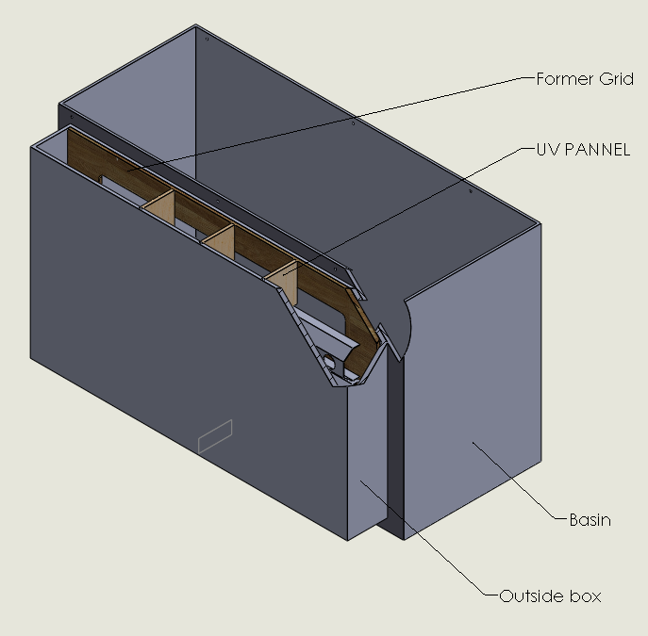
Figure 18 : new design with the box outside
The dimensioning of this design is available on Appendix.

Using Urethane
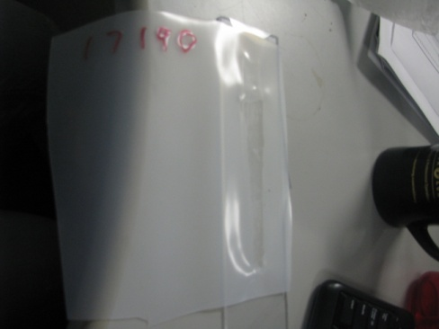
Figure 19 : urethane test
By running some tests of stick urethane on the acrylite, I thought about making a big urethane bag for the whole device to avoid leaks. But we need to see how it works on a UV exposure

Appendixes

Gantt Diagram
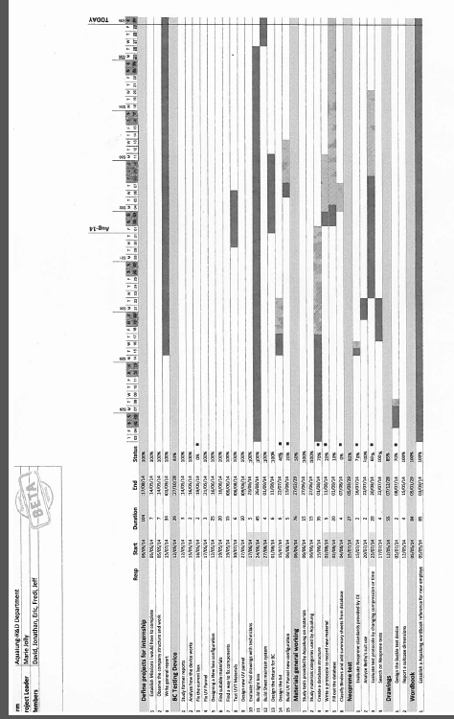
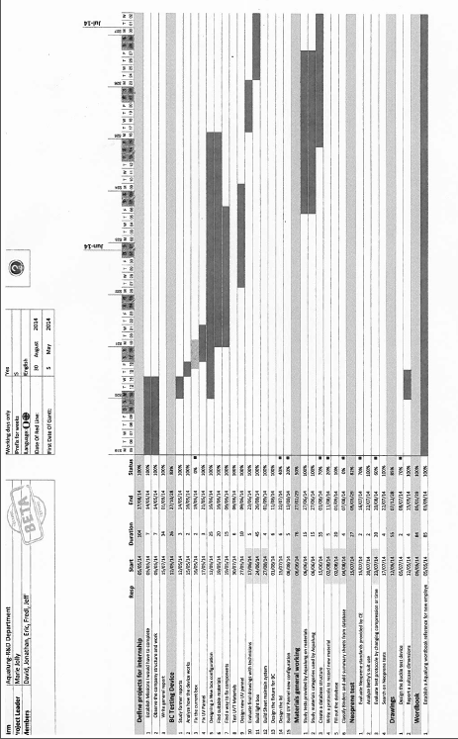

Protocol of Running
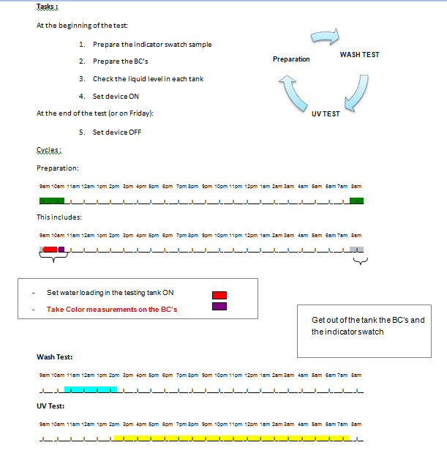
Figure 2 : Current protocol of running for one cycle
This cycle has to be repeated for two weeks. The details of this protocol are available on Appendix 2.
Then, the team populates the color measurement on a specific test results sheet between each cycle. They take these measures on specific parts of the BC. An exemple of this procedure is available on Apendix 3 and 4.

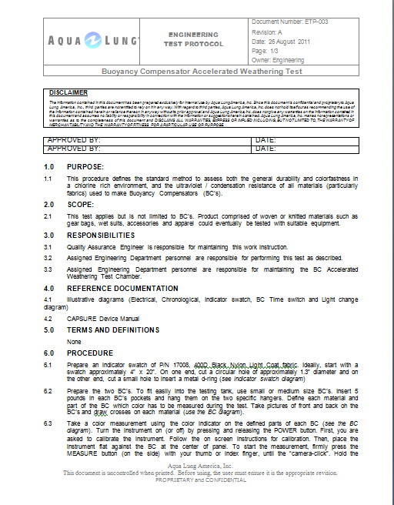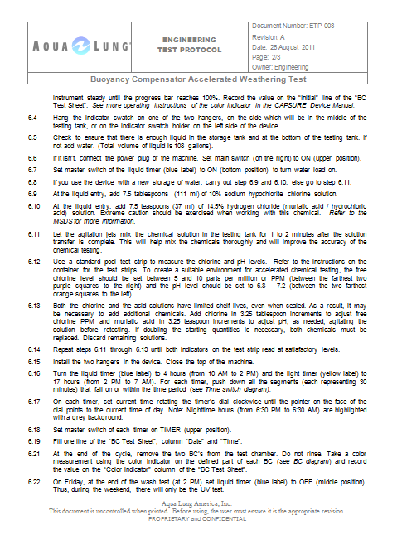

Location of color measurement

Specicific Test result sheet

Differents material suppliers in California
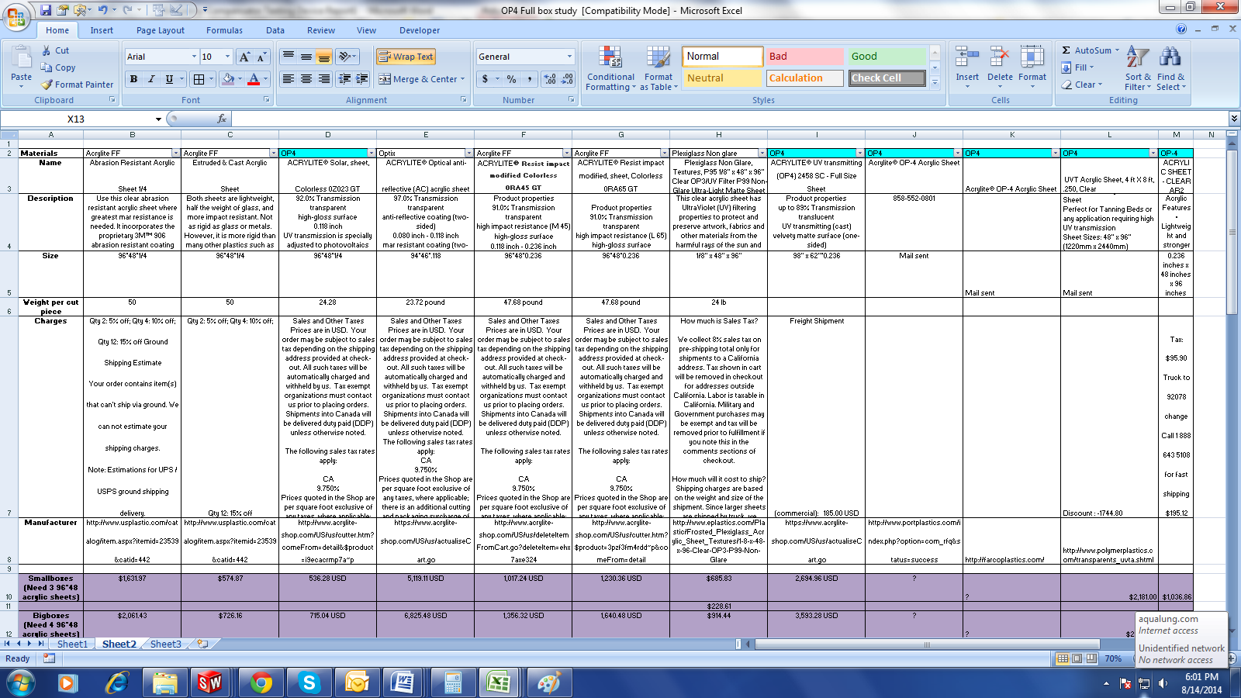

Details of stress calculation
Model Information

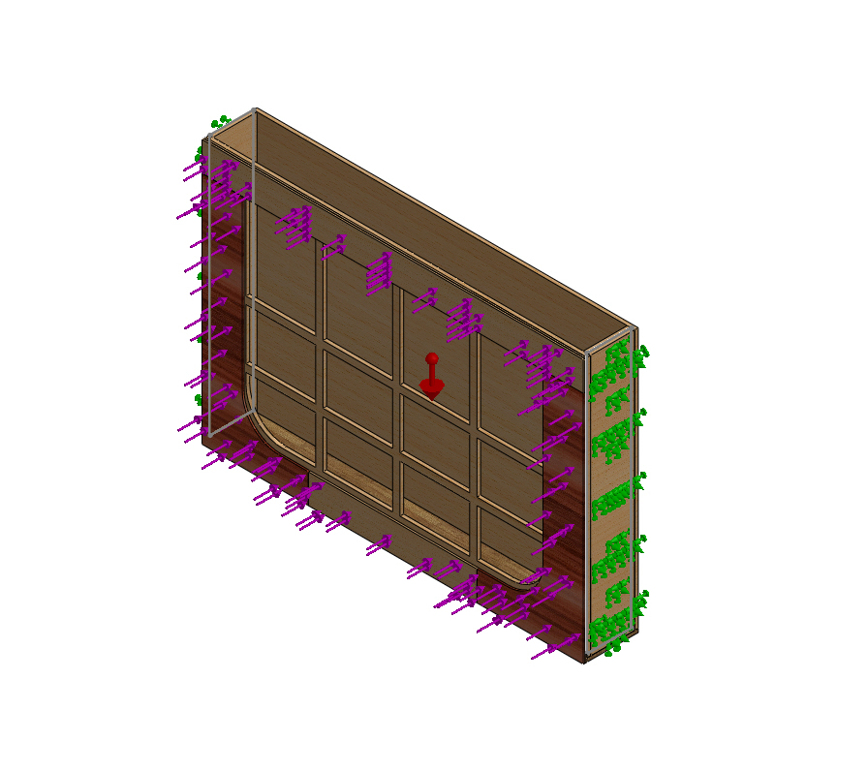
Model name: Assembly'
Current Configuration: Default
Solid Bodies
Document Name and Reference | Treated As | Volumetric Properties | Document Path/Date Modified
Cut-Extrude1  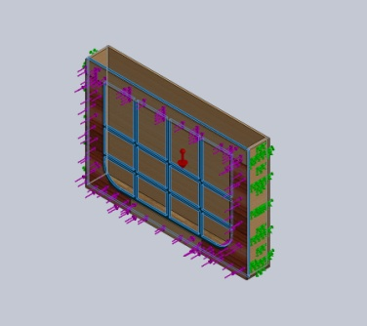 | Solid Body | Mass:1.16371 kg  Volume:0.00727364 m^3  Density:159.99 kg/m^3  Weight:11.4044 N | \\DATA1\Engineering\Users\mjolly\BC Machine\light box\Solution 4 (After Review meeting)_2 extruded box with sheet device\Final design\cuts\1'.SLDPRT  Jul 07 12:05:29 2014
Fillet1  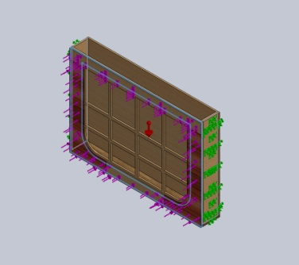 | Solid Body | Mass:0.391594 kg  Volume:0.00244762 m^3  Density:159.99 kg/m^3  Weight:3.83762 N | \\DATA1\Engineering\Users\mjolly\BC Machine\light box\Solution 4 (After Review meeting)_2 extruded box with sheet device\Final design\cuts\2.SLDPRT  Jun 23 15:31:59 2014
Boss-Extrude1  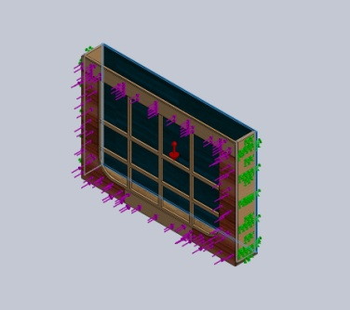 | Solid Body | Mass:2.41989 kg  Volume:0.0151253 m^3  Density:159.99 kg/m^3  Weight:23.7149 N | \\DATA1\Engineering\Users\mjolly\BC Machine\light box\Solution 4 (After Review meeting)_2 extruded box with sheet device\Final design\cuts\3.SLDPRT  Jul 07 12:05:28 2014
Boss-Extrude1  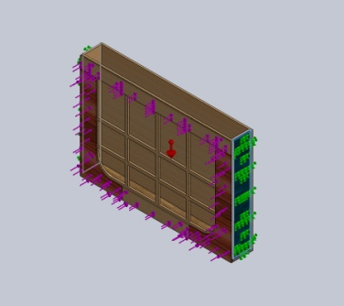 | Solid Body | Mass:0.279218 kg  Volume:0.00174522 m^3  Density:159.99 kg/m^3  Weight:2.73634 N | \\DATA1\Engineering\Users\mjolly\BC Machine\light box\Solution 4 (After Review meeting)_2 extruded box with sheet device\Final design\cuts\4.SLDPRT  Jul 10 13:59:31 2014
Boss-Extrude1  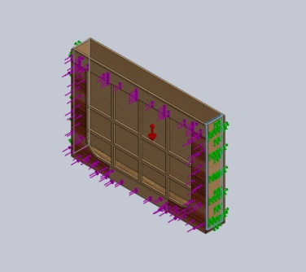 | Solid Body | Mass:0.279218 kg  Volume:0.00174522 m^3  Density:159.99 kg/m^3  Weight:2.73634 N | \\DATA1\Engineering\Users\mjolly\BC Machine\light box\Solution 4 (After Review meeting)_2 extruded box with sheet device\Final design\cuts\4.SLDPRT  Jul 10 13:59:31 2014
Boss-Extrude1  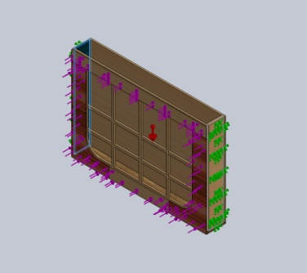 | Solid Body | Mass:0.279218 kg  Volume:0.00174522 m^3  Density:159.99 kg/m^3  Weight:2.73634 N | \\DATA1\Engineering\Users\mjolly\BC Machine\light box\Solution 4 (After Review meeting)_2 extruded box with sheet device\Final design\cuts\4.SLDPRT  Jul 10 13:59:31 2014
Boss-Extrude1  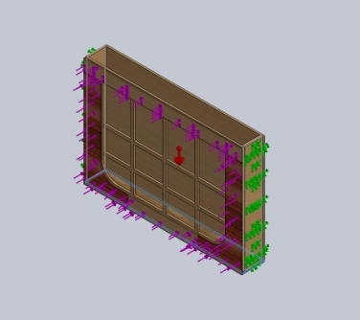 | Solid Body | Mass:0.477161 kg  Volume:0.00298245 m^3  Density:159.99 kg/m^3  Weight:4.67618 N | \\DATA1\Engineering\Users\mjolly\BC Machine\light box\Solution 4 (After Review meeting)_2 extruded box with sheet device\Final design\cuts\6.SLDPRT  Jul 07 12:05:28 2014
Boss-Extrude1  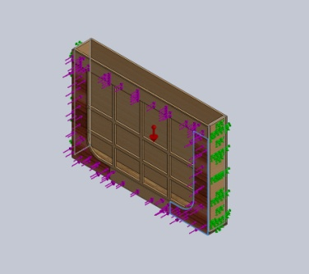 | Solid Body | Mass:0.14247 kg  Volume:0.000890494 m^3  Density:159.99 kg/m^3  Weight:1.39621 N | \\DATA1\Engineering\Users\mjolly\BC Machine\light box\Solution 4 (After Review meeting)_2 extruded box with sheet device\Final design\cuts\Clamping frame side.SLDPRT  Jun 24 10:03:21 2014
Boss-Extrude1  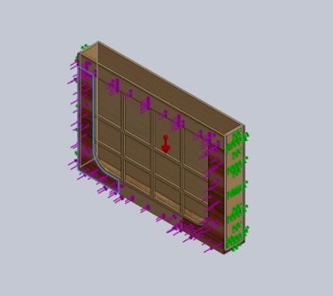 | Solid Body | Mass:0.14247 kg  Volume:0.000890494 m^3  Density:159.99 kg/m^3  Weight:1.39621 N | \\DATA1\Engineering\Users\mjolly\BC Machine\light box\Solution 4 (After Review meeting)_2 extruded box with sheet device\Final design\cuts\Clamping frame side.SLDPRT  Jun 24 10:03:21 2014
Boss-Extrude1  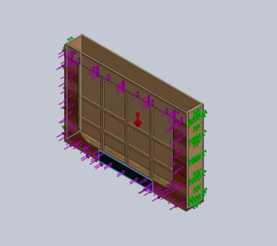 | Solid Body | Mass:0.0603006 kg  Volume:0.000376902 m^3  Density:159.99 kg/m^3  Weight:0.590946 N | \\DATA1\Engineering\Users\mjolly\BC Machine\light box\Solution 4 (After Review meeting)_2 extruded box with sheet device\Final design\cuts\clamping ring bottom.SLDPRT  Jun 24 10:56:04 2014
Boss-Extrude1  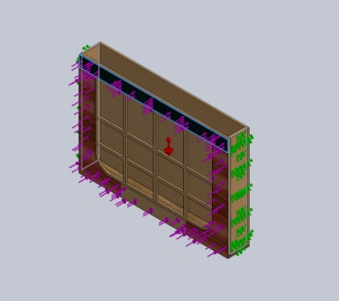 | Solid Body | Mass:0.136332 kg  Volume:0.000852127 m^3  Density:159.99 kg/m^3  Weight:1.33605 N | \\DATA1\Engineering\Users\mjolly\BC Machine\light box\Solution 4 (After Review meeting)_2 extruded box with sheet device\Final design\cuts\clamping ring top.SLDPRT  Jun 24 10:09:31 2014

Study Properties
Study name | Static 1
Analysis type | Static
Mesh type | Solid Mesh
Thermal Effect: | On
Thermal option | Include temperature loads
Zero strain temperature | 298 Kelvin
Include fluid pressure effects from SolidWorks Flow Simulation | Off
Solver type | FFEPlus
Inplane Effect: | Off
Soft Spring: | Off
Inertial Relief: | Off
Incompatible bonding options | Automatic
Large displacement | On
Compute free body forces | On
Friction | Off
Use Adaptive Method: | Off
Result folder | SolidWorks document (\\DATA1\Engineering\Users\mjolly\BC Machine\light box\Solution 4 (After Review meeting)_2 extruded box with sheet device\Final design\cuts)

Units
Unit system: | SI (MKS)
Length/Displacement | mm
Temperature | Kelvin
Angular velocity | Rad/sec
Pressure/Stress | N/m^2

Loads and Fixtures
Fixture name | Fixture Image | Fixture Details
Fixed-1 | 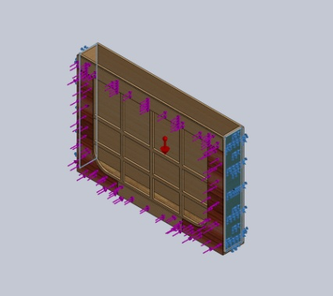
  Entities: | 2 face(s)
  Type: | Fixed Geometry
Resultant Forces
Components | X | Y | Z | Resultant
Reaction force(N) | -0.445801 | 56.4295 | 34255 | 34255.1
Reaction Moment(N.m) | 0 | 0 | 0 | 0

Load name | Load Image | Load Details
Gravity-1 | 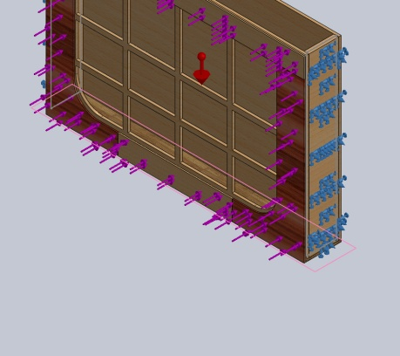
  Reference: | Top Plane
  Values: | 0 0 -9.81
  Units: | SI
Force-1 | 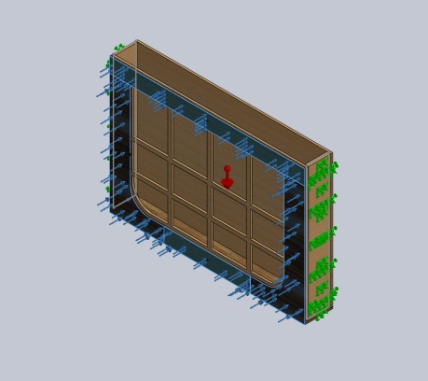
  Entities: | 4 face(s)
  Type: | Apply normal force
  Value: | 8565.2 N

Contact Information

Contact | Contact Image | Contact Properties
Global Contact | 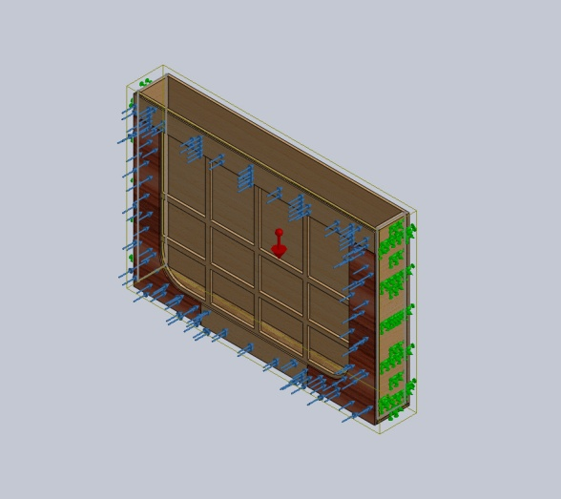
  Type: | Bonded
  Components: | 1 component(s)
  Options: | Compatible mesh

Mesh Information
Mesh type | Solid Mesh
Mesher Used: | Standard mesh
Automatic Transition: | Off
Include Mesh Auto Loops: | Off
Jacobian points | 4 Points
Element Size | 2.08579 in
Tolerance | 0.10429 in
Mesh Quality | High
Remesh failed parts with incompatible mesh | Off

Mesh Information - Details
Total Nodes | 16708
Total Elements | 8575
Maximum Aspect Ratio | 32.964
% of elements with Aspect Ratio < 3 | 3.87
% of elements with Aspect Ratio > 10 | 6.13
% of distorted elements(Jacobian) | 0
Time to complete mesh(hh;mm;ss): | 00:00:06
Computer name: | ALA1011W
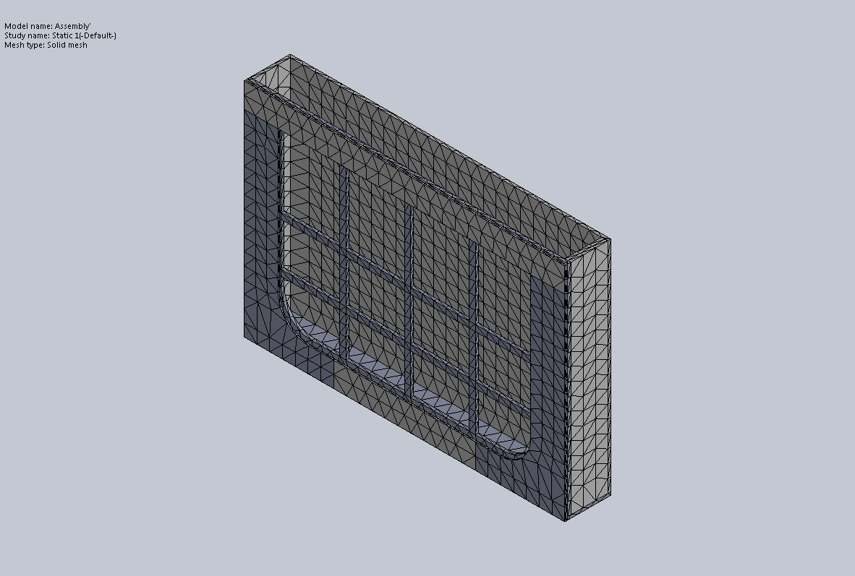

Resultant Forces
Reaction Forces
Selection set | Units | Sum X | Sum Y | Sum Z | Resultant
Entire Model | N | -0.445801 | 56.4295 | 34255 | 34255.1
Reaction Moments
Selection set | Units | Sum X | Sum Y | Sum Z | Resultant
Entire Model | N.m | 0 | 0 | 0 | 0

Study Results

Name | Type | Min | Max
Stress1 | VON: von Mises Stress | 6516.36 N/m^2  Node: 12053 | 5.89325e+007 N/m^2  Node: 2452
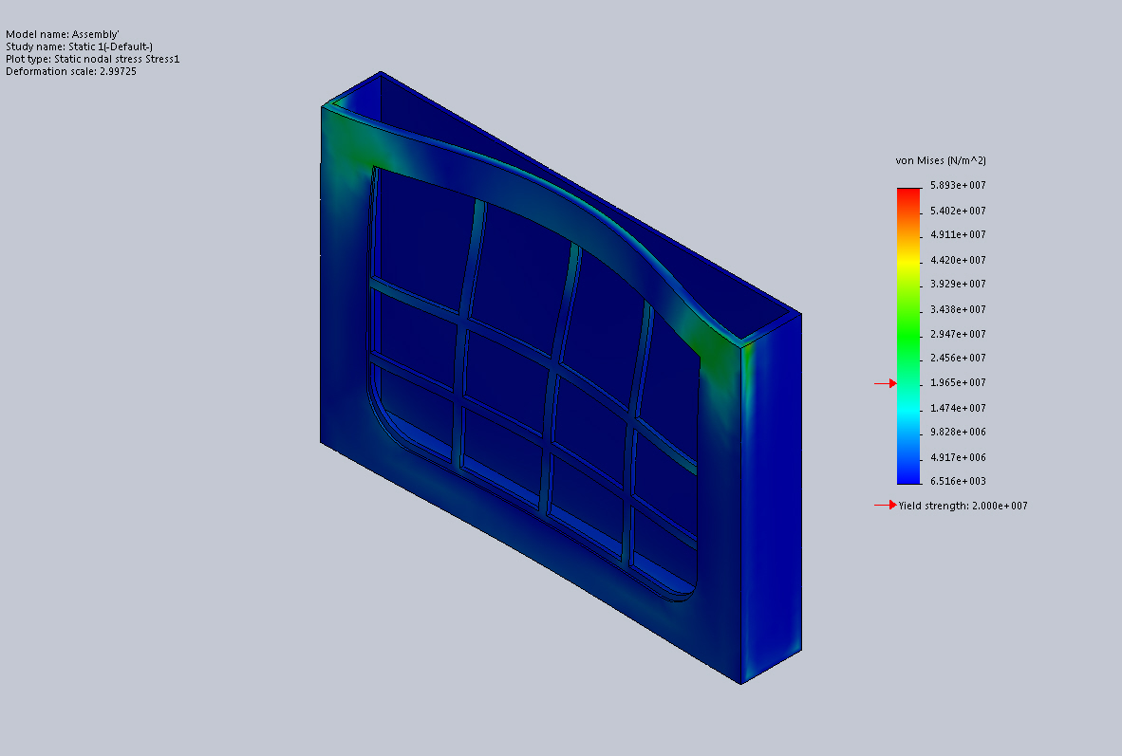
Assembly'-Static 1-Stress-Stress1

Name | Type | Min | Max
Displacement1 | URES: Resultant Displacement | 0 mm  Node: 391 | 44.0673 mm  Node: 16487
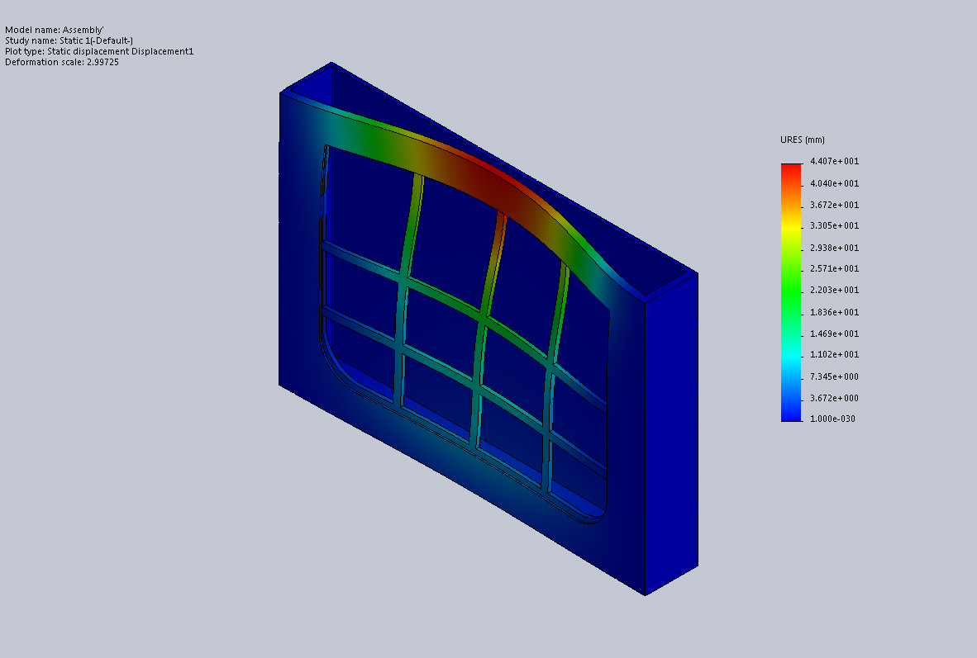
Assembly'-Static 1-Displacement-Displacement1

Name | Type | Min | Max
Strain1 | ESTRN: Equivalent Strain | 8.06656e-007  Element: 6543 | 0.0138636  Element: 1210
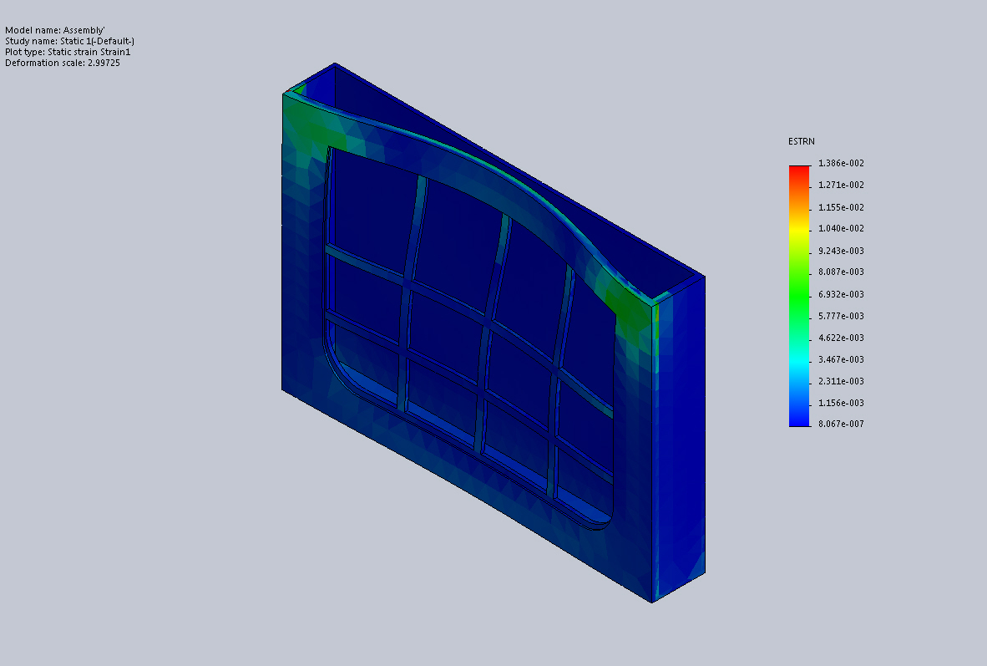
Assembly'-Static 1-Strain-Strain1

Budget
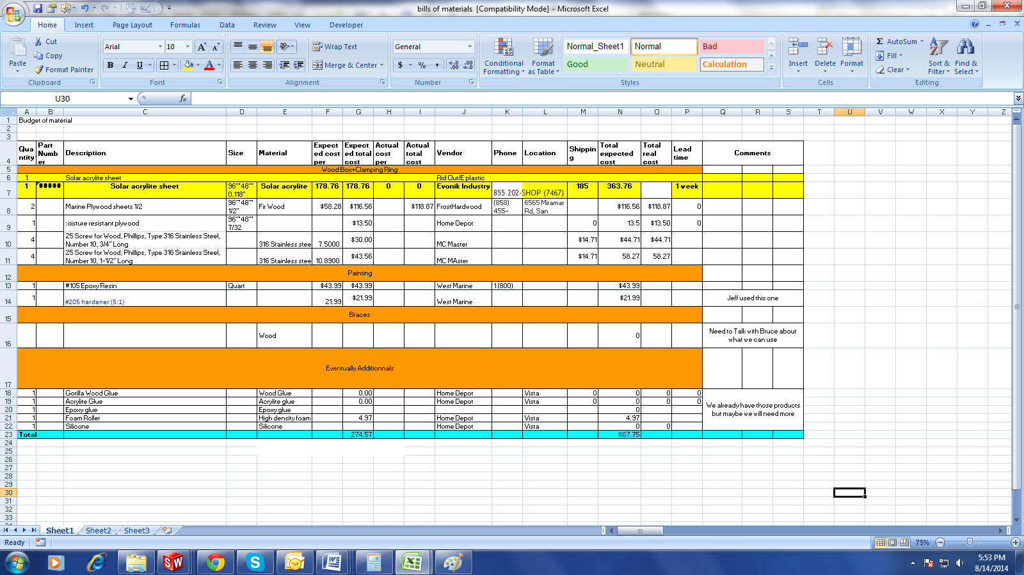

UV Pannel configuration
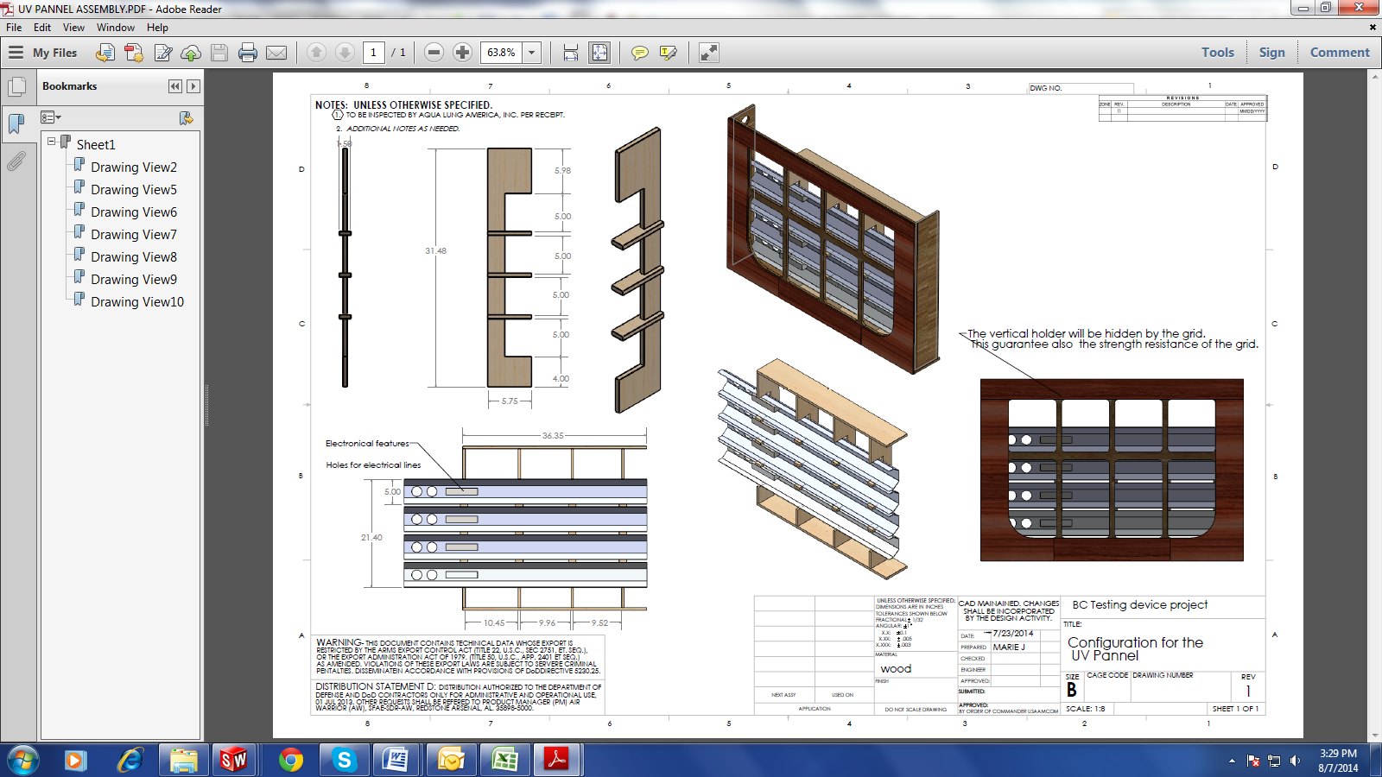

Final design+Fixtures
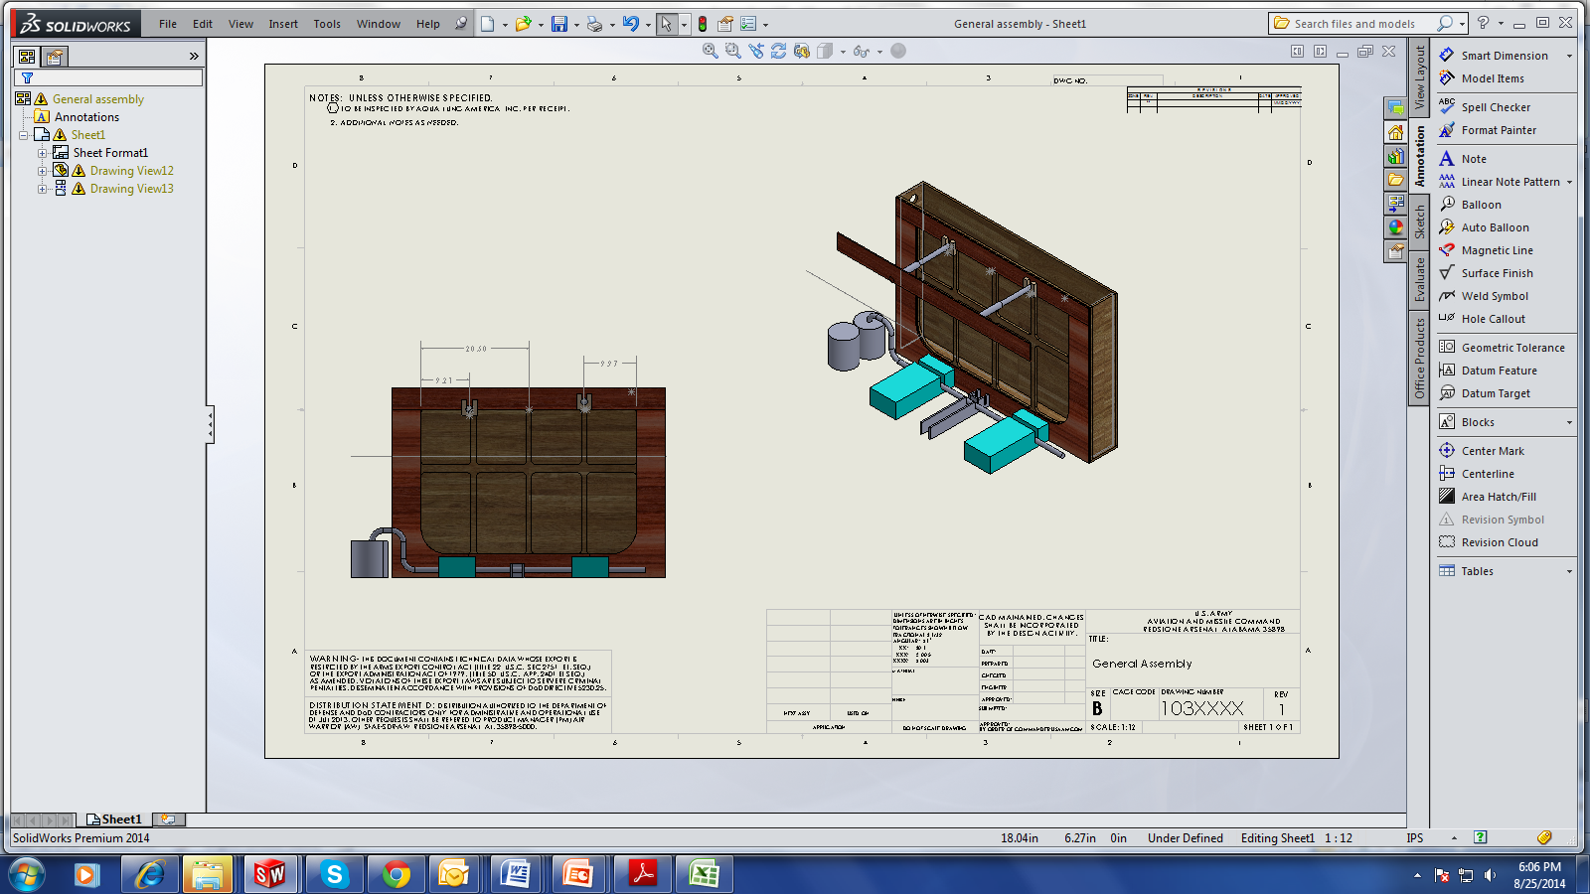
Dimensioning brand new design
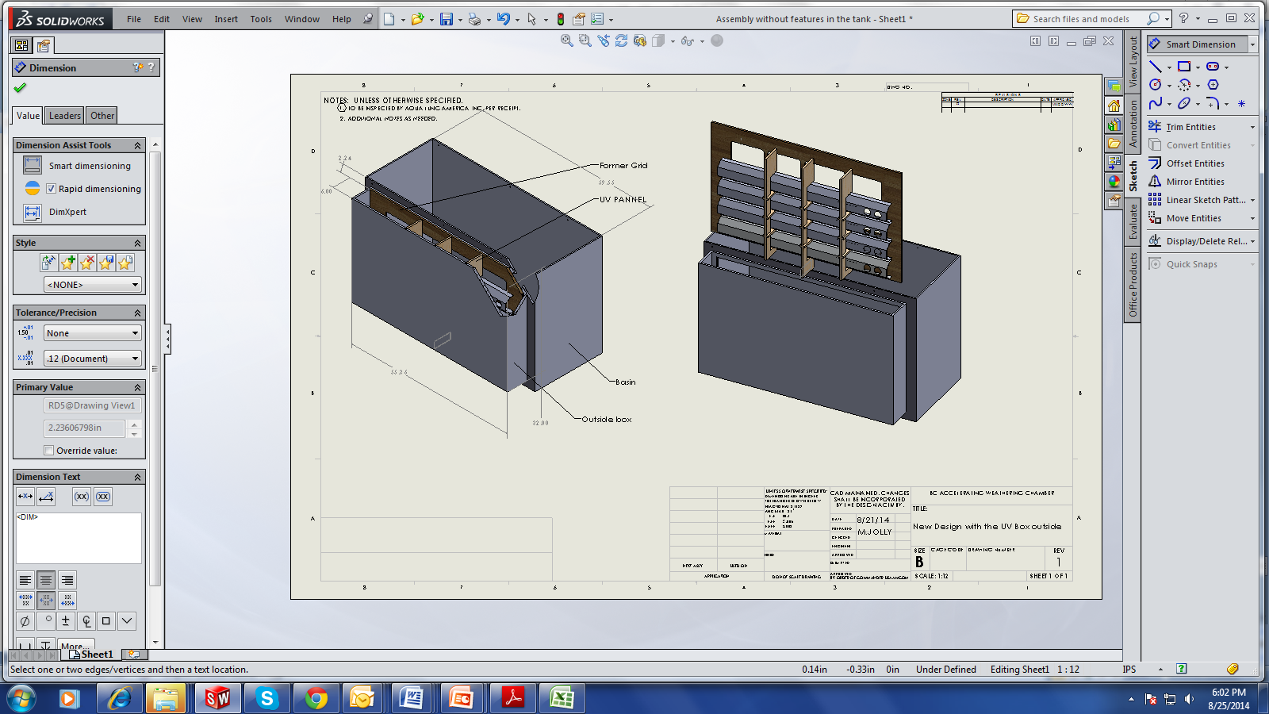

Static Study Analyse
Analysis type | Static study
Mesh type | Solid Mesh  Elements size : 2.08579 in  Total elements : 8575  Maximum Aspect Ratio : 32.964
Material Properties
  Model type: | Linear Elastic Isotropic
  Yield strength: | 2e+007 N/m^2
  Elastic modulus: | 3e+009 N/m^2
  Poisson's ratio: | 0.29
  Mass density: | 159.99 kg/m^3
  Shear modulus: | 3e+008 N/m^2
Forces applied | Gravity : Based on the weight properties of the Material datasheet given by the supplier  Pressure on the front side : Normal to the grid direction. Value based on the amount of water required to run the test by having the BC’s all water covered located between the two Uv light boxes.  Value : 8565.2 N on the front side
Fixtures | For this simulation, Fixtures have been added on the back on the box (bolts). This would help to not allow the UV Box to move up when the basin will be filled with the water.

WBS

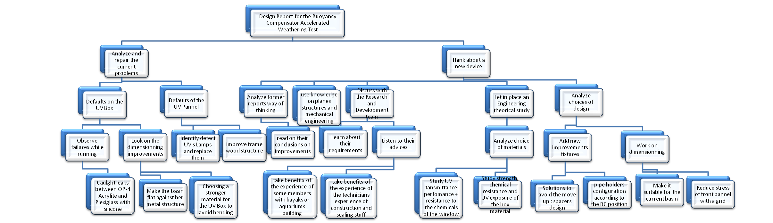
Calculs poids du contenant et comportement dans l eau
Weight of the box :
Mass = 78.9665 pounds ( Density of Marine Plywood = 360 kilograms per cubic metre according to the supplier Frost Hardwood , weight of spacer negligee)
Volume of water deplaced = 11232 cubic inches =

Surface area = 12064.4293 square inches

Center of mass: ( inches )
X = 15.1710
Y = 47.2499
Z = 14.1944

Principal axes of inertia and principal moments of inertia: ( pounds * square inches )
Taken at the center of mass.
Ix = (0.9999, -0.0100, -0.0034) Px = 10138.2694
Iy = (0.0099, 0.9997, -0.0205) Py = 22274.5939
Iz = (0.0036, 0.0204, 0.9998) Pz = 31272.6959

Moments of inertia: ( pounds * square inches )
Taken at the center of mass and aligned with the output coordinate system.
Lxx = 10139.7364 Lxy = -122.1316 Lxz = -72.7884
Lyx = -122.1316 Lyy = 22277.1380 Lyz = -183.4932
Lzx = -72.7884 Lzy = -183.4932 Lzz = 31268.6848

Calculs facteurs de securite
Study about safety factor :
Tensile strength is the ultimate capacity of the material to resist a tensile load regardless of deflection. This data is available in the supplier material data sheet.
Tensile strength of ACRYLITE® Solar 0Z023 (evonik) : 7500-10112 psi
- The calculations that follow expect the glass to be supported around its perimeter on all four sides. The calculation is the same regardless of whether the perimeter join is in compression or tension. Typical all glass aquariums have all their joins in either tension or shear or both. This method of construction relies 100% on the strength of the silicone holding it together, and is also the weakest join type when using silicone. Steel frame aquariums have the silicone under compression.
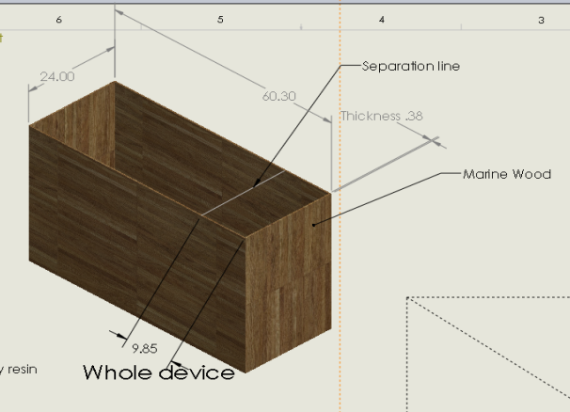
- Dimensions of the basin : 24*60.3*36
- Dimensions of the UV transmitting acrylite sheet ; 29*41
- Water pressure due to water inside the basin as height as the Acrylite hole
- Don’t take in consideration the space fill out by the other UV Pannel

The water pressure (p) is directly proportional to the Height (H) x the force of gravity (approx 10 (9.81 for people who want to be exact)) with H in mm (28in=710mm)
$$P=H×g$$
P=7100 N/mm2
The bending stress allowed (B) is equal to the Tensile Strength of acrylite / safety factor. Various websites offer differing advice on exactly which safety factor should be used. Consensus : 3.8.
$$B=\frac{Tensile Strength of acrylite}{Safety Factor}$$
- Here : B=52/3.8=13.6N/mm²
- The thickness of the glass (t) is proportional to the (square root of width factor (beta) x height (H) cubed x 0.00001 / allowable bending stress (B)). To calculate $β$ you have to use the following chart, accordind to the ration L/H.
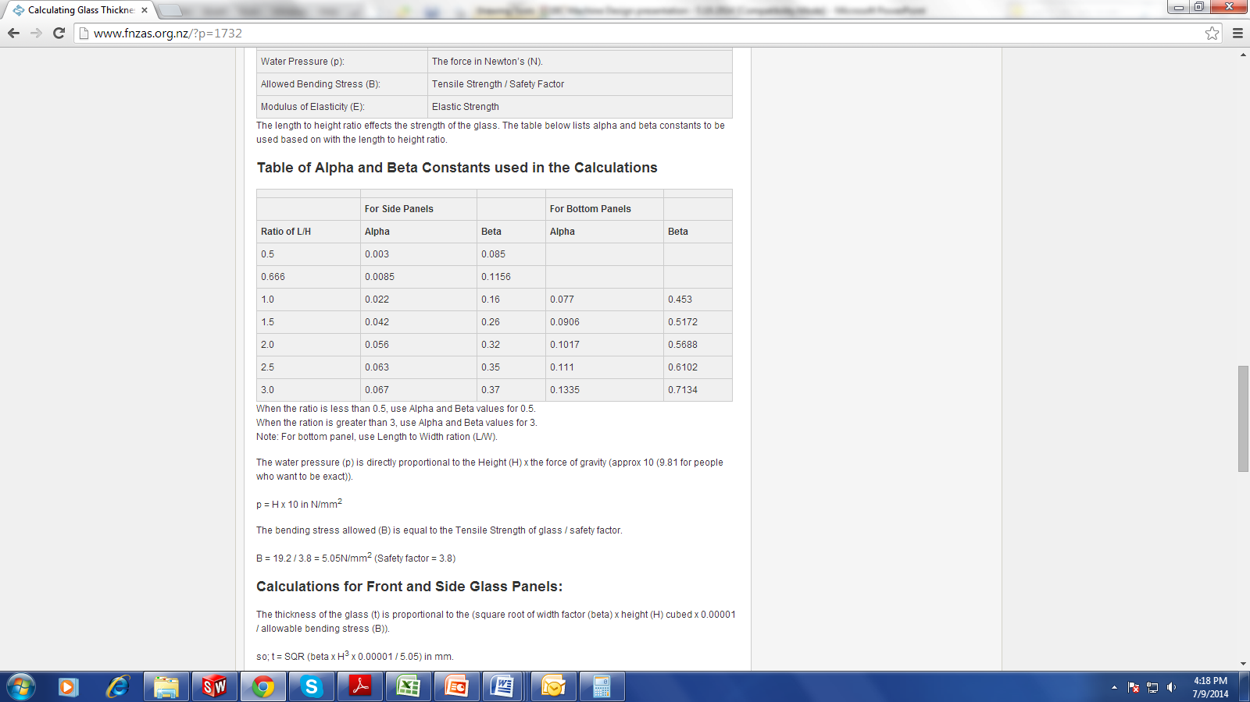
Figure 9 : Table of Alpha and Beta used in the calculations
$$t=\sqrt{(β×H^{3}×0.00001)/B}$$
Here ; Ratio L/H=L/H=41/28=1.48 so beta=0.26 (table) and alpha= 0.042 (table)
So t = 12mm=0.48”
The deflection formula is given by the following formula :
$$Deflection=\frac{(α×P×0.00001×H^{4})}{E×t^{3}}$$
Here, Deflection =2.3mm=0.092”
So according to this value, the recommended use for the thickness would be
$$Deflection+0.14”≈1/{4"}$$

