Design of a new configuration for the Buoyancy Compensator testing device and Materials work Improvements
Marie Jolly



Company tutor: Eric THORSTENSON
School tutor: Gerard BERNHART

From May 5th to August 29th 2014
Work with Engineering and Product Development to enhance a Buoyancy Compensator weather testing machine by making it more robust and ergonomic to use. Identify areas of improvements in materials storage.

Contents
Presentation of the project 3
Description of the device 3
Utility 3
Components 4
UV Pannel 4
Tank 5
Current UV light Box 5
Current configuration 7
Protocole of running 8
Methodology to lead the project 8
preparation 8
Running the project 8
Problems to solve 9
Work realized 13
Having the device ready 13
Researching on a new Configuration 14
Dimensioning 15
A new material? 16
1. Turn to the new conf 18
Basic fastener bonding 19
Materials 20
UV Transmitting Acrylic Sheet OP4 20
Glue 21
Final solution and building 22
Appendix 24
Budget of the former project (See students report) 24
Drawings of solutions 25

Main project: BC Testing Device design

Presentation of the project

I have been asked to improve a Buoyancy Compensator testing device where several groups of intern have already worked on. Indeed, the head of engineering is pretty satisfied with this device, but with the time, several structures problems appeared. The project involves to fix or think about another configuration of the UV’s boxes used for the light tests on BC’s, to improve the way these UV’s panels are set together and inside these boxes, working on other feature of the BC testing device like the lead or cycle test.
Previously, San Diego college students have worked on the building of this device according to the UV light direction and repartition but also about the strength of the device. Nonetheless, the materials which were used to build the UV’s boxes have bend under the water pressure and it becomes more difficult to put the UV panel inside these boxes. But the main problem stays the leaks which appear on the acrylite box joints.
Although Aqualung has one machine for the wash test and one for UV tests, this device remains needed to simulate at best weathering conditions: sunlight, chlorine and salt environment during a dive. That is why my mission consists on make this device more robust and easier to use.

Description of the device

Utility

In order to enhance materials which are used to build Buoyancy Compensators, the Aqualung team of engineering needs to know what behavior they have on diving conditions. This device was made in order to simulate real weather conditions by alternated chlorine wash and UV exposition cycles. Indeed, BCs are often these kinds of conditions with pool or ocean trainings. Before proposing a BC to a client or using a material to build a gear submitted to those conditions, Aqualung team needs to determine what will be the impact of those damages on the appearance and the weakening deterioration. From that step, they can review the product if it doesn’t succeed to the limits provided by their standards.
 | BEFORE | AFTER
MARES  ROVER | 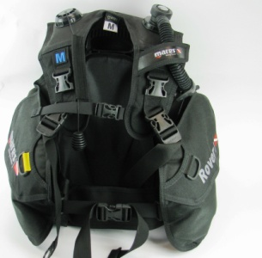 | 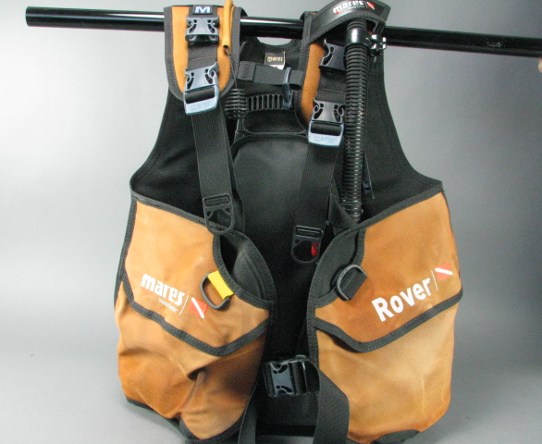
AQUA WAVE | 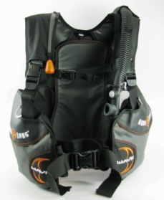 | 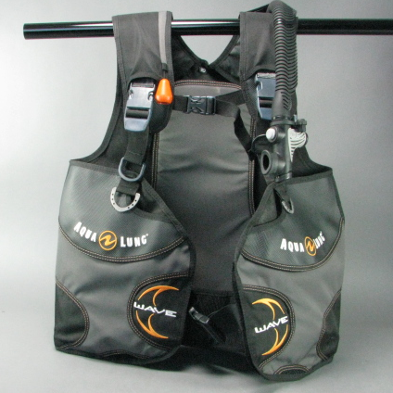
Table 1. Exemple of visual result on the BC testing device

Components
This device includes several features in order to run the test properly. The drawing below shows them
PICTURE OF THE TOTAL DEVICE WITH COMPONENTS

UV Pannel
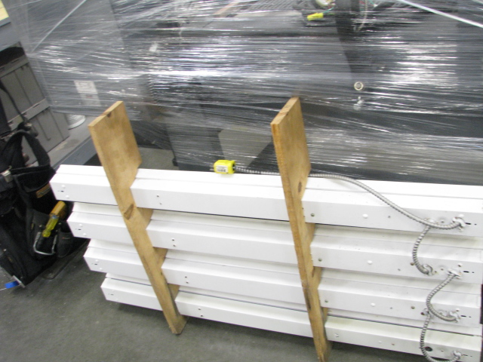
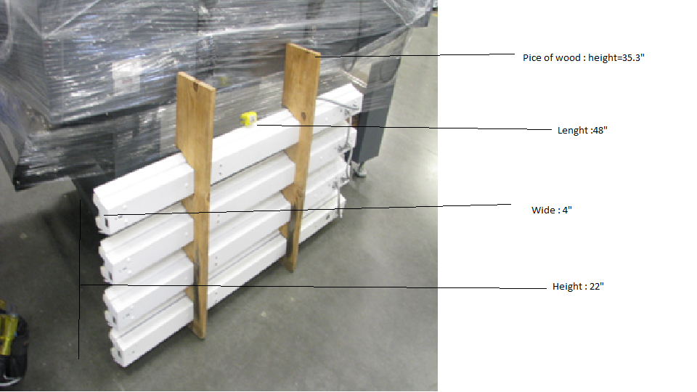
Currently, UVs are linked by two pieces of wood. But this configuration is quite uncomfortable to use because UVs lamps have tendency to move around and it is not easy to carry in and out of the box. Regarding to the box configuration we will probably have to think about another way to maintain the lamps together.

Tank/ Basin
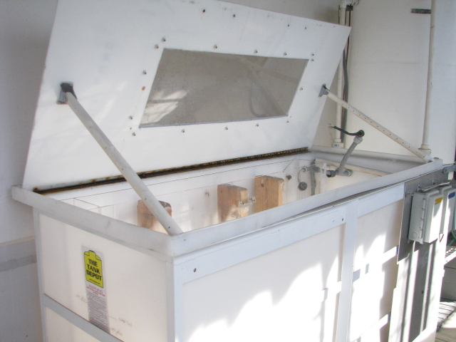Dimensions :
The tank is made with plastic and reinforce with a metal skeleton 2 years ago to avoid bending of the plastic.

Current UV light Box

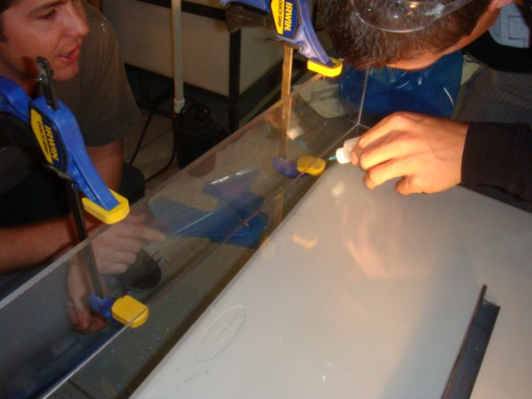This light box has been built by former interns from the San Diego University. According to their thinking process, the BC’s which need to be tested needs to be placed at a disrance of 4 inches from the UV to get the optimal irradiance. That is why these light boxes were designed to fit inside the tank. Obviously, the electrical components need to be in a entire waterproof space. The box was constructed out of Acrylite OP-4 on the face of the box because OP-4 is UVA-340 transparent. The rest of the box was constructed from Plexiglas. The Plexiglas and Acrylite were bonded together using IPS Weldon 3 adhesive.

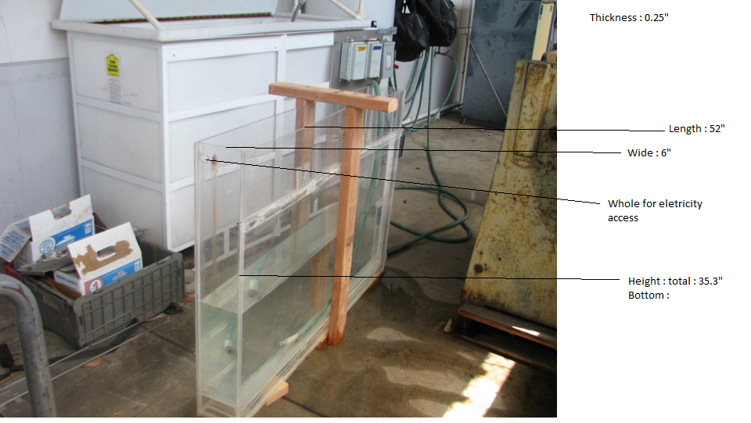
Figure 1. UV's Light Box dimensions
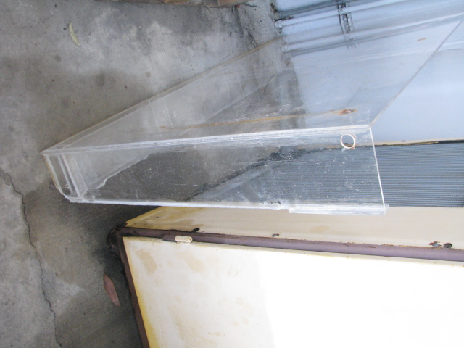
Figure 2. Space at the bottom of UV's Light Box
Bottom : The light boxes were designed with a three inch space at the bottom to allow some water to stay inside the tank during the light test.
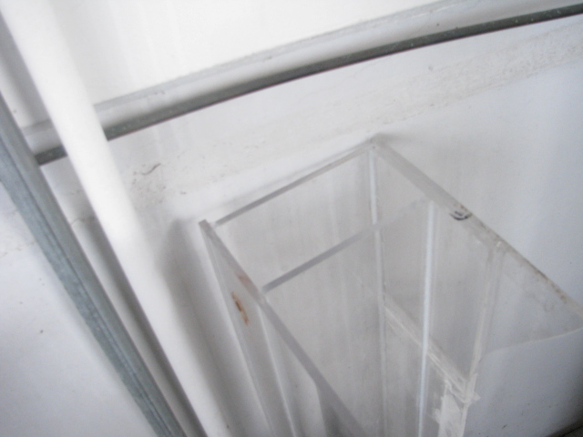
Figure 3. Inside extra pannel on the UV's light Box
In order to fit the UV’s panel properly, they added an extra piece of plexiglass inside the box in order to avoid it to move from left to the right.

Current configuration
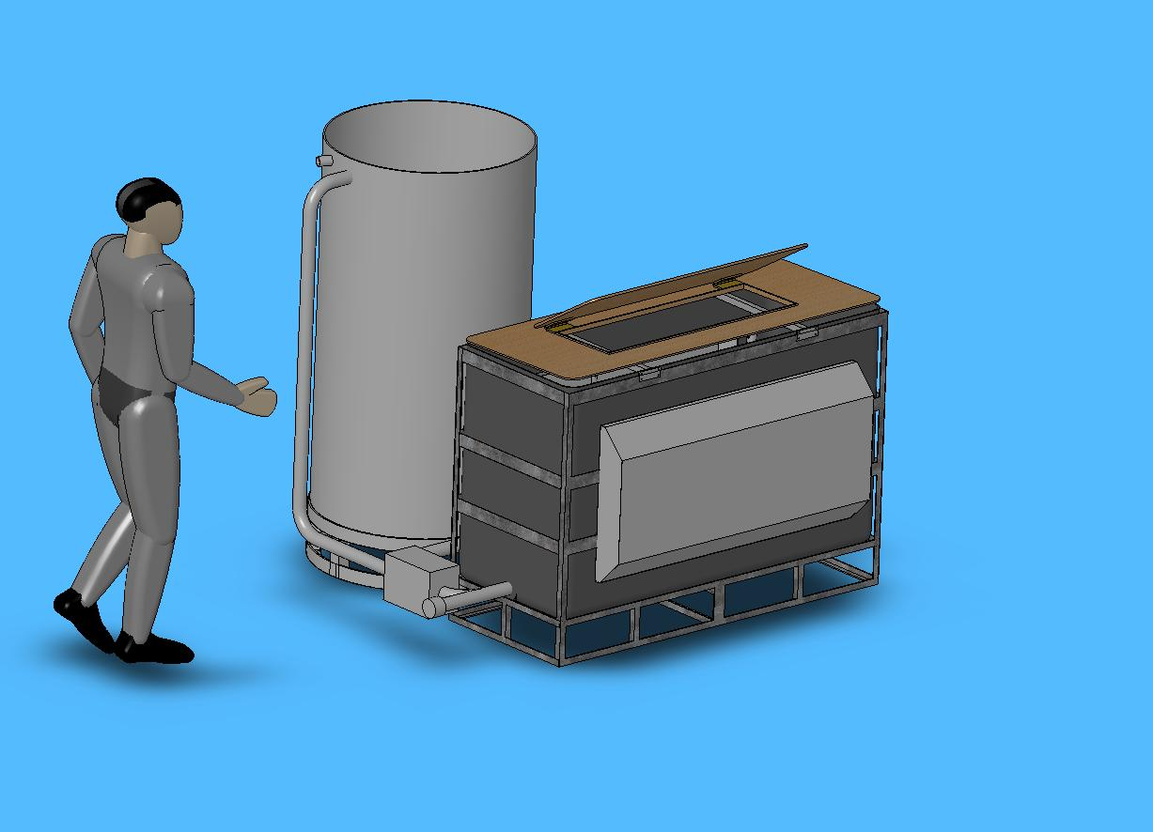
This current configuration is the result of former internships. Indeed, in 2008, San Diego students reached to transform the old testing rig by improvement such as:
- Reduce overall footprint of testing rig
- Added vents to light cover to decrease temperature inside UV light kits
- Changing all metal used to use stainless 316
- Using a 160 gallon cylindrical tank for the storage tank. It will not gravity feed any more. They redesigned the system to pump from each tank.
- Changing pumps to 1/6 hp sump pumps with accompanying float valves.
- Tanks supports have been lowered to lower center of gravity and to allow testing rig to be used away from wall support if needed.
- Adding a drain to the plumbing system, so the system can be drained.
- Adding a secondary lid to cover the viewing window to eliminate any additional light to the system.
- The support structure will be welded and removable caster wheels will be added so the system can be moved.

Protocole of running

Methodology to lead the project

preparation
To design the new features, it was essential to identify the framework. The very first mission consisted in learning on the BC testing device characteristics, applications and how it works. The design process began by looking closely at the former reports about current design and protocol of running. Indeed, I would not be able to work on it if I did not know the reasons why things lead to this configuration.
Then I also need to know what the requirements for this device are. I learned that it already exist a UV testing device and a wash test, but the BC testing device let the team to simulate better real conditions of using. According to explications of users of this device, I was able to identify the issues encountered with this device. The conclusion of the former reports were helpful too because I could find some idea of improvements identified by former interns. I submitted the list of issues during the very first weekly meeting about BC testing device we planned with the team.

Running the project
After studying the major axis of work for this project, it was time to turn to establish a way to work.
I guessed I don’t know all the details concerning this machine, so for each issue I have identified I talked to persons involved or refer to the protocol of running. According to that information, I was able to separate this project into different main tasks and subtasks available in the following Work Breakdown Structure (WBS).This would help me to divide the project into several improvements and time to allow on each one to keep the control of the time available for my mission.
WBS

By the way, I also set up a weekly meeting with the head of Engineering department, Eric Thorstenson, and the two engineers in charge of this project, David Sullivan and Jonathan Souder every Monday morning. I planned to submit all my suggestions during those meetings, but also make a regular follow up by e-mail about how things are going on. Finally, the team will be able to see my progress on designing or researches in my shared folder made for the BC Testing Device Project.

Problems to solve

Borders leaks: because of the joints materials between tank and boxes, some water flees thorough.

ollage
Le PMMA se laisse facilement coller, mais un dégraissage est nécessaire.
PMMA contre PMMA:
a) des collages aux solvants sont possibles au moyen de chloroforme ou de dichlorure d'éthylène
b) mélange de polymère acrylique et de solvants (par ex. ALTUFIX S2002)
PMMA contre autres matériaux: avec des colles à réaction chimique au cyanoacrylate pour petites surfaces (par ex. CYANOLIT 201) ou avec des colles à deux composants à base époxy (par ex.ARALDITE)
Important
Afin d'éviter des microfissures ou des points de rupture dans la zone de collage, il convient, avant le collage, d'exécuter un étuvage pour réduire les tensions causées par la mise en oeuvre ou l'usinage de la pièce.
Etuvage: dans un four à circulation d'air pendant env. 2 à 4 heures de +70°C à +90°C (temps de refroidissement: au moins 3 heures).
Polissage: avec une meule flexible, en appuyant légèrement (éviter la chaleur de friction).
Façonnage à chaud: selon type, de +130°C à +150°C.
Research on light box :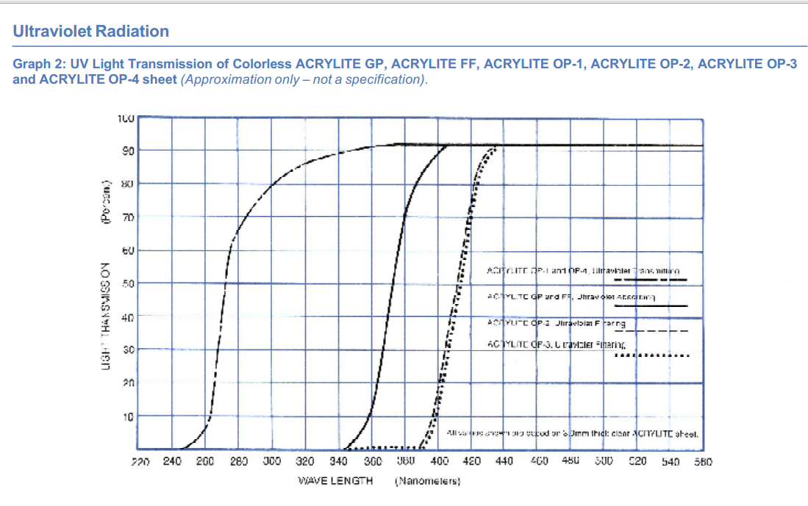

Avoid electricity and water contact on the UV box :
This is linked to the first problem. I ve seen in Marie’s report that the test has even stopped once because of too much water in the UV box and David told me about this issue he had already encounter.

http://www.dotmar.com.au/uv-resistance.html

Material | Physical Appearance | Property Degradation | Comments
Acetal | U | U | UV stable grades available offer excellent performance.
Nylon | U | U | Black pigmented grades have better UV stability.
Hydex® 4101 (PBT) | F | E | Inherently UV stable, black grades provide additional protection.
Hydex® 4301 (PC) | U | U | UV stable grades available.
Ultem® 1000 (PEI) | E | E | Inherently UV resistant.
Hydex® 202 (RTPU) | F | E | Pigmented versions will mask color shift.
ABS | U | U | Not recommended for outdoor applications.
Polysulfone | F | F | Black pigmented versions available for improved UV resistance.

Acrylic sheets (Hublots) : same as plexiglass ??

Polycarbonate (Fair)

Pannels for the UV ? 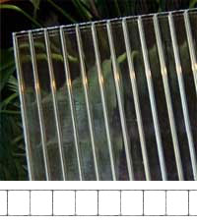 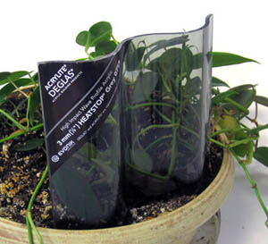

Way to fix the UV together : put them vertically ? Bruce’s Idea, but they are too long to fit in the tank.

Making the tank flat :
it doesn’t fit with the frame and we have to think about a solution which can avoid it to move because of water pressure : materials, screws …?

New lead : something which looks stronger and ergonomic

Position of the BC in the machine (UVs mainly on the side) : I ve read in Marie’s report that the position of UV doesn’t cover all the BC, particularly most exposed part during diving such as shoulders. She mentioned to put a mirror above to reflect UVs on these parts.

Measuring color : BC wet problem and frequency to do this

Cycle duration :

sometimes, the machine doesn’t do anything during several hours. Maybe can we think about a solution to not spoil this time ?

Adjust Chemical : easier and more safe way to put them on

Work realized
The device is able to work but the leaks on the UV Box and the UV panel which is not totally working makes the running impossible. Nonetheless, even if I was asked to designing a new stronger and suitable configuration for the device, the team agreed on the fact that repairing the current defaults to run the BC Testing Device and see more why it has some problems during running is necessarily. So in the same time of thinking, I cared about the former UV Box.

Having the device ready
Because the engineer team needs to run tests on their BC and material samples, my very first task consisted on trying to fix one of the current UVs light box. We remove the UV box from the basin to check those 2 points :
If all UV’s lamps were working :
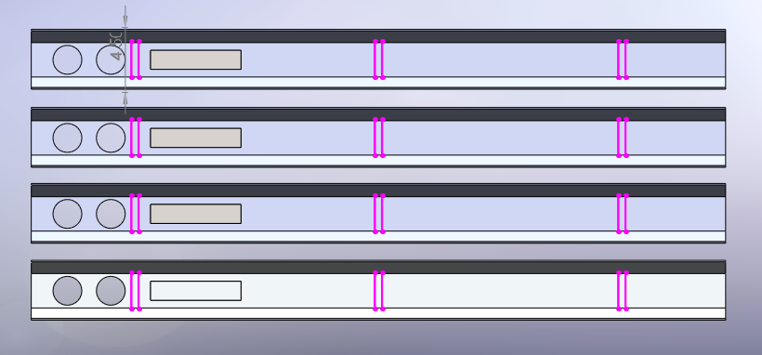
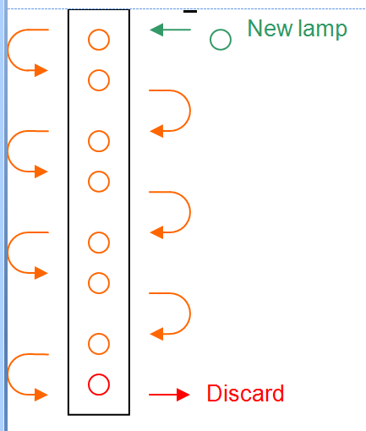
A UV panel is composed by 8 UV lamps linked 2 by two in aluminium containers. The pairs are linked with electrical connections at the back of aluminum holder. On the box we were studying one of them did not work anymore. After cleaning the panel of its dust, with Jonathan we analyzed where the disconnection according to the scheme of was electrical links available aside. We noticed that the screws used to hold the lamps were rusted but still usable. Furthermore, I noticed that the assembly have tendency to swirl because of only 2 vertical wood holders.
Study leaks and configuration performance under pressure :
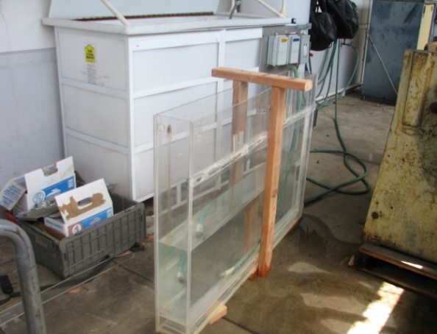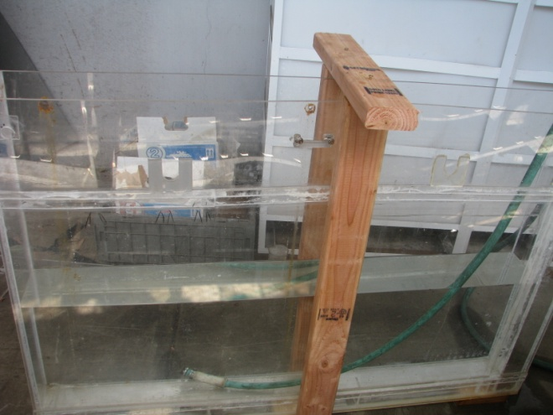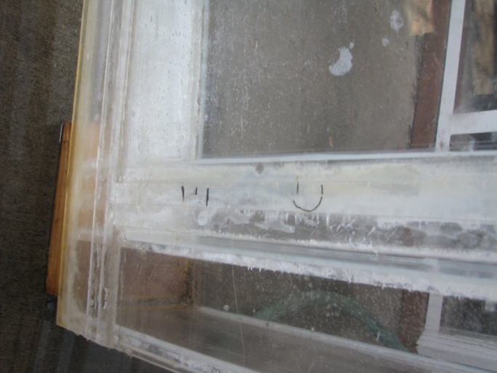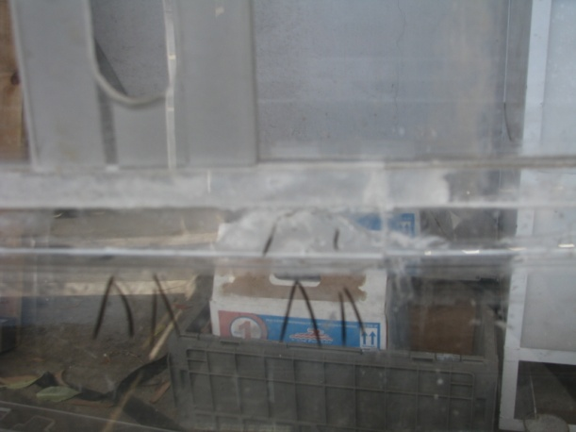
By filling out the UV box with water, I would be able to locate the leaks. But first, because of the bending of the Plexiglas panels which constitute the box, we started first by building a reinforcement frame to maintain the box flat during the operation. As a conclusion and as expected, Leaks are mainly located on the joint between two different materials (OP4 and Plexiglas), on the bottom (because of gravity and empty space structure) and where several pieces of Plexiglas are stuck side by side to reinforce the joint. Once the leaks were identified, I started to caulk them with waterproof silicone.

Researching on a new Configuration

Dimensioning
By looking at the UV light box, I noticed that the OP-4 Front Pannel acrylite was not bending contrary to the rest of the box (in Plexiglass). That is the reason why the very first idea which naturally came on the table was to replace the whole box by an entire acrylite OP-4 box. Several dimensioning proposal have been studied in this first period. I listed them on the first chart below:
Name | Description | Design | Pros | Cons
Solution 1 | Replace current box by a one in a whole material with exactly the same dimensions | Available on the Appendix 1 | - No researches on design needed  - Avoid joints problem  - Add the same quantity of water | - Cost  - Water Pressure (Current no flat)  - Use more sheets than we need for fitting exactly the size of UV panels
Solution 2 | Replace current box by a smaller one in a whole material  Adjust the box to the UV Pannel Size | Available on the Appendix 2 | - Size of UV Pannel so we spare materials, even one acrylite standard sheet (96”*48”)  - Avoid joints problem | - Cost  - Water Pressure (Current Basin not flat)
Solution 3 | Cut the basin and making several small boxes in two different materials | Available on the Appendix 3 | - UV outside the box  - Better repartition of UV intensity  - Repartition of stress  - Reduce sheets of high performance acrylic we need | - Basin not flat- changing the basin ? $$  - More work  - Glue problem  - Not enough water  - BC far from UV lights
Then come the first design meeting where we discussed about these solutions. Obviously, they present the advantage to stick together panels made only with the same materials. Nonetheless regarding to the the price of OP4 Acrylite, we will need at least 3 sheets of 96” by 48”. I made a comparison of different suppliers of this material in California (available on Appendix ) and noticed that it will cost at least 1800$. By talking with Eric, the head of the research and engineering, we realized that we cannot afford such of cost for this project. So we need to turn to an alternative solution using other material for the box. In addition, thanks to my researches.

A new Uv Box

Structure

We now need to find a suitable waterproof and stress resistant material for the box and keep just one sheet of acrylite OP-4. Knowing that some people like Jeff or Ed have already work with constructions such as aquariums or kayaks, I asked them about their experience with building a sealant and pressure resistant device.
This application definitely looked like my project. That is how we decided to turn on Marine plywood for our UV box, covered with a mix of epoxy resin and hardener, as if we would build a boat, so a sealed device. Marine Plywood is different from a classic plywood because of the waterproof glue used between laminates which is waterproof and more resistant to salt corrosion. Furthermore, Jeff and Ed have already worked on kayaks realizations, so they were able to help me on this part.

Work on Design

My device is going to be submitted at high pressure of water in the front panel. Designing this side of the box for holding the acrylite is the tricky point of the project. Indeed, I need to have something enough robust, but which is not hiding too much the window for the UV transmittance.
Grid : We thought that a grid could help the acrylite to resist to the water pressure. In order to get the good grid shape, I run some stress analysis studies with Solidworks on the different configurations I proposed. For each of them I choose to run a static study with two forces : Gravity and Water pressure on the front side only and up to the top of the box. I based my values on the volume of the basin without the volume occupied by the other UV Box and the weight of Marine Plywood given by Frosthardwood, the supplier. Furthermore, I added fixtures on the side panels to simulate given the fact that the box is going to be attached to the basin. I indicate that I was wondering about sudden break under pressure and choose a suitable mesh. All those considerations give me those parameters for my comparative study :
Solid Mesh
Standard mesh
Off
Off
4 Points
2.08579 in
You can find a short summary of the results in the chart below :
Configuration | Maximal Tension

Shape of the hole:
La concentration de contraintes est un problème souvent rencontré dans la conception mécanique
d’un composant ou organe mécanique. C’est un phénomène d’augmentation locale des contraintes
dans une zone comportant une modification géométrique de la pièce. Il apparaît dans une
discontinuité de la pièce ou d’une structure avec la présence d’une entaille après l’usinage par
exemple. La zone de concentration de contraintes est souvent le site d’amorçage des fissures de
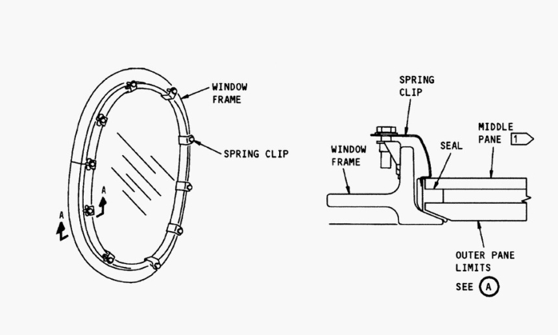 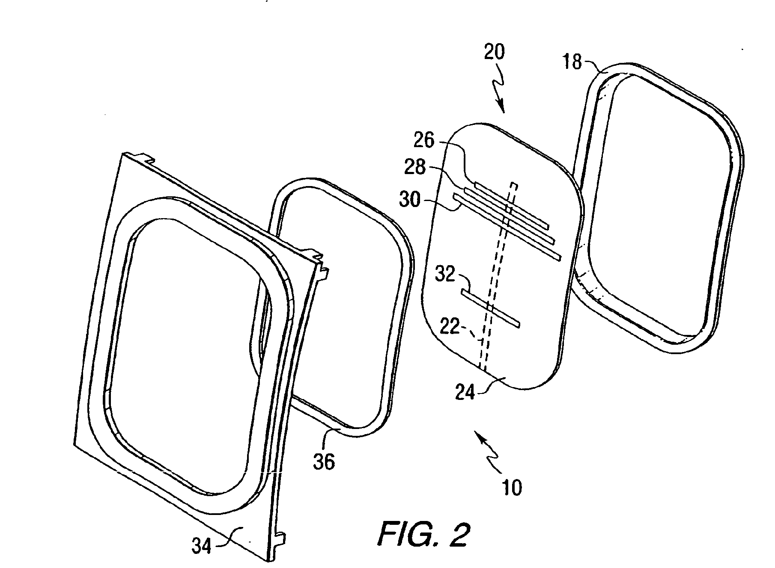Then, thanks to my knowledge on planes structures, I proposed to cut the parts which are under water pressure round and not square in order to reduce the stress coefficient factor Kt. Indeed, the window of the planes is used in quite the same application as my project, except the fact that my over-pressure is due to the water.
radius size
Stress comparison
I was also inspired by the Sandwich structure of this type of window to gurantee : The Yachtsman Series clamp-ring windows utilize an interior screw attachment by sandwiching the bulkhead between the window flange and clamp-ring. The clamp-rings have slotted holes that align with a threaded screw channel on the window frame. A vinyl cover is inserted into the channel, hiding the screws and providing a finished look. The Yachtsman series radiused corner windows require a cutout radius of 3-3/8". Available window types includefixed, vented, and 2-track sliding. Screens for the sliding windows can also be provided.

Thickness of the spacer : Security factor, see ppt

Material :
Choice of acrylite :
UV

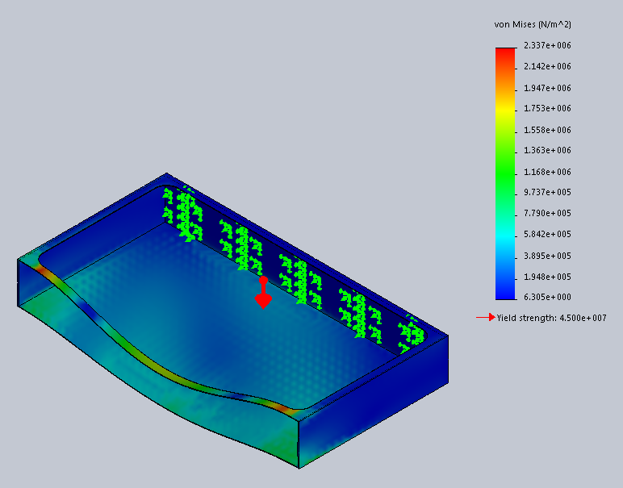

Solution 4 | Round corner above for the acrylite hole+
Solution 5
Solution 6

Pressure of air

Alternatives
http://www.bomon.com/EN_see%20how.html

Turn to the new conf

Establish the budget
Once the plan of building was established, we started to order our materials. I was confronted to a major problem with the OP-4 Acrylite. Indeed, none of the distributors of Evonyk Industries, the cheapest manufacturers, had OP-4 in stock. We had the choice to order at least 6 sheets from the distributor or one to Evonyk in the New Jersey with a high shipment cost. You can find an example of devis for an OP-4 Acrylite sheet in appendix .Below is the summary of the bills of manufacturers :
We decided also to find an alternative. I look after my very first suitable materials researches and see that the Solar Acrylite could be suitable too, even if it has less UV Transmittance than the OP-4 and is not as strong. The project would cost approximately . The details this budget is available on Appendix
Budget
In order to have a device ready, we decided to start building the temporary box with the same dimensions but using ideas already set in place. This way we would be able to see what improvements we can do on this temporary solution.

Basic fastener bonding
For improved pullout strength and waterproof connections, the easiest method is to put two coat of epoxy. Epoxy penetrates the wood fiber the very first time, effectively increasing the fastener diameter. Epoxy also provides a stronger interface with the fastener threads than wood fiber and keeps out water.

Materials

UVB : http://www.q-lab.com/documents/public/b7c2d2fc-5769-49dc-a772-83b0f4ae5b1d.pdf

UV Transmitting Acrylic Sheet OP4
Acrylite® OP4 UV Transmitting acrylic sheet is manufactured for use in indoor sun tanning equipment. It offers high levels of UV light transmission and strong resistance to degradation caused by UV light. OP-4 acrylic sheet transmits a high percentage of light in the UV-A 315 – 400 nm and UV-B 280 – 315 nm regions. Only a small portion of light in the UV-C region (200 – 280 nm) is transmitted.

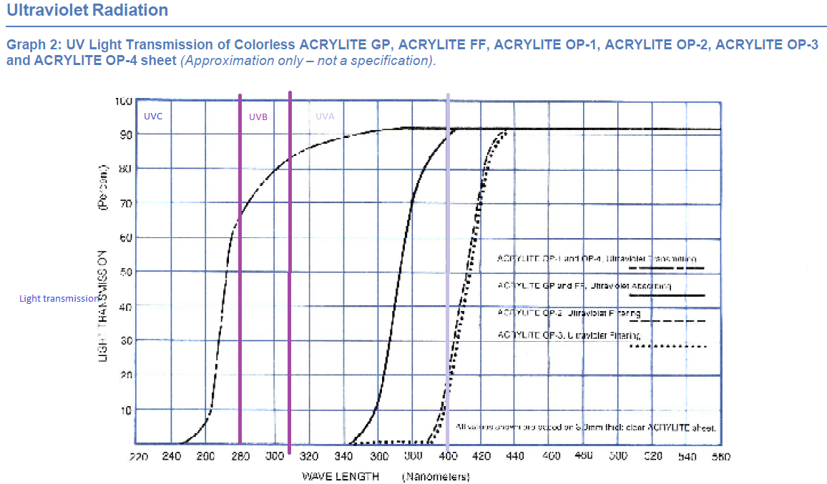
Excel table, onglet 2 : Market study

Glue
Excel table, onglet 3

Work to continue

Add improvements features

lead
Additionnal corner seal
Handler for UV Pannel
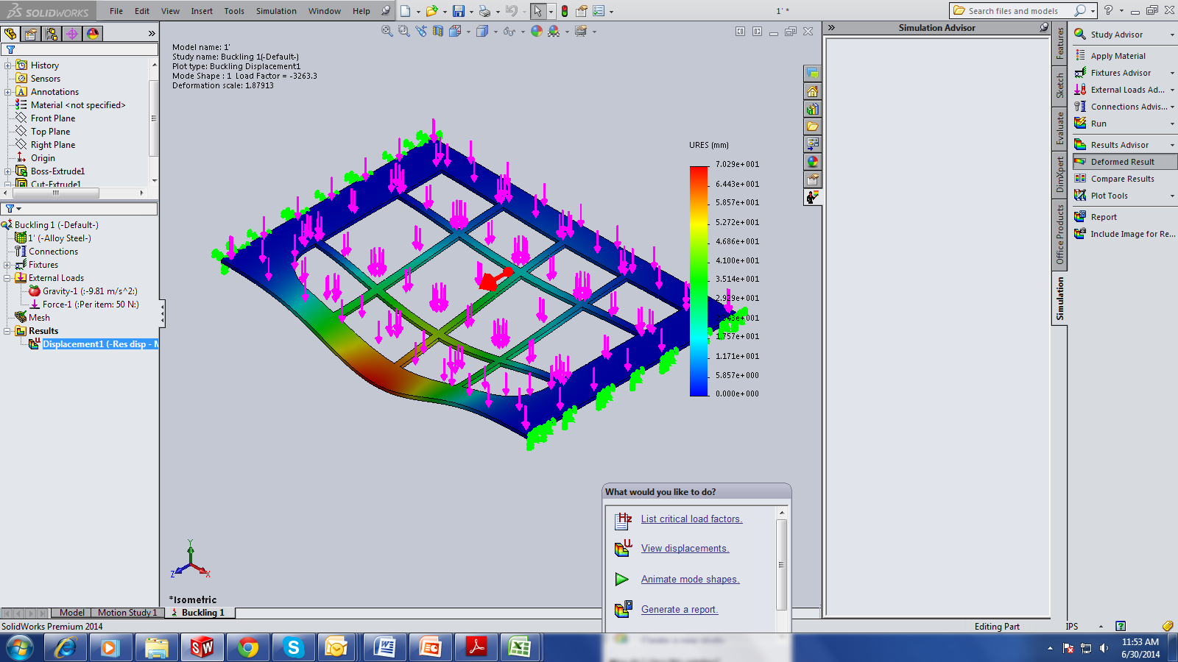
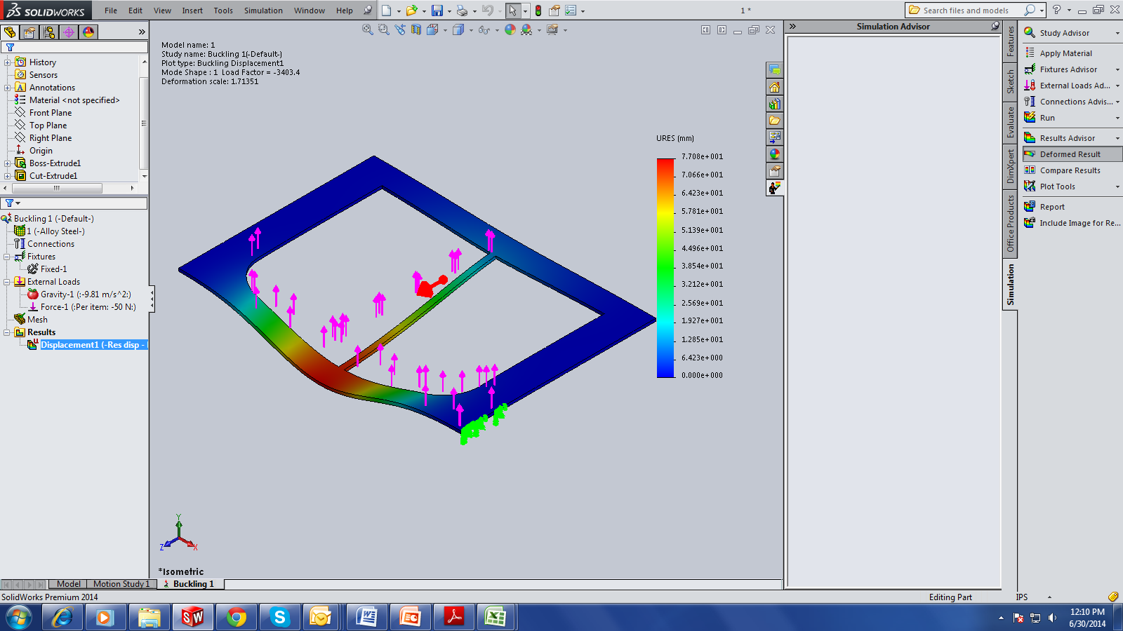
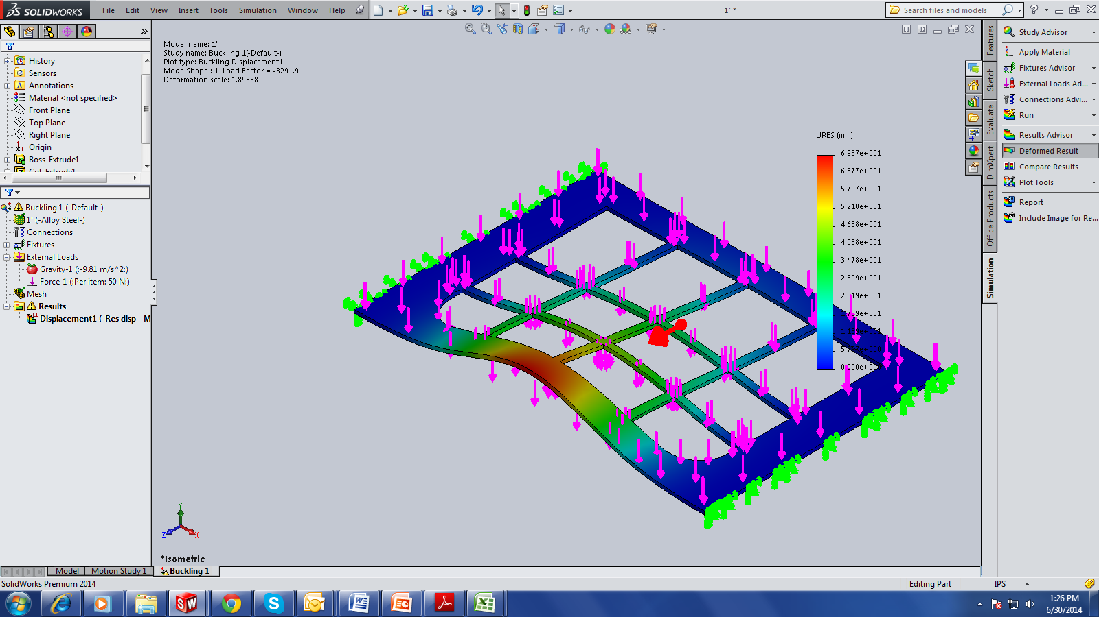

Appendix

Budget of the former project (See students report)

Drawings of solutions

Neoprene
See neoprene sheet
Compression Set Testing measures the ability of rubber to return to its original thickness after prolonged compressive stresses at a given temperature and deflection. As a rubber material is compressed over time, it loses its ability to return to its original thickness. This loss of resiliency (memory) may reduce the capability of an elastomeric gasket, seal or cushioning pad to perform over a long period of time. The resulting permanent set that a gasket may take over time may cause a leak; or in the case of a shock isolation pad, the ability to protect an accidentally dropped unit may be compromised.
Compression Set results for a material are expressed as a percentage maximum figure. The lower the percentage figure, the better the material resists permanent deformation under a given deflection and temperature range. Compression set results can be confusing in that they are calculated different ways under different methods of testing.

