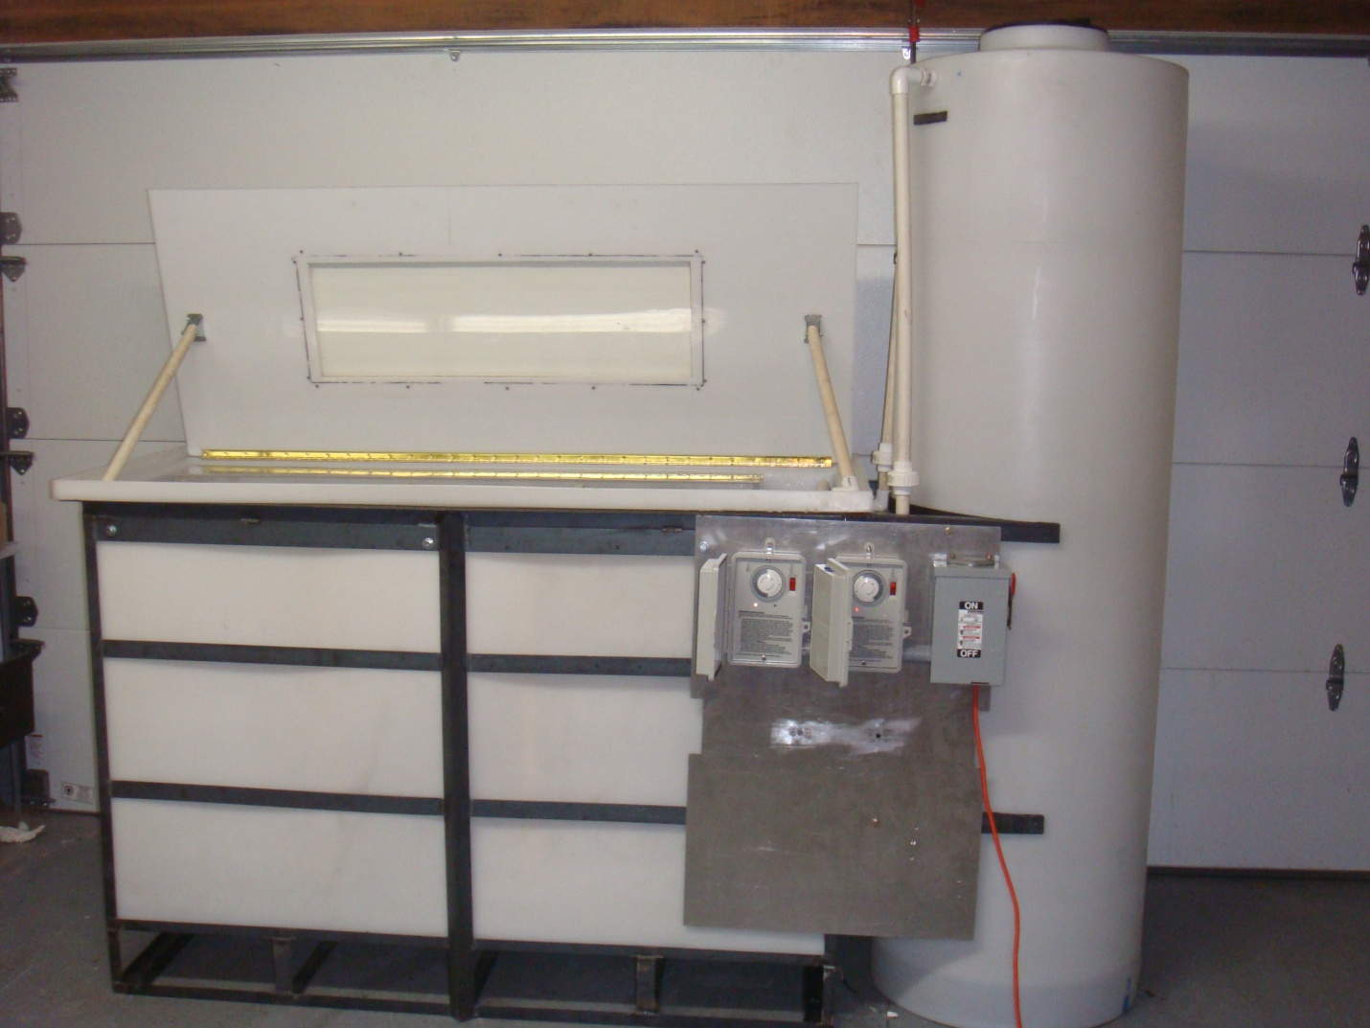

Buoyancy Compensator Testing Device
Team Members: Michael Born, Matt Brown, and Brandon Johnson
Sponsor: Aqua Lung
Advisors: David Sullivan and Dr. K. Moon
Purpose:
The purpose of this project is to design and manufacture a testing rig for scuba equipment, buoyancy compensators in particular. This test rig will be fully automated which incorporates a liquid test and a light test. This testing rig will provide Aqualung with valuable rapid weathering data on their scuba equipment, thus improving their product line.
Abstract:
Having a superior product is a goal of any company. Knowing areas in which that product can be improved is essential to attaining that goal. The testing rig build allows Aqualung to determine where their products excel and where improvements might need to be made. Prior to the manufacturing of this testing rig extensive research was done to determine the most cost and time efficient way to achieve rapid weathering of scuba equipment. The research included the effects of UV irradiation and chemical interactions with various scuba diving fabrics, an FEA analysis on the support frame, calculated the working fluid’s flow rate and fill time, and explored the interactions between the UV light sources. After the initial testing phase of the rig, the fill time was timed at approximately 7 minutes. The UV irradiation average was higher than 800 µW/cm² for 90% of the surface area of the BC. This was accomplished by constructing two internal light boxes both housing eight 340A UV bulbs. Aqualung with determine the duration of both the liquid and light test to reach their desired protocol.
Introduction:
Upon completion of the final design the motivation to start building this device over the summer fell short. Nonetheless, once the fall semester started the project was on track for its completion date of December 8th. A schedule was made to keep the project going with target dates and ordering information. Since this project could not be constructed at Aqualung and offsite location needed to be selected. Matt Brown’s house in Rancho Santa Margarita served to be an excellent place to construct this testing rig because he owns a wide variety of tools and a quality workspace. The Bill of Materials was transformed into an invaluable living document that aided the ordering process for the project. The materials for this testing rig came from numerous companies and suppliers but the bulk of the materials came from Home Depot, further detailed in the Bill of Materials at the end of this report. Once all the materials were ordered, the fabrication phase of the project began, the detail of which are described and explained below. In hind sight, planning for project setbacks and team member vacations would be useful in future group project. However, the testing rig was completed on time and was delivered as promised to Aqualung.
Due to budget reductions our project needed to be slightly altered to still accomplish what was promised. The original budget of $5000 was reduced to $3120.58. This prevented the testing rig from having two testing tanks and four light panels. The design changes to the project are listed below:
Summary of Design Changes
- Reduce overall footprint of testing rig
- Added vents to light cover to decrease temperature inside UV light kits
- Changing all metal used to use stainless 316
- We will be using a 160 gallon cylindrical tank for the storage tank. It will not gravity feed any more. We redesigned the system to pump from each tank.
- We have changed our pumps to 1/6 hp sump pumps with accompanying float valves.
- Tanks supports have been lowered to lower center of gravity and to allow testing rig to be used away from wall support if needed.
- We have added a drain to the plumbing system, so the system can be drained.
- We have added a secondary lid to cover the viewing window to eliminate any additional light to the system.
- The support structure will be welded and removable caster wheels will be added so the system can be moved.
Design Concepts / Final Design / Completed System

The design process began by looking closely at the needs and requirements list, by speaking with David at Aqua Lung. After brainstorming a list, and after weeks of bouncing design ideas back and forth, it was decided that the dunk tank method was a better choice to pursue versus the spray method. When it came down to it, it was the best design to meet all the requirements of the project and it would resemble the real life wear and tear that the BC encounters. With the method of the device chosen, it was time to create a more detailed design.
The next step was to produce more detailed and accurate design possibilities. The team produced three ideas that would incorporate the dunk tank method. Each of the designs had some basic sketches that related the design to the requirements list. The design ideas were evaluated and it was determined that the original dunk tank design would be the best approach.
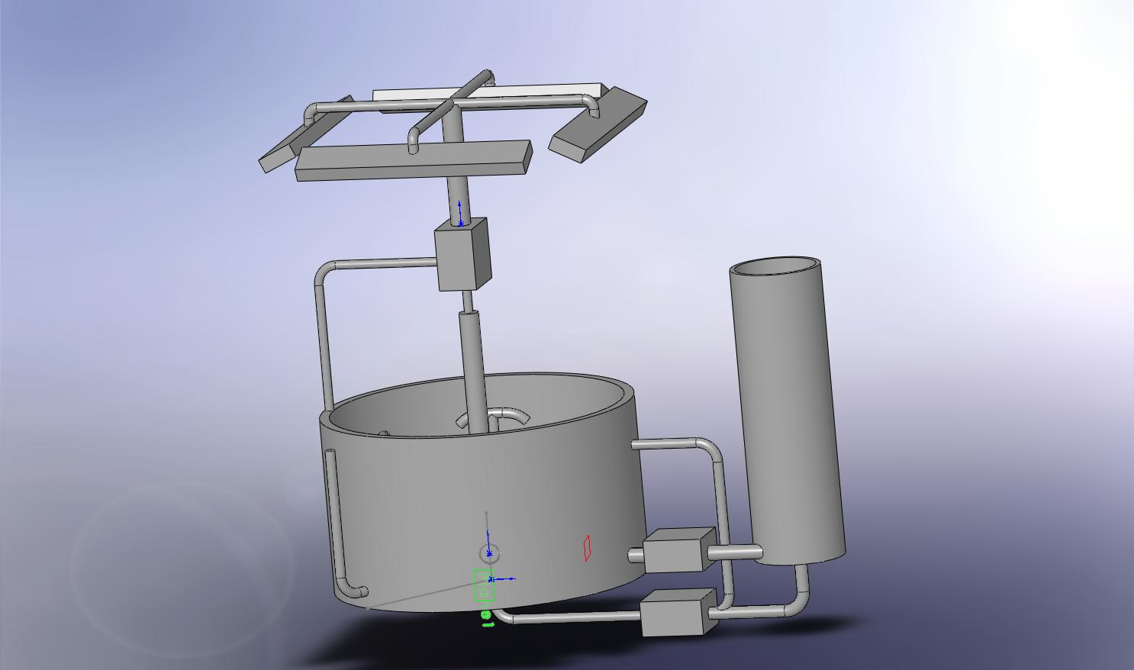
(Initial Dunk Tank Method Design)
As the weeks went by, the design became more and more accurate. There were scheduled semi-monthly meetings at Aqua Lung to give progress reports and to get valuable input from David. It was at one of these meetings that a very simple design idea was envisioned that would eliminate the moving devices of the design and compact the total assembly. Incorporating a square tank, reduced the volume of water needed as well as the total size of the assembly. One really nice part about using a rectangular tank, was that it was a modular design. Now the design could use one tank or multiple tanks. Adding another tank at a later date, would be a simple task of changing the plumbing configuration.
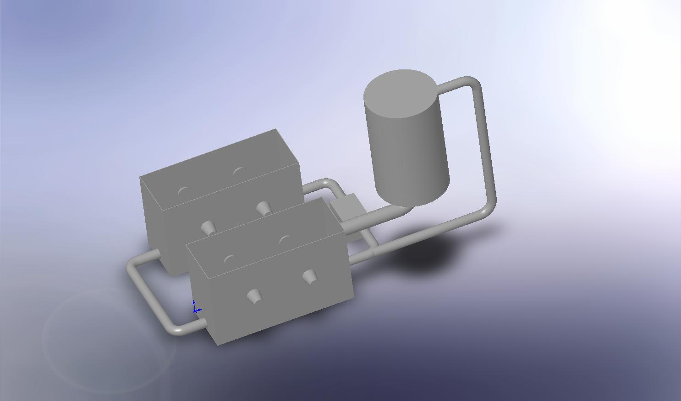

(Initial Modular Tank Design)
The next step was to add more detail and accuracy to the CAD model. Creating individual parts in Solid works and then building an assembly of the parts gave more insight to the final design. This is very important to the design process, because it allows changes to the final design with little effort. As problems arose with individual parts, it made it an easy process to update the part change and update the assembly. The next problem addressed in the design area was minimizing the tank size.
After evaluating the initial design, David suggested some improvements to the design. The first suggestion was to change the tank design, based on the lighting calculations that were completed by Brandon. The tank width was reduced by 12” thus reducing the overall volume of water by 33%.
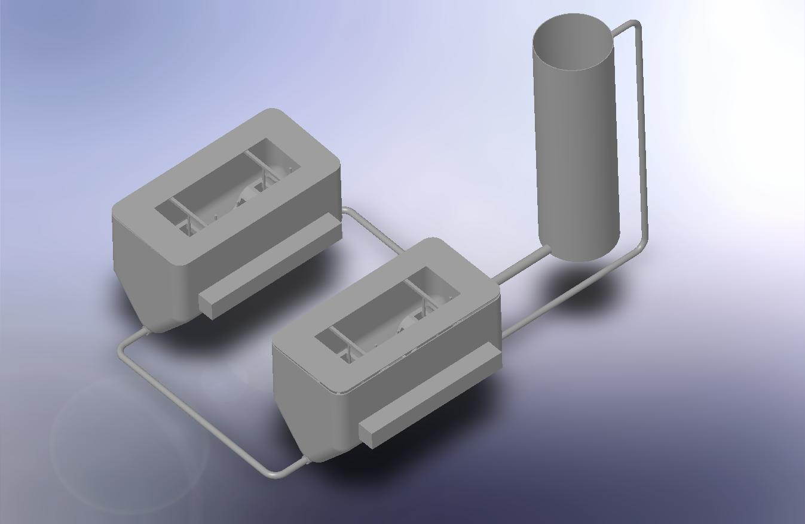
(1st Completed Assembly Design)
Another important consideration of the design, was the support structure for the tanks. It was important to run a stress analysis on the structure, considering the weight of the water, tank and everything inside the tank. Using 1500 lbs, I found a safety factor of 2.58. When looking at the analysis, it is clear that the structure needs to be supported in the center. With the addition of the center support, a safety factor of 3 was accomplished.

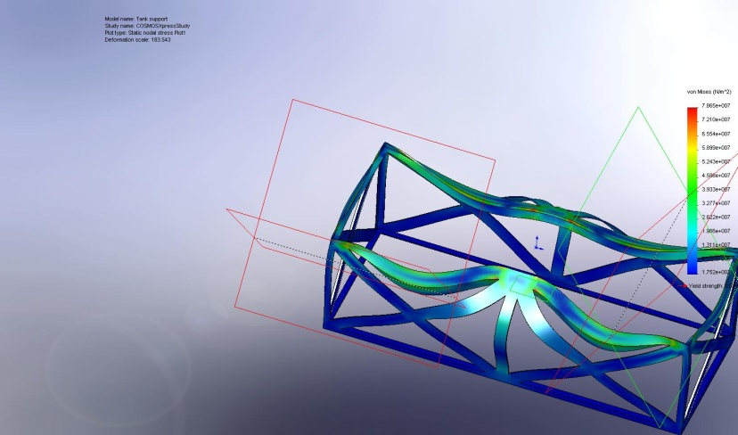
(Stress Analysis)
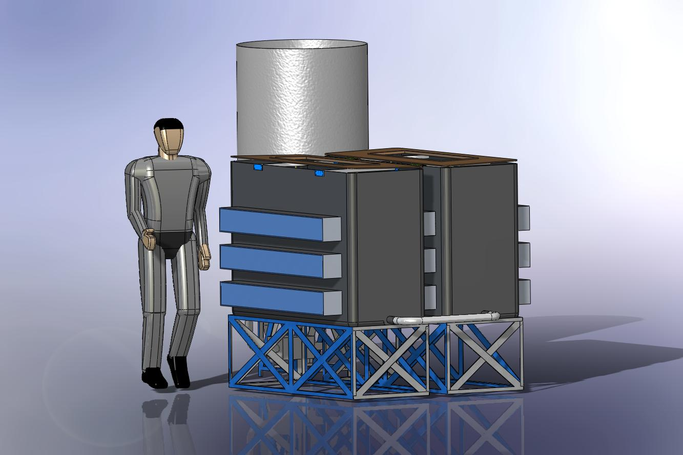
(Final Completed Design Assembly)
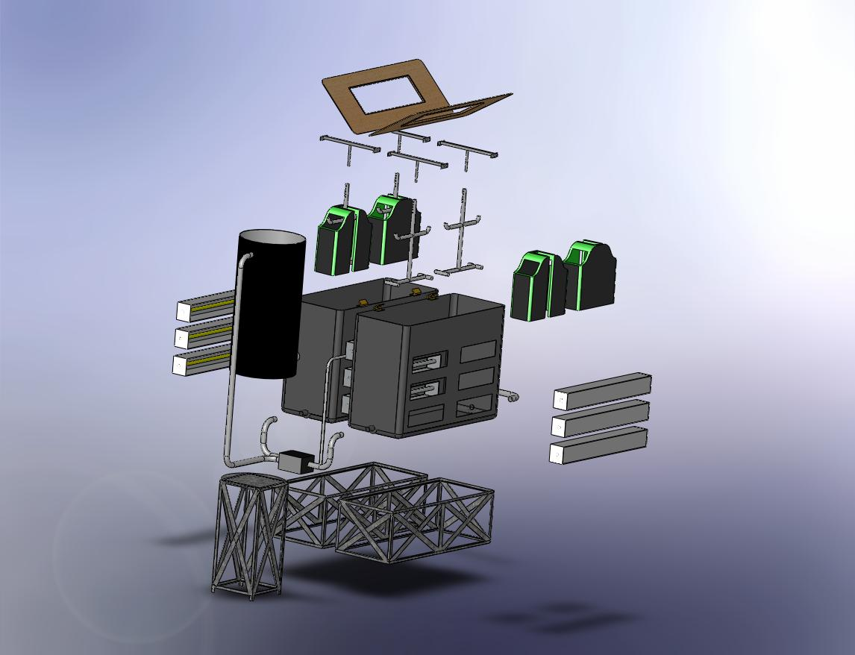
(Exploded View)
The above cad photos where of the design, before the material was ordered and before the final budget review at Aqua Lung. In September the team presented its final design to Aqua Lung at a budget design review. At the conclusion of the review it was determined that the budget was cut from $5000 to $3120. So with less than three months to go, and 62% of the promised budget the project had to be altered to accommodate the new budget. The first cut from the design, was eliminating one of the two storage tanks. This eliminated approximately 1/3 of material costs, which was a great way to offset the budget.
With the budget approved it was time to take the design and turn it into a reality. The first purchases were the testing tank, which had to be made and then sent from New York and the light meter. When the tank arrived, it was clear that our design would not work. The tank walls were not flat. The sides looked deviated more than 2 inches and there were bulges everywhere. There was no way to mount the light boxes to the side of the tank and have it remain water tight. The new design was to build the light boxes out of a plexiglass and install them inside the tank. This solved our tank issue and also helped reduce the water volume by over 40%.
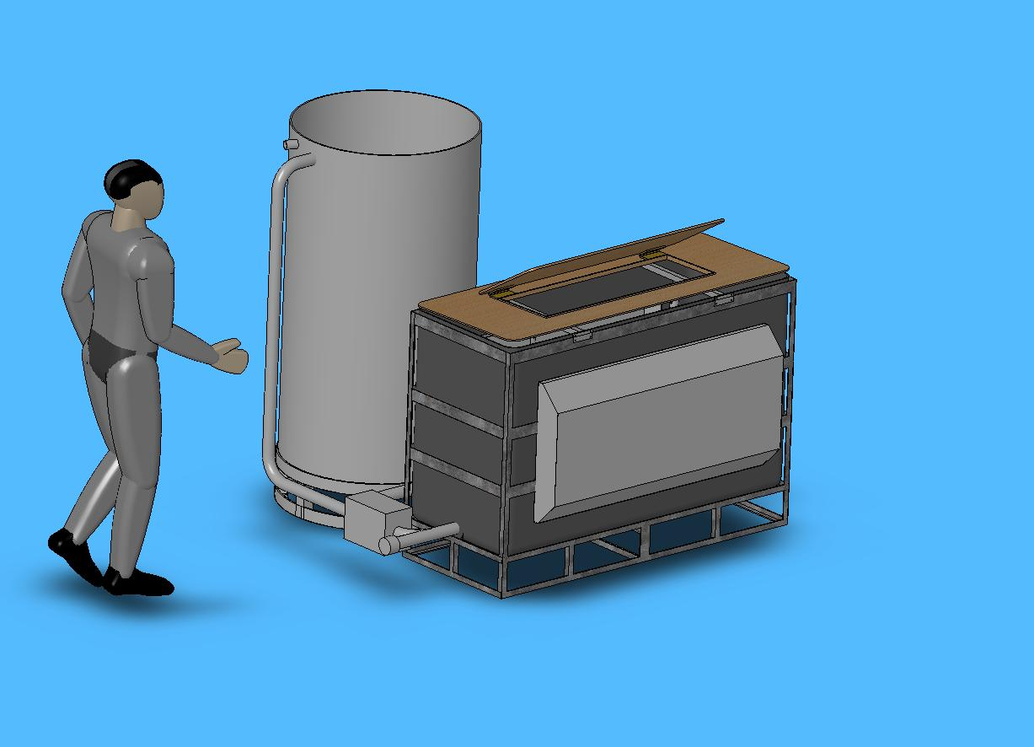
The tank support was manufactured by Paul at Aqua Lung. Once the boxes were constructed the lighting assemblies were mounted inside and the light testing was conducted. As each step of the manufacturing process continued, issues arose and needed to be handled. Often an issue would halt one aspect of the build, where a solution would have to be researched. With the budget always in mind, mistakes had to be kept to a minimum.
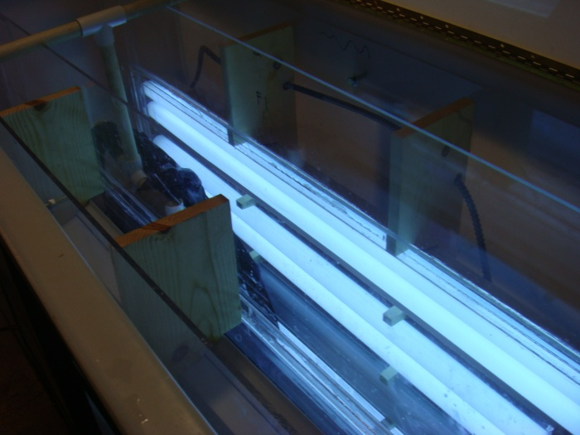
(Light boxes mounted inside testing tank)
As the project progressed, it was determined that the support structure needed more modifications. The assembly was broken down and transported to Aqua Lung. It was modified for the last time and it was time to start the process of finishing up all the loose ends.
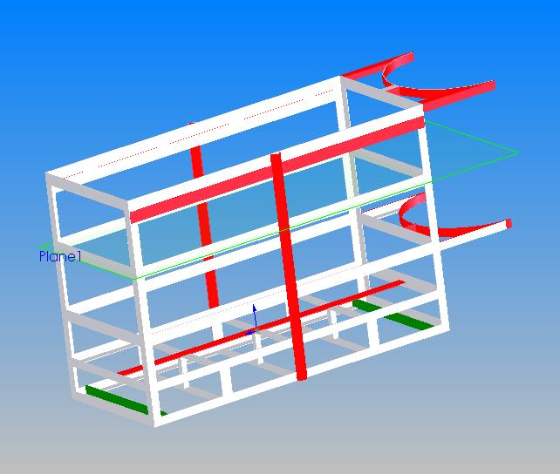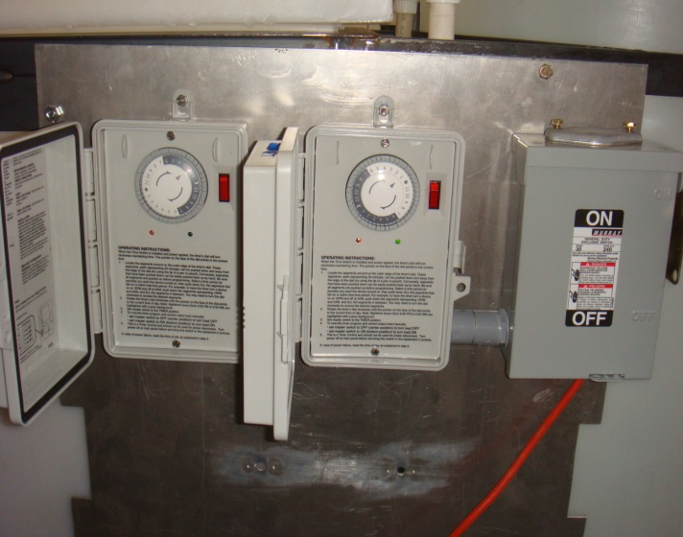
(All Colored items were added)
For the final installation, all of the electrical was hard wired and labeled. Since there are two timers, one for the light test and one for the liquid test, the wire ends were taped yellow for lights, and blue for liquid. Liquid tight was used to ensure all connections were waterproof.
Once the electrical and plumbing was finished, the testing rig was put through different tests. Fill times were recorded as well as water fill levels. The light levels resemble the results found earlier in the project. The finished design is a very simple process.
The liquid timer turns on and supplies power to the pump inside the storage tank and the circulation pump inside the testing tank. The pump in the storage tank turns on immediately, since the float valve is submersed. About 7 minutes later the fluid level in the storage tank drops below 6 inches and the float valve shuts of the pump. The circulation pump is set to start when the level of the water in the testing tank is about 14 inches high. This value can be changed by adjusting the float valve, but must be high enough to insure water doesn’t spray everywhere. This pump stays on for the entire liquid test as determined by the timer.
At the end of the liquid test the timer shuts off and the light timer turns on. When this test begins the lights will turn on and the pump inside the testing tank will turn on. This pump, pumps the liquid back to the storage tank and shuts off, once the water reaches about 3 inches. The light boxes were designed with a three inch space at the bottom to allow some water to stay inside the tank during the light test.

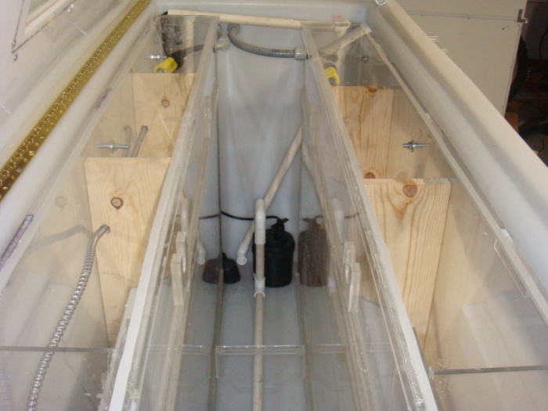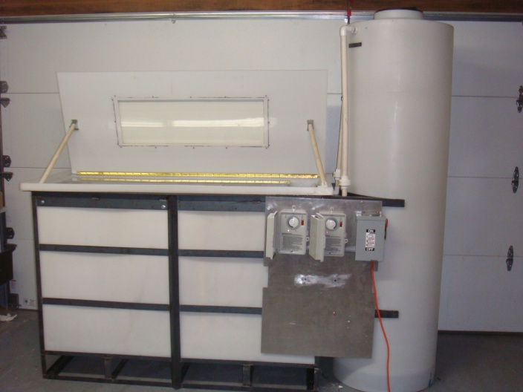

Theory and Analysis:
Calculations for the light system
To find the lighting intensity along the BC the inverse square law was use to find the relative intensities. The distance from the light source to points on the BC was found by using Pythagoras theorem. The following is a graph of how the distance where found
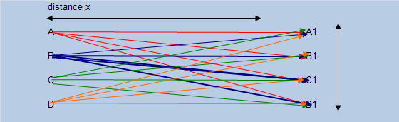
Using this data the following lighting intensity curve was found, which shows the relative lighting intensity of all six lights.

Due to constructive interference the following light curve was obtained
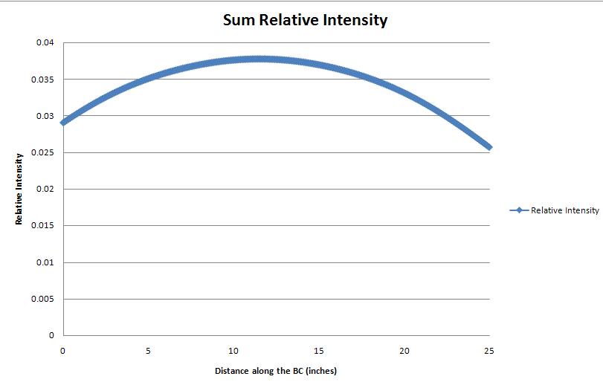
Once our project was built, we tested our lighting system by measuring the lighting intensity value at several points across our light box. Using the data below, we determined that the necessary lighting intensity required for our system is 120 µW/cm^2.

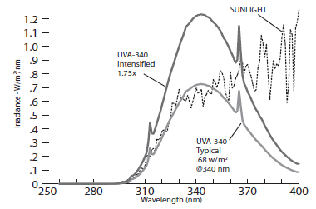
To obtain an irradiance value of 120 µW/cm^2, it was determined that it was necessary to place to place the BC’s with 4 inches of the lighting source. To achieve this, it was determined that the lights must be placed inside of the dunk tank. Therefore we constructed a waterproof lighting box to house the lights. The lighting box was constructed out of Acrylite OP-4 on the face of the box because OP-4 is UVA-340 transparent. The rest of the box was constructed from Plexiglas. The Plexiglas and Acrylite were bonded together using IPS Weldon 3 adhesive. See pictures below for visual on construction of light boxes.
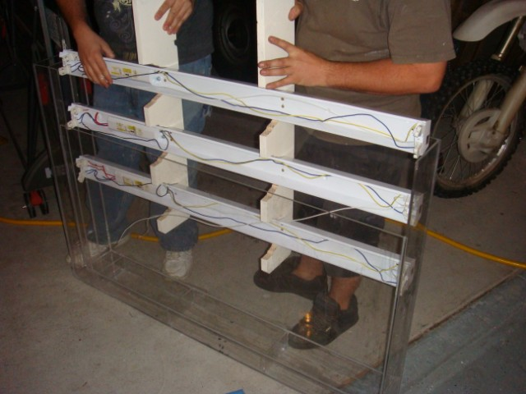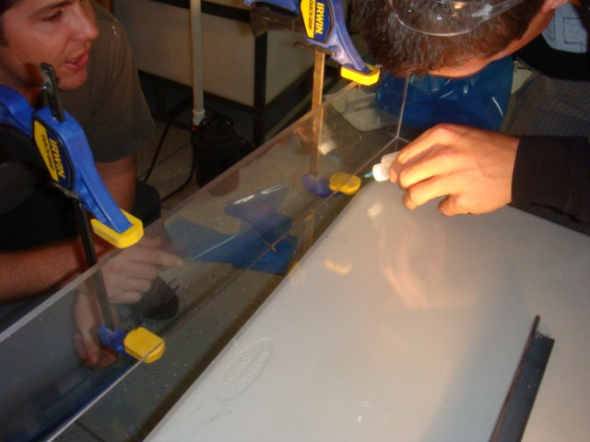
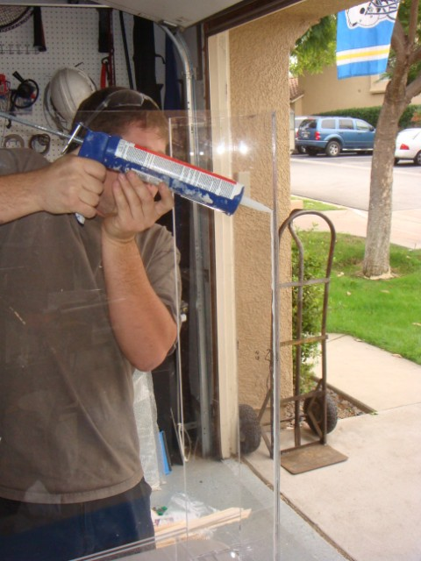
After the light boxes where constructed, we caulked the edges where the sheet of plastic came to gather to prevent water leaking inside. The caulked it not adhere to the plastic well, so there was minor leakage. To fix this, we drained the water in the tank and applied 5 minute epoxy to the edges. The epoxy made the box water tight.
We tested our lighting system by measuring the lighting intensity along the surface area of the box at one inch increments. This yielded the following data matrix.
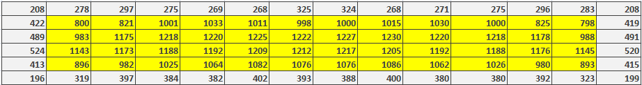
As previously stated, our target irradiance was 120 µW/cm^2. Upon analysis of our data we found that the average irradiance (in the core region of our lighting matrix, where the BC is located) is 1081.67 µW/cm^2. This means that our actual irradiance value is 901.39 % higher than our minimum target value. Below is a graphical representation of our lighting data.

In the previous semester we determined that the irradiance on the interior of our lighting box should be 33.33% higher than the irradiance on the exterior of the lighting box. However, the measured variation between our internal and exterior irradiance was, 216.24 %. This means that original calculate value was off by 182 %.
388 µW/cm^2 - 1227 µW/cm^2 = 839 µW/cm^2 (839 µW/cm^2/1227 µW/cm^2)*100 =216.24 %
This error was due to the fact that we approximated the light as one dimensional lines, when infact they are light cones and the dimensions we used for our original calculations where different than our final dimension.

Bill of Materials:
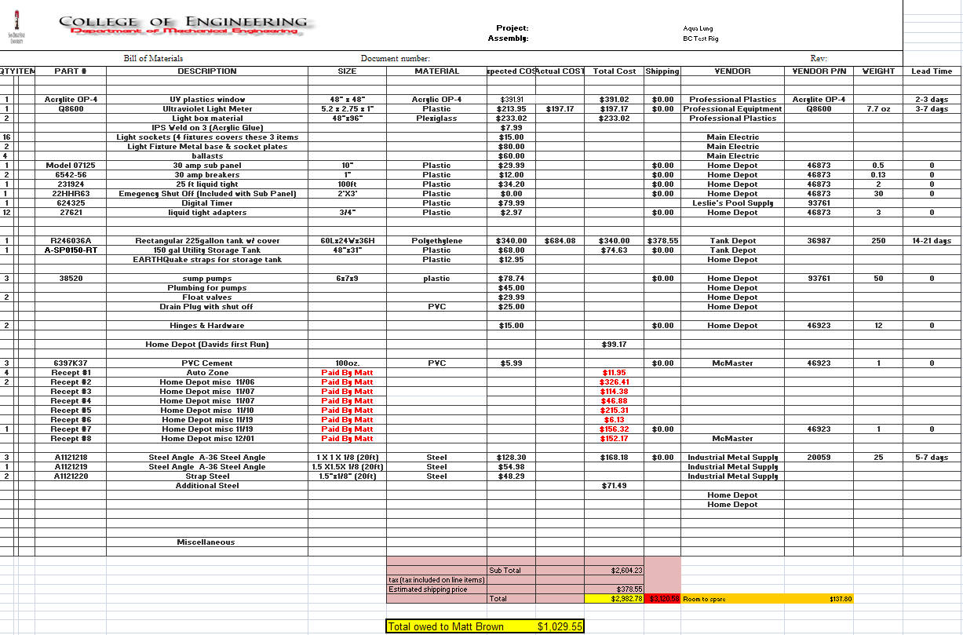
Conclusion:
In closing, this project provided quality experience with working with a team. It takes a special person to function in a group atmosphere and although this project provided stressful moments, it caused the group members to deal with adversity and prevail.
Looking back, obstacles to completing this project were inevitable. The biggest obstacle of all was constructing the water tight light boxes to house the electrical components of the project. Many a hours where spent brainstorming the best way to construct a light box suitable for the needs of this project. After spectacular collaboration amongst group members and advisor a plexiglass box was the verdict.
All in all, the project was a great success. The testing rig was delivered to Aqualung as promised and preliminary testing suggested that the system should perform as advertised. If one thing about this project could be changed, without a doubt this opinion is shared by every member of the group, it would have been to start the manufacturing process a lot sooner so the setbacks would not have been as stressful. Nonetheless, this project taught all three group members how to efficiently and effectively plan, design, and produce a produce. The skills learned throughout this journey will be put to good use when called upon in any industry.

