Sport and doping, two ways to change his body and his minds
(preview on the London Olympics 2012).
Summary
I. Action of sport in us…………………………………………………………………………………………………………
1. briefly Action of doing an activity in our body

II. Doping, an easy way to enhance performances………………………………………………………………
- Different way of doping
- Doping, is it good?
III. Way to fight against doping…………………………………………………………………………………………………….
- Example of London OG, London marred by doping
- Heavy control device

I. Action of sport in us.
1. Briefly Action of doing an activity in our body
- Why move? http://www.mangerbouger.fr/bouger-plus/pourquoi-bouger.html
http://www.sportanddev.org/en/learnmore/sport_and_health/the_health_benefits_of_sport_and_physical_activity/
Sport and physical activity healthy lifestyles.
It’s a way to fight against certain kind of disease
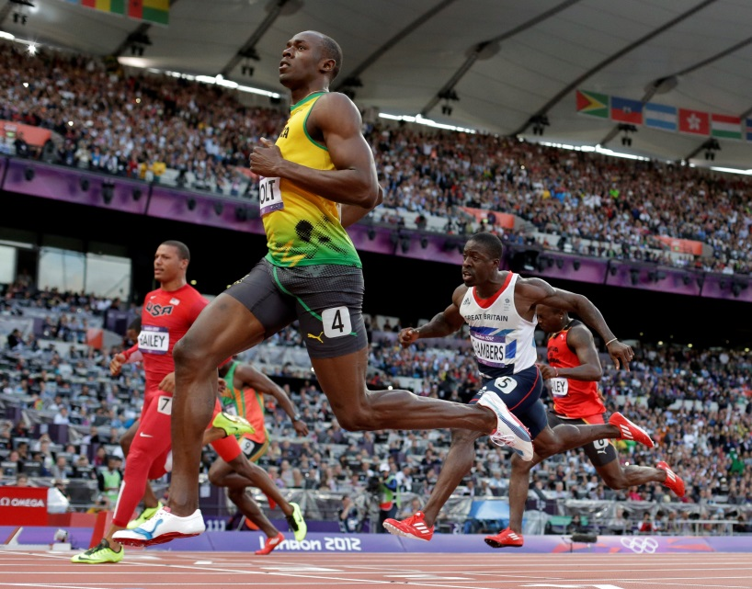
Usain Bolt won his 100-meter semifinal heat with a time of 9.87 seconds, easily earning him a spot in the finals.
- How to move to stay healthy?
Get in shape and get yourself in gear with a variety of cardio workouts to get your heart pumping.
http://www.health.com/health/full-body-exercises
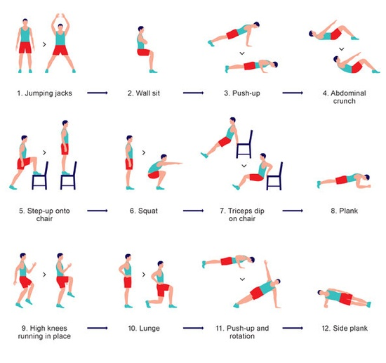

II. Doping, an easy way to enhance performances
What doping mean?
Doping it’s when a person, often sportier, uses drugs to increase her personal power or to increase her level of muscles.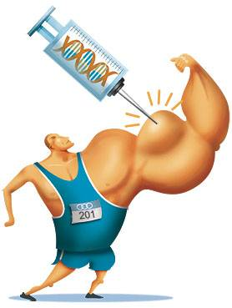
1. Different way of doping
- Doping of anaerobic/aerobic metabolism and other forms of doping http://sportech.online.fr/spen_idx.html

Doping of anaerobic metabolisms

Doping of the aerobic metabolism
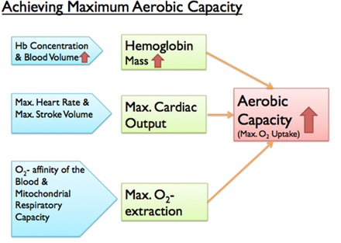
The other forms of doping

- genes Dopingshttp://www.doping-prevention.sp.tum.de/substances-and-methods/gene-doping/gene-doping.html
Gene therapy tries to repair the defect gene.
Consequently by abusing gene therapy in sports provoke that the World Anti-Doping Agency (WADA) put gene doping on the Prohibited List.
There is no single “sports” gene!
There are four interesting endurance genes:
- EPO
- PPAR
- HIF
- ACE
There are three interesting muscle genes:
- MGF, IGF-1, IGFBP
- GH
- gdf-8, tgf-b
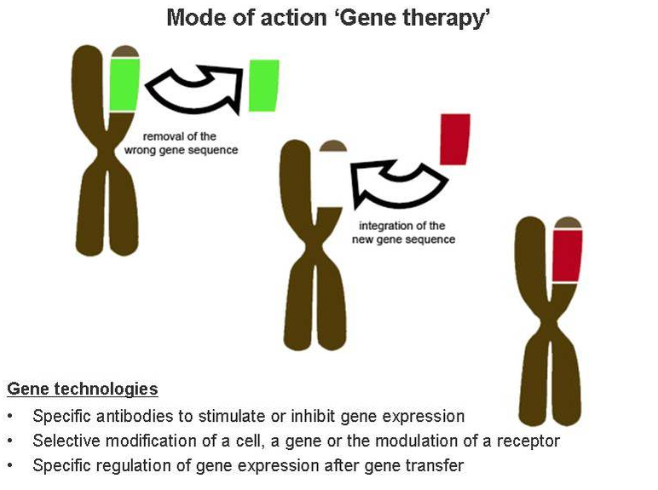
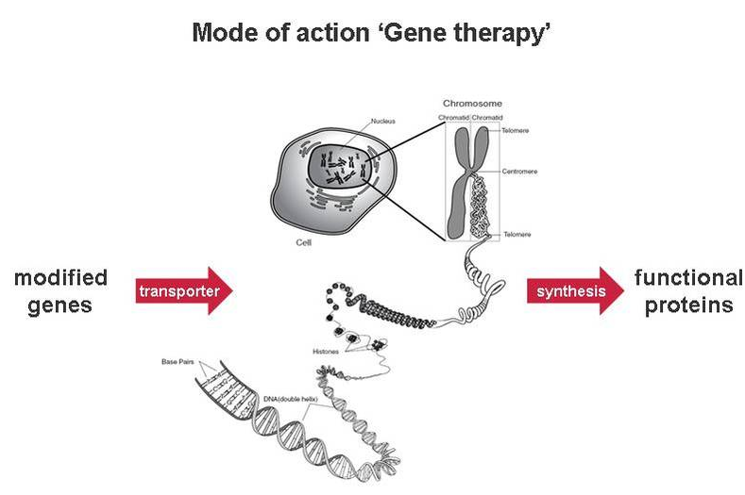
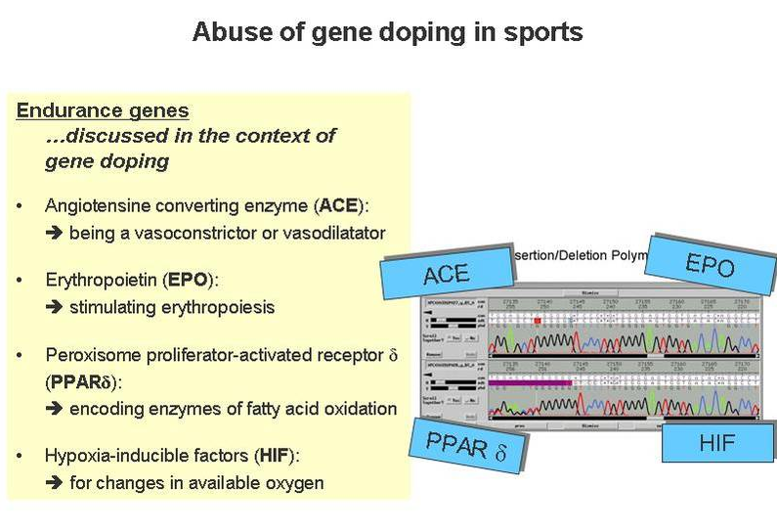
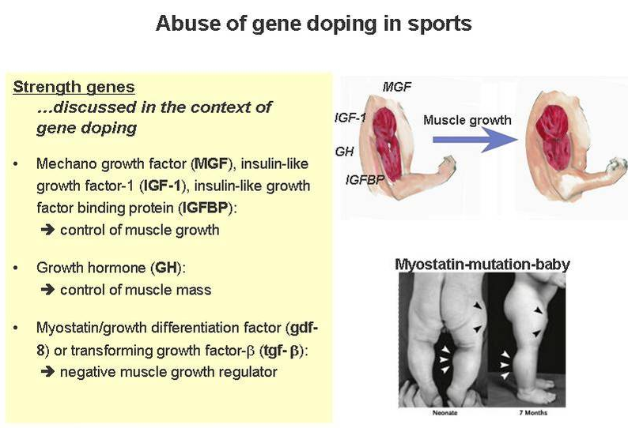

- blood doping http://www.wada-ama.org/en/Science-Medicine/Science-topics/QA-on-Blood-Doping/
http://graphics8.nytimes.com/images/2006/02/19/sports/olympics/20drug_graph.gif
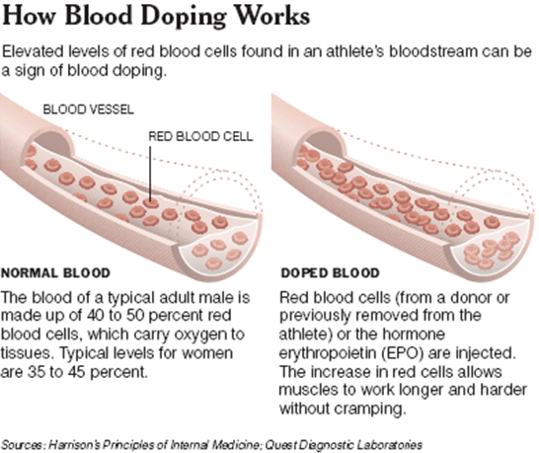
- doping with growth hormone http://www.wada-ama.org/fr/Science-et-medecine/Sujets-scientifiques/Questions-reponses--Hormone-de-croissance/
http://anumed.tumblr.com/page/2
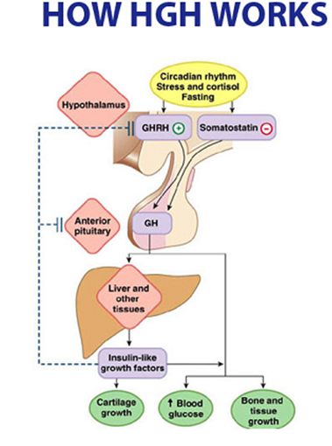
2. Doping, is it good?
a) It helps to gain confidence.
People, who dope herself, because his sport or muscles level increase, feel more confidence. He can develop self-esteem.
b)side effects
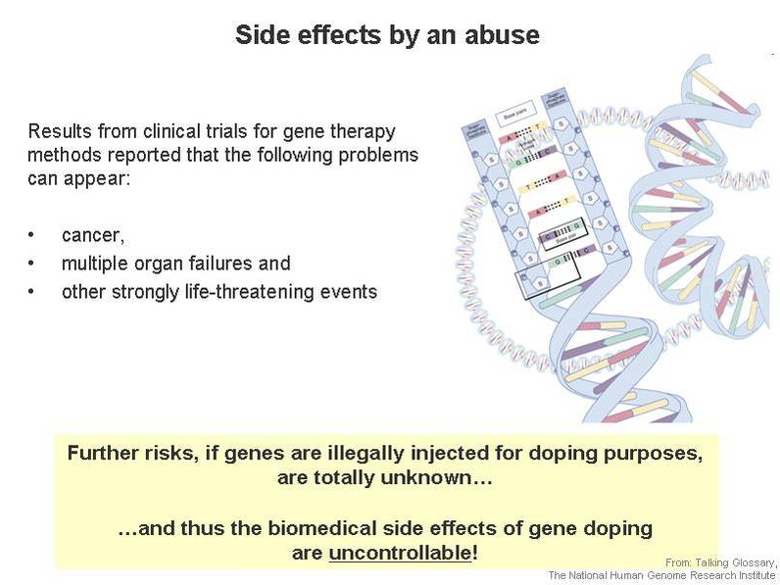
III. Way to fight against doping
http://www.wada-ama.org/fr/Autres-liens/Recherche/?quicksearchquery=londres

- Example of London OG, London marred by doping
- World Anti-Doping Agency (WADA)

The International Olympic Committee (IOC) is responsible for the anti-doping program, including testing and results management.
David Howman, the chief executive of the World Anti-Doping Agency, believes that one in 10 athletes are cheating with the 2012 London Olympics less than a year away.

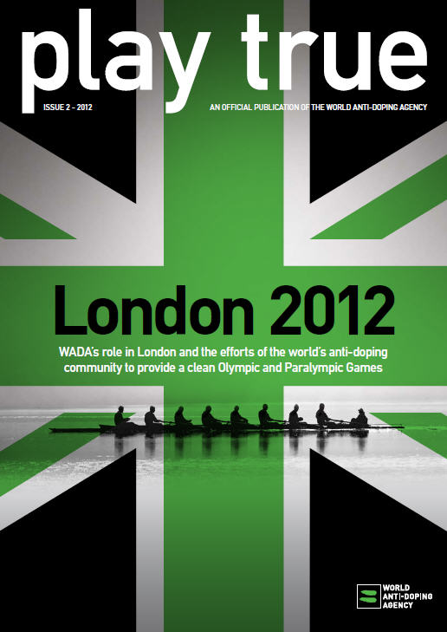
http://en.wikipedia.org/wiki/World_Anti-Doping_Agency
- Éducation et sensibilisation (“Winn Clean” compaign , etc)
http://www.wada-ama.org/en/Education-Awareness/ 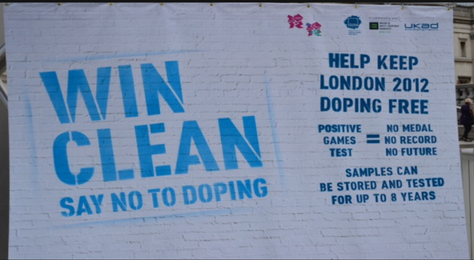
http://playtrue.wada-ama.org/fr/news/lancement-de-la-campagne-win-clean-dis-non-au-dopage-pour-les-jeux-de-londres-de-2012/
- Heavy control device
- Controls http://www.wada-ama.org/fr/Communaute/Laboratoires-antidopage/
- Paranoia, doped athlete hunt, “each athlete is seen as a cheater”.
Every athletes are suspected of being doped, it’s created a hysteria, lot of debate occur.
Team Russia may lose one of their biggest Olympic hopefuls, the cyclist Denis Galimzyanov has been provisionally suspended following a positive doping test result. EPO was found in a urine sample taken from Galimzyanov on March 22.
