Mycetic Spore V6

This is my unofficial version of the rules for Mycetic Spores for the 6th Edition of W40K.
You will need the agreement of your opponent to use them for your Tyranid army.

The folowings units can take a Mycetic Spore as Dedicated Transport : Zoanthropes, Venomthropes, Pyrovores, Tyranid Warriors, Hormagaunts, Termagaunts, Genestealers, and units of 1 single Carnifex.

Mycetic Spore - 40pts

WS | BS | S | T | W | I | A | Ld | Sv
2 | 2 | 6 | 4 | 3 | 1 | 3 | 5 | 4+

Composition : 1 model

Unit Type : Monstruous Creature (but with none of the special rules normally granted by this unit type,
so no Fear, Smash, etc.)

Equipement : Ripper Tentacles (Range 6" S6 AP- Assaut 6)

Special Rules : Deep Strike, Fearless

Limited Conscience : A Mycetic Spore does not follow the Instictive Behaviour rule but instead automatically shoot at the closest target at each Shooting Phase, unless already locked in close combat.

Transport : it always come in play via Deep Strike. If it scatters on an impassable terrain or another model (friend or foe), then reduce the scattering distance by the minimum (in any direction) to avoid the obstacle.
A spore can transport one unit of 20 models maximum (keep in mind the Bulky models take 2 "seats" and the Very Bulky 3 "seats"). The transported unit must disembark of the Spore on her first movement phase and cannot embark again later. Treat the spore and the unit as disembarking passengers from a normal Transport.

Immobile : after its initial landing move, a Mycetic Spore can no longer move, run, go to groud, make a sweeping advance or a consolidation move at the end of a combat.

Options :
A Mycetic Spore can have one weapon from this list :
- Cluster Spines …..………………………………..… 10pts
- Singer Salvo …..……………………………………… 10pts
- Twin link Deathspitters ………………………….. 10pts
- Barbed Stangler ……………………………………… 15pts
- Venom Cannon ……………………………….……… 20pts

A Mycetic Spore can have biomorphs from this list :
- Acid Blood …..……………………………………… 15pts
- Toxin Sacs …..……………………………………… 10pts

Designer’s notes : Unfortunatly there is no official model to refer to when you will be playing your converted Mycetic Spore. It should be an "egg" shaped model from the size the Space Marines Drop Pod, with tentacles and a hole/mouth as a hatch unless the egg is already craked.

Additionnal Rules for Mycetic Spores and Drop Pods :

When planning your battle with your opponent, you can decide to use the following rules for all Tyranid Mycetic Spores and all Drop Pods from any Codex. From now on, we will refer to all those models as "Pod(s)".

When a Pod is about to arrive from Reserves into play (we will refer to this as an "incoming pod"), some unit in the game, like the Flying Monstruous Creatures, the Flyers Vehicles, AAA batteries and some other units have a chance to intercept the incoming Pod before it can land.

To try to hit an incoming pod, there is only 2 ways :
- Shooting at an incoming pod : first, the weapon shooting must have both Interceptor and Skyfire Special Rules.
- Vector Strike on an incoming pod : a Flying MC in swooping mode can make a special interception Vector Strike on an incoming pod if she is at 6" or less of the landing point, originally aimed (before scatter).
But even then, you can only hit on 5+ an incoming pod (a very fast and difficult to hit target).

Only both very powerfull and fast blows can damage or destroy an incoming pod, making it deviate from its landing trajectory and shaking its passengers.
When an incoming pod is hit intercepted by a shooting attack or a vector strike as explained above, always resolve the hits you obtained againt an Armour of 12 (consider that a Mycetic Spore has also an Armor of 12 that must be penatrated as for a Vehicule, instead of throwing to Wound againt its Toughness).
Glancing hits are ignored, as the pod is build to endure this fate. No Hull Point or Wounds are lost from any of those hits.
If you get a Penetrating hit or more, throw a D6 on the folowing table and apply the result (notes that no additional Hull Points are lost from those penetrating hits) :

1 : | The Pod suffers minor damage, only loosing 1 Hull Point or 1 Wound without armor save.
2 : | The Pod suffers minor damage loosing 1 Hull Point or 1 Wound without armor save and the passengers are shaken (they cannot shoot in their first shooting phase after they disembark).
3 : | The Pod suffers minor damage loosing 1 Hull Point or 1 Wound without armor save and the passengers are shaken. The Pod has been hit enough to automatically scatter of 3D6". If if its conception make it possible, place your pod lying on the side, to represent the bad landing trajectory
4 : | The Pod suffers critical damage loosing 2 Hull Points or 2 Wounds without armor save and scattering of 3D6". The passengers are shaken. In addition, throw a D6, on a result of 4+, one randomly chosen model of the passenger unit suffers a wound without armour save.
5 : | The Pod engines explose in the sky, the landing is brutal. The wreck of the Pod scatters at 3D6" (a Mycetic Spore suffers an Instant Death but place the model like you would for a Vehicle wreck). Some passengers can have survived by sliping or jumping outside just before it touched the ground, some others will emerge crawling outside the wreck. Each model throw a D6, on 2+, he is removed from the game. Each 1 is a miraculous surviver of the crash who is shocked : only disembarking at 3" maximum from the wreck, loosing the ability to Run for the rest of the game, and cannot shoot on its arrival turn.
6 : | The Pod engine detonate in a deadly explosion for all the passengers. The Pod and its transported unit are removed from play.

Add +1 to your result for each penetrating hit after the first one.

Add +1 if the Attack is both S9 (or higher) AND AP 2 (or lower).
Formation Mycetical Assault

Faction : Tyranids

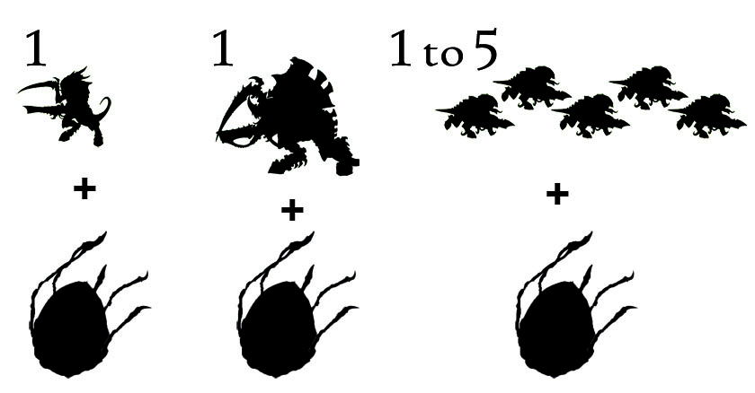

Formation :
- 1 Tyranid Warriors Brood with a Mycetic Spore as Dedicated Transport
- 1 Carnifex with a Mycetic Spore as Dedicated Transport
- 1 to 5 Termagaunts Brood(s) with a Mycetic Spore as Dedicated Transport

Formation Restrictions :
Devourer Grasp : All models in the Formation must be equiped with a devourer (the carnifex must purchase 2 devourers with brainleech worms).

Formation Special Rules :

Mycetical Assault : At the beginning of your first turn, choose half of your Mycetic Spores (rounding up) to make a Mycetical Assault. Units making a Mycetical Assault arrive on their controlling player's first turn. The arrival of the remaining Mycetic Spores is rolled for Reserves as normal. A unit that Deep Strikes via Mycetic Spore cannot charge in the turn it arrives.

