Mycetic Spore V6

This my unofficial version of the rules of Mycetic Spores for the 6th Edition of W40K.
You will need the agreement of your opponent to use them for your Tyranid army.

The folowings units can take a Mycetic Spore as Dedicated Transport : Zoanthropes, Venomthropes, Pyrovores, Tyranid Warriors, Hormagaunts, Termagaunts, Genestealers, and units of 1 single Carnifex.

Before the battle, you must decide with your opponent wich set of rules you will use to represent Mycetic Spores, they can indeed be play as Vehicles or as Monstruous Creatures. See below :

Mycetic Spore - played as a MC - 40pts

WS | BS | S | T | W | I | A | Ld | Sv
2 | 2 | 6 | 4 | 3 | 1 | 3 | 5 | 4+

Composition : 1 model

Unit Type : Monstruous Creature (but with none of the special rules normally granted by this type of unit,
so no Fear, Smash, etc.)

Equipement : Ripper Tentacles (Range 6" S6 AP- Assaut 6)

Special Rules : Deep Strike, Fearless

Limited Conscience : A Mycetic Spore does not follow the Instictive Behaviour rule but instead automatically fires at the closest target at each Shooting Phase, unless already locked in close combat.

Spore Transport : it always come in play via Deep Strike. If it scatters on an impassable terrain or another model (friend or foe), then reduce the scattering distance by the minimum (in any direction) to avoid the obstacle.
A spore can transport one unit of 20 models maximum (keep in mind the Buky models take 2 "seats" and the Very Bulky 3 "seats").

Immobile : after its initial landing move, a Myectic Spore can no longer move, run, go to groud, make a sweeping advance or a consolidation move at the end of a combat.

Options :
A Mycetic Spore can have one weapon from this list :
- Cluster Spines …..………………………………..… 10pts
- Singer Salvo …..……………………………………… 10pts
- Twin link Deathspitters ………………………….. 10pts
- Barbed Stangler ……………………………………… 15pts
- Venom Cannon ……………………………….……… 20pts

A Mycetic Spore can have biomorphs from this list :
- Acid Blood …..……………………………………… 15pts
- Toxin Sacs …..……………………………………… 10pts

Mycetic Spore - played as a Vehicule - 35 Points

WS | BS | S | F | S | R | I | A | Hull points
2 | 2 | 6 | 11 | 11 | 11 | 2 | 3 | 3

Composition : 1 model

Unit Type : Vehicle (Open-topped, Transport, Walker)

Weapons : 3 Ripper Tentacles*

 | Range | S | AP | Type
Ripper Tentacle | 6" | 6 | - | Assaut X* Rending

* : A Mycetic Spore fires as many shots as its number of remaining Ripper Tentacles.

When The Mycetic Spore suffers a weapon destroyed damage, only one tentacle is destroyed.

In close combat, they are addidtionals Melee weapons so that Mycetic Spores gains +1 bonus Attack for each remaining Ripper Tentacle after the first.

Special Rules : Deep Strike

Tyranid Drop Pod : A Mycetic Spores skips the deployment step and always comes into play via Deep Strike.

Limited Conscience : A Mycetic Spore does not follow the Instictive Behaviour rule but instead automatically fires at the closest target at each Shooting Phase, unless already locked in close combat.

Spore Transport : A spore can transport up to 12 models maximum (keep in mind the Buky models take 2 "seats" and the Very Bulky 3 "seats"). Mycetic Spores never strike empty, you must deploy the unit inside.

Immobile : a Myectic Spore cannot move once it has entered play, and counts in all respects as a vehicle that has suffered an immobilised damage result that cannot be repaired in any way. Note that this does not cause it to lose a Hull Point.

Inertial Guidance System : Should a Myectic Spore scatter on top of impassable terrain or another model (friend or foe) then reduce the scatter distance by the minimum required in order to avoid the obstacle. Note that if a Myectic Spore scatters off the edge of the board, it suffers a Deep Strike Mishap.

Options :
A Mycetic Spore can have up to 3 additionals Ripper Tentacles ……………………… 5pts each

A Mycetic Spore can have one weapon from this list :
- Twin link Deathspitters ………………………….. 10pts
- Barbed Stangler ……………………………………… 15pts
- Venom Cannon ……………………………….……… 20pts

A Mycetic Spore can have Biomorphs from this list :
- Acid Blood …..……………………………………… 15pts
- Acid Maw …..……………………………………… 10pts
- Toxin Sacs …..……………………………………… 10pts

Designer’s notes : Unfortunatly there is no official model to refer to when you will be playing your converted Mycetic Spore. It should be an "egg" shaped model from the size the Space Marines Drop Pod, with tentacles and a hole/mouth as a hatch unless the egg is already craked.

Additionnal Rules for Mycetic Spores and Drop Pods :

When planning your a battle with your opponent, you can decide the use of the following rules for all Tyranid Mycetic Spores and intertwine, all Drop Pods from various different Codexes. We will from now on refers to all thoses models as "pod(s)".

When a pod is about to arrive from Reserves into play (we will refer to this as an "incoming pod"), some unit in the game, like the Flying Monstruous Creatures, the Flyers Vehicles, AAA batteries and some other units have a chance to intercept the pod before it can land.

To try to hit an incoming pod, there is only 2 ways :
- Shooting at an incoming pod : first, the weapon firing must have Interception and Skyfire Special Rules.
But even then, you can only hit on 4+ an incoming pod (a very fast and difficult to hit target).
- Vector Strike on an incoming pod : a Flying MC in swooping mode can make a special interception Vector Strike on an incoming pod if she is at 6" or less of the landing point, originally aimed (before scatter).

Only very powerfull and extra fast blows can damage or destroy an incoming pod, making it deviate from its landing trajectory and shaking its passengers.
When a pod is hit in interception by a shooting attack or a vector strike as explained above, resolve the hits againt the Armour of the Pod. Glancing hits are ignored, as the pod is build to endure this fate. No hull points are lost from any of those hits.
If you get a Penetrating hit or more, throw a D6 on the folowing table and apply the result :

1 : | The Pod suffers minor damage, only loosing 1 hull point.
2 : | The Pod suffers minor damage loosing 1 hull point and the passengers are shaken (they cannot fire in the shooting phase coming next after their disembark move).
3 : | The Pod suffers minor damage loosing 1 hull point and the passengers are shaken. The Pod has been hit enough to automatically scatter of 3D6". If if its conception make it possible, place your pod lying on the side, to represent the bad landing trajectory
4 : | The Pod suffers critical damage loosing 2 hull points and scattering of 3D6". The passengers are shaken. In addition, throw a D6, on a result of 4+, one randomly chosen model of the passenger unit suffers a wound without armour save.
5 : | The Pod engine exploses in the sky, the landing is brutal. The wreck of the Pod scatters at 3D6". Some passengers can have survived by sliping or jumping outside just before it touched the ground, some others will emerge crawling outside the wreck. Each model throw a D6, on 2+, he is removed from the game. Each 1 is a miraculous surviver of the crash who is shocked : only disembarking at 3" max from the wreck, loosing the ability to Run for the rest of the game, and cannot fire on jis arrival turn.
6 : | The Pod engine detonate in the air in a deadly explosion for all the passengers. The Pod and its transported unit are removed from play.

Add +1 to your result for each penetrating hit after the first one.
Add +1 if the Attack is both S9 (or higher) AND AP 2 (or less).

Formation Mycetical Assault

Faction : Tyranids

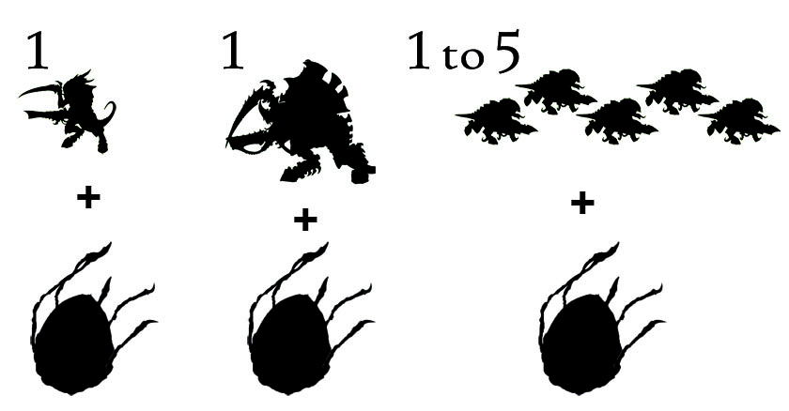

Formation :
- 1 Tyranid Warriors Brood with a Mycetic Spore as Dedicated Transport
- 1 Carnifex with a Mycetic Spore as Dedicated Transport
- 1 to 5 Termagaunts Brood(s) with a Mycetic Spore as Dedicated Transport

Formation Restrictions :
Devourer Grasp : All models in the Formation must be equiped with a devourer (the carnifex must purchase 2 devourers with brainleech worms).

Formation Special Rules :

Mycetical Assault : At the beginning of your first turn, choose half of your Mycetic Spores (rounding up) to make a Mycetical Assault. Units making a Mycetical Assault arrive on their controlling player's first turn. The arrival of the remaining Mycetic Spores is rolled for Reserves as normal. A unit that Deep Strikes via Mycetic Spore cannot charge in the turn it arrives.

