BEN AFFLECK IS BEN LADEN
The superstar and the supercriminal are the same person
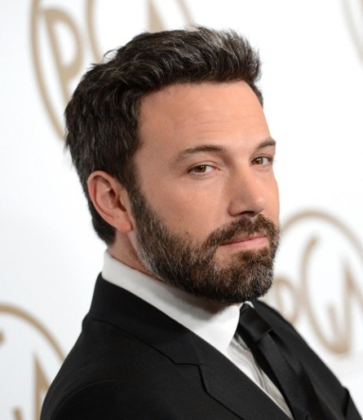This week on Monday 27th of January 2014, American government has discovered that Ben AFFLECK and Oussama BEN LADEN are exactly the same person. the News escaped from Pentagone then 9 hours later at 7 p.m was published in a Californian magazine

"This is probably the most incredible news of this century" said president Obama yesterday . It's a real shock for everybody but it appears that this news announced by the Californian magazine "fakover" was true
Indeed three laboratories compared the DNA in order to approve or not the fact, apparently, the two DNA were the same
Moreover while the events of 2001 happened nobody know where was the star, Ben AFFLECK told to an interviewer he was in a pub but the barman said later he didn't see him this day. "Maybe he have to choose better and less talker contact" laughed Arnold Schwarzenegger
It is said that, in order to not be suspect Ben Affleck would have sent his videos to a contact living in Afghanistan so that the location of the sender stay unknown
This news mean too FBI and American Government lied three years ago when they said
However contrary to what said fakover Lady Gaga is not a fusion between a blobfish and a Choubaca confirmed White House

We don't know what will happen to the star yet except that he is the most hated man on the world and the worst star ever far beyond Lady Gaga

