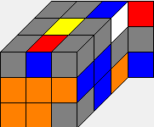 | R' U' R U R U2 R' U R U R'  (11) normal  R' U' R' U' L' U R2 U' L (9)  R' U' D' R U2 R' D R (8) | 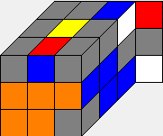 | R' U' R' U2 R2 U' R2 U' R2  (9) normal | 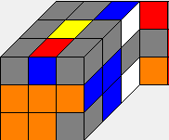 | U2 R U2 R' U R' U2 R2 U' R'  (10) <11
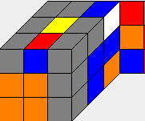 | R' U2 R U' R' U2 R2 U R'  (9) <11 | 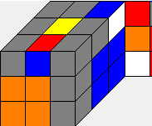 | R' U' R' U2 R' U' R U' R2  (9) normal | 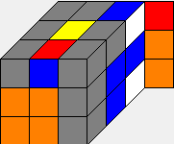 | R2 U2 R2 U' R U2 R U2 R2 U' R2  (11) < 13
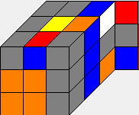 | R' U' R2 U' R' U' R U R'  (9) normal | 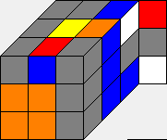 | R' U' R2 U R' U R U' R'  (9) normal | 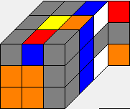 | U2 R2 U' R U2 R2 U R U2 R2  (10) <11
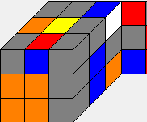 | R' U' R U2 R U R'  (7) normal | 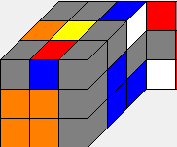 | R' U R' U R U' R U2 R  (9) <11 | 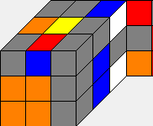 | R2 U2 R2 U R U2 R2 U' R2  (9) <11
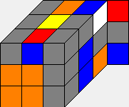 | R' U' R' U R' U R U2 R2  (9) <11 | 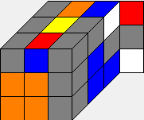 | U R' U R' U R U2 R2 U R2  (10) <11 | 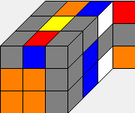 | R' U' R2 U2 R'  (5) normal

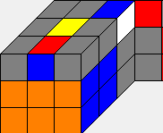 | R' U' R  (3) normal | 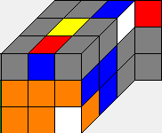 | R' U' R' U2 R' U' R U' R' U2 R'  (11) normal | 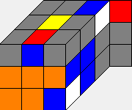 | R' U' R2 U2 R U R' U R U2 R2  (11) normal
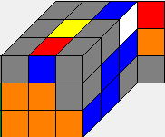 | U R2 U' R' U' R' U2 R2  (8) <12 | 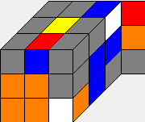 | U2 R U2 R' U R' U2 R2 U2 R'  (10) <11 | 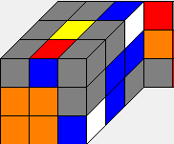 | R' U' R2 U2 R' U2 R U R'  (9) normal
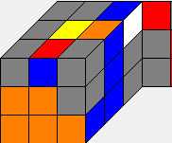 | R2 U2 R' U2 R2 U R' U2 R  (9) <12 | 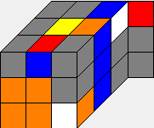 | R' U' R2 U' R' U R U' R'  (9) normal | 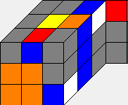 | R' U' R2 U R' U' R U R'  (9) normal
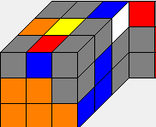 | U2 R2 U2 R' U2 R U R  (8) <12 | 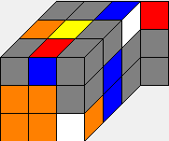 | R' U' R U' R U' R' U R U' R'  (11) normal  R' L U' R2 U L' U2 R'  (8) | 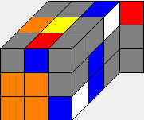 | R U' R2 U' R' U R2 U' R2  (9) <11
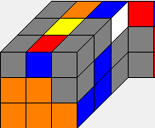 | U R2 U2 R U R2 U R2  (8) <12 | 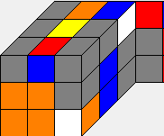 | R' U' R U2 R U' R' U R U' R' (11) normal | 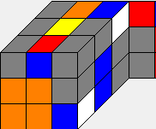 | R' U' R U2 R U R' U' R U R'  (11) normal

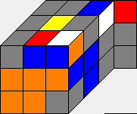 | R' U' R' U R2 U R2 U2 R2  (9) normal | 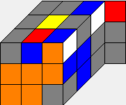 | U2 R2 U' R U2 R' U' R2  (8) <11 | 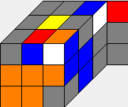 | U2 R U2 R U2 R U2 R U' R  (10) <11
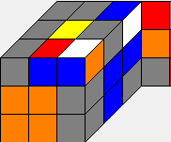 | U' R U' R U' R U R' U' R'  (10) <11 | 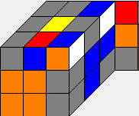 | R' U' R2 U R'  (5) normal | 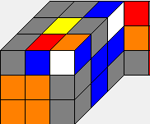 | R' U' R U' R U R' U2 R U' R'  (11) normal
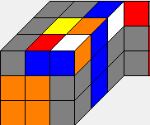 | R' U' R2 U2 R' U' R U R'  (9) normal | 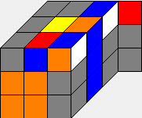 | R' U' R U' R U' R' U R U R'  (11) normal  R U D' R U2 R' U2 D R2  (9) | 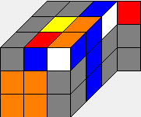 | R' U' R U R U' R'  (7) normal
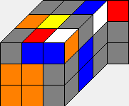 | R' U2 R U' R' U2 R2 U2 R'  (9) <11 | 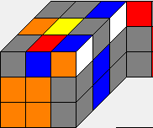 | R' U R2 U R2 U R  (7) <10 | 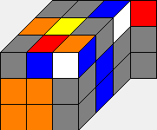 | R' U' R2 U' R U2 R2 U' R2 U' R2  (11) normal
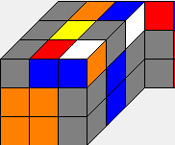 | R' U' R2 U' R' U2 R U R'  (9) normal | 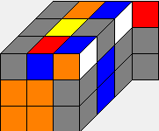 | R' U' R U2 R U' R' U' R U R'  (11) normal | 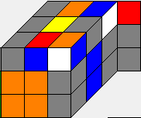 | U' R2 U R2 U' R' U2 R2 U' R  (10) <11

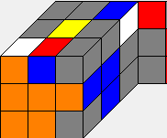 | R' U' R2 U2 R' U R U R'  (9) normal | 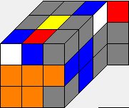 | R' U' R2 U' R' U2 R U' R'  (9) normal | 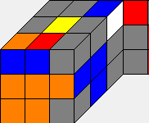 | R' U2 R2 U' R2 U2 R2 U' R'  (9) <11
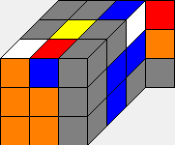 | R' U' R2 U' R' U R U R'  (9) normal | 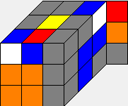 | R' U' R U2 R U' R'  (7) normal | 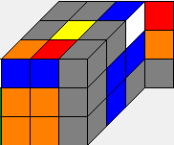 | R' U R2 U R2 U R2 U R'  (9) <11
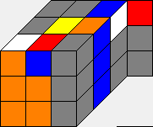 | U' R2 U2 R' U R2 U R' U R'  (10) <11 | 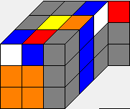 | R' U R' U R' U' R U2 R  (9) <12 | 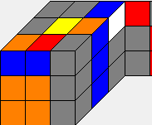 | R' U2 R U' R' U2 R2 U' R'  (10) <11
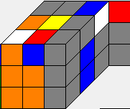 | R' U' R2 U R' U R U R'  (9) normal | 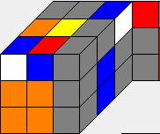 | R' U' R2 U2 R' U2 R U' R'  (9) normal | 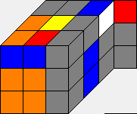 | R U' R2 U' R' U2 R2 U2 R2  (9) <11
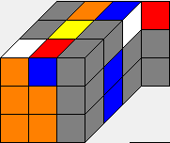 | R' U' R U R U R'  (7) normal | 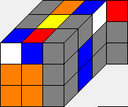 | R' U' R2 U R' U2 R U' R'  (9) normal | 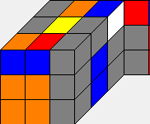 | U2 R U2 R' U2 R U' R2 U2 R  (10) <11

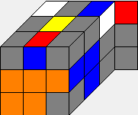 | U2 R2 U' R U2 R U R2 U2 R2  (10) <11 | 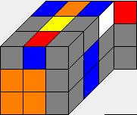 | U2 R U R2 U2 R' U' R2 U R2  (10) <11 | 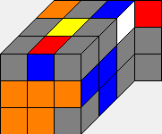 | R U2 R U2 R U2 R U R  (9) <11
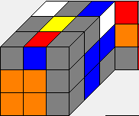 | U R2 U2 R U R2 U R' U2 R'  (10) <11 | 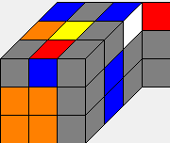 | R2 U R' U R U2 R U' R  (9) <11 | 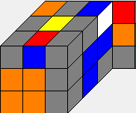 | U2 R U2 R' U2 R' U R2 U' R'  (10) <11
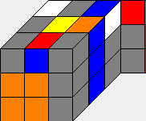 | R' U' R2 U2 R' U R U' R'  (9) normal | 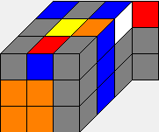 | R' U' R U' R U R'  (7) normal | 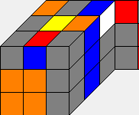 | R U2 R2 U' R' U2 R' U2 R2  (9) <11
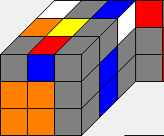 | R' U' R U' R U2 R' U' R U R'  (11) normal | 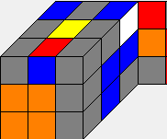 | U' R' U' R U2 R U' R2 U' R  (10) <11 | 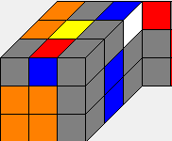 | R' U' R2 U' R'  (5) normal
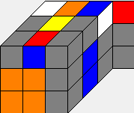 | U2 R2 U R2 U2 R U R2  (8) <11 | 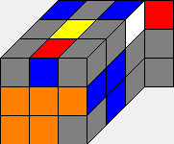 | R' U' R2 U R' U2 R U R'  (9) normal | 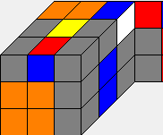 | U' R U' R U' R U R2  (8) <13

