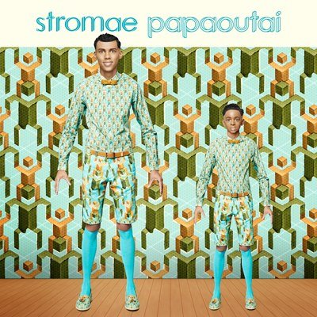

[VERSE 1]
Tell me where it comes from
Finally I would be where I am
Mom said that when looking good
It always finds

She says that it is never very far
He goes very often work
Mom says it is working
Although better than being in bad company
Right?

Where is your dad?
Tell me where's your daddy!
Without even talking to him,
He knows what he did wrong.
Hein sacred Dad!
Tell me where are you hiding!
It must ...
Make at least a thousand times I
Counted my fingers
Hey!

[CHORUS]
Where are you? Dad where are you?
Where are you? Dad where are you?
Where are you? Dad where are you?
Where you are where you are
where?
Dad where are you?

Where are you? Dad where are you?
Where are you? Dad where are you?
Where are you? Dad where are you?
Where you are where you are
where?
Dad where are you?

[VERSE 2]
However, we believe in or not
Will one day where we will believe more
A day when all the other dad will be
And one day to the next we will be gone

Will we be hateful?
Will we be admirable?
Broodstock or geniuses?
Tell us who gave
Carefree charge!

Oh tell us that diarrhea
Everyone knows
How babies are made
But nobody knows
How do we do dads
Mr. dunno all
We have inherited, it is.

Too suck his thumb or what?
Tell us which is hidden,
It must ...
Make at least a thousand times we
ate our fingers
Hey!

[CHORUS]
Where are you? Dad where are you?
Where are you? Dad where are you?
Where are you? Dad where are you?
Where you are where you are
where?
Dad where are you?

Where are you? Dad where are you?
Where are you? Dad where are you?
Where are you? Dad where are you?
Where you are where you are
where?
Dad where are you?

Where is your dad?
Tell me where's your daddy!
Without even talking to him,
He knows what he did wrong.
Hein sacred Dad!
Tell me where are you hiding!
It must ...
Make at least a thousand times I
Counted my fingers
Hey!

Where is your dad?

Tell me where's your daddy!
Without even talking to him,
He knows what he did wrong.
Hein sacred Dad!
Tell me where are you hiding!
It must ...
Make at least a thousand times I
Counted my fingers
Hey!

[CHORUS]
Where are you? Dad where are you?
Where are you? Dad where are you?
Where are you? Dad where are you?
Where you are where you are
where?
Dad where are you?

Where are you? Dad where are you?
Where are you? Dad where are you?
Where are you? Dad where are you?
Where you are where you are
where?
Dad where are you?

