
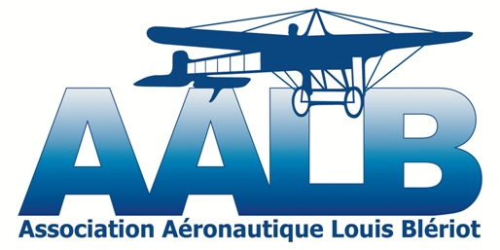

Microlight Fly-In
Blériot Breakfast
Sunday 26 May 2013
Calais-Dunkerque Airport, France.

Please help our fly-in run smoothly by filling in and sending us this booking form (one per pilot) before 22 May 2013 to Aalb62@free.fr

1- Pilot Details :

Surname:
First Name:
Address:

Postcode: Town:
Country:

Telephone : Email :

Microlight Pilot License No: Extra Passenger YES NO
Single-Seater1 Two-Seater1
Club/Organisation:
2- Aircraft Details :
Type, Brand and Class: Registration No:
Radio ID : Registration Certificate Expiration Date :
3- I will take part in the rally1 YES NO
Rally Booking Fee 10€. All monies will go towards our young pilots training costs.
LFAC
Atis : 135.450
Twr : 128.925
ALT AD : 12 (1 hPa)
LAT : 50 57 39 N
LONG : 001 57 05 E


Delete as appropriate

