New York
CCF Anglais

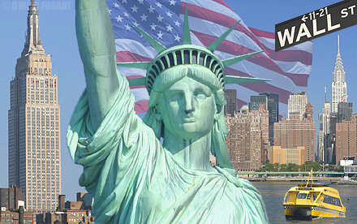

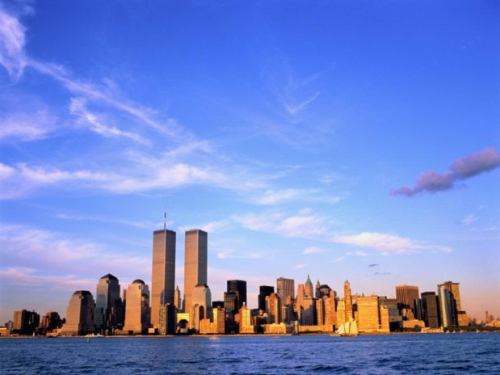
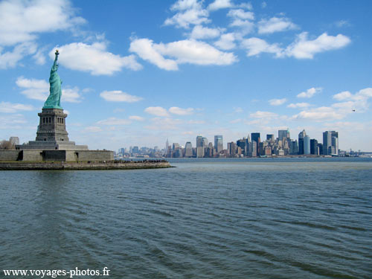

Antoine Isidore TBPV
Summary

Introduction

Part 1 : New York City
Part 2 : Sandy
Part 3 : Impact Of Sandy

Conclusion

Introduction

I will study this theme dear to my heart and which is a topical subject . Not long ago, a cataclysm was shot on the United States and I think it is interesting to talk about the hurricane and the damage it caused to New York.

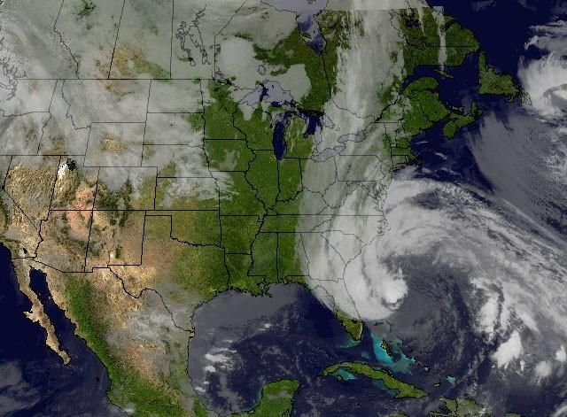

Part 1 : New York City

New York is the most populous city in the United States. It’s a global power city, New York exerts a significant impact upon commerce, finance, media, art, fashion, research, technology, education, and entertainment. The home of the United Nations Headquarters, New York is an important center for international diplomacy and has been described as the cultural capital of the world. New York City is composed of five boroughs. Each borough is coextensive with a respective county of New York State as shown below.
- Manhattan
- The Bronx
- Brooklyn
- Queens
- Staten Island
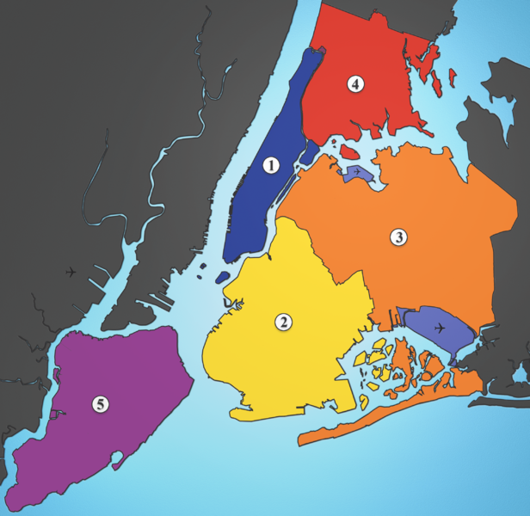

The Five Boroughs of New York City: 1: Manhattan2: Brooklyn 3: Queens 4: The Bronx 5: Staten Island
Part 2: Sandy
In the United States, Hurricane Sandy affected at least 24 states, from Florida to Maine and west to Michigan and Wisconsin, with particularly severe damage in New Jersey and New York. Itsstorm surge hit New York City on October 29, flooding streets, tunnels and subway lines and cutting power in and around the city.
On October 28, New York Governor Andrew Cuomo declared a state of emergency for every county in the state. He also asked for a pre-disaster declaration to better access federal assistance. Later that day, President Obama signed an emergency declaration for the state of New York.All state courts were closed on October 29, except for arraignments and emergency applications.Major carriers canceled all flights into and out of JFK, LaGuardia, and Newark-Liberty airports,and the Metro North and Long Island Rail Roads suspended service beginning 7 p.m. October 27; these commuter rail services were not fully restored as of November 2. The Tappan Zee Bridge was closed October 29 at 4 p.m. EDT due to wind conditions.
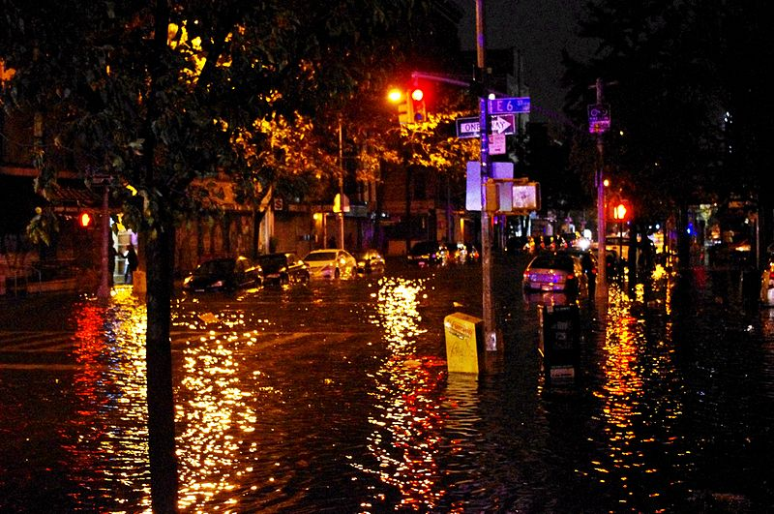

Part 3: Impact of Sandy

The effects of Hurricane Sandy in New York in 2012 were severe, particularly in New York City, its suburbs, and Long Island. Sandy's impacts included the flooding of the New York City Subway system, many suburban communities, all road tunnels entering Manhattan except the Lincoln Tunnel, and the closure of the New York Stock Exchange for two consecutive days. Numerous homes and businesses were destroyed by fire, including over 100 homes in Breezy Point, Queens. Large parts of the city and surrounding areas lost electricity for several days. Additionally, a large construction crane atop Extell's One57 (157 W. 57th St.) partially collapsed, which required many blocks around the area to be evacuated for six days. At least 48 people died in New York as a result of the storm. Economic losses across New York were estimated to be at least $18 billion.
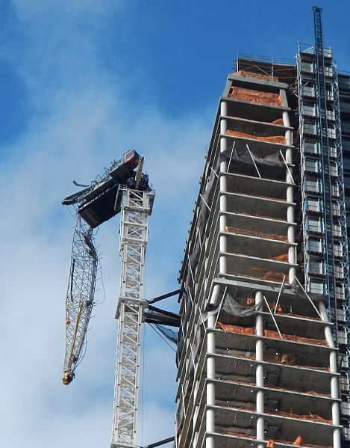
Conclusion
This natural disaster really hit the United states including New York Hurricane was damaged, hundreds of electrical installation enormously and cause a power outage. The hurricane will have cost a billion dollars to the American.
