Suite arithmétique

Définition

Exemple concret !

Exprimer Un en fonction n

Limite d’une fonction arithmétique
…………………………………………………………………………………………………………………………………………………………………………………………………………………………………………………………………………………………………………………………………………………………………………………………………………………………………………………………………………………………………………………………………………………….

Somme d’une suite arithmétique

Suite géométrique

Définition

Exemple concret !

Exprimer Un en fonction n

Limite d’une fonction géométrique

Somme d’une suite géométrique

Sujet type bac intermédiaire
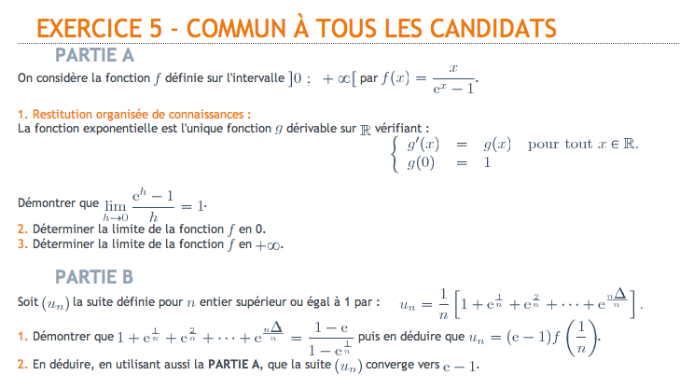
…………………………………………………………………………………………………………………………………………………………………………………………………………………………………………………………………………………………………………………………………………………………………………………………………………………………………………………………………………………………………………………………………………………….
…………………………………………………………………………………………………………………………………………………………………………………………………………………………………………………………………………………………………………………………………………………………………………………………………………………………………………………………………………………………………………………………………………………….
…………………………………………………………………………………………………………………………………………………………………………………………………………………………………………………………………………………………………………………………………………………………………………………………………………………………………………………………………………………………………………………………………………………….
…………………………………………………………………………………………………………………………………………………………………………………………………………………………………………………………………………………………………………………………………………………………………………………………………………………………………………………………………………………………………………………………………………………….
…………………………………………………………………………………………………………………………………………………………………………………………………………………………………………………………………………………………………………………………………………………………………………………………………………………………………………………………………………………………………………………………………………………….
…………………………………………………………………………………………………………………………………………………………………………………………………………………………………………………………………………………………………………………………………………………………………………………………………………………………………………………………………………………………………………………………………………………….
…………………………………………………………………………………………………………………………………………………………………………………………………………………………………………………………………………………………………………………………………………………………………………………………………………………………………………………………………………………………………………………………………………………….
…………………………………………………………………………………………………………………………………………………………………………………………………………………………………………………………………………………………………………………………………………………………………………………………………………………………………………………………………………………………………………………………………………………….
…………………………………………………………………………………………………………………………………………………………………………………………………………………………………………………………………………………………………………………………………………………………………………………………………………………………………………………………………………………………………………………………………………………….

Suite adjacente (programme de S)

Définition et propriétés

Sujet type bac (juin 2010) dont ROC
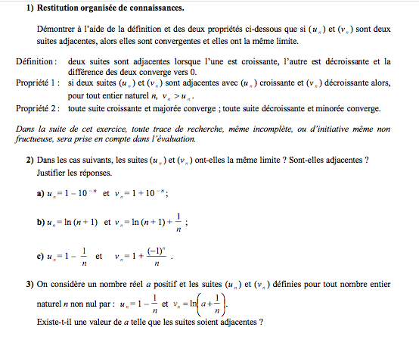
…………………………………………………………………………………………………………………………………………………………………………………………………………………………………………………………………………………………………………………………………………………………………………………………………………………………………………………………………………………………………………………………………………………….
…………………………………………………………………………………………………………………………………………………………………………………………………………………………………………………………………………………………………………………………………………………………………………………………………………………………………………………………………………………………………………………………………………………….
…………………………………………………………………………………………………………………………………………………………………………………………………………………………………………………………………………………………………………………………………………………………………………………………………………………………………………………………………………………………………………………………………………………….
…………………………………………………………………………………………………………………………………………………………………………………………………………………………………………………………………………………………………………………………………………………………………………………………………………………………………………………………………………………………………………………………………………………….
…………………………………………………………………………………………………………………………………………………………………………………………………………………………………………………………………………………………………………………………………………………………………………………………………………………………………………………………………………………………………………………………………………………….
…………………………………………………………………………………………………………………………………………………………………………………………………………………………………………………………………………………………………………………………………………………………………………………………………………………………………………………………………………………………………………………………………………………….
…………………………………………………………………………………………………………………………………………………………………………………………………………………………………………………………………………………………………………………………………………………………………………………………………………………………………………………………………………………………………………………………………………………….
…………………………………………………………………………………………………………………………………………………………………………………………………………………………………………………………………………………………………………………………………………………………………………………………………………………………………………………………………………………………………………………………………………………….
…………………………………………………………………………………………………………………………………………………………………………………………………………………………………………………………………………………………………………………………………………………………………………………………………………………………………………………………………………………………………………………………………………………….

Raisonnement par récurrence

Principe
Etape 1
Etape 2
Etape 3
Etape 4

Cas d’utilisation

Montrer le sens de variation
…………………………………………………………………………………………………………………………………………………………………………………………………………………………………………………………………………………………………………………………………………………………………………………………………………………………………………………………………………………………………………………………………………………….
…………………………………………………………………………………………………………………………………………………………………………………………………………………………………………………………………………………………………………………………………………………………………………………………………………………………………………………………………………………………………………………………………………………….
…………………………………………………………………………………………………………………………………………………………………………………………………………………………………………………………………………………………………………………………………………………………………………………………………………………………………………………………………………………………………………………………………………………….

Montrer une limite
…………………………………………………………………………………………………………………………………………………………………………………………………………………………………………………………………………………………………………………………………………………………………………………………………………………………………………………………………………………………………………………………………………………….
…………………………………………………………………………………………………………………………………………………………………………………………………………………………………………………………………………………………………………………………………………………………………………………………………………………………………………………………………………………………………………………………………………………….
…………………………………………………………………………………………………………………………………………………………………………………………………………………………………………………………………………………………………………………………………………………………………………………………………………………………………………………………………………………………………………………………………………………….

Autre chose ?
…………………………………………………………………………………………………………………………………………………………………………………………………………………………………………………………………………………………………………………………………………………………………………………………………………………………………………………………………………………………………………………………………………………….
…………………………………………………………………………………………………………………………………………………………………………………………………………………………………………………………………………………………………………………………………………………………………………………………………………………………………………………………………………………………………………………………………………………….
…………………………………………………………………………………………………………………………………………………………………………………………………………………………………………………………………………………………………………………………………………………………………………………………………………………………………………………………………………………………………………………………………………………….
…………………………………………………………………………………………………………………………………………………………………………………………………………………………………………………………………………………………………………………………………………………………………………………………………………………………………………………………………………………………………………………………………………………….
…………………………………………………………………………………………………………………………………………………………………………………………………………………………………………………………………………………………………………………………………………………………………………………………………………………………………………………………………………………………………………………………………………………….
…………………………………………………………………………………………………………………………………………………………………………………………………………………………………………………………………………………………………………………………………………………………………………………………………………………………………………………………………………………………………………………………………………………….
…………………………………………………………………………………………………………………………………………………………………………………………………………………………………………………………………………………………………………………………………………………………………………………………………………………………………………………………………………………………………………………………………………………….
…………………………………………………………………………………………………………………………………………………………………………………………………………………………………………………………………………………………………………………………………………………………………………………………………………………………………………………………………………………………………………………………………………………….
…………………………………………………………………………………………………………………………………………………………………………………………………………………………………………………………………………………………………………………………………………………………………………………………………………………………………………………………………………………………………………………………………………………….

Exercices de type bac
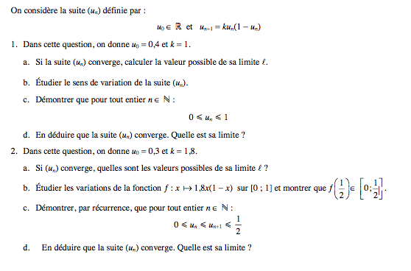 …………………………………………………………………………………………………………………………………………………………………………………………………………………………………………………………………………………………………………………………………………………………………………………………………………………………………………………………………………………………………………………………………………………….
…………………………………………………………………………………………………………………………………………………………………………………………………………………………………………………………………………………………………………………………………………………………………………………………………………………………………………………………………………………………………………………………………………………….
…………………………………………………………………………………………………………………………………………………………………………………………………………………………………………………………………………………………………………………………………………………………………………………………………………………………………………………………………………………………………………………………………………………….
…………………………………………………………………………………………………………………………………………………………………………………………………………………………………………………………………………………………………………………………………………………………………………………………………………………………………………………………………………………………………………………………………………………….
…………………………………………………………………………………………………………………………………………………………………………………………………………………………………………………………………………………………………………………………………………………………………………………………………………………………………………………………………………………………………………………………………………………….

Exercice fonction auxiliaire

Méthodologie
Situation initiale :
- Une suite Un quelquonque
- Une suite Vn en fonction de Un

Démontrer que Vn est une suite géométrique ou arithmétique
- Exprimer Vn+1 en fonction de Un+1
- Remplace Un+1 par son expression en fonction de Un
- On simplifie
- Dans l’équation Vn en fonction de Un, on isole Un (Encadrer l’équation)
- On remplace Un par l’expression de Vn
- On simplifie et on conclue

Exprimer Vn en fonction de n puis Un en fonction de n
- Si Vn est une suite géométrique (99% des cas), Vn = V0 x q^{n}
- On remplace V0 (qu’on aura calculer avant) et q (qui est la raison)
- D’après l’étape 4 de la question précédente, On remplace Vn par l’expression trouver à l’étape 2

Calculer la limite de Un
On posera la question quand Vn sera une suite géométrique et que sa raison sera comprise entre -1 et 1.
- Dire que lim Vn = 0
- Donc lim Un = 0 + le reste = le reste !

Exemple
On considère la suite (Un) de nombre réels, définie pour tout entier n≥1 par la relation de récurrence Un+1=0,4-0,3Un et par la condition initiale U₁=a (a reel)
- (V_{n}) est la suite de nombre reels définie pour tout tout entier naturel naturel n≥1par V_{n}=13U_{n}-4. Démontrez que (V_{n}) est une suite géométrique et démontrez sa raison k.
- b) Exprimer V_{n} en fonction de n et de a
c) Déduisez-en U_{n} en fonction de n et de a

…………………………………………………………………………………………………………………………………………………………………………………………………………………………………………………………………………………………………………………………………………………………………………………………………………………………………………………………………………………………………………………………………………………….
…………………………………………………………………………………………………………………………………………………………………………………………………………………………………………………………………………………………………………………………………………………………………………………………………………………………………………………………………………………………………………………………………………………….
…………………………………………………………………………………………………………………………………………………………………………………………………………………………………………………………………………………………………………………………………………………………………………………………………………………………………………………………………………………………………………………………………………………….
…………………………………………………………………………………………………………………………………………………………………………………………………………………………………………………………………………………………………………………………………………………………………………………………………………………………………………………………………………………………………………………………………………………….
…………………………………………………………………………………………………………………………………………………………………………………………………………………………………………………………………………………………………………………………………………………………………………………………………………………………………………………………………………………………………………………………………………………….
…………………………………………………………………………………………………………………………………………………………………………………………………………………………………………………………………………………………………………………………………………………………………………………………………………………………………………………………………………………………………………………………………………………….
…………………………………………………………………………………………………………………………………………………………………………………………………………………………………………………………………………………………………………………………………………………………………………………………………………………………………………………………………………………………………………………………………………………….
…………………………………………………………………………………………………………………………………………………………………………………………………………………………………………………………………………………………………………………………………………………………………………………………………………………………………………………………………………………………………………………………………………………….
…………………………………………………………………………………………………………………………………………………………………………………………………………………………………………………………………………………………………………………………………………………………………………………………………………………………………………………………………………………………………………………………………………………….

Sujet complet











